Chun-Wei Chen

1267040

CSE 344 Homework 4

02/13/14

Employee(eid, name, office)

Manager(eid, mid)

1.

(a) Q(e, n) = ∃o. ∃m1. ∃m2. (Employee(e, n, o) ˄ Manager(e, m1) ˄ Manager(e, m2) ˄ m1 ≠ m2)

(b) A(e, n) :- Employee(e, n, _), Manager(e, m1), Manager(e, m2), m1 != m2

(c)

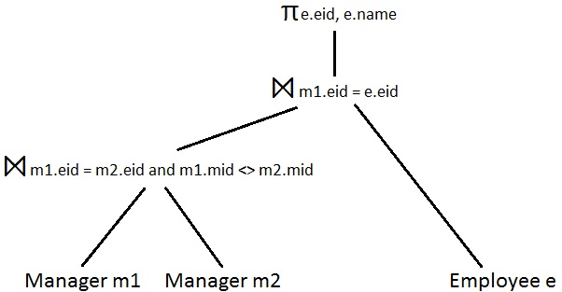

2.

(a) Q(e, n) = ∃o1. Employee(e, n, o1) ˄ ∀m. (∃n2. ∃o2. Employee(m, n2, o2) => ¬Manager(e, m))

(b) HasManager(e) :- Employee(e, _, _), Manager(e, _)

A(e, n) :- Employee(e, n, _), NOT HasManager(e)

(c)

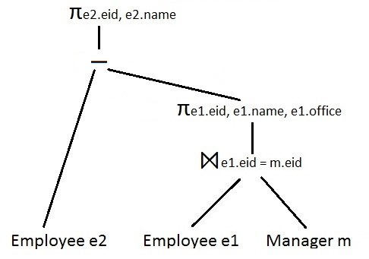

3.

(a) Q(o) = ∃e. ∃o1. ∃m. ∃n. (Employee(e, ‘Alice’, o1) ˄ Employee(m, n, o) ˄ Manager(e, m))

(b) A(o) :- Employee(e, ‘Alice’, _), Employee(m, _, o), Manager(e, m)

(c)

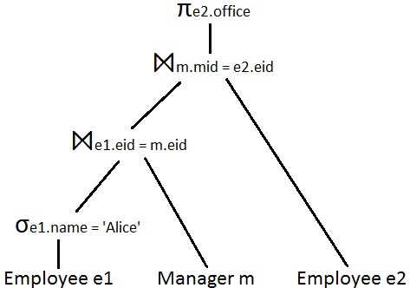

4.

(a) Q(m, n, o) = ∃o0. ∃e1. ∃n1. (Employee(m, n, o0) ˄ Employee(e1, n1, o) ^ Manager(e1, m) ^

∀e2. (∃n2. ∃o2. Employee(e2, n2, o2) ˄ o ≠ o2 => ¬Manager(e2, m)))

(b) DifferentOffice(m) :- Manager(e1, m), Employee(e1, _, o1),

Manager(e2, m), Employee(e2, _, o2), o1 != o2

AllSameOffice(e, m) :- Manager(e, m), NOT DifferentOffice(m)

A(m, n, o) :- Employee(m, n, _), Employee(e, _, o), AllSameOffice(e, m)

(c)

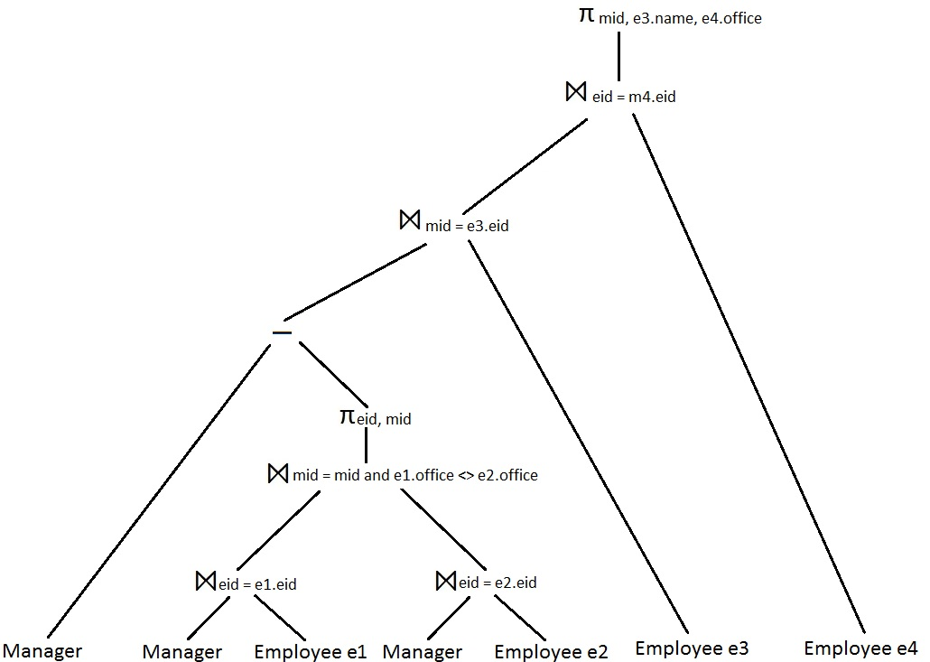

5.

(a) Q(a, b) = ∃o1. (Employee(m, n1, o1) ˄ ∀m1. (Manager(m1, m) =>

∀n2. ∀o2. (Employee(m1, n2, o2) =>

∃e. Manager(e, m1))))

(b) NotManager(e) :- Employee(e, _, _), NOT Manager(_, e)

NotSndLvl(m) :- Manager(e, m), NotManager(e)

A(m, n) :- Employee(m, n, _), NOT NotSndLvl(m)

(c)

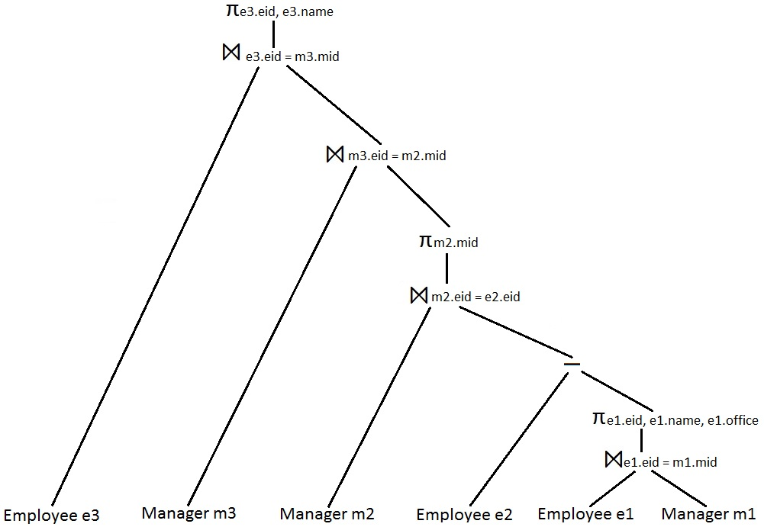

**Extra Credit**

ManagedBy(x, y) :- Manager(x, y)

ManagedBy(x, y) :- ManagedBy(x, z), Manager(z, y)

A(x) :- ManagedBy(x, ‘Alice’)