**ASSIGNMENT – 6A**

**AIM :-** Write a Program to implement concept of Props and States

**Code:-**

**CODE-1 :-**

**App.js**

import React from 'react';

import './App.css';

import DateTime from './DateTime';

function App() {

  const date_time = new Date().toLocaleString();

  return (

    <div className='container'>

      <div className='greet'>

          <p>React Wecomes You!!</p>

          <p>See The Date and Time below....</p>

      </div>

      <div className='data'>

          <DateTime data={date_time}/>

      </div>

    </div>

  );

}

export default App;

**DateTime.js**

import React from 'react';

function DateTime(props){

    return(

        <div className='info'>

            <p>Date and Time : {props.data}</p>

        </div>

    )

}

export default DateTime;

**App.css**

.App {

  text-align: center;

}

.App-header {

  background-color: #282c34;

  min-height: 100vh;

  display: flex;

  flex-direction: column;

  align-items: center;

  justify-content: center;

  font-size: calc(10px + 2vmin);

  color: white;

}

.greet{

  height: 100px;

  width: 250px;

  align-content: center;

  background-color: aqua;

  border: 5px solid black;

  border-radius: 4px;

  font-weight: bold;

  padding: 10px;

}

.data{

  height: 100px;

  width: 250px;

  align-content: center;

  background-color: coral;

  border: 5px solid black;

  border-radius: 4px;

  font-weight: bold;

  text-align: center;

  padding-left: 15px;

}

.container{

  display: flex;

  flex-direction: column;

  height: 100vh;

  width: 100vw;

  background-color: rgb(125, 119, 119);

  justify-content: center;

  align-items: center;

  /* padding-left: 40%; */

}

#root{

  background-color: black;

}

**Code 2 –**

**App.js**

import React from 'react';

import './App.css';

import ColorChange from './ColorChanger'

function App() {

  return (

    <>

    <ColorChange />

    </>

  )

}

export default App;

**ColorChange.js**

import React from 'react';

class ColorChange extends React.Component{

    constructor(){

        super();

        this.state = ({ backgroundColor: '#ff4200' });

    }

    //let background;

    changeColor(){

        const randomval = '#' + Math.floor(Math.random()*167815).toString(16);

        this.setState({

            backgroundColor : randomval

        })

    }

    render(){

        const {backgroundColor}  = this.state;

        return(

            <div style={{background : backgroundColor, border: '5px solid black', padding:'10px', margin:'140px', borderRadius: '5px'}}>

                <p style={{fontWeight :'bolder'}}>Color Changer Game</p>

                <button style={{fontWeight:'bold', borderRadius:'3px'}} onClick={()=>this.changeColor()}>Change Color</button>

            </div>

        )

    }

}

export default ColorChange;

**Screen Shot:-**

**Output 1 –**

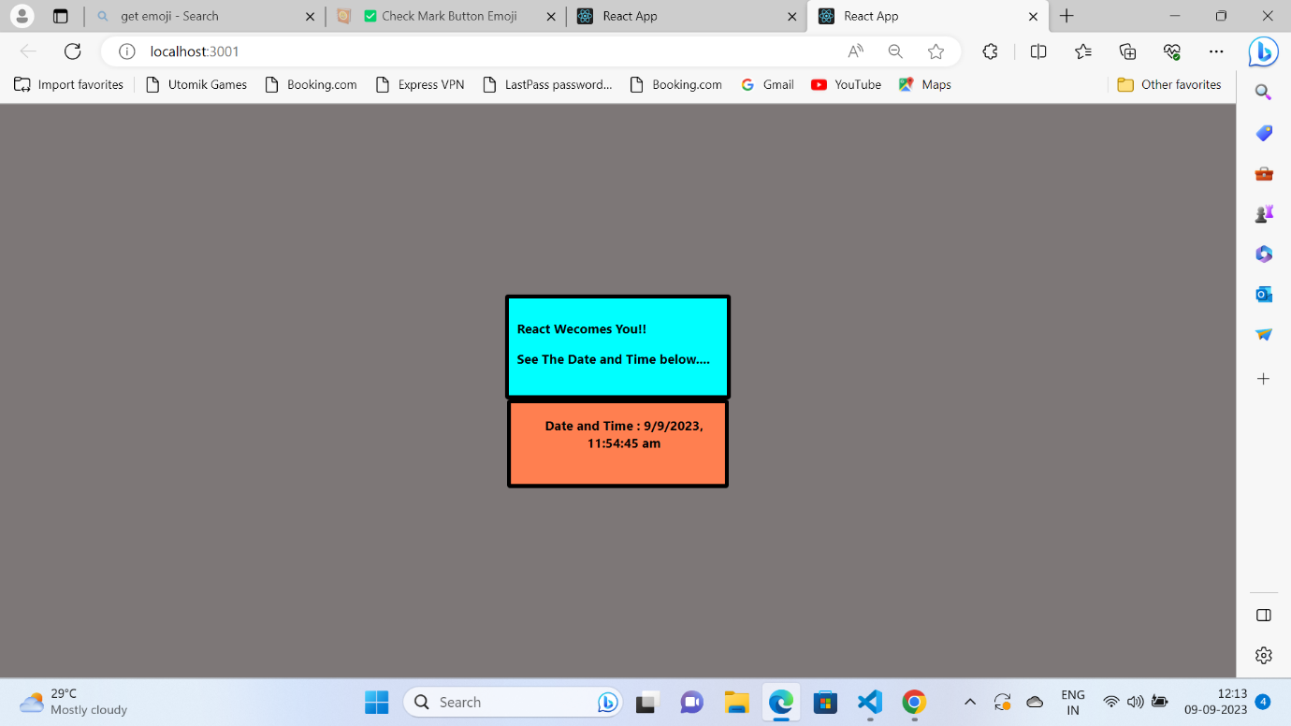

**Output 2 –**

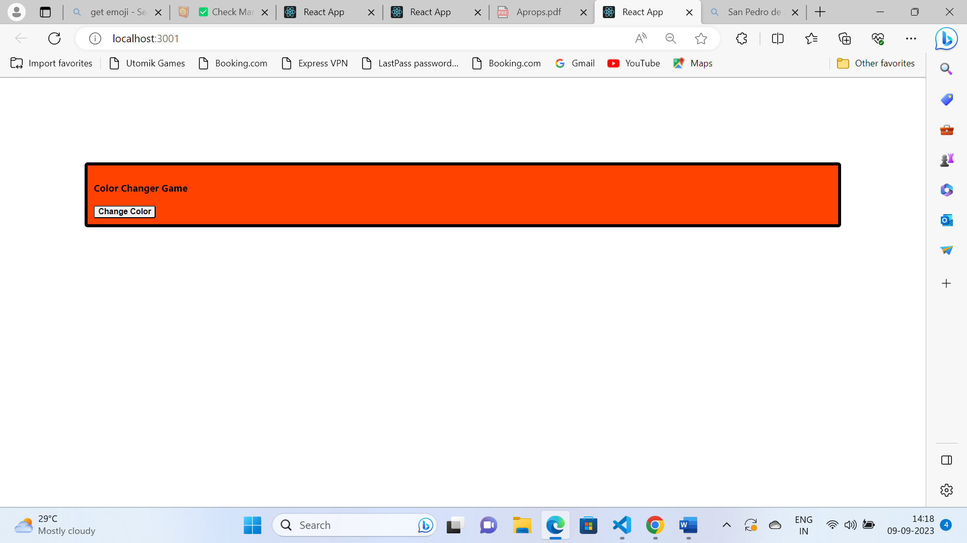

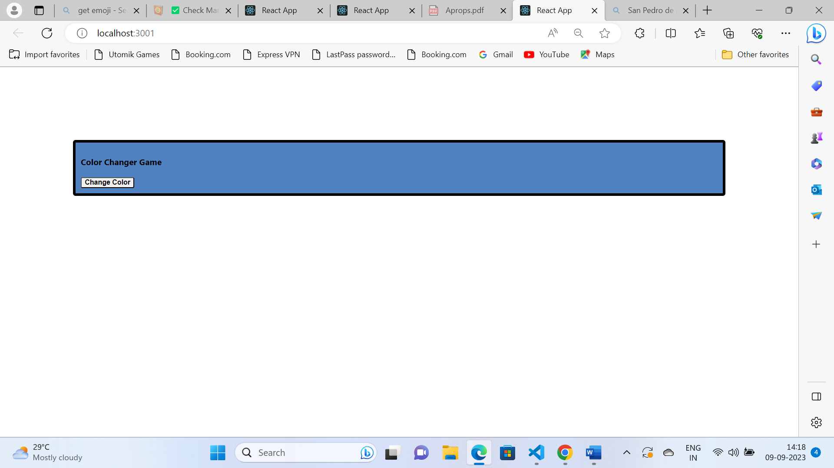

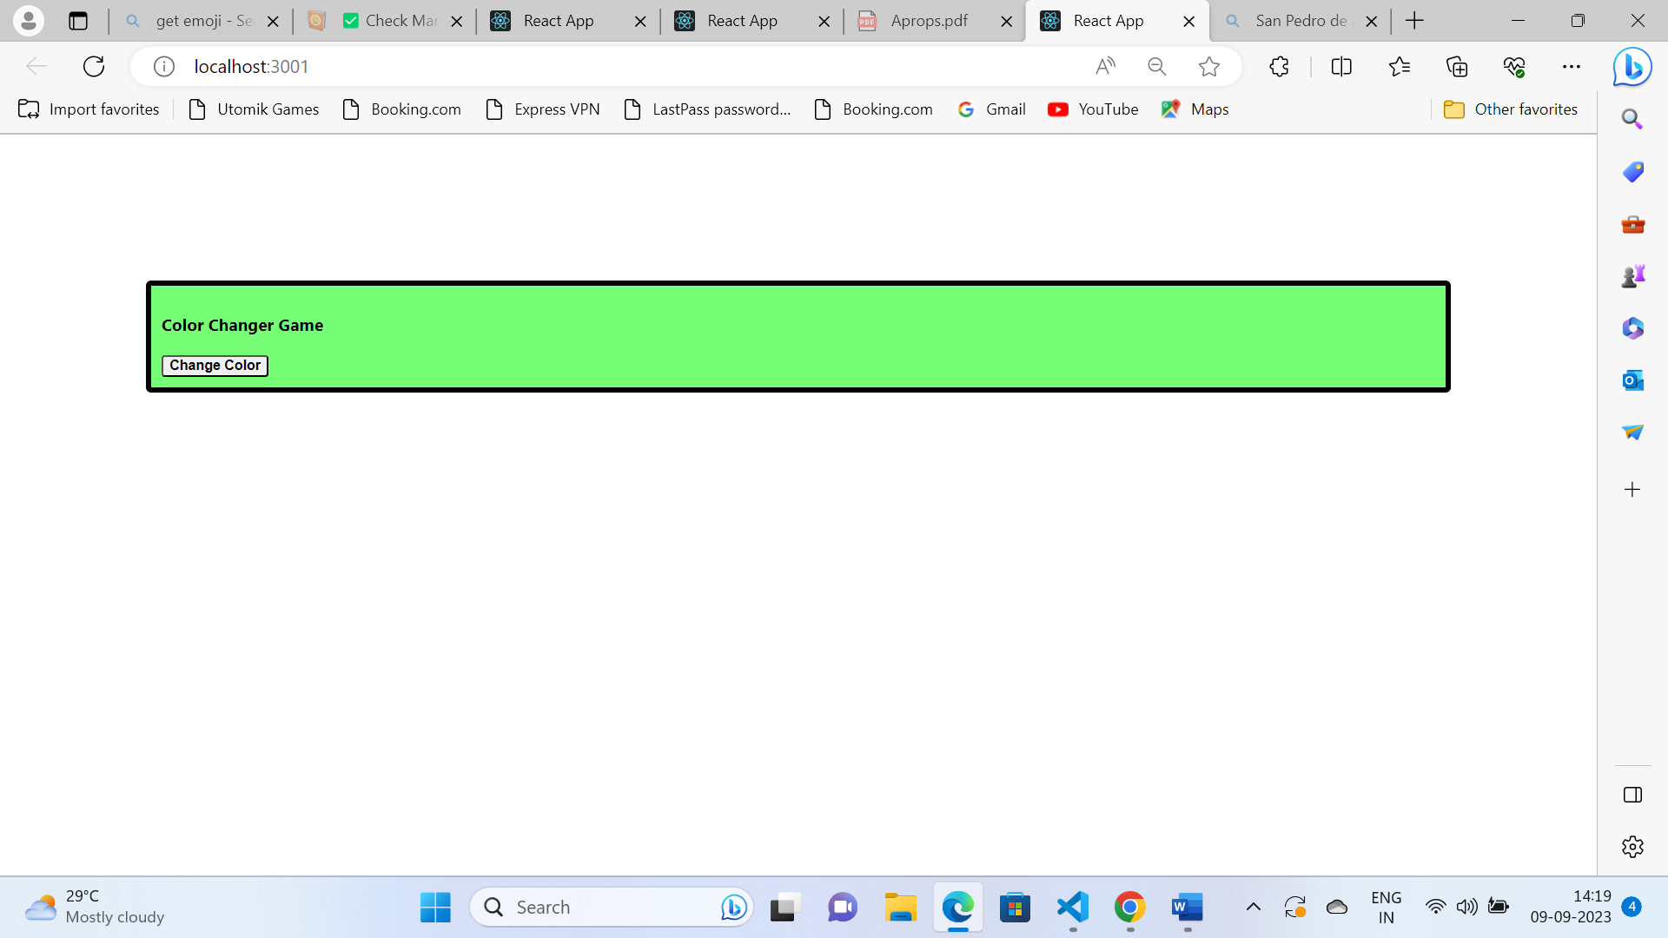

**Conclusion :-**

We have successfully implemented the concept of **Props** and **State** in react. In above programs we have used **Props** in **functional component** which is actually a **read only value** and cannot be used to update the page on render, while on the other hand we have used the **State** using **class component** for updating the page content.