Tubulu System Architecture Overview
This document presents a detailed breakdown of the Tubulu platform architecture, split into clear logical modules. This structural information serves as a comprehensive reference guide for an architectural review.

1. System Block Diagram & Flow
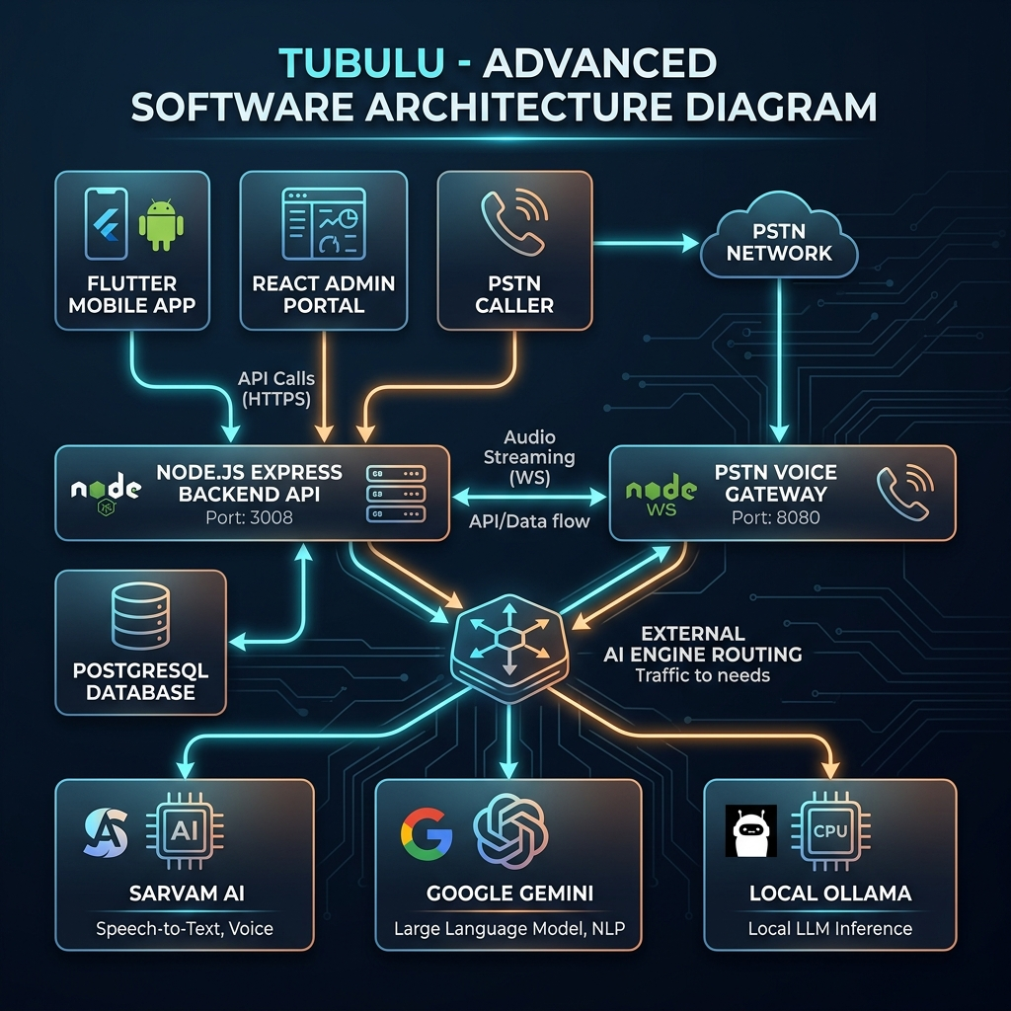
Figure: Tubulu System Architecture Diagram
Below is the high-level block diagram illustrating the end-to-end integration flow between the clients, gateway servers, core backend APIs, and external services.
The interaction between client portals, real-time gateways, core database servers, and external third-party AI APIs is depicted in the flow diagram below:
graph TD
%% Styling
classDef client fill:#e1f5fe,stroke:#0288d1,stroke-width:2px,color:#01579b;
classDef gateway fill:#e8f5e9,stroke:#388e3c,stroke-width:2px,color:#1b5e20;
classDef backend fill:#fff3e0,stroke:#f57c00,stroke-width:2px,color:#e65100;
classDef db fill:#eceff1,stroke:#455a64,stroke-width:2px,color:#263238;
classDef external fill:#fce4ec,stroke:#c2185b,stroke-width:2px,color:#880e4f;
%% Components
subgraph Clients ["📱 Clients & User Interfaces"]
Mobile["Flutter Mobile App<br>(Customers / Android & iOS)"]:::client
Admin["React / Vite Admin Portal<br>(Merchants & Super Admins)"]:::client
PSTN["PSTN Caller / Asterisk Voice VoIP"]:::client
end
subgraph Gateways ["⚡ Real-Time Gateways"]
PSTNGateway["PSTN Voice Gateway Server<br>(Node.js WS - Port 8080)"]:::gateway
end
subgraph CoreBackend ["⚙️ Core Backend Services"]
BackendAPI["Node.js Express Backend API<br>(Port 3008)"]:::backend
DB[("Database Storage<br>(PostgreSQL / SQLite)")]:::db
end
subgraph ExternalServices ["☁️ AI & External APIs"]
SarvamAI["Sarvam AI REST Suite<br>- STT (saarika)<br>- LLM (sarvam-m)<br>- TTS (bulbul)"]:::external
Gemini["Google Gemini LLM / Voice"]:::external
Ollama["Ollama Local Host LLM"]:::external
SMS["SMS Gateway (Pinnacle API)"]:::external
end
%% Flows & Connections
Admin -->|REST API / HTTPS| BackendAPI
Mobile -->|REST API / HTTPS| BackendAPI
BackendAPI <-->|Reads/Writes SQL| DB
PSTN <-->|Audio Stream SLIN16 WebSockets| PSTNGateway
PSTNGateway -->|Store & Catalog Lookup| BackendAPI
PSTNGateway <-->|Dynamic AI Gateway Routing| BackendAPI
PSTNGateway <-->|TTS / STT Fallbacks| SarvamAI
PSTNGateway -->|Send Receipt link| SMS
SMS -.->|SMS Alert| PSTN
```

2. Modular Architecture Breakdown
The system is organized into four main modules:

Module A: Core Backend Services (`backend/`)
- Technology: Node.js, Express, Sequelize ORM.
- Responsibilities:
- Database Layer: Implements Models for User, Store, Category, Product, Order, Integration, and SystemSetting.
- Admin API: Handles authentication, store onboarding, dynamic configuration updates, product uploads, order tracking, and SMS dispatcher queues.
- Dynamic AI Routing Router:
- Stores user-configured preferred models in the SystemSetting table (e.g., DEFAULT_TEXT_PROVIDER, DEFAULT_VOICE_PROVIDER).
- Implements AIHelper.js (Store level Chat), GlobalAIHelper.js (Global Chatbot), and Chatbot.controller.js (Fallback Chat).
- Performs dynamic failover: Checks token lengths against the chosen engine (e.g., Sarvam context limits ~7k tokens) and automatically routes chats to Google Gemini or local Ollama if constraints are violated.

Module B: Voice & PSTN WebSocket Gateway (`server.js`)
- Technology: Node.js, WebSocket (ws), Axios, WaveFile (audio resampling).
- Responsibilities:
- Establishes a direct audio socket connection (running Asterisk SLIN16 format at 16 kHz Mono, 20 ms frames) with PSTN switches/voice servers.
- Translates incoming voice frames using Voice Activity Detection (VAD) to feed Sarvam STT (saarika).
- Passes conversation context dynamically to the AI Router for LLM responses.
- Runs text outputs through TTS (bulbul:v2) and resamples output WAV audio from 22.05 kHz to 16 kHz before streaming PCM frames back to the client.

Module C: Admin Portal Frontend UI (`apps/admin_portal/`)
- Technology: React, Vite, TypeScript, TailwindCSS.
- Responsibilities:
- Merchant Dashboard: Enables store owners to manage inventory/catalogs, edit categories, view transactional details, and check call logs.
- Super Admin Control Center: Provides dynamic forms to update global configurations including AI models, API keys, routing fallback criteria, and SMS providers.

Module D: Mobile Consumer App (`apps/tubulu_mobile/`)
- Technology: Flutter (Dart).
- Responsibilities:
- Direct shopping interface for customers to browse store categories (FB, GROCERY, etc.), place orders, review history, and view active order tracking.

Summary of Implemented Capabilities
Module / Scope | Category | Implemented Capabilities
Core Backend (backend/) | Database & ORM | Sequelize mapping to PostgreSQL & SQLite. Relational structure managing Users, Stores, Products, Categories (standardized to FB/GROCERY), Orders, Integrations, and dynamic Settings.
Core Backend (backend/) | Dynamic AI Routing | Prompt compilation, context history building, token constraint tracking (e.g. ~7k token Sarvam threshold), and automated runtime failovers between Google Gemini, Sarvam, and Local Ollama engines.
Core Backend (backend/) | Business REST APIs | Merchant onboarding, category classification updates, menu/catalog imports, order execution pipelines, and SMS dispatcher alerts.
Voice Gateway (server.js) | Voice Audio Pipeline | Raw WebSocket audio receiver streaming SLIN16 format at 16 kHz Mono in 20 ms frames directly from Asterisk or VoIP simulators.
Voice Gateway (server.js) | Speech Translations | Interfacing voice activity detection with Sarvam STT (saarika), sending clean text to backend controllers, converting outputs using TTS Bulbul, and resampling WAV audio from 22.05 kHz to 16 kHz telephony rates.
Admin Portal (apps/admin_portal) | Web UI Dashboard | React/Vite portal managing catalogs, category assignments, and Super Admin inputs defining active text/voice AI routing selections.
Mobile Client (apps/tubulu_mobile) | Customer Interface | Flutter app (Android/iOS) permitting customers to browse shop catalogs, select products, place cart orders, and view delivery logs.

3. Recommended Architectural Review Locations
For an architectural review, the reviewer should evaluate these crucial components:
- AI Routing Routing Logic:
- Inspect AIHelper.js, GlobalAIHelper.js, and Chatbot.controller.js.
- Evaluate the fallbacks, model swapping logic, and response caching strategies when external APIs suffer high latency or downtime.
- Audio Resampling & WebSocket Throughput:
- Inspect server.js.
- Evaluate the CPU usage of real-time audio resampling (WAV 22kHz to SLIN16 16kHz) and connection buffering for concurrent voice call streams.
- Database Schema & Key Security:
- Evaluate dynamic API key lookup (stored in SystemSetting encrypted keys vs. server environment configs).
- Review Sequelize migrations and schema integrity.

4. Phase 1 Infrastructure Key Items
For the Phase 1 production launch, the goal is to establish high availability and security for standard users, while keeping operations cost-effective and manageable.

A. Compute & Hosting Layer
- Application Load Balancer (ALB):
- Handles incoming HTTPS traffic on port 443.
- Terminates SSL certificates (managed via AWS Certificate Manager or Let's Encrypt).
- Routes traffic to the backend API nodes.
- Web / API Server (VMs or Containers):
- Runs the Node.js Express Backend API (clustered using PM2 or running on ECS / GKE containers).
- Standard CPU/RAM optimization (e.g., 2 vCPUs, 4GB RAM minimum for API workloads).
- PSTN Voice Gateway Server:
- Runs the WebSocket listener on port 8080 (secured via wss:// behind the load balancer/reverse proxy).
- Dedicated compute instance (needs moderate CPU capacity for audio resampling, or GPU-bound if hosting local speech models in the future).
- Frontend CDN (Static Web Hosting):
- Host the compiled React/Vite Admin Portal on AWS S3 + CloudFront or Google Cloud Storage + Cloud CDN. This keeps the compute servers free from serving static files.

B. Database & Storage Layer
- Managed Relational Database:
- PostgreSQL instance (AWS RDS or Google Cloud SQL) with automated daily backups.
- Recommended sizing: gp3 storage volumes with automatic storage autoscaling enabled.
- Redis Cache (Optional but recommended for session/limit scaling):
- Used for rate-limiting public endpoints and caching store catalog lookups to minimize DB hits.

C. Security & Credentials
- Secret Manager:
- Secure storage of third-party API tokens (Google Gemini, Sarvam, SMS Gateway, database credentials) rather than committing them in plain text env files.
- VPC & Network Security Groups:
- Place the database in a private subnet, accessible only by the backend API security group.
- Expose only port 80/443 to the public internet on the Load Balancer.

