**Curriculum Vitaé**

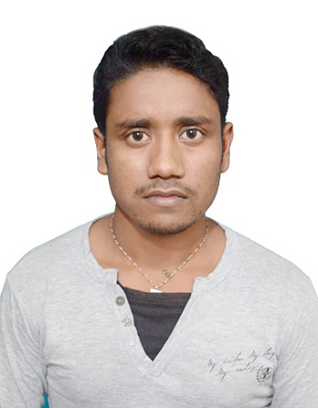

Photo

(Passport Size)

**Name: SK. ARMAN ALI**

**Address: VILL.: PACHIRDANGA, P.O.:PAPURDIHI,**

**DIST.:BANKURA, PIN:722132 (WEST BENGAL),**

**INDIA**

**Mobile No:  9775653770**

**E-mail:    skarmanali27@gmail.com**

**Academic Qualifications:**

|  |  |  |  |  |  |
| --- | --- | --- | --- | --- | --- |
| **Degree / Certificate** | **Qualification** | **Institute** | **Board /**  **University** | **Year** | **Aggregate % / CGPA** |
| Graduation | B.TECH  (COMPUTER SCIENCE & ENGINEERING) | MALLABHUM INSTITUTE OF TECHNOLOGY | W.B.U.T. | 2015 | 7.9(CGPA upto 8th semester) |
| 12th | HIGHER SECONDARY EXAMINATION | MADHUBAN GOENKA VIDYALAYA | W.B.C.H.S.E. | 2011 | 58.42% |
| 10th | SECONDARY EXAMINATION | MADHUBAN GOENKA VIDYALAYA | W.B.B.S.E. | 2009 | 71.33% |

**Experience:**

* Experience of 14 months as Sr. Web Developer (PHP) in Exprolab Technology pvt. Ltd. , Kolkata.Currently working.

**Live Projects:**

* [http://www.maintdrop.com](http://www.maintdrop.com/)
* [http://www.healthrecall.com](http://www.healthrecall.com/)
* [http://www.tyreandbattery.com](http://www.tyreandbattery.com/)
* http://rishichemicals.com/

**Key Skill:**

* PHP, MySql, Codeigniter
* Operating System: Windows, Linux

**Additional Qualification / Achievements / Certifications:**

* Certificate on Participation in Workshop on LINUX Basics and Administration held from 13th February’2014 to 15th february’2014 at Mallabhum Institute of Technology, Bishnupur.

**Family Details:**

|  |  |  |
| --- | --- | --- |
| **Details** | **Name** | **Occupation** |
| **Father** | SK. ALIJAN ASRAFI | MAULANA |
| **Mother** | HALIMA BIBI | HOUSEWIFE |
| **Siblings** | SK. MURAD ALI | BPO EMPLOYEE |

**Personal Details:**

* **Date of Birth:  05/05/1993**
* **Sex:**      MALE
* **Nationality:**      INDIAN
* **Languages Known:    BENGALI, HINDI, ENGLISH**
* **Strengths:** Good Time Management skill,

Honest,

Hard Working.

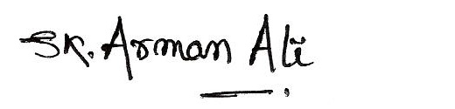

**Place: BANKURA**

**Date:  15/06/2015                                                                       Signature**