SMART INDIA HACKATHON 2026 · PS26249
Aeolus (Keeper of Wind) – Project Guide
A beginner's guide to the prototype, every page and number, and a script for recording the demo video
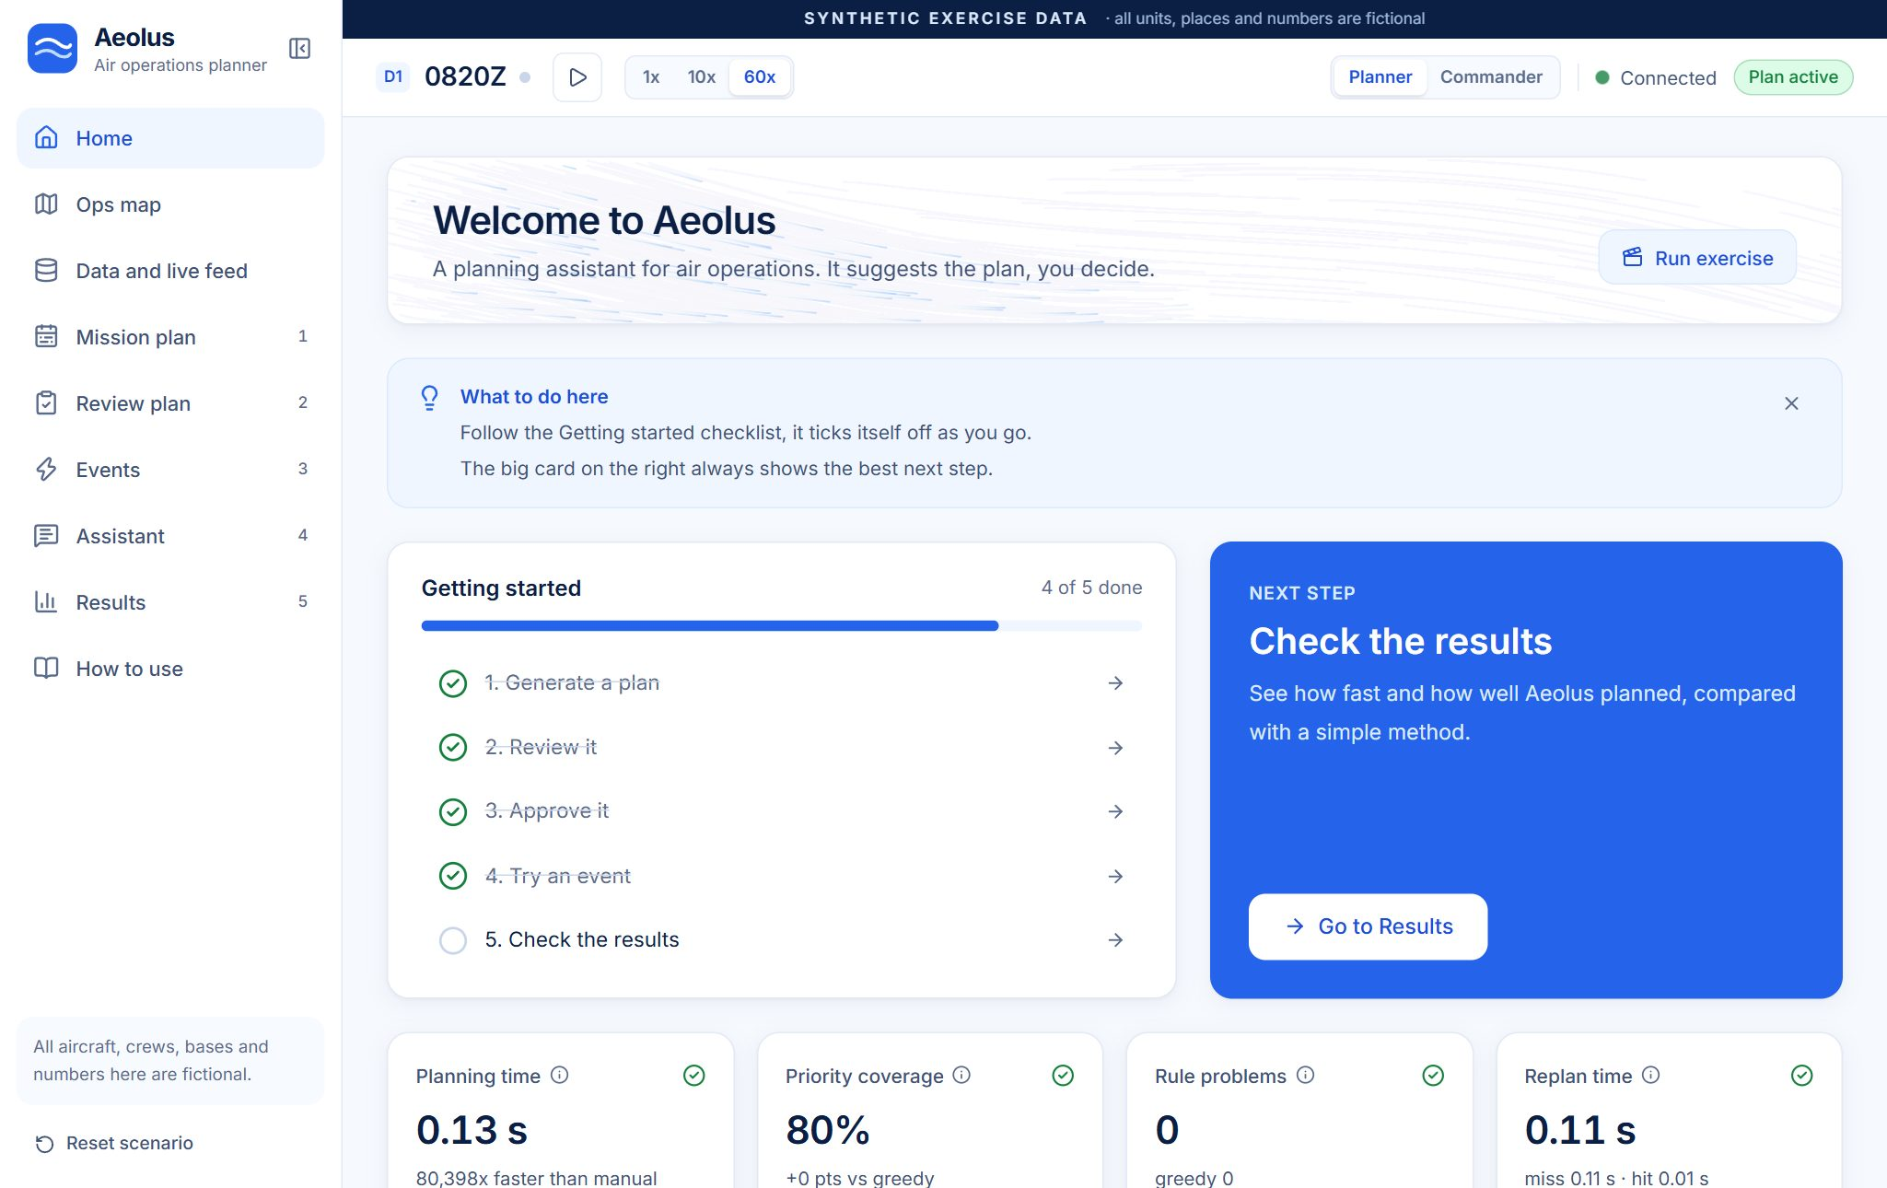

Team: Squad 106
Problem statement: SIH 2026 PS26249
Date: 20 October 2026
All data in Aeolus is synthetic and fictional. No real aircraft, units, places or military data are used.
Contents
1. The big picture 3
1.1 The problem, in simple words 3
1.2 What Aeolus does 3
1.3 Who would use it, and why it matters 3
1.4 The flow, from data to a new plan 3
2. Key words 4
3. Page-by-page guide 6
3.1 Home 6
3.2 Ops map 8
3.3 Data and live feed 10
3.4 Mission plan 11
3.5 Review plan (Review and approve) 15
3.6 Events 18
3.7 Assistant 20
3.8 Results 22
3.9 How to use 24
4. Global controls 24
4.1 The Commander view 25
5. Backend endpoints (simple version) 26
5.1 The live feed in one paragraph 27
6. The numbers and scores explained 27
7. The demo story (for recording the video) 29
7.1 Timing 30
7.2 Tips for recording 30
7.3 Checklist before recording 31
8. Common questions a judge might ask 31
9. Setup and troubleshooting for the demo 32
9.1 Live website 32
9.2 Run it on your own computer 32
9.3 If something goes wrong 32

How to read this guide: section 1 gives the big picture, section 2 explains the words, section 3 walks through every page. Sections 4 to 6 explain the controls, the server and the numbers. Section 7 is the script for the demo video, and sections 8 and 9 cover judge questions and setup.

1. The big picture

1.1 The problem, in simple words
An air force plans every day which aircraft fly which missions, with which crew and which weapons. The information needed for that sits in many separate places: one system knows which aircraft are fit to fly, another knows which crews are on duty, others know the weapon stock, the weather, the closed airspace and the enemy threats.
Putting all of that together by hand is slow. And when something changes during the day (an aircraft breaks, the weather closes a base, an urgent new mission arrives), the plan has to be rebuilt quickly. Doing that by hand takes hours and often wastes scarce aircraft.

1.2 What Aeolus does
Aeolus is a planning assistant. Think of it as a smart timetable maker for a school: you tell it the teachers, the rooms, the subjects and the rules (no teacher in two rooms at once, labs only in lab rooms), and it builds the best timetable in seconds. When a teacher is ill, it repairs the timetable by moving as few lessons as possible, and tells you why each lesson moved.
- One live picture: it merges all the separate information into one screen that keeps updating.
- Best plan in seconds: an optimiser (a maths engine) assigns aircraft, crews and weapons to missions, most important missions first, without breaking any rule.
- Fast replanning: when something changes, it builds a new plan in about a tenth of a second, often instantly from an answer it prepared in advance, and changes as little as possible.
- You stay in control: every change comes with a plain reason, an independent checker tests every plan against 18 rules, and nothing goes live until a human clicks Approve.

1.3 Who would use it, and why it matters
The main user is an air-operations planner: the officer who builds and changes the daily flying plan. A commander can switch to a simple summary view. It matters because a plan that used to take hours (we assume 180 minutes for a manual plan) is ready in well under a second, scarce aircraft are used better, and the human still makes every decision.

1.4 The flow, from data to a new plan
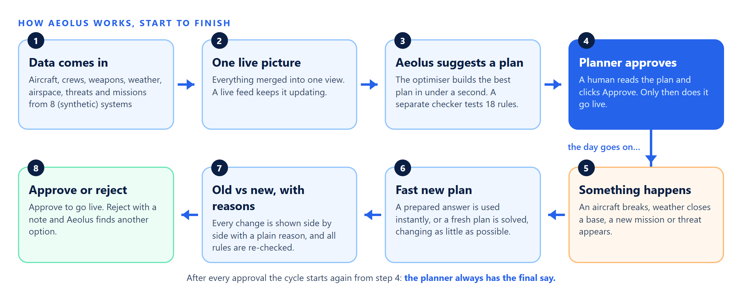
Figure 1. How Aeolus works: data comes in, a plan is approved, an event happens, a new plan is approved. All data is synthetic.

2. Key words
These are the words a viewer will hear in the video or see on screen, with a simple meaning.
Word | Simple meaning
Aeolus | The name of the project. In Greek stories Aeolus is the keeper of the winds.
Sortie | One flight by one aircraft for one mission: take off, do the job, land. A mission that needs 2 aircraft has 2 sorties. The app often says flight.
Mission | A job in today's tasking, for example a patrol or a strike. There are 15 missions in the demo, named M01 to M15.
Tasking | The list of missions the planners must cover today.
P1, P2, P3, P4 | Mission priority. P1 = critical, P2 = high, P3 = routine, P4 = low. Darker blue means higher priority on every chart.
Retasking | Changing who does what during the day because something changed.
Serviceability / Ready to fly | Whether an aircraft is fit to fly. Aeolus shows a predicted chance (for example 91%) that it stays ready.
Down / Outage | An aircraft that cannot fly for a period, for example for a gearbox replacement.
Crew / duty hours | The pilots of an aircraft. Each crew has a shift and may work at most 10 hours including briefings.
Turnaround | The time an aircraft needs on the ground between two flights (refuel, checks).
Base (B1, B2) | An airfield. B1 is Corvane, B2 is Ostrel (both fictional).
Zone (Z1 to Z6) | A target area on the map, for example Z3 Vennic Plateau.
Restricted airspace | Sky where flying is not allowed for a time window, for example Z4 restricted 09:00 to 11:00.
Weather minimums | The lowest cloud base and visibility an aircraft type is allowed to take off or land in.
Threat level | How dangerous a zone is, from 0 (none) to 3 (high).
CAP | Combat air patrol: aircraft guard an area of sky.
Strike (STK) | An attack on a target.
SEAD | Suppression of enemy air defences: taking out radars and missile sites.
ISR / Recce | Intelligence, surveillance and reconnaissance: watching and photographing an area.
Airlift / resupply (LIFT) | Carrying supplies to a post.
Callsign | A radio name for an aircraft (ARROW-01) or a crew (Ember). Mission codes like CAP-01 or STK-02 combine type and number.
Zulu time (0600Z) | Time in UTC, the standard used in aviation. 0600Z means 06:00.
Optimiser / CP-SAT | The maths engine that builds the plan. CP-SAT is Google's free constraint solver (part of OR-Tools). It searches millions of combinations for the best one that breaks no rule.
Simple method / greedy | The comparison method: take missions in priority order and grab the first free aircraft and crew. Quick, but it wastes resources.
Validator / rule checker | Separate code that re-reads the raw data and checks every plan against 18 rules. It never trusts the optimiser.
Hard constraint / rule problem | A rule that must never be broken (no double booking, crew hours, weapon stock and so on). Aeolus shows broken rules as Rule problems.
Event | Something that changes the picture: aircraft down, weather closure, new mission, new threat.
Replan | Building a new plan after an event, warm-started from the current one so that little changes.
Warm start | Starting the new search from the current plan instead of from zero, so the answer is fast and similar.
Plan stability | How much of the plan stayed the same after an event. Fewer changes means crews are not re-briefed for nothing.
Prepared answer / cache | After each approval Aeolus solves the 5 likeliest problems in advance and keeps the answers (a cache). A cache hit means the answer was ready. A miss means it was solved fresh.
Diff | The side-by-side list of what changed between the current and the proposed plan.
Plan strength / fragility | How easily a flight could be covered if it fails, based on spare aircraft and crews. Strong (S), Moderate (M) or Weak (W).
Gantt chart / timeline | A chart with one row per aircraft and coloured bars for flights along a time axis, like a train timetable turned sideways.
Sankey chart | A flow chart where band thickness shows how many flights go from each base, by each aircraft type, to each priority.
KPI | Key performance indicator: one of the 8 numbers that show how well Aeolus is doing.
LLM / language model | The AI that reads plain English. Aeolus uses one (Groq) only to turn your words into conditions. It never makes the plan.
Offline reader | A rule-based text reader that works without internet or AI, so the assistant always works.
Live feed | A stream of small updates from the source systems (fleet, weather, crews, weapons, intelligence).
Synthetic data | Invented data that looks realistic but describes nothing real.

3. Page-by-page guide
The app has nine planner pages, reached from the left sidebar. Steps 1 to 5 in the sidebar are the planning flow. Each page has the same pattern: a title and one-line description, a blue What to do here box (close it with the X; it stays closed), the page content, and a Next: button at the bottom that takes you to the next logical page.
The screenshots below were taken from the running app on a 1366 × 900 window during one full demo run. Orange numbered circles mark the items explained in the table under each picture. Numbers you see (times, percentages) come from that run; your own run will be very close but may differ by a few hundredths of a second.

3.1 Home
Purpose: the starting point. It shows the next step, your progress and the headline numbers.
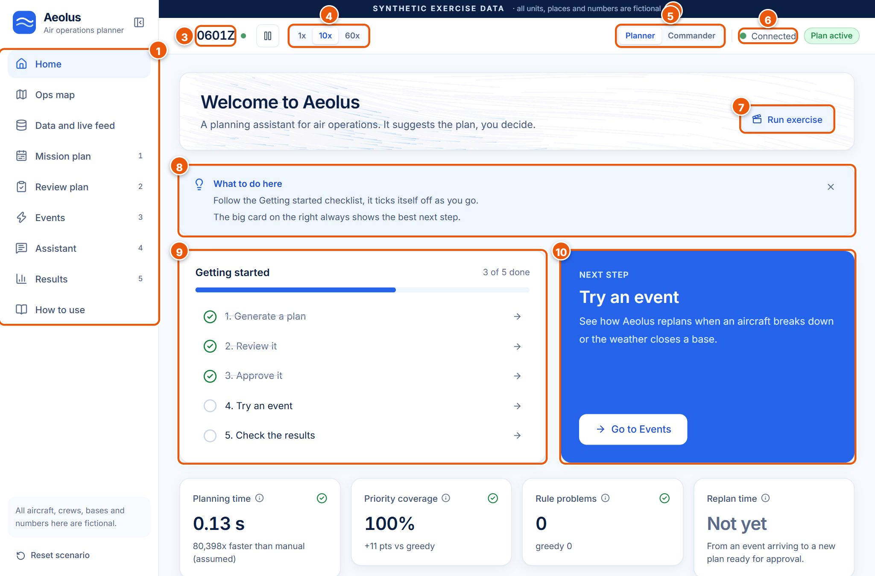
Figure 2. Home: top bar, sidebar, checklist and next-step card (after the first plan was approved).
# | Item | What it shows or does | What happens when you click it | Why it matters
1 | Sidebar menu | The pages of the app. Numbers 1 to 5 are the planning steps. | Opens that page. | You can always see where you are.
2 | SYNTHETIC EXERCISE DATA banner | A reminder that all data is invented. | Nothing. | Honesty: judges see at once that no real data is used.
3 | Scenario clock (D1 0601Z) | Day 1 and the scenario time in Zulu. A green dot means the clock is running. | Nothing (hover for a tip). | Flights move through their stages as this clock runs.
4 | Clock speed 1x / 10x / 60x | How fast scenario time runs (see section 4). | Changes the speed. | 60x shows a day of flying quickly.
5 | Planner / Commander | Switches between the full planner view and the commander summary. | Opens the other view. | Two kinds of users, one app.
6 | Connection status | Green Connected, amber Connecting or Waking up the server, red Offline. | Nothing (hover for details). | Shows the server is reachable.
7 | Run exercise | A hands-free guided demo. | Resets the scenario and plays the whole story with captions from real results. | A safe way to show everything; it resets your work.
8 | What to do here | Two short hints for this page. | The X hides it. | Helps first-time users.
9 | Getting started (3 of 5 done) | Five steps that tick themselves off, with a progress bar. | Each line opens its page. | Shows how far you are.
10 | Next step card | The single best next action (here: Try an event). | The white button opens that page or generates the plan. | No guessing what to do next.
– | Plan status pill (top right) | No plan yet (grey), Waiting for approval (amber), Plan active (green) or Plan ended. | Nothing. | The plan lifecycle at a glance.

Further down the Home page are four headline KPI cards (Planning time, Priority coverage, Rule problems, Replan time; explained in section 6), a compact Theatre map with an Open ops map link, a Flights board, the Ops overview charts, Recent activity (latest approvals and events, with All events link) and What Aeolus does (four short promises).
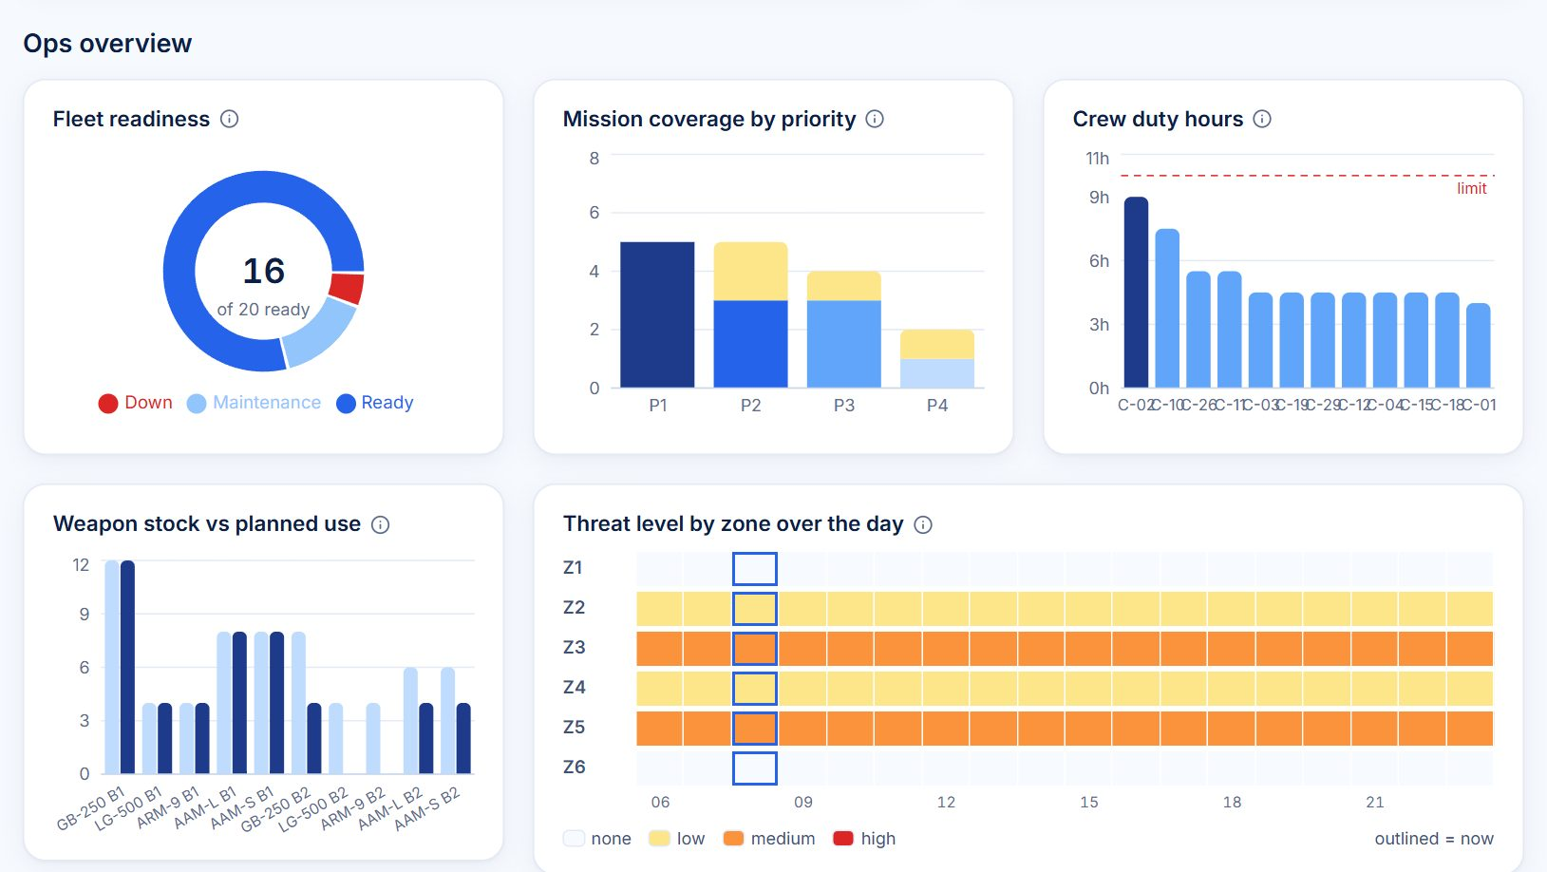
Figure 3. The Ops overview charts (also on the Data page), after the demo events at 08:20Z.

How to read the Ops overview charts
Chart | How to read it | Good / bad | Value in the demo
Fleet readiness (donut) | Each slice is a group of aircraft right now: dark blue Ready, light blue Maintenance (planned work), red Down (fault or outage). The big number is how many are ready. | More blue is better. Red means aircraft lost. | 18 of 20 ready at the start; 16 of 20 after the demo events.
Mission coverage by priority (stacked bars) | One bar per priority P1 to P4. The blue part is missions with aircraft and crew; the yellow top is missions not assigned. Height = number of missions. | Yellow on P1 or P2 is bad. Some yellow on P3/P4 is normal when resources are short. | First plan: all P1 and P2 covered, 1 P3 not assigned.
Crew duty hours (bars) | One bar per busy crew (C-02, C-10 ...). Height = planned duty in hours (flight time plus briefings). Red dashed line = the 10-hour limit. Bars above 8.5 h are dark blue. | Bars must stay under the red line. Dark bars are close to it. | Busiest crew about 9 h, all under 10 h.
Weapon stock vs planned use (paired bars) | For each weapon at each base: light bar = stock, dark bar = how many the plan loads. | Dark must never be taller than light (that would break a rule). | For example GB-250 at B1: 12 in stock, 12 planned after the events.
Threat level by zone over the day (heat strip) | Rows = zones Z1 to Z6, columns = hours 06 to 23. Colour = highest threat: white none, yellow low, orange medium, red high. The outlined column is now. | Red cells are dangerous; aircraft have threat limits. | Z3 and Z5 medium all day, Z2 and Z4 low.

3.2 Ops map
Purpose: a live picture of the fictional theatre: bases, targets, threats, weather, closed airspace and every flight moving on the scenario clock.
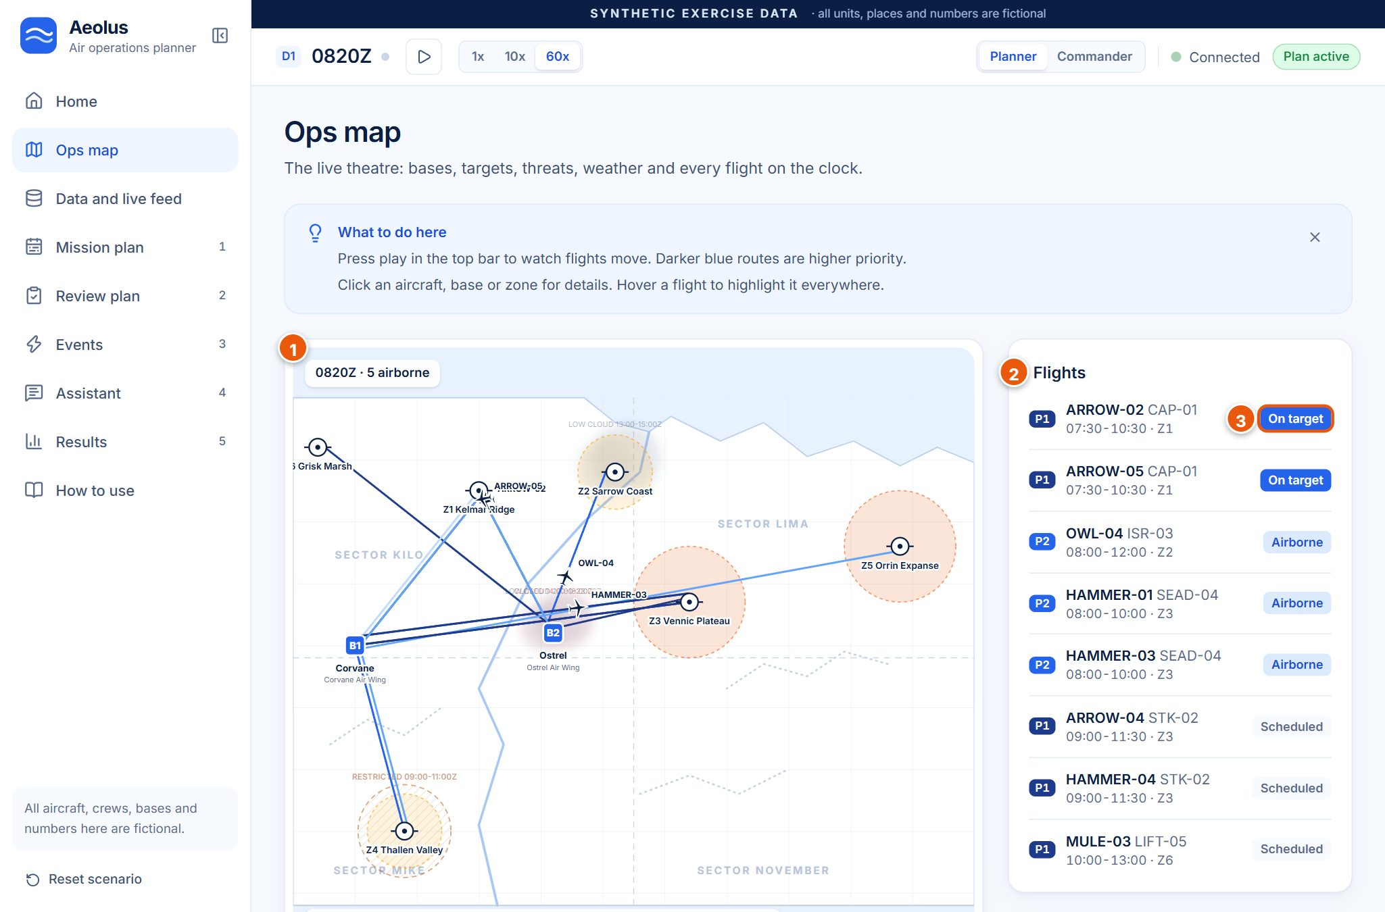
Figure 4. Ops map at 08:20Z with five aircraft airborne (clock at 60x, then paused).
# | Item | What it shows or does | What happens when you click it | Why it matters
1 | Theatre map | An invented map (no real places): coastline, river, ridges, four sectors. | Click a base, zone or aircraft to open a details drawer. | Shows where everything is.
2 | Flights board | Upcoming and active flights: priority tag, aircraft callsign, mission code, times, zone. | Opens the aircraft drawer. Hovering highlights the flight everywhere. | A departure board for the day.
3 | Stage pill | Scheduled, Taxi (15 min before take-off), Airborne, On target, Returning, Complete. | Part of the flight row. | Shows what each flight is doing now.
– | Activity log (below the flights) | Who did what and when: Planner approved, Aeolus published, events. | Nothing. | A simple record of decisions.

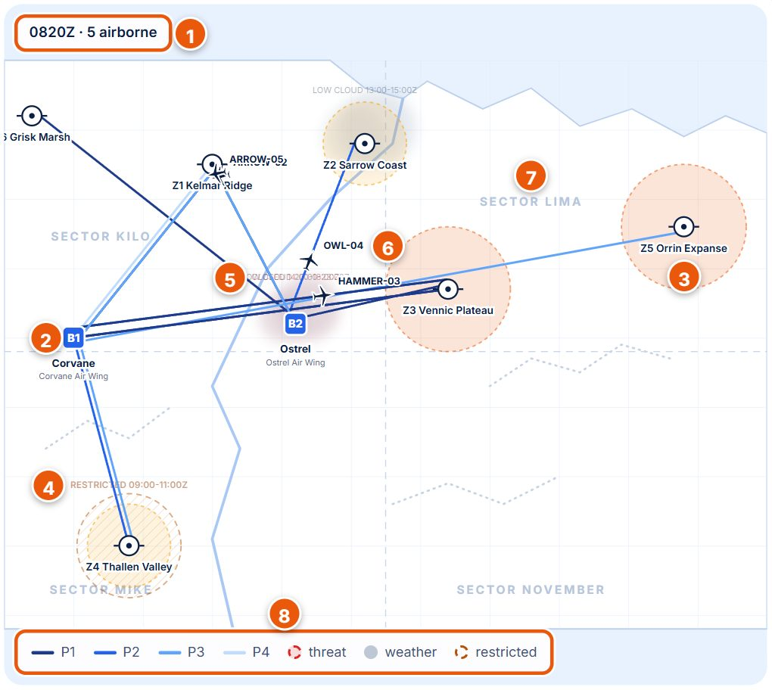
Figure 5. Close-up of the map with its legend.
# | Map element | What it means
1 | Clock badge (0821Z · 5 airborne) | Scenario time and how many aircraft are in the air. While a plan waits for approval it adds proposed plan in amber.
2 | Blue square (B1, B2) | A base. B1 Corvane (Corvane Air Wing) and B2 Ostrel (Ostrel Air Wing).
3 | Target symbol and name (Z5 Orrin Expanse) | A target zone, Z1 to Z6.
4 | Brown hatched circle, RESTRICTED 09:00-11:00Z | Restricted airspace and its time window (faded when not active yet).
5 | Grey cloud, LOW CLOUD or red CLOSED | Weather cell. Grey = low cloud, red = closed by weather.
6 | Plane icon with callsign (OWL-04) | An aircraft, moving along its route as the clock runs. Click it for details.
7 | Sector name | Background label for orientation only.
8 | Legend | Route colours P1 (darkest) to P4 (lightest), red dashed ring = threat, grey = weather, brown dashed = restricted. Routes being replaced show as dashed amber lines.

3.3 Data and live feed
Purpose: everything Aeolus knows, merged from eight simulated systems (fleet management, crew rostering, armament and logistics, airspace control, met office, intelligence, tasking order, planning rules) into one picture.
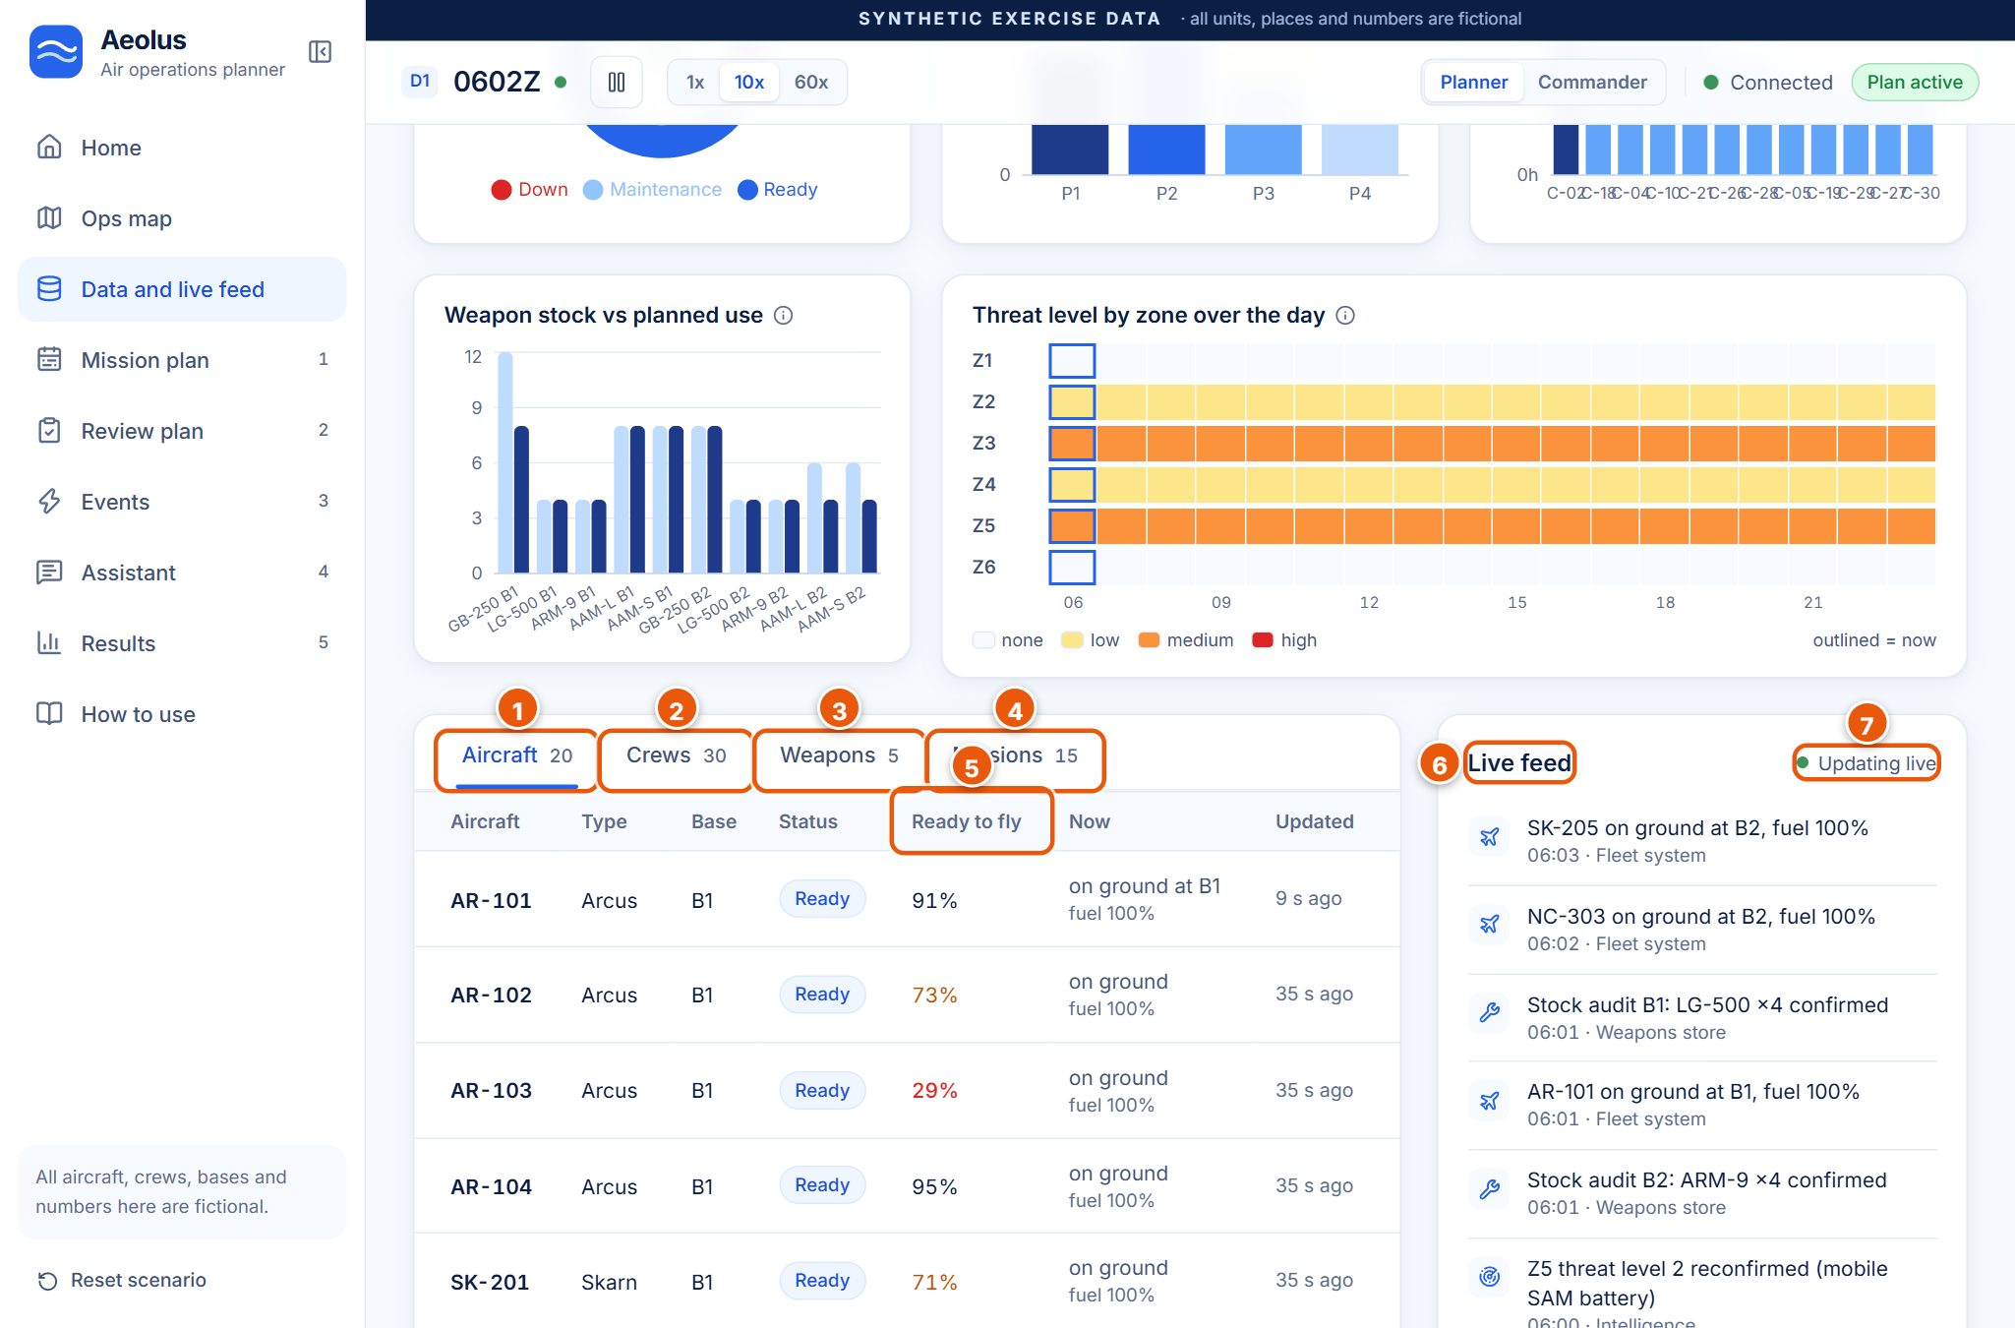
Figure 6. Data page: charts (top), data tables with tabs, and the live feed on the right.
# | Item | What it shows or does | What happens when you click it | Why it matters
1 | Aircraft tab (20) | Table: aircraft, type (Arcus, Skarn, Nocta, Travan), base, status, ready to fly, now (position, fuel), updated. | Shows this table. | The fleet at a glance.
2 | Crews tab (30) | Crew, call sign, base, aircraft types they may fly, shift, status (On duty, Off shift, Unavailable). | Shows the crews table. | Crews limit what can fly.
3 | Weapons tab (5) | Weapon (GB-250, LG-500, ARM-9, AAM-L, AAM-S), use, which aircraft it fits, stock at B1 and B2. | Shows the weapons table. | Weapon stock is scarce.
4 | Missions tab (15) | All missions sorted by priority: type, zone, take-off window, length, aircraft needed, origin. | Shows the missions table. | Today's tasking.
5 | Ready to fly column | Predicted chance the aircraft stays serviceable. Amber below 75%, red below 50%. | – | Feeds the optimiser: risky aircraft are avoided for important missions.
6 | Live feed | Messages as they arrive: telemetry, weather observations, crew check-ins, stock audits, intelligence, each with time and source. | Scrolls. | Shows the picture is live.
7 | Updating live | Green dot = new messages are arriving. Paused when the server is not reachable. | – | Confirms the connection.

At the top of the page a synthetic data note lists the eight simulated systems, followed by the same five Ops overview charts as on Home (explained in section 3.1). Example values from the demo: AR-103 is only 29% ready to fly, SK-205 12%, and SK-202 is Down for a gearbox replacement.

3.4 Mission plan
Purpose: which aircraft and crew fly each mission, hour by hour. The Generate plan button (top right, only before the first plan) asks Aeolus for the first plan of the day. Afterwards the button becomes Review proposed plan when a plan is waiting.
When you click Generate plan, a small window shows three steps (reading aircraft and crews, optimising, validating) and then a result banner such as Planned in 0.15 s, 23 sorties, 0 rule problems with a Review changes button.
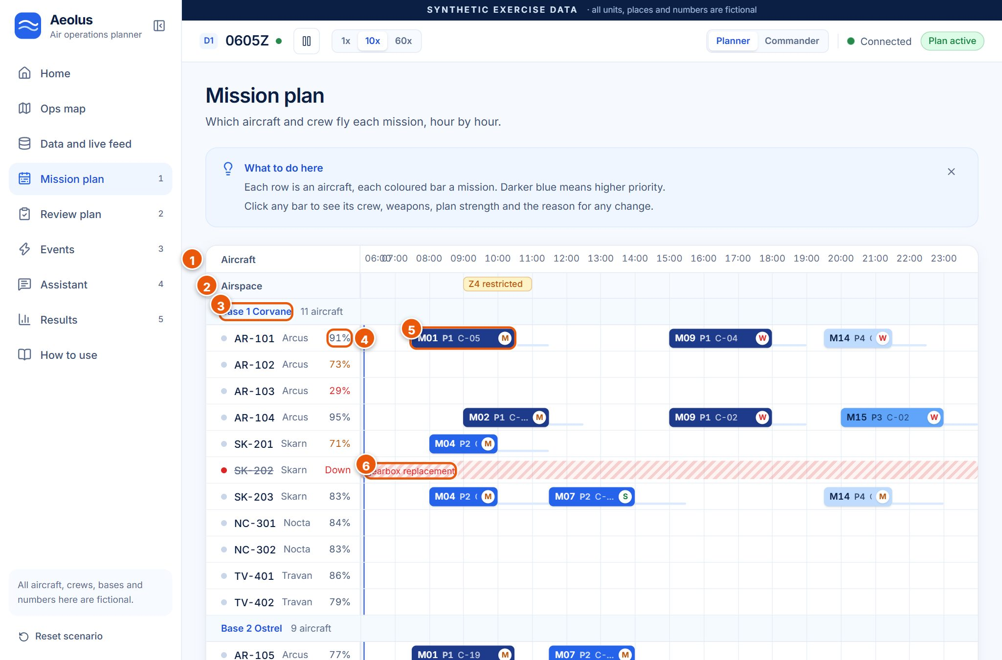
Figure 7. The Gantt timeline of the live plan.
# | Item | What it shows or does | What happens when you click it | Why it matters
1 | Time axis (06:00 to 23:00) | Hours of the planning day. The blue vertical line is now. | – | Read flights left to right in time.
2 | Airspace lane | Restrictions, weather closures and high threats over time (for example Z4 restricted). | Hover for the reason. | Explains why some slots are empty.
3 | Base group (Base 1 Corvane, 11 aircraft) | Aircraft grouped by base, with the latest weather report. | – | Each base has its own weather and stock.
4 | Ready to fly % | Predicted serviceability per aircraft (amber/red when low). | Hover for a tip. | Why some aircraft are left idle.
5 | Mission bar (M01 P1 C-05 M) | One flight: mission, priority, crew, and a plan-strength badge (S, M or W). Darker blue = higher priority. | Opens the flight drawer (Figure below). | The heart of the plan.
6 | Hatched red block (gearbox replacement) | Aircraft unavailable for that time, with the reason. | Hover for details. | The optimiser never books over it.

Legend under the timeline: P1 critical, P2 high, P3 routine, P4 low (darkest to lightest blue); S / M / W plan strength badges (Strong green, Moderate amber, Weak red); red hatching = aircraft down; grey hatching = weather below limits; already flying = locked bars that can no longer change.
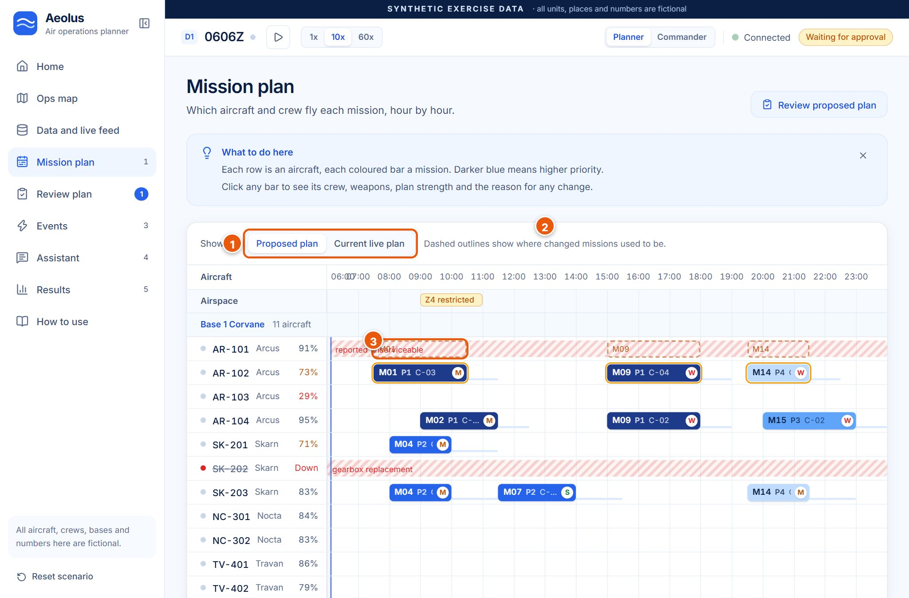
Figure 8. After an event: the Proposed plan view. Dashed amber outlines show where moved flights used to be.
(1) Showing: Proposed plan / Current live plan switches the timeline between the plan waiting for approval and the plan that is live now. (2) The note explains the ghost slots. (3) A ghost slot (dashed amber outline, here M01 on AR-101) marks where a changed flight used to be; the new bars also pulse for a few seconds.
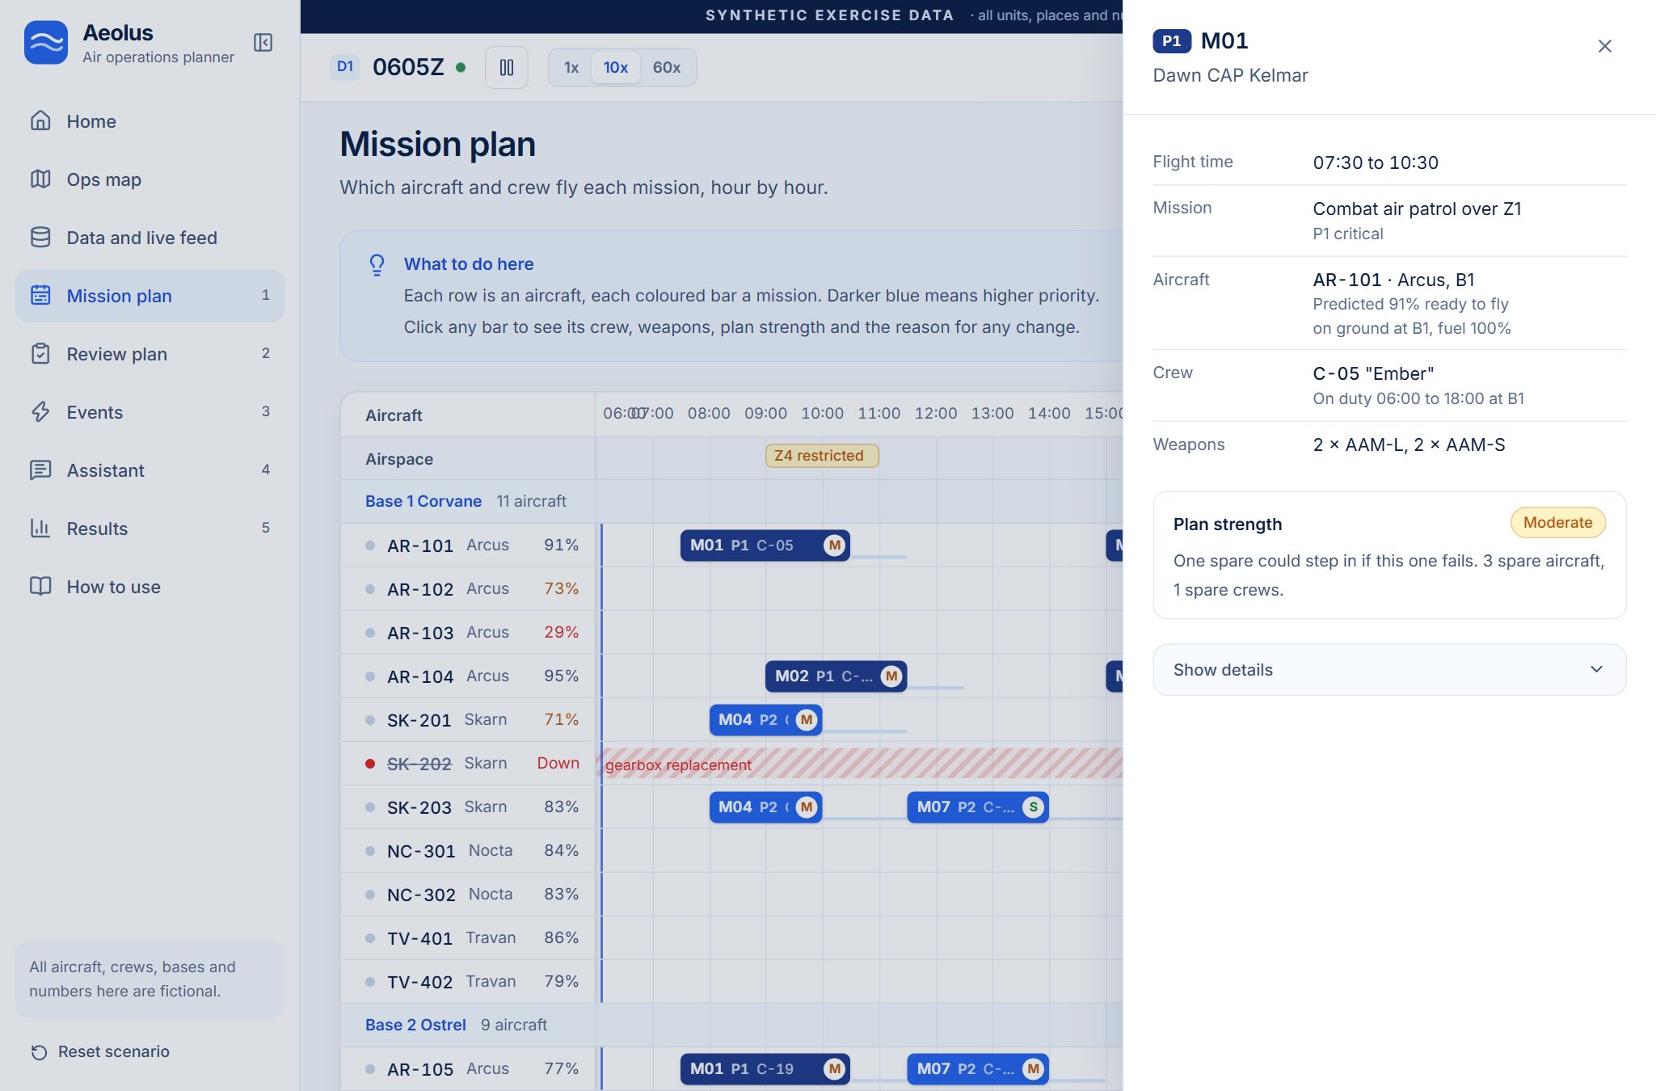
Figure 9. Clicking a bar opens the flight drawer: time, mission, aircraft, crew, weapons and plan strength.
The drawer shows Flight time, Mission (and priority), Aircraft (with predicted readiness, position and fuel), Crew (with shift), Weapons (for example 2 × AAM-L, 2 × AAM-S) and Plan strength (here Moderate: one spare could step in; 3 spare aircraft, 1 spare crew). After a replan it also shows Why this changed. Show details reveals the fragility score (0 to 100). Close it with the X or Escape.
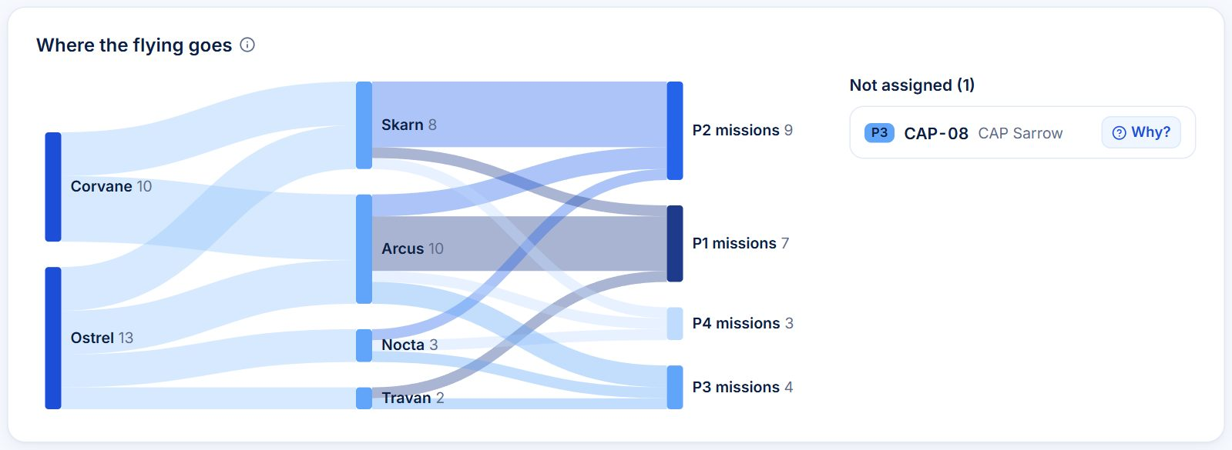
Figure 10. Where the flying goes: bases to aircraft types to mission priorities.
How to read the Sankey: left column = bases (Corvane 10 flights, Ostrel 13), middle = aircraft types (Arcus 10, Skarn 8, Nocta 3, Travan 2), right = priorities (P1 7 flights, P2 9, P3 4, P4 3). A thicker band means more flights. The box on the right lists missions that are Not assigned (here P3 CAP-08) with a Why? button that explains the reason in plain words.
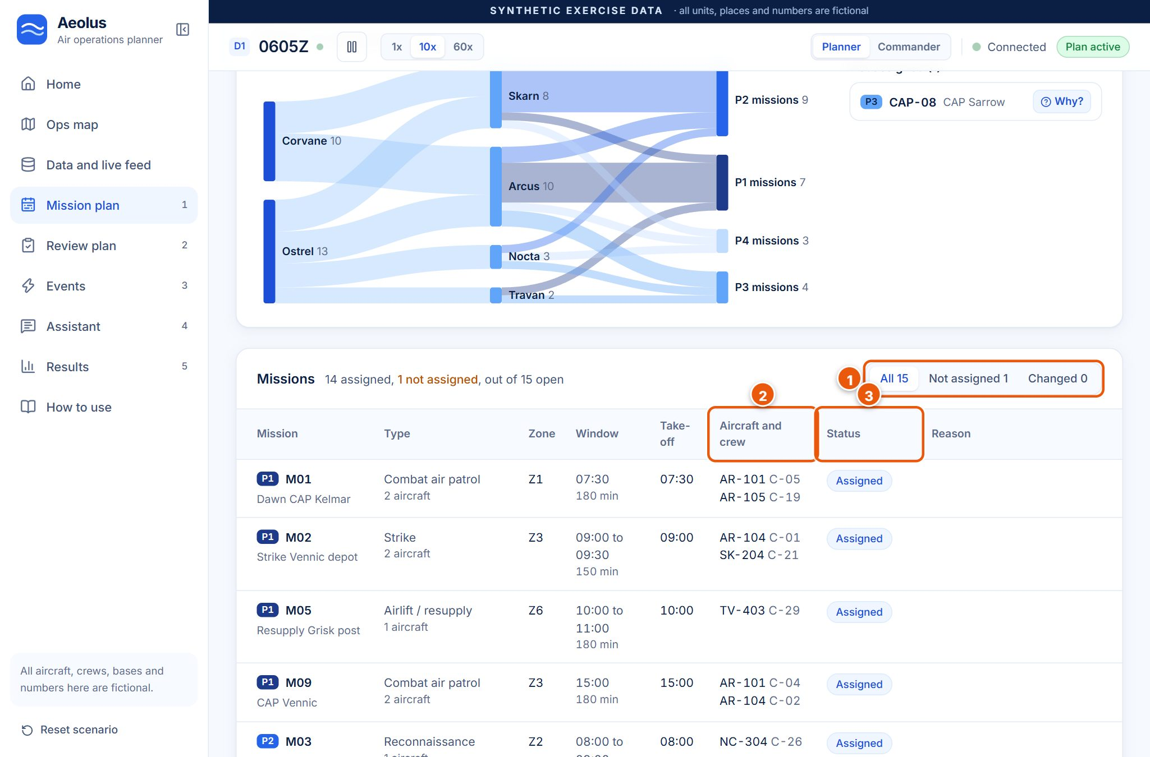
Figure 11. The Missions table under the timeline.
# | Item | What it shows or does | What happens when you click it | Why it matters
1 | Filter: All 15 / Not assigned 1 / Changed 0 | Which missions to list. | Filters the table. | Find problems fast.
2 | Aircraft and crew column | Which aircraft and crew fly each mission (AR-101 C-05 ...). | – | The assignment itself.
3 | Status column | Assigned (blue), Not assigned (amber), Changed, Cancelled, Waiting for plan. | – | Shows coverage.
– | Reason column / Why? | For unassigned or changed missions, the plain reason (for example not enough AAM-L missiles left). | Why? opens the explanation. | Every gap is explained.

3.5 Review plan (Review and approve)
Purpose: see what changed and why, check the rules, then decide. The sidebar shows a blue 1 on Review plan whenever a plan is waiting.
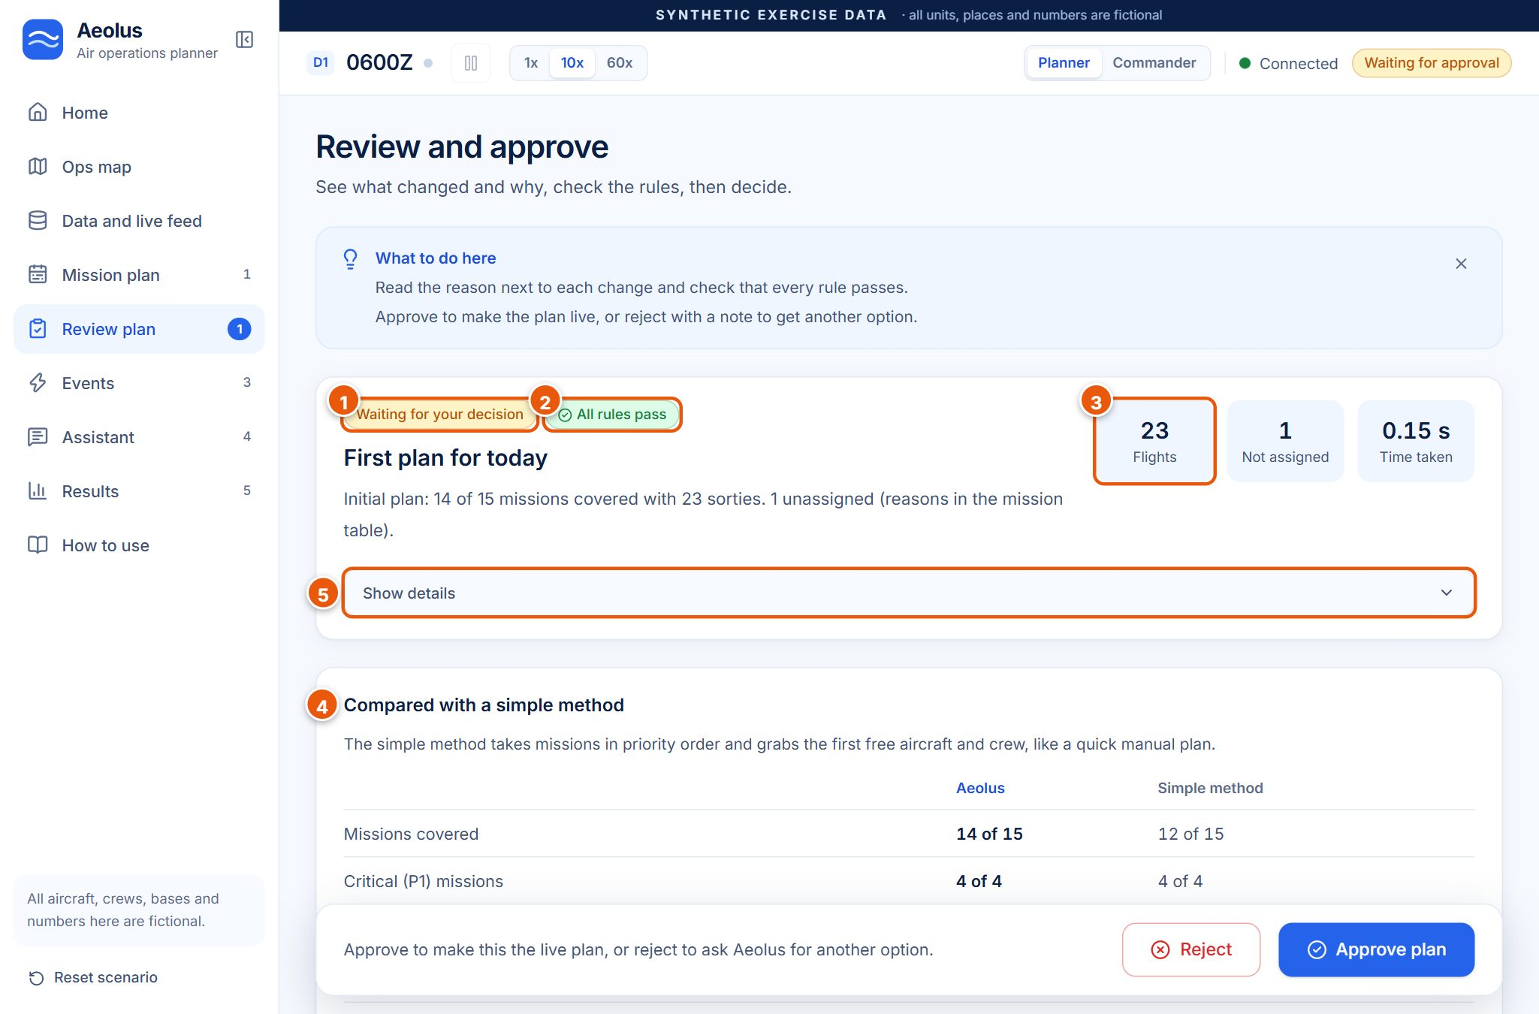
Figure 12. Review of the first plan of the day, with the comparison against the simple method.
# | Item | What it shows or does | What happens when you click it | Why it matters
1 | Waiting for your decision | The plan is not live yet. | – | Human approval is required.
2 | All rules pass | The independent checker found 0 rule problems. If a rule failed, this turns red and the plan cannot be approved. | – | Safety check.
3 | Summary numbers | First plan: 23 flights, 1 not assigned, 0.15 s time taken. After an event it shows Changed, Added and Time taken. | – | Size and speed of the plan.
4 | Compared with a simple method | Aeolus vs the greedy method on the same data: missions covered 14 of 15 vs 12 of 15, P1 4 of 4 vs 4 of 4, P2 5 of 5 vs 4 of 5, flights 23 vs 19, time 0.13 s vs 0.01 s. | – | The before/after story for judges.
5 | Show details | Technical details: solver status, timing, stability numbers. | Expands the box. | For curious judges.

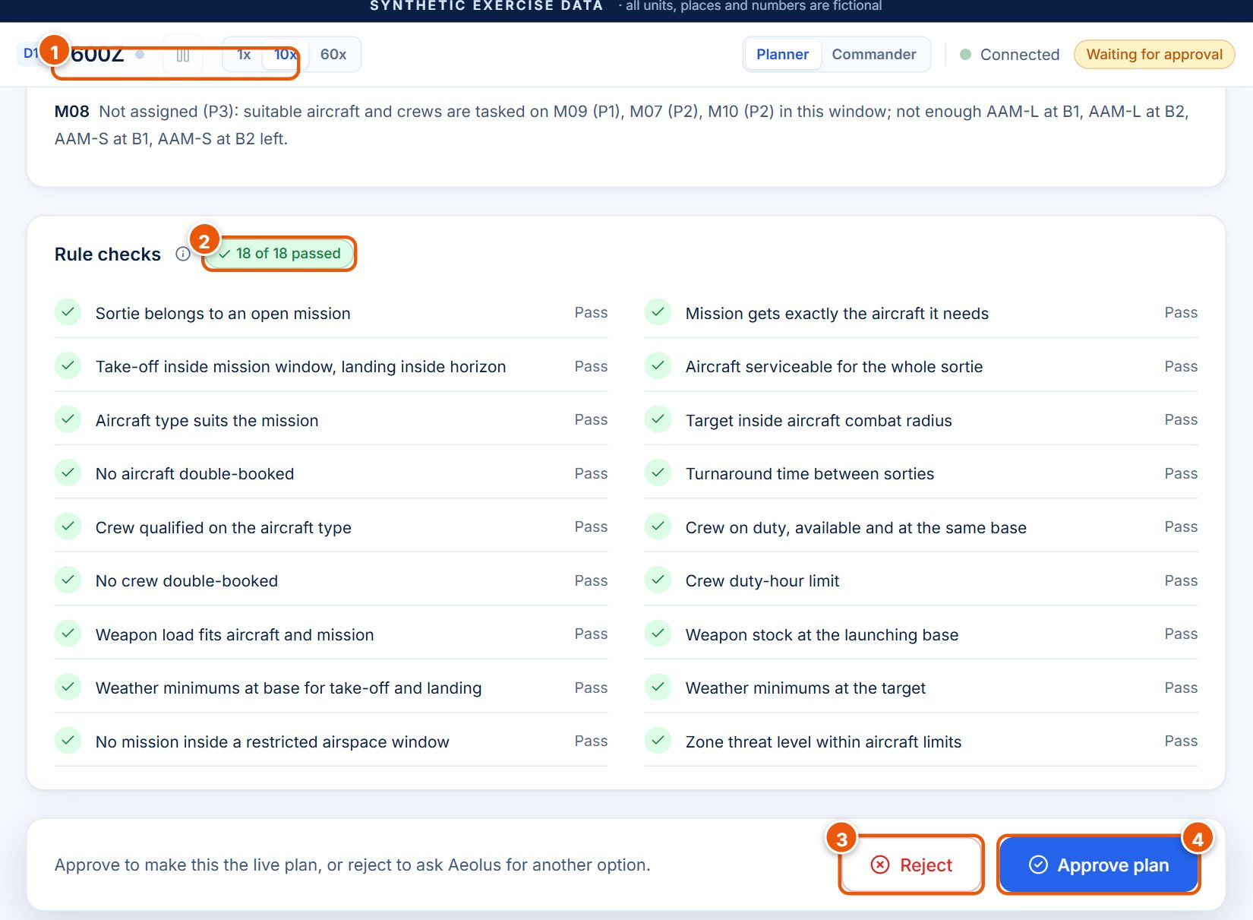
Figure 13. Missions without aircraft, the 18 rule checks, and the Approve / Reject bar.
# | Item | What it shows or does | What happens when you click it | Why it matters
1 | Missions without aircraft | Each uncovered mission with its reason (M08: not enough air-to-air missiles left in that window). | – | Honest about gaps.
2 | Rule checks (18 of 18 passed) | Every rule with Pass or Fail (list below). | – | Proof the plan is safe.
3 | Reject | Opens a dialog with an optional note. | Aeolus finds another option; your note can become a new condition. | The human can say no.
4 | Approve plan | Opens a confirm dialog. | After Confirm the plan goes live, the clock starts and Aeolus prepares answers for the 5 likeliest problems. | Nothing goes live without this click.

The 18 rules checked on every plan: sortie belongs to an open mission; mission gets exactly the aircraft it needs; take-off inside the mission window and landing inside the day; aircraft serviceable for the whole sortie; aircraft type suits the mission; target inside the aircraft's combat radius; no aircraft double-booked; turnaround time between sorties; crew qualified on the aircraft type; crew on duty, available and at the same base; no crew double-booked; crew duty-hour limit; weapon load fits aircraft and mission; weapon stock at the launching base; weather minimums at base for take-off and landing; weather minimums at the target; no mission inside a restricted airspace window; zone threat level within aircraft limits.
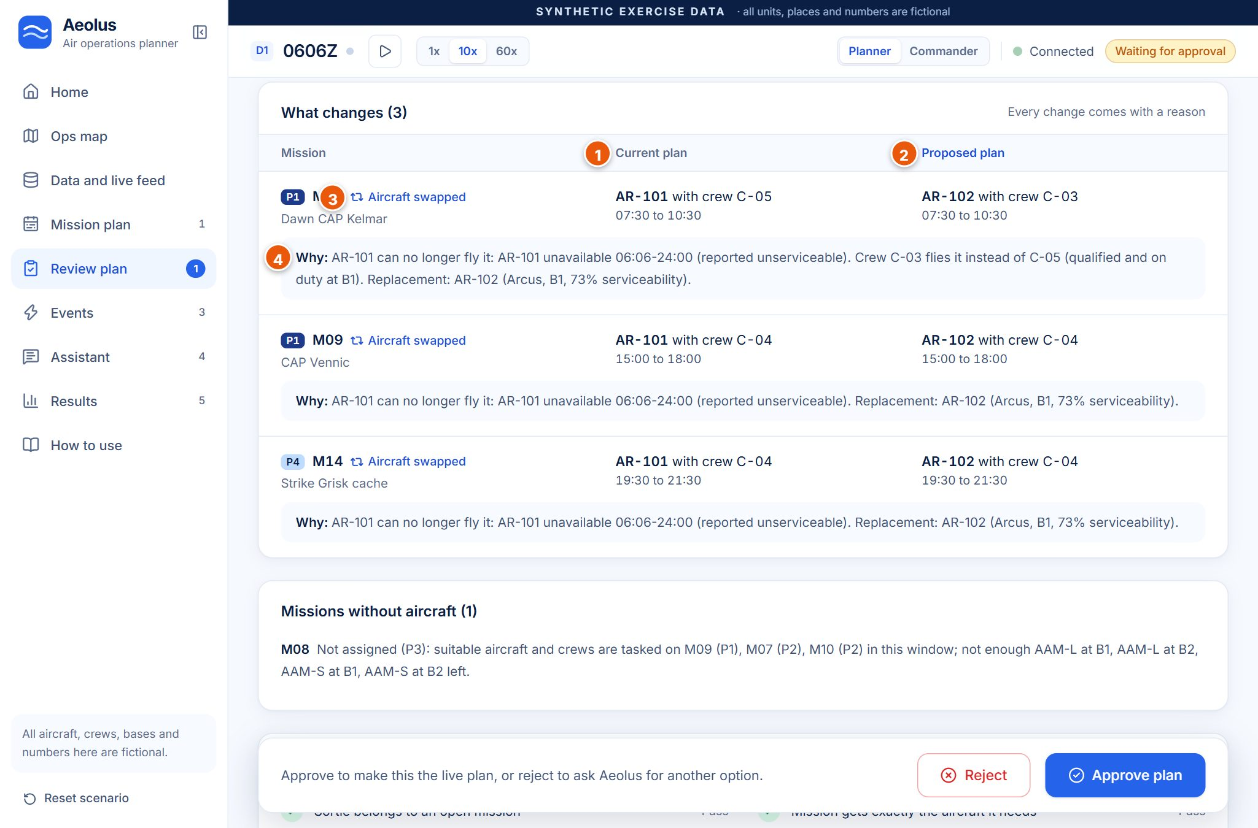
Figure 14. After an event: old vs new for each change, with a reason.
# | Item | What it shows
1 | Current plan column | What the live plan does now (AR-101 with crew C-05, 07:30 to 10:30).
2 | Proposed plan column | What the new plan would do (AR-102 with crew C-03).
3 | Change type | Aircraft swapped, Crew swapped, Time moved, Dropped or Added.
4 | Why: | A plain reason built from the facts, for example: AR-101 can no longer fly it ... Replacement: AR-102 (Arcus, B1, 73% serviceability).

In the Reject this plan? dialog, the Note (optional) box accepts plain English such as keep SK-205 on the ground. Reject and find another option sends it: Aeolus turns the note into a condition (SK-205 down until end of day), cuts out the rejected plan and proposes a new one (in our run in 1.02 s, 10 of 23 changed). Without a note it simply finds the next best option.

3.6 Events
Purpose: tell Aeolus that something changed. It replans in about a second or less, then you review.
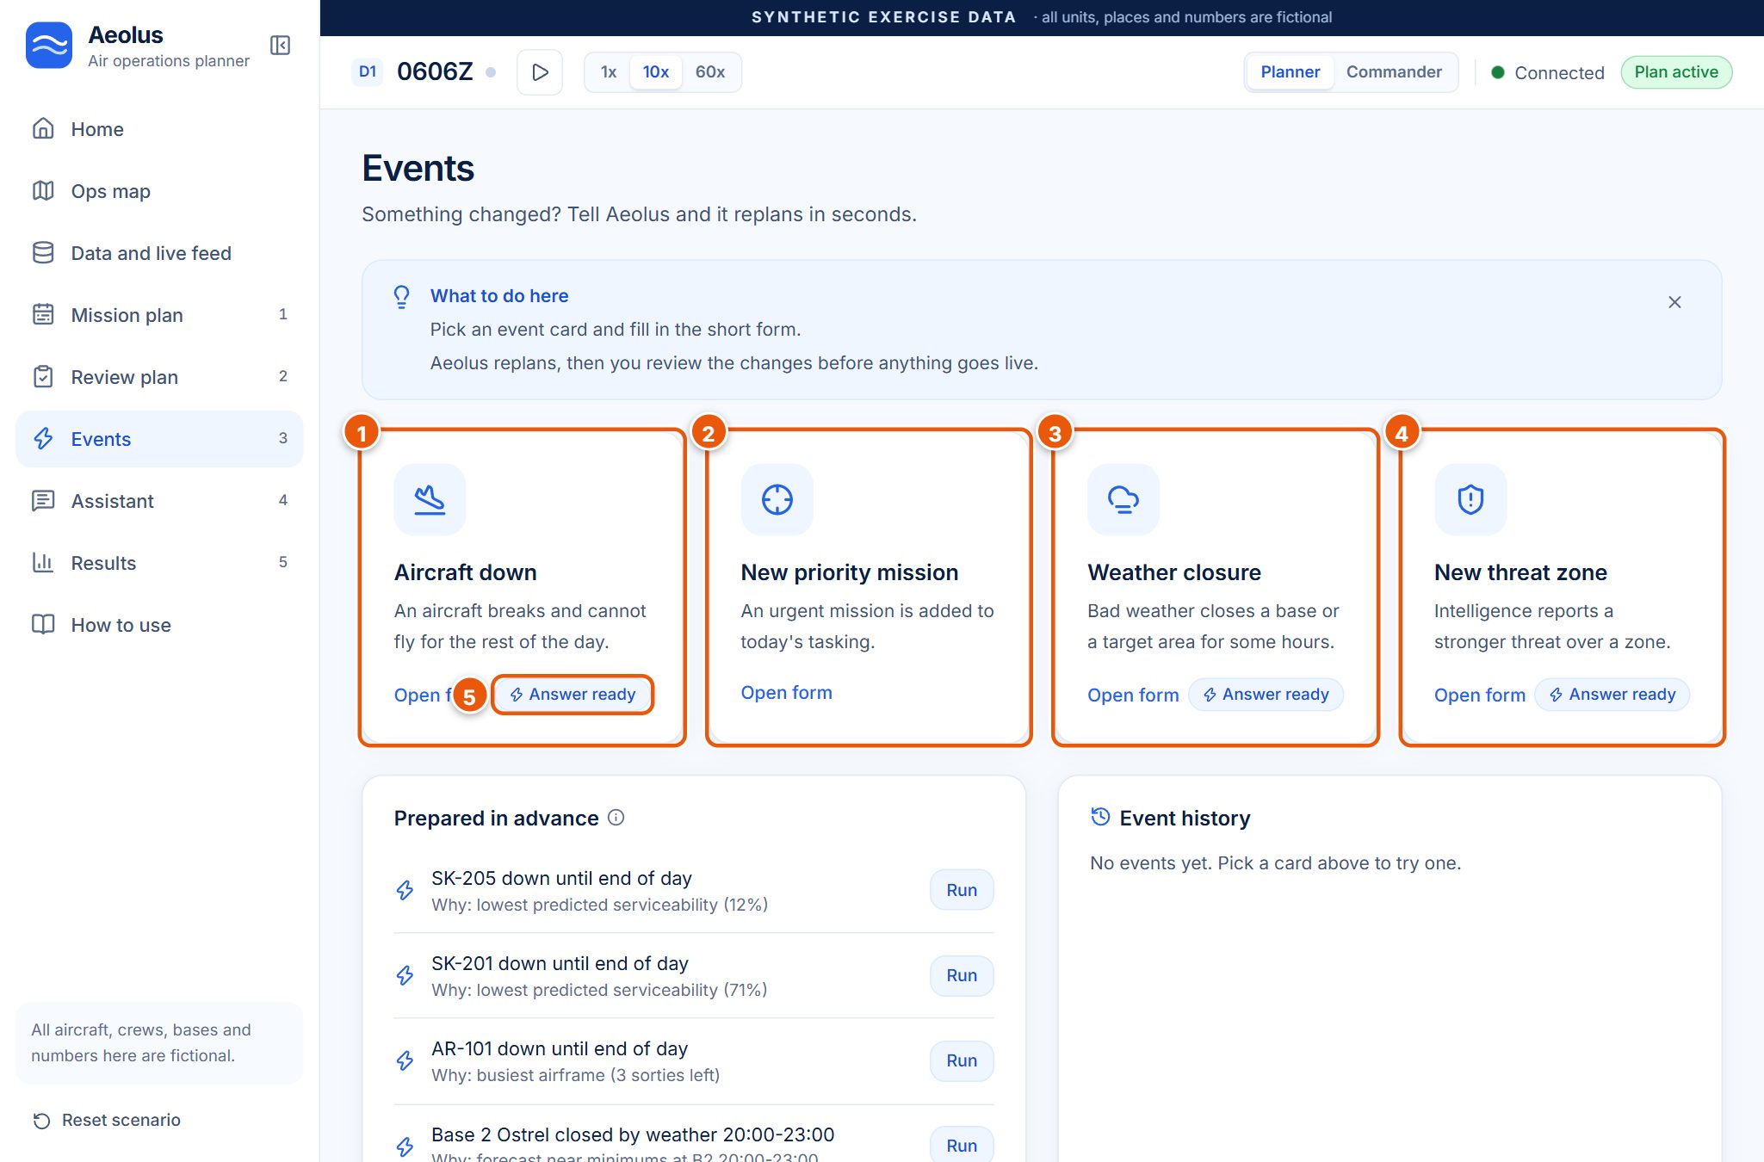
Figure 15. The four event cards. Answer ready means Aeolus already prepared a new plan for that kind of event.
# | Item | What it shows or does | What happens when you click it | Why it matters
1 | Aircraft down | An aircraft breaks and cannot fly for the rest of the day. | Opens a form: which aircraft, down until. | The most common disruption.
2 | New priority mission | An urgent mission is added. | Form: mission type, priority, target zone, take-off time, aircraft needed. | Tasking changes during the day.
3 | Weather closure | Bad weather closes a base or a target zone for some hours. | Form: where, closed from, until (pre-filled with the prepared case). | Weather is a frequent cause of replans.
4 | New threat zone | Intelligence reports a stronger threat over a zone. | Form: zone, new threat level 1 to 3. | Keeps aircraft out of danger.
5 | Answer ready badge | A prepared answer exists for this kind of event. | – | Expect a near-instant result.

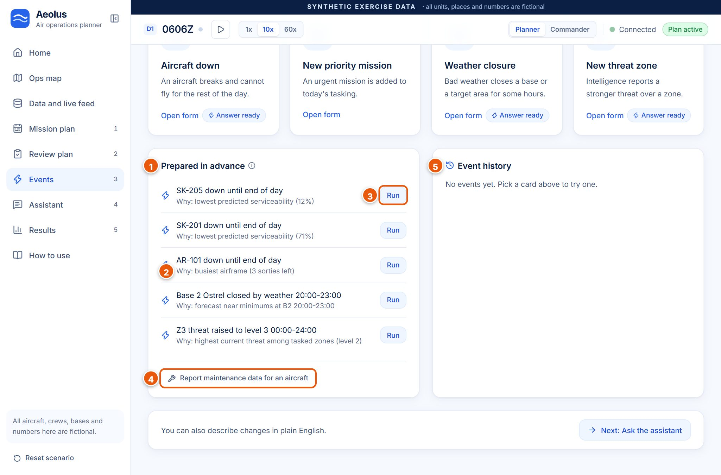
Figure 16. Prepared in advance (the contingency cache), maintenance report and event history.
# | Item | What it shows or does | What happens when you click it | Why it matters
1 | Prepared in advance | The 5 problems Aeolus solved in advance after the last approval. | – | Instant answers for likely events.
2 | Why: line | Why this case was chosen, for example busiest airframe (3 sorties left) or lowest predicted serviceability (12%). | – | The choice is explained.
3 | Run | Injects that exact event. | Serves the prepared plan at once. | Fastest way to show a cache hit.
4 | Report maintenance data for an aircraft | Form: faults in the last 30 days, hours since maintenance. | Updates the predicted readiness and replans. | Shows the prediction affects the plan.
5 | Event history | Every event: time, description, category (for example Resource loss), flights affected, prepared answer or solved fresh, and its time. | Show details expands it. | A record of what happened.

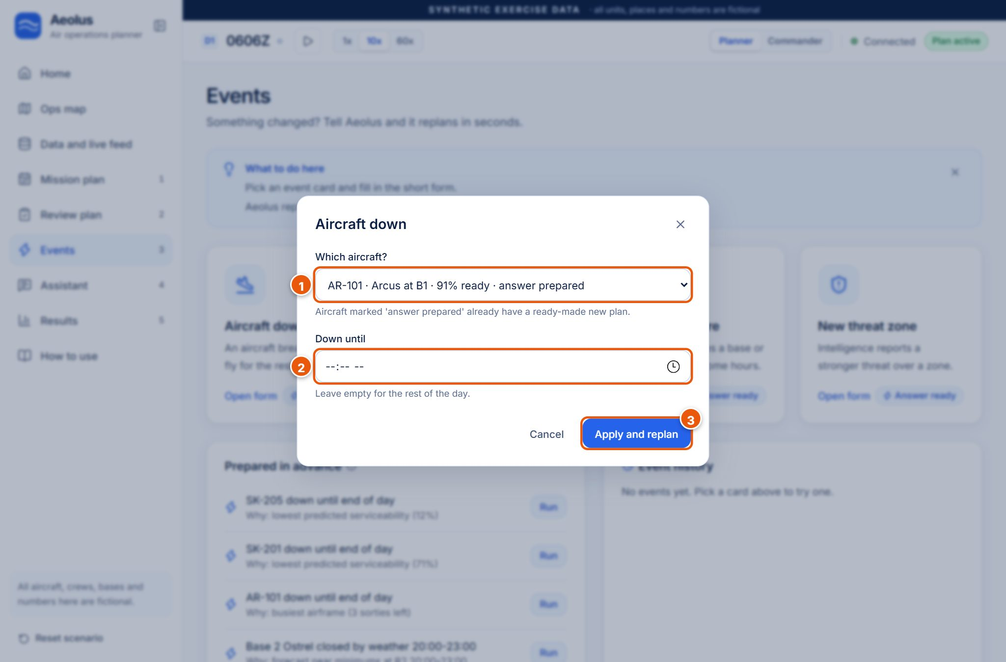
Figure 17. Aircraft down form, pre-selected on AR-101 · Arcus at B1 · 91% ready · answer prepared.
In the form, (1) Which aircraft? lists every serviceable aircraft with its readiness; those marked answer prepared have a ready-made plan. (2) Down until can stay empty for the rest of the day. (3) Apply and replan runs it; Cancel closes the form.
After Apply, a result banner appears at the top, in our run Served in 0.01 s, 3 of 23 changed with the line Aeolus used a prepared answer. Every rule check passed. It gives the measured time and how many flights changed, and says whether a prepared answer was used. The blue Review changes button opens the Review page. Once the picture changes, the Prepared in advance box says the answers are out of date until you approve again.

3.7 Assistant
Purpose: describe a change in plain English. Aeolus turns it into conditions you can check before anything is replanned.
The page has a chat area, three example prompts, a text box with a Send arrow (Enter sends, Shift+Enter makes a new line) and a status line: Language model on, offline reader as backup (or offline reader only). Clicking an example puts it in the box; Send shows what Aeolus understood as chips, and nothing is replanned yet.
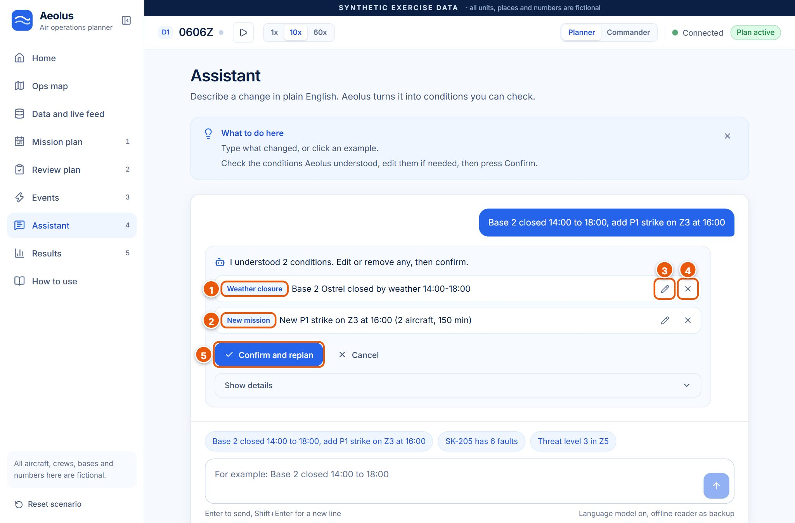
Figure 18. Aeolus understood 2 conditions, shown as editable chips.
# | Item | What it shows or does | What happens when you click it | Why it matters
1 | Condition type (Weather closure) | What kind of change was understood, with its plain description: Base 2 Ostrel closed by weather 14:00-18:00. | – | You check the meaning.
2 | Second condition (New mission) | New P1 strike on Z3 at 16:00 (2 aircraft, 150 min). | – | One sentence can hold several changes.
3 | Pencil (edit) | Edit the condition's values. | Opens small fields to change times, zones and so on. | Fix a misunderstanding.
4 | X (remove) | Drops that condition. | Removes the chip. | Keep only what you meant.
5 | Confirm and replan | Applies the conditions and replans. | In our run: solved fresh in 0.11 s, 10 of 23 changed, 2 added. | The human confirms before any change.

3.8 Results
Purpose: how fast and how well Aeolus is planning. Every number comes from the current session.
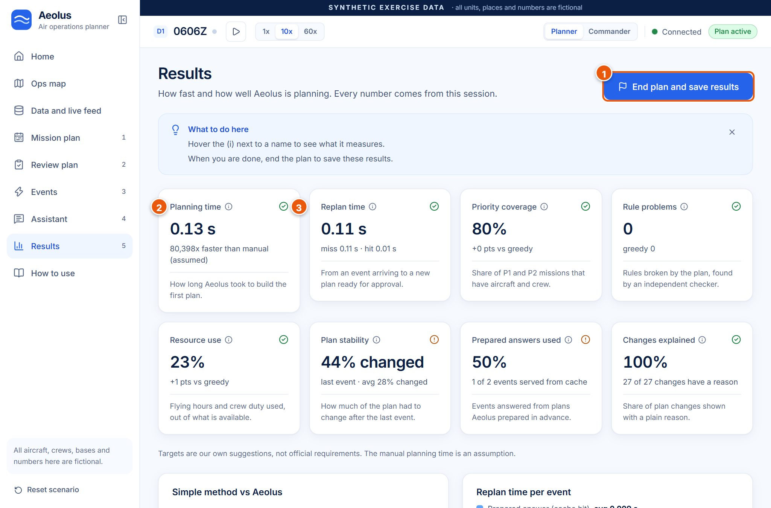
Figure 19. The 8 KPI cards at the end of the demo run.
# | Item | What it shows or does | What happens when you click it | Why it matters
1 | End plan and save results | Ends the plan and saves a KPI snapshot to the database. | Confirm dialog, then a summary window. The clock stops. | Use only at the very end.
2 | KPI card | Name, (i) tooltip, value, comparison line, one-line meaning. | Hover (i) for what it measures and the suggested target. | All 8 numbers explained in section 6.
3 | Target icon | Green tick = meets our suggested target, amber ! = misses it. | – | Honest at a glance.

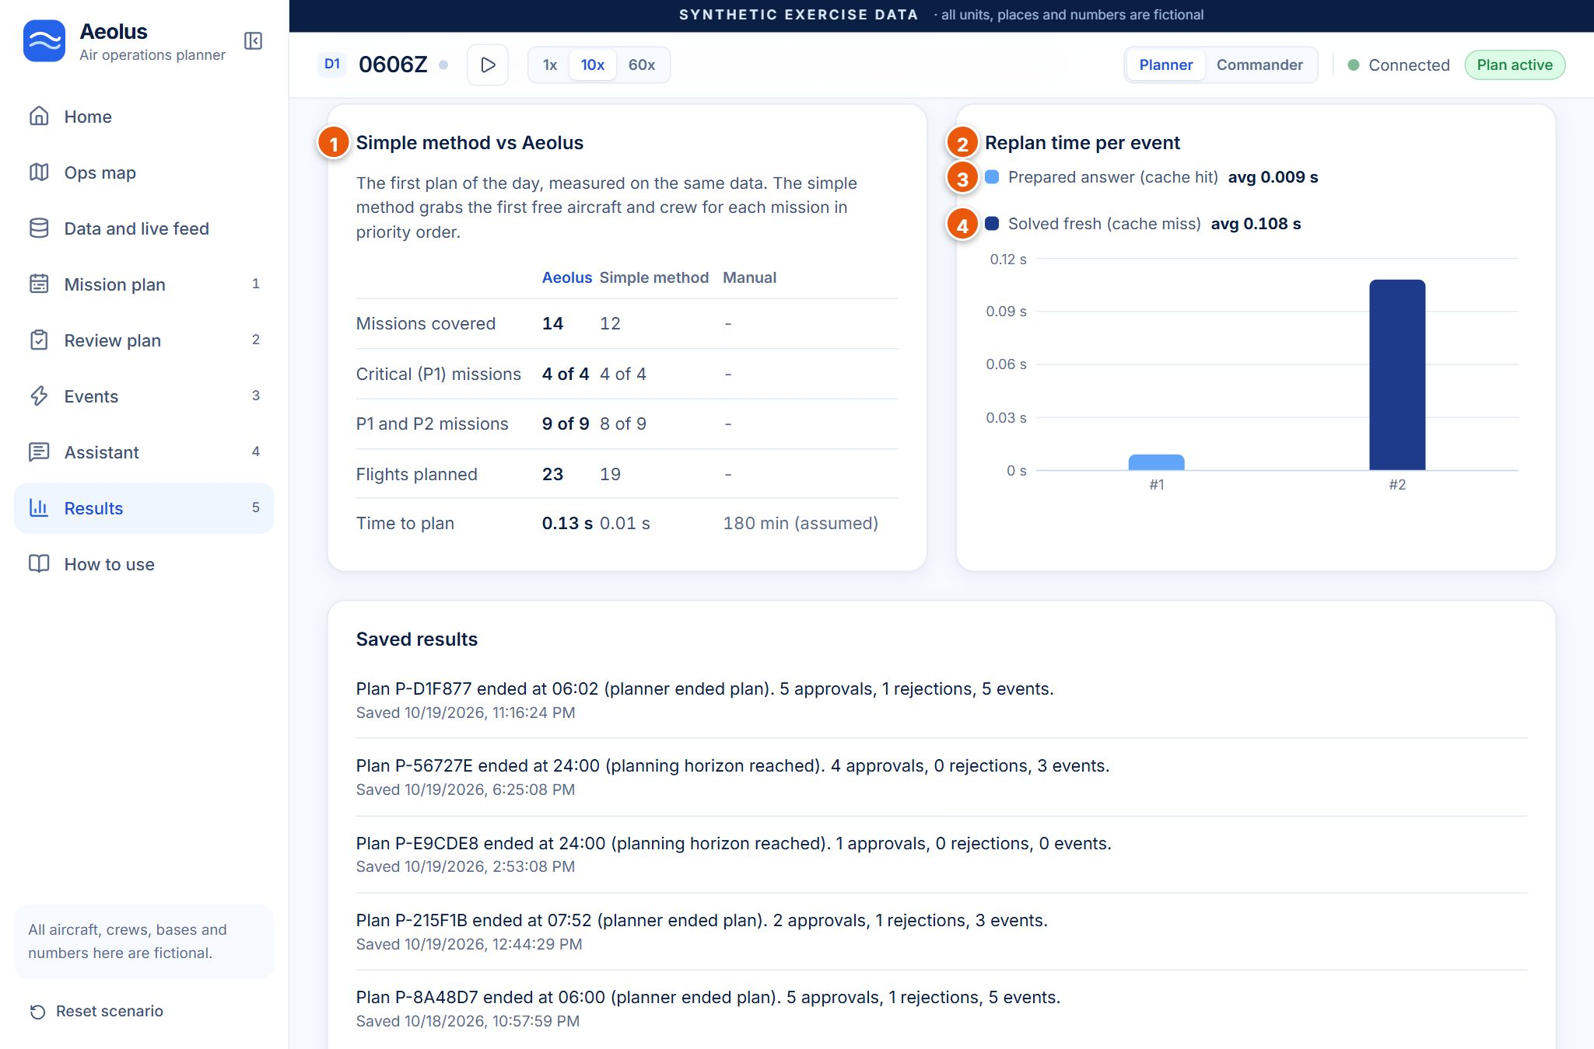
Figure 20. Simple method vs Aeolus, and replan time per event.
# | Item | How to read it
1 | Simple method vs Aeolus | First plan of the day on the same data: Aeolus covers 14 missions vs 12, P1 4 of 4 vs 4 of 4, P1+P2 9 of 9 vs 8 of 9, 23 flights vs 19, time 0.13 s vs 0.01 s vs 180 min manual (assumed).
2 | Replan time per event (bar chart) | One bar per event (#1, #2). Height = seconds from the event to a plan ready for approval. Lower is better.
3 | Prepared answer (cache hit) | Light blue bars; average 0.009 s in our run.
4 | Solved fresh (cache miss) | Dark blue bars; average 0.108 s in our run.

Below the chart, Saved results lists earlier KPI snapshots stored in the database (for example: Plan ended at 24:00, planning horizon reached, 4 approvals, 0 rejections, 3 events).

3.9 How to use
Purpose: the full flow with a button per step, the five-minute demo script and the guided Run exercise.
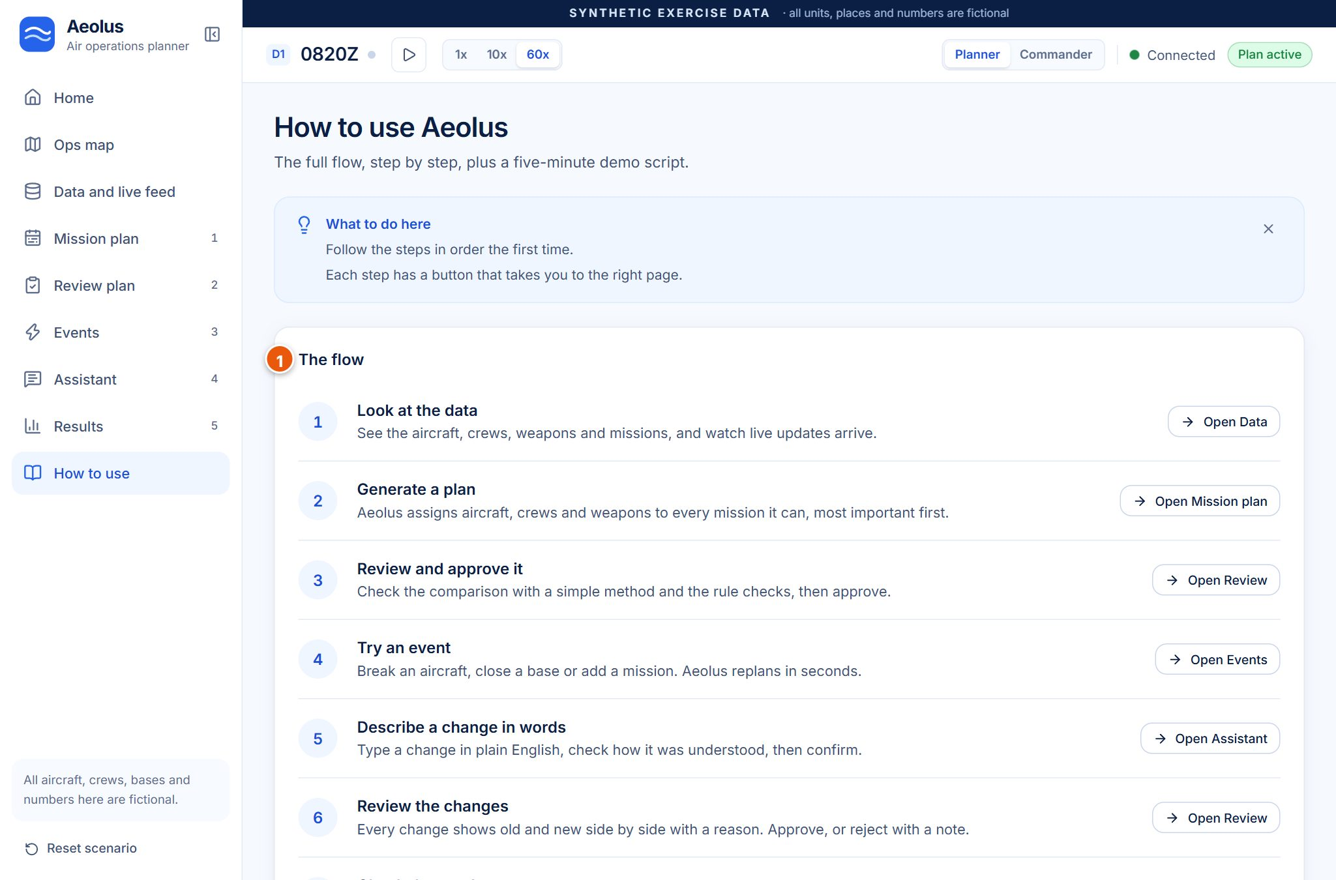
Figure 21. How to use: the flow (seven steps) and the demo script.
(1) The flow lists seven steps (look at the data, generate, review and approve, try an event, describe a change in words, review the changes, check the results), each with an Open button. (2) Run exercise plays a hands-free version of the demo: it resets the scenario and pauses at each step with a caption made from the measured results; press Next to move on. The Five-minute demo script below repeats the spoken lines; Show technical details reveals the engineering terms.

4. Global controls
Control | Where | What it does
Sidebar | Left edge | Links to every page. Steps 1 to 5 are numbered. A blue 1 on Review plan means a plan waits for approval. At the bottom: a fictional-data note and Reset scenario.
Collapse / expand button | Top of the sidebar, next to the logo | Shrinks the sidebar to an icon rail (hover an icon for its name). The app remembers your choice and collapses it automatically on screens narrower than 1280 pixels.
Reset scenario | Bottom of the sidebar | Opens a confirm dialog. Reloads the original synthetic data and clears the plan, events and chat. Saved results in the database are kept.
Scenario clock (D1 0600Z) | Top bar | Starts at 06:00 and only runs once a plan is approved. Flights move through their stages as it runs.
Play / pause | Next to the clock | Pauses or resumes the scenario clock (greyed out until a plan is approved).
Clock speed 1x / 10x / 60x | Top bar | Scenario minutes per real minute. 1x = real time, 10x = one scenario hour every 6 real minutes (default), 60x = one scenario hour every real minute.
Planner / Commander | Top right | Planner shows all nine pages. Commander shows a short sidebar (Commander summary, Ops map, Results, How to use) and opens the Commander summary.
Connection status | Top right | Connected (green), Connecting or Waking up the server (amber), Offline (red, with a Retry banner).
Plan status pill | Top right | No plan yet, Waiting for approval, Plan active, Plan ended.

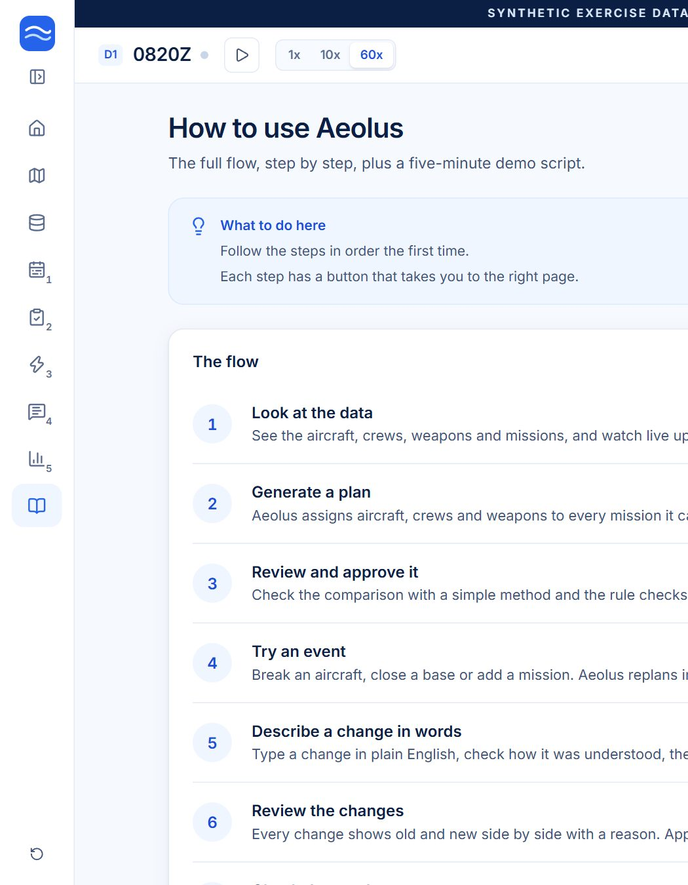
Figure 22. Sidebar collapsed to an icon rail (step numbers stay visible).

4.1 The Commander view
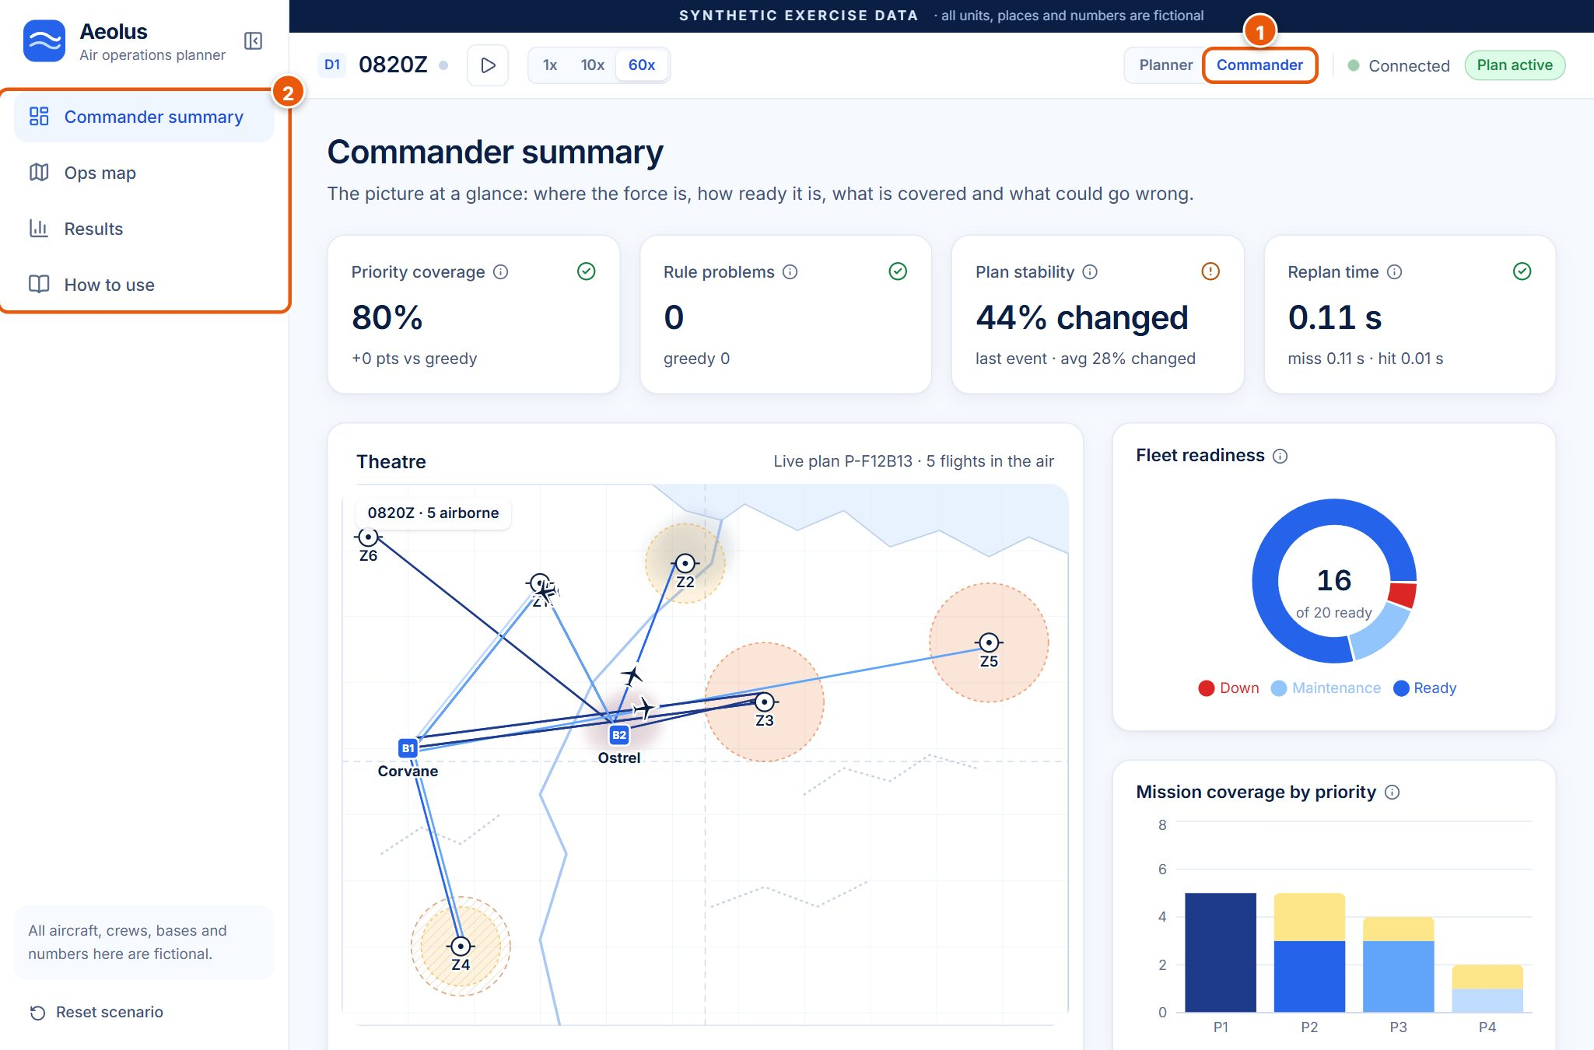
Figure 23. Commander summary: the same data, simplified for a senior viewer.
Clicking Commander (1) changes the sidebar (2) to four pages and opens the Commander summary: four KPI cards (priority coverage, rule problems, plan stability, replan time), the theatre map with the live plan id and flights in the air, fleet readiness, mission coverage, Risks to watch (for example a P1 mission with no spare aircraft or crew, or an aircraft tasked with a high fault risk) and Latest decisions. Switch back with Planner to make changes.

5. Backend endpoints (simple version)
The dashboard (what you see) talks to the Aeolus server (the backend, written in Python with FastAPI) through web addresses called endpoints. Each one does a single job.
Endpoint | What it does, in plain words | Called by
GET /api/health | Says the server is alive and whether the database and the language model are available. | The app, every 10 seconds (connection status).
GET /api/live | Returns the clock, new live-feed messages and the plan if it changed. | The app, every 2 seconds (6 seconds when the tab is in the background).
GET /api/state | The whole picture: aircraft, crews, weapons, missions, weather, threats, readiness predictions. | Data page, charts, timeline, after every change.
GET /api/plan | The plan status: live plan, proposed plan, KPIs, events, history. | On load and after changes.
GET /api/map | Map shapes: coastline, bases, zones, threats, weather cells. | Ops map, Home and Commander maps.
POST /api/plan/generate | Builds the first plan of the day (and the simple-method plan for comparison). | Generate plan (Mission plan, Home), Run exercise.
POST /api/plan/approve | Makes the proposed plan live, then prepares answers for likely events. | Approve plan (Review).
POST /api/plan/reject | Rejects the proposal; the note becomes a condition; a new option is solved. | Reject (Review).
POST /api/plan/end | Ends the plan and saves a KPI snapshot. | End plan and save results (Results).
POST /api/events | Applies an event (aircraft down, new mission, weather, threat, maintenance data) and replans. | Events page cards, Run buttons.
POST /api/chat/parse | Reads plain English and returns conditions (language model, or the offline reader). | Assistant: Send.
POST /api/chat/apply | Applies the confirmed conditions and replans. | Assistant: Confirm and replan.
POST /api/clock | Pauses or resumes the clock and sets 1x, 10x or 60x. | Top bar controls.
POST /api/scenario/reset | Reloads the original synthetic data. | Reset scenario, Run exercise.
GET /api/kpis/history | The last saved KPI snapshots. | Results: Saved results.
POST /api/settings | Changes how strongly replans avoid changes (the stability weight). | Not used by the dashboard (developer use).

5.1 The live feed in one paragraph
The live feed imitates the real systems that report all day long. About every 3 seconds the server produces a small message from one of them: the fleet system reports an aircraft's position and fuel, the weather office reports cloud and visibility, the crew roster checks a crew in, the weapons store confirms a stock count, or intelligence reconfirms a threat. The dashboard asks the server for news every 2 seconds and adds new messages to the Live feed. The scenario clock works the same way: on every request the server moves the clock forward by the real time that has passed, at the chosen speed. Feed messages update live details only; real planning changes come in as events.

6. The numbers and scores explained
Aeolus shows 8 KPIs live, plus a plan strength (fragility) badge on every flight. All targets below are our own suggestions, not official requirements. The comparison with a manual plan uses an assumed 180-minute manual planning time.
The values below come from one complete demo run (first plan, aircraft down AR-101, the chat change, one reject with keep SK-205 on the ground, approve). First = after the first plan; End = at the end of that run.
KPI (name on screen) | Meaning in simple words, and how it is calculated | Good or bad | Our target | Value in the demo
Planning time | How long the optimiser took to build the first plan, in seconds. Compared with the simple method and with the assumed 180-minute manual plan (180 min ÷ solver time). | Lower is better. | Seconds, not hours | 0.13 s, about 80,000× faster than manual (assumed). Simple method 0.01 s but worse plan.
Replan time | Seconds from an event arriving to a new plan ready for approval. Shows the last one and the averages for prepared answers (hit) and fresh solves (miss). | Lower is better. | < 10 s miss, < 2 s hit | Hit 0.01 s (AR-101 down). Miss 0.11 s (chat change).
Priority coverage (P1/P2 coverage) | Share of P1 and P2 missions that have aircraft and crew. P1 coverage is shown in the details. | Higher is better; every P1 matters most. | 100% P1 when feasible | First: 100% (+11 points vs the simple method). End: 80%, with P1 5 of 5; two P2 missions at Base 2 cannot fly because the base is closed 14:00 to 18:00.
Rule problems (hard-constraint violations) | How many of the 18 rules the plan breaks, counted by the independent checker. | Must be 0. | 0 | 0 on every plan in the run.
Resource use (utilisation) | Average of aircraft flying hours used and crew duty used, out of what is available. | Higher means scarce resources are put to work. | Above the simple method | First: 26% (+5 points vs simple method). End: 23%.
Plan stability | Share of flights that had to change after the last event (shown as % changed), plus the average. | Lower % changed is calmer. | < 15% changed per event | Aircraft down: 13% changed. Chat change (base closed 4 h + new P1 mission): 44% changed, a big change, average 28%.
Prepared answers used (cache hit rate) | Share of events answered from a plan prepared in advance. | Higher is better. | 60%+ on modelled events | 100% after the first event; 50% at the end (1 of 2: the chat change was a new situation).
Changes explained (explanation coverage) | Share of plan changes shown with a plain reason. | Must be 100%. | 100% | 100% (27 of 27 changes).
Plan strength (fragility) | Per flight: how many spare aircraft and crews could step in. Strong = 2 or more spares, Moderate = 1, Weak = none; one level weaker if the aircraft is under 70% ready. Score 0-100 in Show details. | Strong is safer. | Fewer Weak flights | Example M01: Moderate (3 spare aircraft, 1 spare crew). End of run: 3 Strong, 4 Moderate, 12 Weak (resources are deliberately scarce).

WATCH OUT: Why some numbers are amber at the end
The chat change closes a whole base for 4 hours and adds a new P1 mission at the same time. Aeolus covers every P1 mission but has to move many flights (44% changed) and leave two P2 missions at the closed base unassigned, with the reason shown. The amber icons are honest: they show where our suggested targets are missed and why.

GOOD TO KNOW: Planning time vs Time taken
The Planning time KPI (0.13 s) is the optimiser alone. The Review page shows Time taken (0.15 s), which also includes checking the plan and writing the explanations.

7. The demo story (for recording the video)
A script of about 3 to 4 minutes. Each step says the page to open, what to click, what to say, and what the viewer should notice. Speak slowly and let each screen settle for a second before talking.
Step | Page | What to click | What to say | What to notice
1. Overview | Home | Nothing yet. Point at the Getting started checklist and the Next step card. | "Air planners pull aircraft, crews, weapons, weather and threats from separate systems. Aeolus puts them in one live picture and suggests the plan. The planner decides. All data here is synthetic." | The SYNTHETIC EXERCISE DATA banner, Connected, No plan yet.
2. Fused data | Data and live feed | Scroll once to the Aircraft table and the Live feed. | "Eight simulated systems are merged here. Each aircraft has a predicted chance of being ready; AR-103 is only 29%. On the right, updates arrive live." | Ready to fly %, new feed messages appearing.
3. First plan | Mission plan | Click Generate plan. Then Review changes. | "Aeolus builds the whole day's plan in about a tenth of a second." | Planned in about 0.15 s, 23 sorties, 0 rule problems.
4. Compare and check | Review plan | Show Compared with a simple method, scroll to Rule checks, click Approve plan, then confirm. | "A simple method covers 12 of 15 missions. Aeolus covers 14, including every critical one. A separate checker tests 18 rules: all pass. Nothing goes live until I approve." | 14 of 15 vs 12 of 15, 18 of 18 passed, status turns Plan active.
5. Aircraft down | Events | Click Aircraft down. Keep AR-101 (answer prepared). Click Apply and replan. | "An aircraft breaks. Aeolus had already prepared an answer, so the new plan is ready almost instantly, and it is still checked." | Served in 0.01 s, 3 of 23 changed.
6. Old vs new | Review plan | Click Review changes. Read one Why line. Click Approve plan, confirm. | "Every change has a reason. AR-101 is down, so AR-102 takes its flights. Only 3 of 23 flights moved." | Current vs Proposed columns, Aircraft swapped, the Why text.
7. Plain English | Assistant | Click the example Base 2 closed 14:00 to 18:00, add P1 strike on Z3 at 16:00. Send. Show the two chips. Click Confirm and replan. | "I can type a change in plain English. The AI only reads my words; I check what it understood before anything changes. The optimiser makes the plan." | Two condition chips with edit and remove buttons; solved fresh in about 0.1 s.
8. Reject, then approve | Review plan | Click Reject, type keep SK-205 on the ground, click Reject and find another option. Then Approve plan and confirm. | "I am not happy, so I reject with a note. My note becomes a new condition and Aeolus finds another option. I approve it." | New condition SK-205 down, all rules pass.
9. Results | Results | Point at the 8 cards, the Simple method vs Aeolus table and the replan chart. | "Every number comes from this session. The targets are our own suggestions; the 180-minute manual time is an assumption." | Planning 0.13 s, replan hit 0.01 s and miss 0.11 s, rule problems 0, 100% changes explained.
10. Closing | Results (or Ops map at 60x) | Optionally switch to Ops map, set 60x for a few seconds to show aircraft moving, then pause. | "Aeolus: one live picture, a better plan in seconds, fast and calm replanning, and the human always decides." | Aircraft moving on the map.

7.1 Timing
Step | Start | Length
1. Overview | 0:00 | 0:20
2. Fused data | 0:20 | 0:25
3. First plan | 0:45 | 0:20
4. Compare and check | 1:05 | 0:35
5. Aircraft down | 1:40 | 0:20
6. Old vs new | 2:00 | 0:25
7. Plain English | 2:25 | 0:35
8. Reject, then approve | 3:00 | 0:25
9. Results | 3:25 | 0:25
10. Closing | 3:50 | 0:10
Total |  | about 4:00

7.2 Tips for recording
TIP: Set-up that works
Use Chrome or Edge, full screen (F11), window at least 1366 × 768. Browser zoom 100%; use 90% only if the page does not fit.
Click Reset scenario (bottom of the sidebar) just before recording so the day starts at 06:00 with no plan.
Keep the clock at 10x during steps 3 to 8. Use 60x only at the end on the Ops map, then pause.
Use the example sentence in the Assistant (click it, do not type it) and the note keep SK-205 on the ground in the Reject step. Both are tested.
On the live site, open it 2 minutes early and generate one plan to wake the server, then Reset scenario.
If you prefer a hands-free run, How to use > Run exercise plays the whole story with captions.

WATCH OUT: Things that change the story
At 10x the first flights taxi at 07:15 scenario time, about 7 real minutes after approval. If you wait much longer, some flights are already flying and Aeolus may solve the aircraft-down event fresh instead of using the prepared answer (still well under a second).
The reject note keep SK-201 on the ground (an older script) leaves the new P1 strike without aircraft in our tests. Use keep SK-205 on the ground instead.
Numbers can differ by a few hundredths of a second between runs. Read them from the screen, not from this guide.

DO NOT CLICK: Do not click during the recording
End plan and save results before the very end: it stops the clock and the plan cannot be changed until you reset.
Reset scenario or Run exercise in the middle: both wipe the plan you have built.
Commander in the middle of the planner flow: it changes the sidebar (switch back with Planner).
Double-clicking Approve, Apply or Confirm: wait for each result instead.

7.3 Checklist before recording
☐ The app shows Connected (green) in the top bar.
☐ Reset scenario done: clock at D1 0600Z, status No plan yet, Getting started 0 of 5.
☐ Clock speed on 10x.
☐ Browser full screen, zoom 100%, no other tabs or notifications visible.
☐ Microphone tested; screen recorder set to the browser window.
☐ One full rehearsal done, then Reset scenario again.
☐ This guide's script open on a second screen or printed.

8. Common questions a judge might ask
Question | Short, honest answer
Is the data real? | No. Every aircraft, base, crew, place, weapon and number is synthetic and fictional, generated from a fixed seed so the demo is repeatable. The app says so in the top banner and on the Data page.
How do you know the plan is correct? | Every plan, including prepared answers, is re-checked by an independent validator: separate code that re-reads the raw data and tests 18 rules (crew hours, weapon stock, weather limits, double booking and more). It does not reuse the optimiser's model. A plan with a broken rule cannot be approved.
What if the AI is wrong? | The language model only turns your sentence into conditions, shown as chips that you can edit or remove before confirming. It never creates, edits or approves a plan; the optimiser builds the plan and a human approves it. Explanations are generated from solver facts; the AI may only reword the summary.
What happens without internet? | Run locally, Aeolus works fully offline: the optimiser, checker and predictions run on the laptop, and the assistant falls back to a built-in offline reader. Without internet only the language model is unavailable (and saving results to the online database). The live website itself needs internet.
How fast is it really? | Measured, not assumed: the first plan took 0.13 s in our run, a prepared answer 0.01 s and a fresh replan about 0.1 s. The only assumed number is the 180-minute manual planning time used for comparison.
Why not just use the simple method? | It is faster on paper (0.01 s) but covered 12 of 15 missions and missed a P2 mission, while Aeolus covered 14 of 15 with every P1 and P2 mission.
Does the prediction use real maintenance data? | No. The readiness model is a small machine-learning model trained on synthetic data, clearly labelled as such. It shows the pipeline works, not real-world accuracy.
What is still in development? | The Plan Resilience Score (testing the plan against every single failure and many random scenarios to give a success probability) is still in development, as are why-not questions, a what-if sandbox and a ripple view. Real data links, secure pipelines, route planning and certification-grade checking are future scope.
Who is in control? | The planner. Aeolus suggests; nothing becomes the live plan until the planner clicks Approve, and Reject always sends Aeolus back for another option.

GOOD TO KNOW: Remember
The data is synthetic. The Plan Resilience Score is still in development. Targets are our own suggestions.

9. Setup and troubleshooting for the demo

9.1 Live website
The prototype is deployed at https://aeolus-sih.vercel.app (frontend and backend on Vercel, scenario saved in a cloud PostgreSQL database). The first visit after a quiet period may show Waking up the server for a few seconds while the server starts; the first plan after that can take 5 to 8 seconds, later ones well under a second.

9.2 Run it on your own computer
You need Python 3.11 to 3.13, Node.js 20 or newer and pnpm. Ask the team for the .env file (it holds the database address and the language-model key; never share it). Then, in the project folder:
Command | What it does
pnpm setup | One-time setup: creates the Python environment, installs everything, creates the database tables.
pnpm dev | Starts the server (port 8000) and the dashboard (port 3000) together. Open http://localhost:3000.
pnpm dev:clean | Frees ports 3000 and 8000 if pnpm dev says a port is busy, then run pnpm dev again.
pnpm test | Runs the automatic tests (optional).
pnpm smoke | Runs the whole demo story without a browser and prints the KPI table (optional).

9.3 If something goes wrong
What you see | What to do
Amber Connecting or Waking up the server | Wait up to a minute; the server is starting. The page fills in by itself.
Red Offline and a banner Cannot reach the Aeolus server (older versions said Reconnecting) | Click Retry in the banner. On your computer, check that pnpm dev is still running (restart it if not). On the live site, wait a minute and press Retry, or reload the page.
A button does nothing | Wait for the current action to finish (only one runs at a time), then try again.
Prepared in advance says the answers are out of date | Normal after a change. Approve the current plan and new answers are prepared.
Results look strange or the clock is far ahead | Click Reset scenario at the bottom of the sidebar to start the day again at 06:00.
The assistant did not understand a sentence | Use one of the example prompts, or shorter sentences with base, zone and times (Base 2 closed 14:00 to 18:00).

TIP: Where to reset the demo
Sidebar > Reset scenario (bottom left) > Reset scenario in the dialog. It reloads the original synthetic data and clears the plan, events and chat. Saved results stay in the database.

