**Company Valuation of Intel Corp.**

**Executive summary**

The report has shed light on the company valuation of Intel Corp. after the conduction of cost of capital calculation to consider the capital structure of the company. The company valuation has been calculated based on the five-year financial projection of forecasting the income statement and balance sheet of the company. An evaluation of the fair price value has been elaborated with the conduction of sensitivity analysis based on the company financials.

# 1. Introduction

Undertaking the company valuation estimates helps in knowing the accurate valuation of the business operated that impacts the contemporary financial positions along with critical decision-making. The computation of company valuation enables knowing the company’s worth of the shares if it decides on future strategies to exit the operational market. The report has shed light on estimating the company valuation of Intel Corp. after acknowledging the financial position of the company by producing financial forecasts and estimating the fair price of its shares. Furthermore, a critical evaluation of the sensitivity analysis has benefitted to identify any major risk positioned for the valuation of the company's financials.

# 2. Company valuation

The capital structure evaluated in the previous stages for Intel has critically helped in the estimation of the financial forecasts including a financial projection of income, expenses, assets and liabilities of the firm. As per the suggestions of Miciuła*et al.* (2020, p.9), business or company valuation not only helps the financial analysts in analysing the financials of the company but also assists the investors in their decision-making. A critical benefit is projected when the financial managers assist a potential investor in deciding which stocks to buy by evaluating the acceleration of the expected returns and growth percentages.

## 2.1 Production of financial forecast

In projecting the financial forecasts for Intel, it has been required to determine a significant input range that has been rendered to highlight the output range where the overall company valuation has been estimated. The input ranges involved projecting forecasted income statements along with the balance sheet of Intel considering the base year to be 2021, where forecasts are made for consecutive five years from 2022-2026.

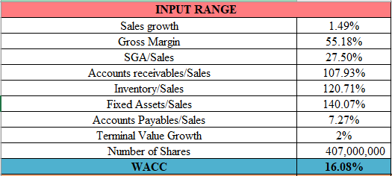

**Figure 1: Input range used for financial forecasting**

Based on the trend analysis the calculated sales growth is determined at 1.49% along with the gross margin rate of 55.18%. The variation of the SGA, accounts receivables, assets, accounts payables, and inventories are presented as per the sales and projected as percentages. The ***“terminal value growth rate”*** of 2% is considered in this case as the industry standard along with the projection of a total number of shares of Intel as 4070 million for the base year 2021. The WACC estimated for the company was 16.08%, which has been critically useful for consideration.

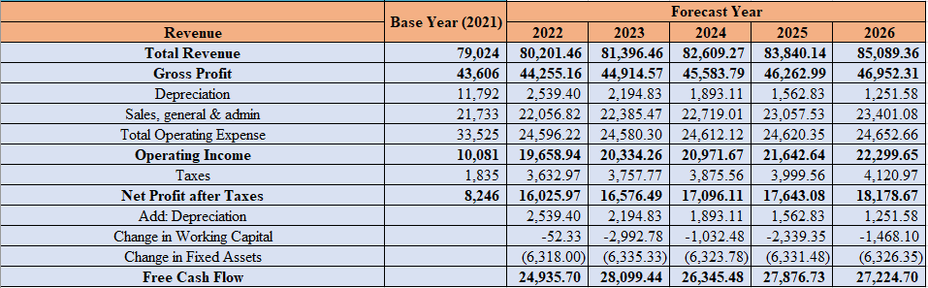

**Figure 2: Income statement with forecasts for the next five years**



**Figure 3: Balance Sheet with forecasts for the next five years**

The financial inputted from the income statement and balance sheet of Intel has helped in the estimation of ***“free cash flows”*** at the end of the years from 2022 until 2026, consecutively forecasted. The estimated growth rates are critically helpful in delivering the forecasted values of the future years to structure the overall income statement of a company (Zhou *et al.* 2022, p.15). The balance sheet financials have also been useful to be input in order to analyse the future projected financials and the computation of the output range. ***[Refer to Appendix 1]***

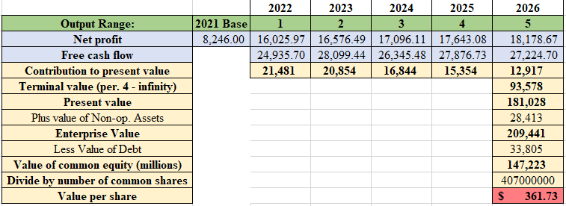

**Figure 4: Required Output range**

The output range is projected from figure 3, which comprises the calculation of company valuation, which is the preliminary aim of this report. The share value of the company Intel is estimated at the end of the fifth forecasted year which is 2026 which is resulting in $361.73. The current stock price of Intel is $38.61 per share (Finance.yahoo, 2022). It can be highlighted in this context that the calculated value is much higher than the contemporary share price which critically suggests that the ***share price is overpriced***. It can be critically commented that the growth rate of the profit generation along with ***“free cash flow”*** rates are not as high compared to the rapidly changed price in fair value. Contrarily, as Intel is performing well in its sector it can probably be foreseen to have an increased price of the shares.

## 2.2 Conduction of a sensitivity analysis

The growth rate of the sales projected from Intel Corp.’s financials for revenue generation is 1.49% which is considered to be comparatively lower for a global enterprise like Intel (Intc, 2022). The rates determined to analyse the sensitivity of the sales projections are taken as the positive and negative 10% and 20% from the deviations. For Intel, the price is sensitive where the critical deviation of the rates has been seen to project the influence of the changed prices of present values of the company.

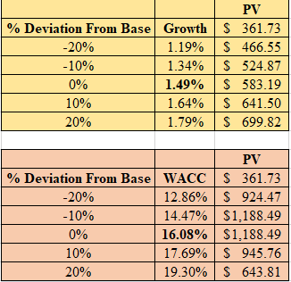

**Figure 5: Sensitivity analysis of sales growth and WACC**

Based on the sensitivity analysis projected for gross margin along with fixed assets determined based on sales values further project critical influence that results in the present values being sensitive. As per the opinions of Lee and So (2022, p.7), the sensitivity analysis of a company critically evaluates the uncertainty of the output values that is possible to be apportioned towards diverse sources. Intel has projected significant sensitivity in terms of the figures projected.

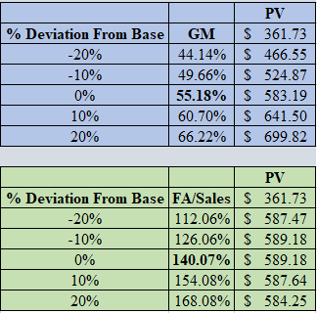

**Figure 6: Sensitivity analysis of gross margin and Fixed assets**

# 3. Conclusion

The determination of the economic values of a company or enterprise provides the owners and investors of the company with a considerable estimation of company values. The identification of the operational inefficiency of Intel can be critically projected in operating lesser growth of operating income that critically undermines the growth of the company. Asset growth is comparatively higher which has critically praised the ***company valuation price*** which is suggested to be ***unfair and overpriced*** compared to the current prices. Thus, major risks identified from the financial forecast along with sensitivity analysis that Intel must approach to reduce the rates of operating expenses.

# Reference list

Finance.yahoo (2022), *Intel Corporation*. Available from: https://finance.yahoo.com/quote/INTC?p=INTC [Accessed on 18.06.22]

Intc (2022), *INTEL CORPORATION*. https://www.intc.com/filings-reports/annual-reports/content/0000050863-22-000007/0000050863-22-000007.pdf [Accessed on 18.06.22]

Lee, T.T.H. and So, A.R., 2022. Economic valuation of a national shipping company using a contingent valuation method (CVM): The case of Korea. Marine Policy, 135, p.104870.

Miciuła, I., Kadłubek, M. and Stępień, P., 2020. Modern methods of Business Valuation—case study and new concepts. Sustainability, 12(7), p.2699.

Zhou, J., Jing, F., Liu, X., Li, X. and Zhang, Q., 2022. Field-aware attentive neural factorization with fuzzy mutual information for company investment valuation. Information Sciences, 600, pp.43-58.

# Appendices

## Appendix 1: Intel’s five-year forecasted balance sheet

