**Capstone Project: Air Canada**

**Task Requirement (Question)**

The student will submit a professional font typed; 1.5 spaced report based on individual research. The student will choose a Research Topic that must relate to the Travel and Tourism sector and be approved by the instructor. The time of research is current, and the purpose is to find opportunities for emerging businesses. The word limit of the report is 2,500 words +/-10% (excluding exhibits and references). It should be of the highest possible quality in its research, writing, analysis, citations and approach. It is critical that students demonstrate superior oral and written communication skills, grade deductions will be made for grammar and spelling errors in the written report. There will be zero tolerance for plagiarism. Please refer to Hanson’s plagiarism policy and be reminded to follow APA style citation. The report requires the following key components: a) Title Page b) Executive Summary c) Table of Contents d) Introduction e) Literature Review (includes your research and analysis with appropriate subheadings) f) An Environmental Scan (Micro and Macro analysis – PESTEL) g) Complete SWOT analysis h) Recommendations i) Conclusion j) ALL References must be included (APA style) k) Exhibits/Appendix (I.e., Images, charts, graphs, tables etc.) Topic: 1. Students choose a topic related to the Travel and Tourism sector (see list below) and must be approved by the instructor. 2. Research and define the existing challenges in (the Industry/ Business) your approved topic. 3. How does the organization (your chosen business) can maintain its position in the industry? 4. Provide recommendations for the Opportunities for new startups. 5. Submit Capstone Project in Schoology in Week 14. 6. Perform an environmental scan, a complete SWOT analysis of the industry.

**Answer**

**Introduction**

Pandemic has brought an unprecedented impact on the airline industry. Fall in business performance has resulted in bankruptcy for many airlines worldwide. On the other hand, travelers face various issues when they travel through airlines post Covid (Stevens & Templeton, 2020). The negative impact of the pandemic has resulted in an excess burden on the airline industry. To analyze what problems users face when they travel through airlines post Covid, here an analysis has been made for the airline industry considering the case of Air Canada. For the analysis, firstly, literary evidence has been checked to find out the issues post Covid airline travel, and then external environmental analysis and internal business analysis have been done. Underpinning the finding, recommendations have been produced for the airline industry and case organization.

# Literature review

The pandemic has wholly reshaped the airline industry. The pandemic has mainly affected airport processes (Sun et al., 2021). The social distancing rules and regulations, in addition to the requirements for screening, have led to several changes in the processing of the airline industry. This has brought an unprecedented impact on the tourism industry. Fall in the traveler led to a fall in the business, and revenue fell sharply, forcing various airlines to file bankruptcy due to the pandemic. It has also resulted in a fall in employment, causing a further burden on the economy (figure 2 in appendix).

## The problem associated with the check-in process

One of the major problems faced by users when traveling through airlines would be check-ins. The check-in process encompasses several efficiency metrics, such as passenger waiting time containing passport and luggage screening. Also, the operational efficiency and attitude of the employees providing services are considered. Check-in is deemed a vital activity since it is the first and foremost step of operation encountered by the passengers when traveling. In the study conducted by Sulu, Arasli & Saydam (2021), where the researchers analyzed the review of customers on their traveling experience from TripAdvisor, they found that the word "check-in" was mentioned in a negative tone. It means that the customers are not satisfied with the check-in process of the airlines. The reason behind the dissatisfaction of the customers is due to the long waiting time. The longer the waiting time, the higher the stress level experienced by the customers (Bilgili, Ozkul&Koc, 2020). Therefore, the users of the airlines bear higher pressure and feel anxious due to a long waiting time.

## A Problem associated with the cancellation process

Cancellation has been a significant problem in the airline industry post-covid. As per an article in The Atlanta Journal-Constitution, the global airline industry canceled 4.5% of their domestic flights in February 2022, which was 6.3% in January (figure 1 in appendix). Therefore, several flights are being canceled post Covid which will have a repercussion for the customers, and they will faceseveral problems. The disappointment caused due to flight cancellation is a significant problem. Liau and Tan found out that customers who had purchased a low-cost airline ticket also negatively perceived flight cancellations even though the company had tried to appease the customers with a monetary refund (Sulu, Arasli & Saydam, 2021). Therefore, it is evident that customers who wanted to travel via airlines could not reach their destination, resulting in distress. Also, it must be understood that people could not move from one place to another for a long time due to the traveling restrictions; therefore, as soon as the traveling restrictions were lifted, people wanted to travel. Now, if excited individuals cannot travel after the pandemic, it will be a problematic experience for the people.

According to Sulu, Arasli & Saydam (2021), the theme of cancellation was closely attached to the concept of refund. It implies that people who expressed their problems due to cancellation were also stressed about a refund. As per Forbes, several companies concealed the steps to obtain a cash refund. Therefore, in addition to the inability to fly to the destination, the passengers also had to suffer in getting a refund. Many had booked premium seats. Therefore, the price was high as well. Therefore, if they could not fly to the desired place, they should expect the refund to be made as early as possible. However, many did not receive a refund. Many suspect that the airline companies were not making enough money, delaying or not paying the customers. However, they should have paid off the customers because the airline company canceled the bookings.

## The problem associated with the luggage issue:

Another problem that the customers are facing is luggage issues. The luggage is being found missing, stolen, or, holistically speaking, "mishandled". The reason behind this problem is a lower number of employees working in the airline industry. During the pandemic, there has been massive downsizing of the airline industry. Due to the travel restrictions, the companies were losing money; therefore, under the advent of not being able to pay salaries to the employees, the companies had to conduct mass downsizing. For instance, in the Asia Pacific, there has been a total of 11.2 million people in the airline industry who have lost their jobs (Statista, 2022). Now that there has been a sudden increase in the number of passengers traveling through airplanes, there has been a shortage of employees. As a result, the number of employees working in the luggage department has fallen. Hence, there is a significant number of problems being faced by the passengers. Although airlines are trying to reimburse the losses, however, it is more than the money if the luggage consists of something that is very valuable monetarily and sentimentally.

## A Problem associated with the mental satisfaction of the travelers

The pandemic has affected the mental health of several people. Therefore, it is evident that people might not be in their pink of health while traveling as well. The most interesting problem the passengers face is the rage from other passengers. In May 2021, an attendant on a Southwest airline flight had two teeth knocked out after the attendant had an altercation with the mask of the passenger. In the US, there were over 150 cases as such before the pandemic; however, in 2021, it increased to 3000 (agcs.allianz.com, 2022). If an attendant can face these kinds of problems, the passengers can quickly rage on other passengers. Considering that several patients and children travel by airline, this kind of activity is not a good sign in general.

# PESTEL analysis

The PESTLE analysis of the airline industry is going to cover both the micro and macro factors which are impacting the operations it is the biggest airline in the world. PESTEL analysis here has demonstrated the political, economic, social technological, environmental, and legal factors of an operational market for Air Canada.

**Political factors:** The airline industry is said to have a high amount of taxes and legal charges, and it is difficult to start the airline industry mainly because of the various political factors like political instability and different strict rules as well as various regulations within the industry. But the political factors have also promoted the safety of passengers by promoting the security and wellness of the passengers for Air Canada (Zahari &Romli, 2019).

**Economic Factors:** In the Airplane industry, people are required to pay a high amount of money for Airplane travel. It is costly for people to travel from one country to another. The amount is higher, and the problems like recession and unstable economic conditions have made the Airplane industry challenging to operate.

**Social Factors:** In the case of global operation, the Airline industry is affected by various factors because today, everybody questions the value they are receiving for the money they are going to pay. People today like to compare and select the best offer available for them.

**Technological factors:** In the case of technology, various changes are happening, and the Airline industry can be seen as interested in taking up Artificial Intelligence. Artificial intelligence is expected to benefit the organization by improving the operations of the organization and satisfy the customers (Tsvetkov et al., 2019). The Airline industry must invest in technology as it is an essential aspect of life today. Air Canada in this regard has always focused on providing best in class technical service to consumers.

**Environmental factors:** The various environmental factors like Air pollution causing health problems and environmental effects and health problems also affect the Airline Industry. To solve the environmental issues, the Airline industry has taken steps toward maintaining sustainability in their system as well as the flight. All the Airline industries have taken steps toward reducing the harmful emission of gases.

**Legal factors:** The Airline industry is also subjected to legal rules and regulations. The Airline industry requires to follow the rules and regulations that are put forth by each country, and all the countries have different types of rules and regulations. In case of accidents, the Airline industry or the airline is held responsible, so the Airline industry must follow all the legal rules and regulations.

The external environment of Air Canada demonstrates that it operates in a diverse and competitive market. Here, the focus is given on quality, and adherence with the policies and laws to safeguard the interest of the travelers (Tran, 2019). Change in the external factors thus can rapidly influence the performance of the case organization.

# SWOT analysis

SWOT analysis has been made to analyze the internal strengths, weaknesses, opportunities, and threats of the case organization.

Strengths of Air Canada:

1. The reputation of Air Canada is excellent. It is ranked 15th among the largest airline companies all around the globe. Also, Air Canada is a 4-star airline; therefore, the quality of service provided by the company is excellent (Canada, 2022).
2. The pricing strategy of Air Canada is perfect. It has a unique feature wherein the passengers are given the lowest price in case the passenger finds the price more inadequate in another airline within 24 hours from purchasing a ticket. The company provides a promotion code of $50 to its passengers, and the price difference will be refunded.
3. It has a budget-friendly airline that is known as Tango fare. It helps the company to compete with other companies very easily (Air Canada, 2022). After the pandemic, the company used this strategy to ensure that the demand increased.

Weaknesses of Air Canada:

1. The company has not been able to generate profit. Currently, the company has a negative net profit margin of 39.82% (Macrotrends.net, 2022). Therefore, the company is not being able to retain cash for the future. The negative income margin implies that the company’s shareholders must not be satisfied with its performance.
2. Air Canada has been using a very old fleet. The company has retired Airbus A320 after flying it for more than 30 years (Air Canada, 2022). Most of the airplane flown by the company is old; therefore, the cost of purchasing newer aircraft will be higher in the upcoming years. In addition, a more aging fleet will increase the tension of engaging with some mishap, creating enormous problems for the company.

Opportunities of Air Canada:

1. Air Canada and Emirates have agreed to shake hands on a strategic relationship that will be including a codeshare agreement (Paul, 2022). According to the president of Emirates, the deal will help them to reach out to more destinations in Canada. Therefore, Air Canada will have an opportunity to increase revenue as well.
2. The pact between European Union and Canada will help Air Canada. The deal will allow Air Canada to fly its airplanes to the European nations directly, and as a result, the company will be able to witness a higher pull of customers. This is because people are most likely to board a direct airplane than to travel via interconnecting flights.

Threats of Air Canada:

1. The weather has always been a foe to Air Canada. In 2010, the Eyjafjallajökull volcanic eruption resulted in the company incurring a loss of more than $20 million per day. Therefore, as the weather conditions deteriorate, the company will incur more debt in the upcoming years.
2. The tax charged to the Canadian Airline industry is exceptionally high. Therefore, the company is not being able to increase its profitability in the long run. Already the company is incurring losses; higher tax will affect the income-generating capabilities of the company even further.

# Recommendations

The recommendations to Air Canada have been discussed below that can aid the case organization in overcoming the issues faced by the travelers in post pandemic traveling:

1. The case organization should try to employ more people to reduce the burden on the shoulders of the existing employees. Also, the fact that there has been an issue with the luggage will be solved as well.
2. The security of the airports should be ramped up because there are cases where luggage is stolen (Tsvetkov et al., 2019). The number of security cameras installed in an airport should be increased, and more emphasis should be given to the luggage trolley.
3. The screening process in the airports should be amped up as well because the increase in waiting will create chaos which might lead to violence between the passengers.
4. Air Canada should try to merge with another company because it is losing considerable money. Considering the corporate tax in Canada is high, and Air Canada is still incurring losses, the company will not be able to generate profit in the upcoming years (figure 3 in appendix). Hence, it will not be able to retain cash that the company can use in the future for further expansion.
5. The airline industry should try to impose rules and regulations which will compel the airline companies to refund the customers properly. This will ensure that the customers are satisfied with the services provided to them, and therefore, they will be availing of the services in the future as well.
6. The airline regulatory philosophy of case organization must be redefined. A one-size-fits-all will not work for every company since this has increased the cost for the airline companies, which in turn has increased the customer expenditure.
7. The airline industry charges huge taxes; therefore, the profitability of the companies declines (Maneenop & Kotcharin, 2020). Thus, the airline industry should mandate to reduce the tax, which will increase the company's profitability.

# Conclusions

As per the analysis, it is evident that the customers are facing several problems post-pandemic. Starting from getting annoyed due to waiting time to losing luggage, passengers have become irritated with the services being provided by the airline industry. Therefore, the airline industry must try to improve customer experience, enhancing the demand for companies like Air Canada. Already the company is incurring losses. Therefore, the company should be trying to make severe amendments to its strategies to increase its revenue. Also, Air Canada should make more and more strategic alliances which will increase its demands across the world.

# References

agcs.allianz.com. (2022). Retrieved 5 August 2022, from <https://www.agcs.allianz.com/news-and-insights/reports/aviation-trends-post-covid-19.html>.

Air Canada. (2022). Retrieved 5 August 2022, from <https://www.aircanada.com/content/dam/aircanada/portal/documents/PDF/en/annual-report/2020_ar.pdf>.

ajc.com. (2022). Retrieved 5 August 2022, from https://www.ajc.com/news/atlanta-airport-blog/flight-cancellations-persisted-after-january-covid-19-spike-data-show/XR2ODD5ONBCNNH7F2V2GUXRGGY/.

Bilgili, B., Ozkul, E., &Koc, E. (2020). The influence of the colour of lighting on customers’ waiting time perceptions. *Total Quality Management & Business Excellence*, *31*(9-10), 1098-1111.<https://www.researchgate.net/profile/Erdogan-Koc/publication/324660179_The_influence_of_colour_of_lighting_on_customers'_waiting_time_perceptions/links/5b38ad5fa6fdcc8506e43f0a/The-influence-of-colour-of-lighting-on-customers-waiting-time-perceptions.pdf>

Canada, A. (2022). *Air Canada is certified as a 4-Star Airline | Skytrax*. Skytrax. Retrieved 5 August 2022, from <https://skytraxratings.com/airlines/air-canada-rating#:~:text=Air%20Canada%20is%20Certified%20as%20a%204%2DStar%20Airline%20for,onboard%20product%20and%20staff%20service>.

Macrotrends.net. (2022). *Air Canada Profit Margin 2018-2022 | ACDVF*. Retrieved 5 August 2022, from <https://www.macrotrends.net/stocks/charts/ACDVF/air-canada/profit-margins#:~:text=Air%20Canada%20net%20profit%20margin,%2C%202022%20is%20%2D21.93%25.&text=Air%20Canada%20provides%20airline%20and,market%20to%20and%20from%20Canada>.

Maneenop, S., &Kotcharin, S. (2020). The impacts of COVID-19 on the global airline industry: An event study approach. *Journal of air transport management*, *89*, 101920.<https://www.ncbi.nlm.nih.gov/pmc/articles/PMC7451055/>

Paul, M. (2022). *Emirates unveils codeshare partnership with Air Canada*. Travel Daily. Retrieved 5 August 2022, from <https://www.traveldailymedia.com/emirates-unveils-codeshare-partnership-with-air-canada/#:~:text=Emirates%20and%20Air%20Canada%20intend,and%20to%20destinations%20beyond%20Dubai>.

Statista. (2022). *Spillover unemployment effect of COVID-19 on air transport by region 2020 | Statista*. Retrieved 5 August 2022, from <https://www.statista.com/statistics/1110572/job-loss-air-transport-covid19/>.

Stevens, A., & Templeton, A. (2020). Collective action and labour militancy interrupted: Back-to-work legislation and the state of permanent exceptionalism at Air Canada. Economic and Industrial Democracy, 41(1), 6-28. Retrieved 5 August 2022, from <https://journals.sagepub.com/doi/pdf/10.1177/0143831X16682306>

Sulu, D., Arasli, H., & Saydam, M. B. (2021). Air-Travelers’ Perceptions of Service Quality during the COVID-19 Pandemic: Evidence from Tripadvisor Sites. *Sustainability*, *14*(1), 435.<https://www.mdpi.com/2071-1050/14/1/435/pdf>

Sun, X., Wandelt, S., Zheng, C., & Zhang, A. (2021). COVID-19 pandemic and air transportation: Successfully navigating the paper hurricane. *Journal of Air Transport Management*, *94*, 102062. <https://www.sciencedirect.com/science/article/pii/S0969699721000454>

Tran, Y. (2019). Challenges the airline industry faces at present (Doctoral dissertation). Retrieved 5 August 2022, from <https://twu-ir.tdl.org/bitstream/handle/11274/10997/TRAN-THESIS-2018.pdf?sequence=1>

Tsvetkov, V. A., Gurinovich, A. G., Afanasyev, I. V., Anastasov, M. S., Vrazhnova, M. N., &Churin, V. V. (2019). Effective management of a company's economic security: 21st century challenges. *International Journal of Civil Engineering and Technology*, *10*(2), 1810.<https://www.academia.edu/download/60380887/IJCIET_10_02_17720190824-40314-ydap29.pdf>

Zahari, A. R., &Romli, F. I. (2019). Analysis of suborbital flight operation using PESTLE. Journal of Atmospheric and Solar-Terrestrial Physics, 192, 104901. Analysis of suborbital flight operation using PESTLE. <https://www.sciencedirect.com/science/article/pii/S1364682617303309>

# Appendix

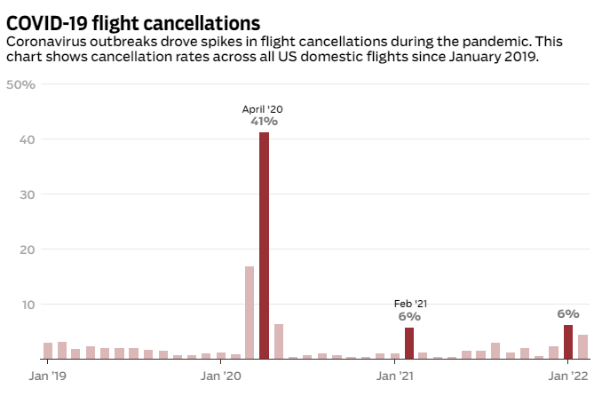

Figure 1: Flight cancellation

(ajc.com, 2022)

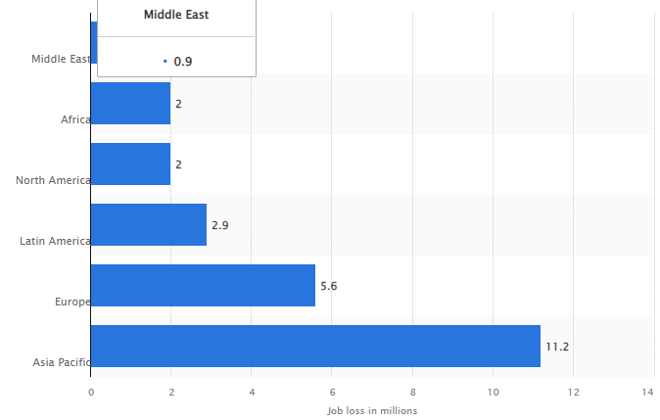

Figure 2: Job loss in airline industry

(Statista, 2022)

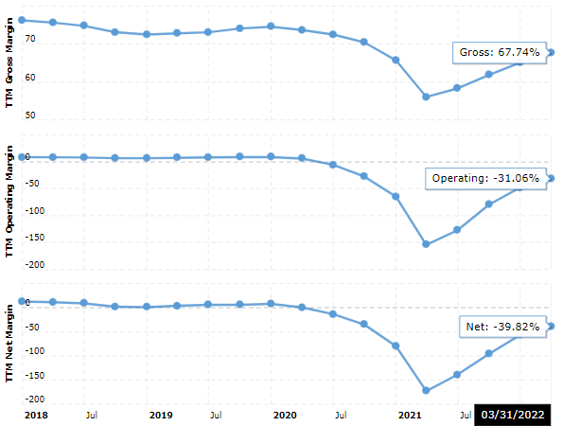

Figure 3: Revenue and income of Air Canada

(Macrotrends.net, 2022)