**Case Study Comparative Analysis – Aritzia and Urban Outfitters**

**I. Company Information and Contact Details**

## a. Aritzia

The business name of Aritzia is Aritzia Inc. and is trading as ATZ (Aritzia Annual Report, 2021). The company is a design house specialising in women's fashion and has an innovative global platform. With a wide range of exceptional brands for every purpose and personal taste, the company is the architect and distributor of Everyday Luxury. Customers worldwide and worldwide may enjoy an immersive and highly customized shopping experience at aritzia.com and our more than 100 shops across the continent (Aritzia Store Locations, 2022). The company was founded in 1984 by Brian Hill in Vancouver, British Columbia (Aritzia About Us, 2022). Aritzia operates in the industry of Fashion, with clothing and accessories as the primary line of business (Aritzia- About Us, 2022). A total of 3480 employees work for the company, and each of Aritzia's shops is unique (Aritzia Annual Report, 2021). Sixty-eight of Aritzia's shops are in Canada, including 5 TNA locations, 8 Wilfred locations, and 4 Babaton locations, as of January 2021. Aritzia has 33 locations in the United States, including a flagship site in Manhattan, New York City, with a 13,000 square foot area (Aritzia Store Locations, 2022).

Company Address: 611 Alexander St Suite, 118 Vancouver, BC, V6A 1E1 Canada,

Phone: (604) 251-3132

## b. Urban Outfitters

The company name of Urban Outfitters is Urban Outfitters, Inc. (URBN) and trading as a public company with the name URBN. The company operates in the industry of retail and is a multinational lifestyle retail corporation (Urban Outfitters Annual Report, 2021). Urban Outfitters has its headquarters in Philadelphia, Pennsylvania, with operations in various countries, including US, UK, Sweden, Denmark, Spain, Germany, Ireland, France, Belgium, Portugal, Italy, Poland, Netherlands, United Arab Emirates, and Canada (Urban Outfitters Annual Report, 2021). Young adults are targeted by Urban Outfitters' goods combination of women's and men's clothing and footwear, sportswear and gear, and housewares. The Urban Outfitters brand also offers music, primarily vinyl records and cassettes. The wholesale component of the corporation creates and manufactures the majority of the items, which are then sold under various private brands. A total of 24,000 employees work for the company as of 2019, and it is located in 248 locations as of 2020 (Urban Outfitters Annual Report, 2021). Various global consumer brands such as Urban Outfitters, Anthropologie, Free People, Menus & Venues, BHLDN, Terrain and Nuuly exist in the portfolio of URBN (Urban Outfitters Annual Report, 2021). The company offers fashion for women and men, including boho dresses, jeans, and graphic tees and accessories like hats and backpacks; beauty products; intimate apparel; swim; and a carefully chosen selection of antique items.

Company Address: 5000 South Broad St, Philadelphia, PA 19112-1495

Phone: 215-454-5500

# II. Company Objectives/Mission/Vision/Philosophy

## a. Aritzia

Its values guide the actions of Aritzia, and these values also help the company unite their employees and put together the tenets of Everyday Luxury. The values of Aritzia are creativity, loyalty, excellence, good judgment, integrity, and teamwork (Aritzia About Us, 2022). The principle of creativity states that the company's core and its actions are defined by creativity. Each member of Aritzia is expected to have loyalty, and the company persistently works towards world-class results for excellence. The company also makes a good judgment as they think smart and trust their integrity to do what is right. Finally, the teamwork principle of the company describes that individually each member of the company is great, but when they work together, the results are exceptional. The company's vision is to become the world's most popular fashion destination for global women. The company believes in fashion that is beautiful and can be made beautiful and inspiring. The company's hallmark service includes delightful personal service along with enthralling communications, aspirational experience, and environment. At Aritzia, this is called Everyday Luxurious (Aritzia Annual Report, 2021).

## b. Urban Outfitters

The mission of Urban Outfitters is to provide consumers with an extraordinary shopping experience by bringing together the best of fashion, art, and design with a profound grasp of global culture (Urban Outfitters Annual Report, 2021). The company's mission statement shows that the company is into developing a connection with the consumer on an emotional level. Therefore, the company developed a lifestyle environment that elicits an emotional response and periodic availability of forwards fashion. To meet this mission, the company focuses on two key components: services and quality that can be easily distinguished and consistently exceeds expectations. Urban Outfitters assures that it only provides its customers with the best brands and the most competitive prices to fulfil the first component's demands. Whether it's for men or women, cosmetics or accessories, or anything else, this company's products are top-notch. The firm goes a step further to ensure customer pleasure by allowing customers to return or replace any item that does not meet their expectations.Urban Outfitters does not yet have a formal vision statement. However, the firm states that it is committed to impressing consumers with a unique blend of product, innovation and cultural knowledge.Customer loyalty, variety, originality, and honesty are the key principles of Urban Outfitters (Urban Outfitters Annual Report, 2021). The company has the industry's best culture as far as corporate cultures go. As a result of the company's basic ideals, Urban Outfitters has grown to be one of the most prominent companies in the fashion industry, with more than 200 locations worldwide.

# III. Company History and Background

## a. Aritzia

70-year-age in Vancouver, Canada, a small department store called “Aritzia” was started by the Hill family. In his hometown's luxury retail complex, Oakridge Centre, Brian Hill built the first independent Aritzia store in 1984 (Aritzia Annual Report, 2021). The guiding principle was offering high-quality clothing in an upscale setting with great customer service. This notion has remained primarily unchanged in the intervening years. Aritzia launched its e-commerce website, aritzia.com, in November of 2012 (Aritzia Annual Report, 2021). In addition, a digital magazine was made available, with articles about artists and photographs of current fashions.Next, on the 3rd of October 2016, Aritzia became a public organization and started trading. Chicago's Rush Street became home to Aritzia's first flagship shop in January 2017.Next, an equity firm, Berkshire Partners, which at that time was the major shareholder of the company, sold its share of the company in 2019. Aritzia announced in June 2021 that it would pay $63 million for the Canadian streetwear company Reigning Champ, which specializes in menswear (Aritzia Annual Report, 2021).Finally, in 2022 the company opened in Overbrook academy with Damiana Corran and Petita Grilla as the founders. Now that Aritzia is a publicly-traded company and a household brand, it continues to provide Everyday Luxury to communities throughout North America and across the world.

## b. Urban Outfitters

Dick Hayne started fashion retail in West Philadelphia, Pennsylvania, in the 1970s and named it Free People. The company's name was changed from Free People to Urban Outfitters as it expanded from one to two locations. Urban Outfitters is a lifestyle company that sells clothes, home decor, and other items for homes and apartments. It primarily focuses on teenagers and young adults interested in the hipster subculture and alternative fashion. In 1993 the company sold shares for $18 in an initial public offering (Urban Outfitters-Our History, 2022). Presently the company is trading under the ticker URBN on the Nasdaq exchange. In 2000 the first web store for Urban Outfitters came online, followed by the web store for Free People in 2004. The Urban Outfitters Corporate Office Campus at the Philadelphia Naval Shipyard earned the National Preservation Honor Award in 2007 from the National Trust for Historic Preservation (Urban Outfitters Our History, 2022).The Vetri Family, a Philadelphia-based restaurant business, was touted as a potential acquisition target by the corporation in late 2015. Acquisition shows retailer's new approach as it tackles dwindling store sales and foot traffic. Pizzeria Vetri, Amis Trattoria, and Bar Amis are all included in this. It's possible to find a Pizzeria Vetri in King of Prussia, PA, as well as in Washington, DC.URBN introduced a new way to experience clothes in July 2019 with the debut of Nuuly. This subscription-based monthly rental service offers a wide range of URBN's brands, third-party labels, and unique vintage items via a custom-built digital platform. With the help of Nuuly, consumers can get their hands on the most up-to-date fashion at a far cheaper cost per wear than retail, allowing them to balance their passion for fashion innovation with their goal to live more sustainably (Urban Outfitters Annual Report, 2021).

# IV. Product List and Description

## a. Aritzia

Aritzia sells women's clothing and trendy accessories under its brand name. Various products of the company include pants, t-shirts,j umpsuits,denim,shorts,blouses, dresses, sweaters,coats,sweatshirts,leggings,jackets,bodysuits,skirts,hats,intimates,socks, face masks, and others (Aritzia Annual Report, 2021). Various brands associated with the company are Babaton,Tna Sweatfleece,Wilfred,Wilfred Free,Tna,The Group Babaton,Denim Forum,Sunday Best,Talula,Main Character,Citizens of Humanity,tkees,Auxiliary, Suicoke,wildflower, andAgolde (Aritzia Annual Report, 2021). However, each company's product is aesthetically independent, sharing key elements of considered detailing, fabrics of high quality, superior fit, and sophisticated construction. Due to the company's multi-brand portfolio and product mix, which caters to a wide range of client demographics and lifestyles, it has been able to build strong and long-lasting customer loyalty. The company's products are sold exclusively through Aritzia.com and the company's store so that they can control the presentation of their brands and customer relationships. To maintain its consistent growth, the business relies on a unique multi-brand approach that gives it control over its goods and allows it to adjust its brand mix to respond to changes in customer demand and fashion preferences.The company's mission is to offer attractive, high-quality items at an affordable price range, and it does so in a way that encourages people to remain loyal to the brand over the long term. The products of the brand are also assorted across each season. Its in-house design teams create goods that thrill and inspire its consumers. Mills, trim suppliers, and manufacturers in Asia and Europe are the primary sources of

raw materials for the vast majority of its products.Additionally, the organisation collaborates with its suppliers throughout the manufacturing process. With this strategy, it can provide its consumers with beautiful, high-quality items at an affordable price while making a profit (Aritzia Annual Report, 2021).

## b. Urban Outfitters

In addition to retail locations, Urban Outfitters sells its goods and services directly to its consumers via its websites, mobile apps, catalogues, customer contact centres, and third-party managed digital enterprises.The majority of the company goods are only available at Urban Outfitters and include a mix of in-house items and those created in partnership with third parties. Products that are sold under the brand name of Urban Outfitters include fashion apparel for men and women, electric merchandise, intimates, accessories, electronics activewear, beauty, home products, and footwear (Urban Outfitters Annual Report, 2021). The Anthropologie Group also has extended format shops that incorporate numerous Anthropologie Group brands, allowing a greater variety of items.The Anthropologie Group of the company consists of the brands; Anthropologie, Bhldn and Terrain. Products offered by the Anthropologie brand include accessories, women's casual apparel, shoes, intimates, a wide selection of gifts and home decor, home furnishings, and beauty and wellness. The products of the Bhldn brand of the company include heirloom-quality wedding gowns, party dresses, bridesmaid frocks, headpieces, assorted jewellery, lingerie, decorations, and footwear. The products associated with the Terrain brand are garden and outdoor living products, flowers, live plants, accessories, antiques, lifestyle homes, wellness products. Other brands associated with the company are Free People, FP Movement, Nuuly, and The Menus & Venues. Products sold under the brand name Free People are casual apparel for women with a unique mix of merchandise, FP Movement activewear, intimates, accessories, shoes, beauty and wellness, gifts, and product for the home. From gym basics to essentials for everyday life, the FP Movement brand has everything one needs to keep one’s body and mind in peak condition.Using the Nuuly brand, customers may rent women's clothing from a wide variety of our own and third-party brands and unique antique items.In addition, the concept of casual dining is included under The Menus & Venues brand (Urban Outfitters Annual Report, 2021).

# V. Product Analysis and Comparison (Last 3 years)

The information gathered in the above section about the products of Aritzia and Urban Outfitters shows that the major products offered by both the brands are similar, that is, fashion products. However, the product category of Urban Outfittersis vast compared to Aritzia. The product category offering of Urban Outfitters is mainly due to its penetration into the retail market. The company sells various products, including apparel, beauty and welling, electronics, garden and outdoor living antiques, etc. In addition to this, Urban Outfitters also offers product renting for their customers. The recent adoption in the company's product category is casual dining, which is sold under the brand name of The Menus & Venues. Further, Urban Outfitters also sells the products of third-party brands along with their brands. Therefore, it can be said that the company acquires customers from the various product offering. On the other hand, Aritzia focuses on sales of products only in women's clothing and accessories. Like Urban Outfitters, the company owns a variety of brands that are aesthetically independent but share the same key elements. The key elements in the products of Aritzia are: considered detailing, fabrics of high quality, superior fit, and sophisticated construction. No such specific key elements linking the products of Urban Outfitters were discovered. Similar to Urban Outfitters, Aritzia has its stores with the help they control the quality of customer service. However, unlike Urban Outfitters, the company does not sell third-party brands. The focus of Aritzia, unlike Urban Outfitters, which is focused on product assortment, is on the development of beautiful products of high quality but affordable and generates profits for the company. Since the products in the fashion industry change at a fast rate, the success of Aritzia depends on its product innovation which is continually developing prospects. Urban Outfitters and Aritzia both understand the wide diversity of their customer base and develop or differentiate products that serve the diverse customer base.

# VI. Market Profile

## a. Aritzia

The essential creative concepts that convey the core beliefs of Aritzia are articulated using of holistic marketing strategy. This strategy has a significant influence on raising Aritzia's visibility and affinity in current and new market segments, such as North America and the rest of the world. The company can effectively target its marketing efforts to promote top store productivity and traffic. The firm believes that its premium real estate presence serves as an effective marketing tool at Aritzia as the company occupies great real estate in high-traffic retail malls and main thoroughfares. The company's placement is precisely where most of its customer's shop and in the regions with high brand visibility. The aspirational image of the company's brand is visible in its store design, windows, signage, customer service, packaging, and in-store displays. To grow and preserve our client base, we devote our marketing efforts to relationship building operations. Customer segmentation, direct marketing, and highly personalized customer interactions are possible because of our extensive database. The company has extended its in-store experience across many channels, including e-commerce and social media, when it comes to online marketing. With the encouragement of user-generated material on aritzia.com, a strong resonance is generated between the company and its customers (Aritzia Annual Report, 2021).

The primary in-store market of Aritzia is in Canada and the US, with 65 stores in Canada and 22 in the US. Aritzia mainly serves the female market segment in these two markets. However, with the help of its e-commerce, the company has turned its focus toward the internal market to acquire the internal fashion market share (Aritzia Annual Report, 2021).

## b. Urban Outfitters

Websites, mobile apps, catalogues, email campaigns, and social media presence are all considered very successful marketing strategies of Urban Outfitters. The company's marketing strategies are updated daily to reflect the most recent fashion and cultural trends. The company's customers are inspired to explore the channels of the firm and make purchases because ofextensive product offerings,prominent store locations, and creative and visually appealing presentation of the products on the websites and the mobile apps. Therefore, the company's dependency is on direct marketing strategies rather than conventional advertising methods. Consequently, Special event promotions and a wide array of public relations activities promote the brand's retail outlets and goods in each location. Urban Outfitters also has a presence on social media and its blog. Through the company’s blogs, they not only express what motivates them but also hear from their customers. This helps them build stronger ties with our clients and keeps them coming back for more (Urban Outfitters Annual Report, 2021).

The main target market of Urban Outfitters is the young adults within the age group of 18 to 28 years, having sophisticated culture, active peer group engagement, and are self-expressive. The main markets of Urban Outfitters are the US, Canada, Europe, and United Arab Emirates. 174 stores are located in the United States, 17 in Canada, and 56 in Europe as of January 31, 2021. In the United Arab Emirates, the company owns a franchisee-owned store. The company's future growth plans include international and national market expansion using the strategies of joint ventures and franchises (Urban Outfitters Annual Report, 2021).

Each product category of the company serves different markets. The Bhldn brand serves the niche market of wedding requirements. The Terrain brand appeals to a customer interested in gardening and outdoor living. Free People and FP Movement retail stores target customers of the 25 to 30 age group. The Menus & Venues focused on the dining experience (Urban Outfitters Annual Report, 2021).

# VII. Market Analysis and Comparison (last 3 years)

The main target market of both Aritzia and Urban Outfitters is Canada and US. However, Urban Outfitters serves other markets, such as Europe and the United Arab Emirates. This shows that the market expansion of Urban Outfitters is higher than Aritzia. Furthermore, the target market segment of Aritzia is only the female segment of its target markets. However, Urban Outfitters carters to a higher market segment which consists of both male and female customers. In addition to this, Urban Outfitters' every brand targets a specific market segment. The Bhldn brand serves the niche market of wedding requirements; the Terrain brand appeals to a customer interested in gardening and outdoor living. Free People and FP Movement retail stores target customers in the 25 to 30 age group. The Menus & Venues focused on the dining experience.

The company's marketing strategy is also different, whereas Urban Outfitters focuses on conventional marketing strategies of direct marketing, and Aritzia focuses on customer experience, store design, and environment. Both the brands use high brand visibility locations for their stores and focus on developing customer relationships. The market expansion strategy adopted by Aritzia is the use of a website to gain international customers. On the other hand, the market expansion strategy of Urban Outfitters includes joint ventures and franchises.

# VIII. Organizational Structure and Leadership

## a. Aritzia

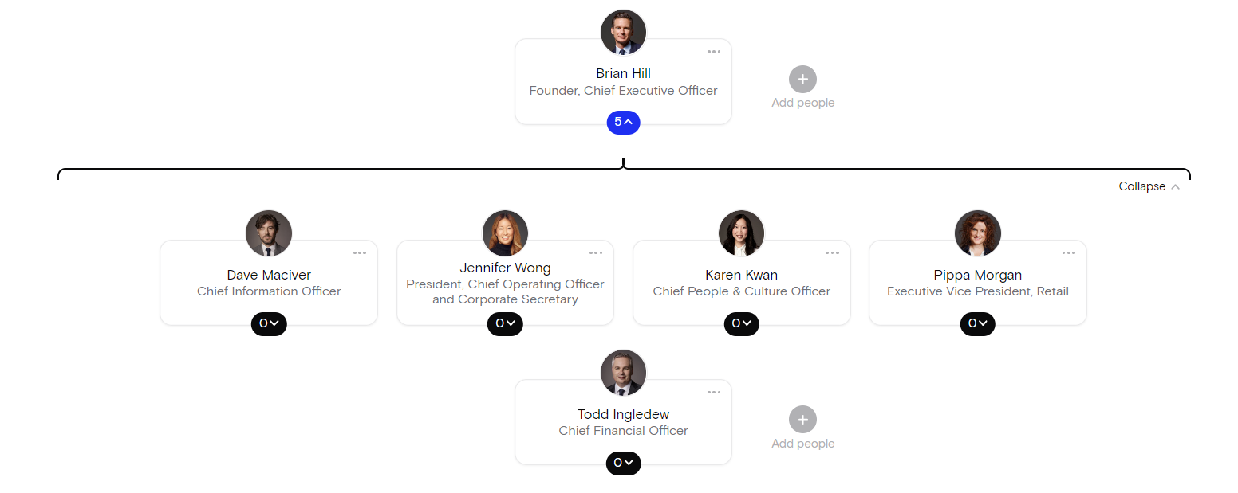

**Figure 1: Organizational Structure of Aritzia**

**Source: Aritzia - Org chart (2022)**

## b. Urban Outfitters

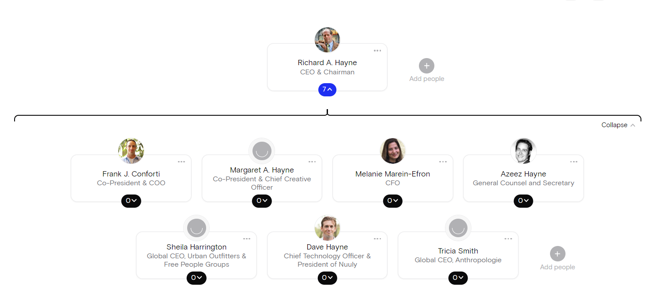

**Figure 2: Organizational Structure of Urban Outfitters**

**Source: URBN - Org chart (2022)**

# IX. Financial Status

## a. Aritzia

The income statement of Aritzia (in table 1, appendix) shows that the total revenue grew at the rate of 12.16% from 2019 to 2020; however, in 2021, the company growth declined at the rate of 12.57%. The company's net income also shows similar growth and decline, which is in 2020, it grew by 15.07%, whereas in 2021, the net income declined at the rate of 78.78%. Further, the balance sheet (table 2 in appendix) shows that the total current assets of Aritzia decreased by 1.9% in 2020, whereas in 2021, it grew by 53.58%. Observing the growth in total assets of the company shows a growth of 64.72% in 2020 whereas 10.03% growth in 2021. The company's balance sheet also shows that the company's total liabilities in 2020 grew by 176.26% and 10.76% in 2021. Table 3 (in the appendix) shows that the number of outstanding shares of Aritzia in 2020 declined by 4.07%, whereas in 2021, it grew by 0.99%. Finally, the company's EPS in 2020 grew by 20%, whereas in 2021 declined by 78.57%.

## b. Urban Outfitters

The income statement of Urban Outfitters (in table 4, appendix) shows that the total revenue grew at 0.84% from 2019 to 2020; however, in 2021, the company growth declined at the rate of 13.40%. The company's net income also shows in both 2020 and 2021. The company observed a decline in 2020, a decline of 43.59%, and in 2021, 99.26%. Further, the balance sheet (table 5 in appendix) shows that the total current assets of Urban Outfitters decreased by 12.42% in 2020, whereas in 2021, it grew by 16.13%. Observing the growth in total assets of the company shows a growth of 53.46% in 2020 whereas 6.96% growth in 2021. The company's balance sheet also shows that the company's total liabilities in 2020 grew by 177.07% and 11.22% in 2021. Table 6 (in the appendix) shows that the number of outstanding shares of Urban Outfitters in 2020 declined by 7.82%, also a decline of 2.02% in 2021. Finally, the company's EPS in 2020 also declined by 38.91% and in 2021 declined by 99.40%.

# X. Financial Analysis and Comparison (last 3 years)

The comparison of the financial analysis of the two companies is shown in figures 3and 4 (in appendix). Figure 3 shows that despite the low revenue growth percentage of Urban Outfitters than Aritzia, the amount of growth in Urban Outfitters' revenue is significantly higher than Aritzia. Additionally, figure 3 also shows that the net income earnings of Urban Outfitters are significantly higher than Aritzia from 2019 and 2020. Still, for 2021 the amount of net income earnings of Urban Outfitters is low compared to Aritzia.

Figure 4 shows that the total assets of Urban Outfitters are significantly higher than Aritzia for all three years, 2019, 2020, and 2021, despite the low growth percentage. Finally, from figure 4, it is also observed that the EPS of Urban Outfitters in 2019 is significantly higher than that of Aritzia in 2020; however, in 2021, the EPS of Urban Outfitters is less Aritzia.

# XI. Company Milestone and Latest News

## a. Aritzia

The latest news of Aritzia is as follows:

* From 2016 to 2020, growth of more than 36% to 88% in the financial year 2021 of CAGR e-commerce revenue (Aritzia Annual Report, 2021).
* From 23% e-commerce penetration in 2020 to 50% penetration in the financial year 2021 (Aritzia Annual Report, 2021).

## b. Urban Outfitters

The milestones of growth in Urban Outfitters are as follows:

🡪1970: In Philadelphia, Pennsylvania, the first Urban Outfitters store; 🡪1984: Establishment of Free People Wholesale; 🡪1992: In Wayne, Pennsylvania, first Anthropologie store; 🡪1993: Initial Public share offering on NASDAQ; 🡪1998: Launch of Anthropologie website and first store in London; 🡪1999: Launched of Urban Outfitters website; 🡪2002: In Paramus, New Jersey first Free People store; 🡪2004: Launch of Free People website; 🡪2008: In Glen Mills, Pennsylvania first Terrain garden; 🡪2009: In London first Anthropologie store; 🡪2011: In Houston, Texas first Bhldn store; 🡪2016: In Philadelphia, Pennsylvania acquisition of Vetri Family restaurants; 🡪2018: Establishment of Urban Outfitters Wholesale and first European Free People store; 🡪2019: Subscription rental service, Nuuly was launched; 🡪2020: In Los Angeles first FP Movement store (Urban Outfitters Annual Report, 2021)

# XII Conclusion

This report provides detailed information and a comparison of two fashion brands, Aritzia and Urban Outfitters. The comparison of the two companies shows that Urban Outfitter is much larger in stature than Aritzia as the products category and market of Urban Outfitter are highly assorted and expanded, respectively. The financials also show that Urban Outfitters' position is higher than Aritzia's; however, the performance of Aritzia is better than Urban Outfitters. In addition to all these differences, the industries of both the companies are also different as Urban Outfitters operates in the retail industry, but Aritzia operates in the Fashion industry. Moreover, both the companies are public trading companies and focus mainly on apparel.

# Reference List

Aritzia - Org chart | The Org. (2022). Retrieved 2 April 2022, from <https://theorg.com/org/aritzia/org-chart>

Aritzia About Us | Aritzia INTL. (2022). Retrieved 2 April 2022, from https://www.aritzia.com/intl/en/aritzia/about-aritzia/about-us.html

Aritzia Annual Report (2020). Retrieved 2 April 2022, from <https://s21.q4cdn.com/489771965/files/doc_financials/2020/ar/Aritzia_Annual_Report_2020_Final.pdf>

Aritzia Annual Report (2021). Retrieved 2 April 2022, from <https://s21.q4cdn.com/489771965/files/doc_financials/2021/ar/Aritzia_Annual_Report_2021_FINAL-(web).pdf>

Aritzia Store Locations | Aritzia INTL. (2022). Retrieved 2 April 2022, from <https://www.aritzia.com/intl/en/store-locator>

Urban Outfitters Annual Report (2020). Retrieved 2 April 2022, from <https://urbanoutfittersinc.gcs-web.com/static-files/5404ac0c-c3c2-4f68-b589-6c0da6622f43>

Urban Outfitters Annual Report (2021). Retrieved 2 April 2022, from <https://urbanoutfittersinc.gcs-web.com/static-files/a90c74c5-198d-4509-af6f-ee9554266c88>

Urban Outfitters Our History (2022). Retrieved 2 April 2022, from<https://www.urbn.com/who-we-are/history>

URBN - Org chart | The Org. (2022). Retrieved 2 April 2022, from <https://theorg.com/org/urbn/org-chart>

# Appendix

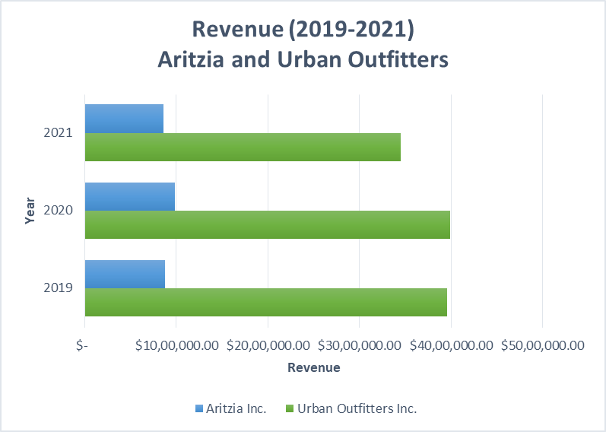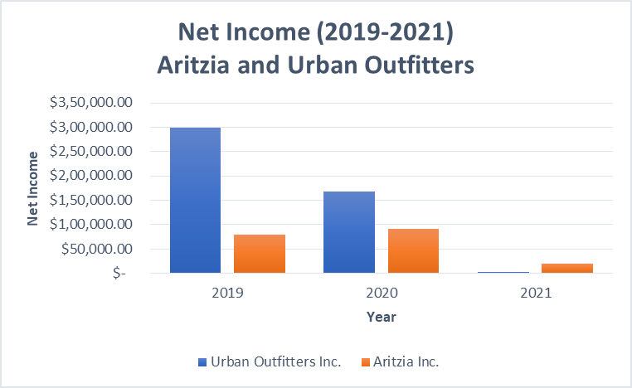

**Figure 3: Revenue and Net Income Comparison**

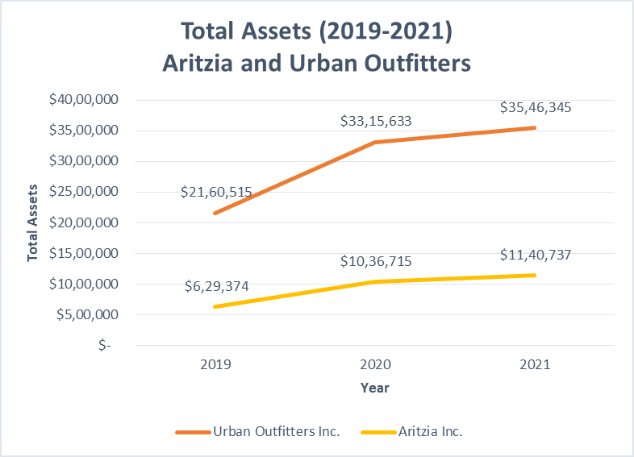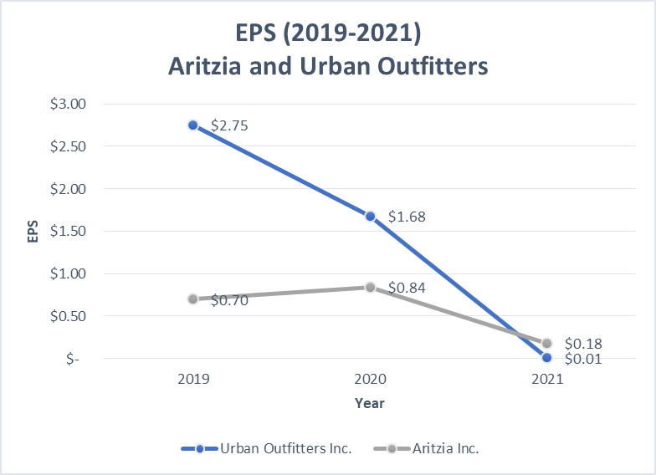

**Figure 4: Total Assets and EPS Comparison**

**Table 1: Aritzia Income Statement**

|  |  |  |  |  |  |
| --- | --- | --- | --- | --- | --- |
| ***(In thousands of Canadian dollars)*** |  |  |  |  |  |
| **INCOME STATEMENT INFORMATION** | **2019** | **Growth in 2020** | **2020** | **Growth in 2021** | **2021** |
| Total Revenue | $ 8,74,296 | 12.158% | $ 9,80,589 | -12.571% | $ 8,57,323 |
| Cost of Goods Sold | $ 5,31,383 | 8.616% | $ 5,77,165 | -5.604% | $ 5,44,818 |
| Gross Profit | $ 3,42,913 | 17.646% | $ 4,03,424 | -22.537% | $ 3,12,505 |
| Total Operating Expenses | $ 2,15,297 | 13.035% | $ 2,43,362 | 3.026% | $ 2,50,726 |
| Interest Expense | $ 4,821 | 487.409% | $ 28,319 | 0.357% | $ 28,420 |
| Income Tax Expense | $ 32,922 | 7.964% | $ 35,544 | -80.376% | $ 6,975 |
| Net Income | $ 78,728 | 15.072% | $ 90,594 | -78.777% | $ 19,227 |

**(Source: Aritzia Annual Report 2021, 2020)**

**Table 2: Aritzia Balance Sheet**

|  |  |  |  |  |  |
| --- | --- | --- | --- | --- | --- |
| ***(In thousands of Canadian dollars)*** |  |  |  |  |  |
| **BALANCE SHEET INFORMATION** | **2019** | **Growth in 2020** | **2020** | **Growth in 2021** | **2021** |
| Total Current Assets | $ 2,35,857 | -1.900% | $ 2,31,376 | 53.577% | $ 3,55,341 |
| Total Property, Plant, and Equipment | $ 1,67,593 | 10.170% | $ 1,84,637 | 2.671% | $ 1,89,568 |
| Total Assets | $ 6,29,374 | 64.722% | $ 10,36,715 | 10.034% | $ 11,40,737 |
| Total Current Liabilities | $ 90,611 | 69.784% | $ 1,53,843 | 61.980% | $ 2,49,195 |
| Total Non-Current Liabilities | $ 1,64,454 | 234.931% | $ 5,50,807 | -3.545% | $ 5,31,279 |
| Total Liabilities | $ 2,55,065 | 176.263% | $ 7,04,650 | 10.761% | $ 7,80,474 |
| Total Stockholders' Equity | $ 3,74,309 | -11.286% | $ 3,32,065 | 8.492% | $ 3,60,263 |
| Total Liabilities and Stockholders' Equity | $ 6,29,374 | 64.722% | $ 10,36,715 | 10.034% | $ 11,40,737 |

**(Source: Aritzia Annual Report 2021, 2020)**

**Table 3: Aritzia Statement of Equity**

|  |  |  |  |  |  |
| --- | --- | --- | --- | --- | --- |
| ***(In thousands of Canadian dollars and units)*** | **2019** | **Growth in 2020** | **2020** | **Growth in 2021** | **2021** |
| Number of Shares Outstanding | 1,13,015 | -4.074% | 1,08,411 | 0.993% | 1,09,487 |
| EPS | $ 0.70 | 20.000% | $ 0.84 | -78.571% | $ 0.18 |

**(Source: Aritzia Annual Report 2021, 2020)**

**Table 4: Urban Outfitters Income Statement**

|  |  |  |  |  |  |
| --- | --- | --- | --- | --- | --- |
| ***(In thousands of Canadian dollars)*** |  |  |  |  |  |
| **INCOME STATEMENT INFORMATION** | **2019** | **Growth in 2020** | **2020** | **Growth in 2021** | **2021** |
| Total Revenue | $ 39,50,623.00 | 0.840% | $ 39,83,789.00 | -13.405% | $ 34,49,749.00 |
| Cost of Goods Sold | $ 26,00,367.00 | 4.960% | $ 27,29,352.00 | -5.752% | $ 25,72,347.00 |
| Gross Profit | $ 13,46,712.00 | -7.937% | $ 12,39,826.00 | -30.482% | $ 8,61,906.00 |
| Total Operating Expenses | $ 9,65,399.00 | 2.962% | $ 9,93,990.00 | -13.688% | $ 8,57,934.00 |
| Interest Expense | $ 1,751.00 | -31.354% | $ 1,202.00 | 183.278% | $ 3,405.00 |
| Income Tax Expense | $ 87,550.00 | -18.191% | $ 71,624.00 | -96.821% | $ 2,277.00 |
| Net Income | $ 2,98,003.00 | -43.593% | $ 1,68,096.00 | -99.265% | $ 1,236.00 |

**(Source: Urban Outfitters Annual Report 2021, 2020)**

**Table 5: Urban Outfitter Balance Sheet**

|  |  |  |  |  |  |
| --- | --- | --- | --- | --- | --- |
| ***(In thousands of Canadian dollars)*** |  |  |  |  |  |
| **BALANCE SHEET INFORMATION** | **2019** | **Growth in 2020** | **2020** | **Growth in 2021** | **2021** |
| Total Current Assets | $ 12,02,755 | -12.418% | $ 10,53,396 | 16.132% | $ 12,23,332 |
| Total Property, Plant, and Equipment | $ 7,96,029 | 11.809% | $ 8,90,032 | 8.695% | $ 9,67,422 |
| Total Assets | $ 21,60,515 | 53.465% | $ 33,15,633 | 6.958% | $ 35,46,345 |
| Total Current Liabilities | $ 3,86,644 | 65.209% | $ 6,38,770 | 41.856% | $ 9,06,132 |
| Total Non-Current Liabilities | $ 2,84,773 | 328.941% | $ 12,21,508 | -4.802% | $ 11,62,855 |
| Total Liabilities | $ 6,71,417 | 177.067% | $ 18,60,278 | 11.219% | $ 20,68,987 |
| Total Stockholders' Equity | $ 14,89,098 | -2.266% | $ 14,55,355 | 1.512% | $ 14,77,358 |
| Total Liabilities and Stockholders' Equity | $ 21,60,515 | 53.465% | $ 33,15,633 | 6.958% | $ 35,46,345 |

**(Source: Urban Outfitters Annual Report 2021, 2020)**

**Table 6: Urban Outfitters Statement of Equity**

|  |  |  |  |  |  |
| --- | --- | --- | --- | --- | --- |
| ***(In thousands of Canadian dollars and units)*** | **2019** | **Growth in 2020** | **2020** | **Growth in 2021** | **2021** |
| Number of Shares Outstanding | 10,83,03,594 | -7.821% | 9,98,33,011 | -2.019% | 9,78,17,651 |
| EPS | $ 2.75 | -38.909% | $ 1.68 | -99.405% | $ 0.01 |

**(Source: Urban Outfitters Annual Report 2021, 2020)**