**The Origin of Life**

**Introduction**

# ‘Origin of life’ is a phrase which has been used to talk about the evolutionary process which had has occurred on the surface of the earth over the course of time and has resulted in the vast variety of life forms available today. The basic concept behind the origin is that there must have been some come origin of life which has later diversified into various life forms we observe today (Pross & Pascal, 2013). Various theories have suggested how the origin of life had begun on earth**.**

# **Early Theories**

One of the earliest theories about the origin of life believes that it is the lightning that had happened on the earth’s surface and may have then has generated some form of electric sparked energy which has resulted in the production of the earliest amino acids and sugar in the environment (Choi, 2011). To support this, it was suggested that the environment already has the ingredients needed for the production of simpler organic molecules such as methane, ammonia, and hydrogen gases in the atmosphere (Choi, 2011). This lightning theory was supported by the famous scientist’s duo Miller and Urey who experimented in 1952. They created an artificial system similar to primitive earth and used electric sparks which resulted in the formation of simpler amino acids that could combine and give rise to bigger complex biomolecules (Ferus *et al.,* 2017).

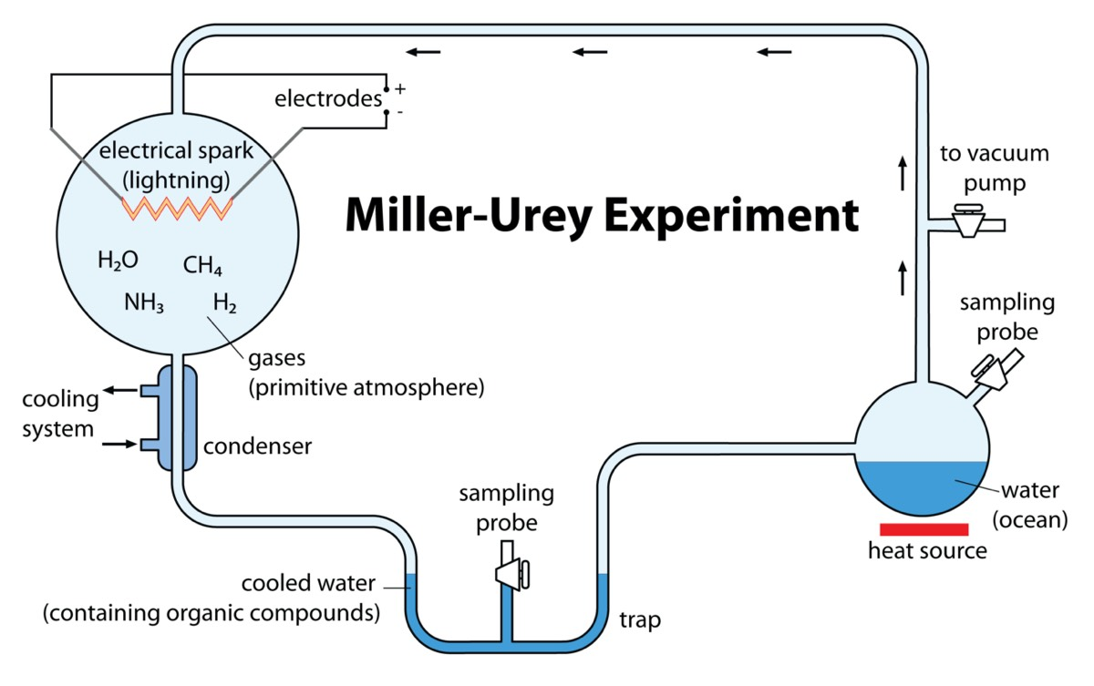

Figure: - Miller-Urey’s experiment, showing how lightening could have started life on earth.

Source: - (Ouellette, 2021).

Another theory believes that the earth must have been covered with ice on its surface and the important molecules which are necessary to initiate the life must have been stabilized in the lower temperature (Mcnally, 2021). This hypothesis argues that the organic molecules for example amino acids, sugars, etc. are present in scattered form in the lower temperature but then get clumped or accumulate into the complex organization in the lower temperature. These concentrated complex organic molecules then must have given rise to life by further multiplication or replication (Mcnally, 2021). This theory is also supported by the fact that the ice must have protected the complex organic molecules from UV lights and other harmful radiations which may result in their destruction. It is also suspected that ice must have also facilitated in speeding up many reactions by providing the suitable lower temperature and also helped in maintaining their configuration (Yong, 2010).

While one theory suggests that it’s the cold temperature due to ice that must have initiated the process of origin, the other believes it’s the deep-sea vent and the high temperature inside the deep sea that must have initiated the process of origin of life on earth. The deep-sea vent hypothesis argues that the high-temperature water which is present in the deep of the sea must have rapidly expelled some crucial elements such as carbon, hydrogen, etc. which must have then combined and given rise to numerous biomolecules initiating the origin of life (Choi, 2011). The ducts present in the deep sea erupt fluid which is hot due to its movement via the earth’s crust from the core. The fluid must have accumulated various minerals and gases during its journey from the core via crust and eventually came out with carbon and hydrogen (Ghose, 2013). The hydrogen and carbon must have been there in the rocky core of the earth and along with it, some catalytic compounds must have been present as well that had worked in speeding up the chemical reactions and had helped information of various complex biomolecules (Ghose, 2013).

The theory of spontaneous generation talks about the interaction between the non-living entities which have given rise to the living bodies (lkouniv, 2022). This theory argues that at some stage some interactions between the non-living articles such as clay, mud, straw, etc. may have given rise to living organisms due to their association with the prebiotic molecules (lkouniv, 2022). This must-have happened under the primitive earth conditions and the conditions that evolved on earth, the organisms formed also get evolved in various aspects with time. Although there are various experiments performed which have disapproved the theory of spontaneous generation. Louis Pasteur did the famous broth experiment and proved that life comes from pre-existing life and not from any interaction between non-living and prebiotic molecules (lkouniv, 2022).

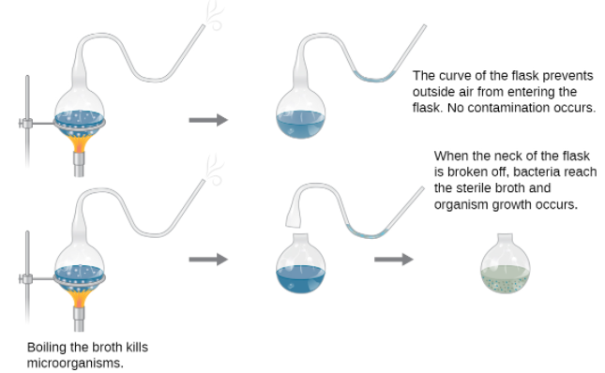

Figure: - Louis Pasteur’s experiment.

Source: - (Pasteur Brewing, 2022).

Oparin and Haldane gave the theory named biochemical theory which is considered as the first chemical theory towards the origin of life. According to this theory, there must be a cascade of chemical reactions that must have given rise to complex molecules (Tirard, 2017). The evolution in biochemical theory can be divided into three parts. First, the simpler chemical reactions must have given rise to simpler inorganic molecules. These simpler inorganic molecules must have combined to form the first simpler organic molecules. These organic molecules must have been reacted in the last part of a cascade of chemical reactions and must have resulted in the formation of complex organic molecules (Tirard, 2017). These complex organic molecules must have then undergone division and rounds of self-replications and have populated the earth. The theory argued that there must be some common gases already present in the earth which must have been combined initially to form the first simpler inorganic compounds. The complex organic molecules formed in the end must have differentiated themselves from the surrounding environment and have gained some features of the living organisms which have then reproduced further (lkouniv, 2022). 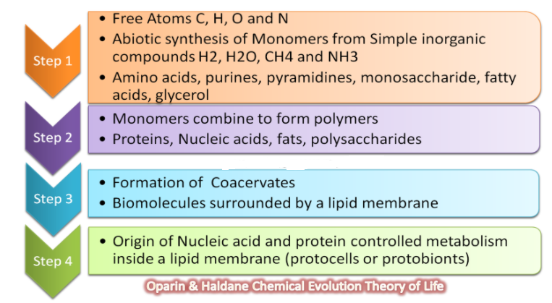

Figure: - Steps of Chemical Theory given by Oparin and Haldane.

Source: - (Biology Exams 4 U, 2022).

The genetic material stores all the necessary information needed to make proteins and thus survive. DNA and RNA are two types of nucleic acids which act as genetic materials. In today’s world DNA is the prominent genetic material but, in many organisms, RNA also acts as genetic material. The RNA world theory is a hypothesis that suggests that it must be the RNA that must have formed initially by the cascade of chemical reactions (Bernhardt, 2012). The RNA has the property of self-replication and has simpler requirements as compared to DNA which suggests the survival of the RNA. With time, as the conditions become favorable, the RNA must have been modified into DNA which has been adapted well by the organisms (Neveu et al., 2013). Thus, the catalytic property and the self-replicating nature of the RNA suggest that the first life on earth must have been based upon the RNA instead of DNA (Neveu et al., 2013).

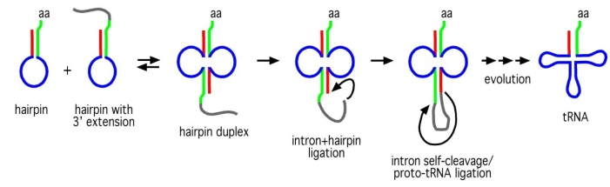

Figure: - A proposal for the origin of tRNA through the ligation of a hairpin duplex catalyzed by an ancestral self-splicing group I-type intron.

Source: - (Bernhardt, 2012).

# **Recent Theories**

**Some recent theories which talk about the origin of life are-**

## ***Iron- Sulphide Theory***

The Iron-sulphide theory is one of the recent theories proposed by William Martin, of Heinrich-Heine University in Dusseldorf, Germany, and Michael Russell of the Scottish Universities Environmental Research Centre in Glasgow, UK (Whitfield, 2002). The theory believes that the ocean floor has deposits of minerals (iron sulfide) which is the ideal place for life to begin. Iron sulfide acts as a bio-catalyst that functions to join the inorganic molecules converting them into organic molecules (Whitfield, 2002). Recent pieces of evidence suggest that some bacteria still use the organic molecules formed by the inorganic molecules by the action of iron sulfide. The hot water in the springs flows down into the ocean floor which is enriched with raw materials such as carbon monoxide and ammonia resulting in the formation of organic molecules which work as fuel for micro-organisms (Whitfield, 2002). It is suggested that the molecules formed by the iron sulfide could join further to form complex molecules such as proteins and genetic materials which then have two fates. They could either diffuse off into the ocean or could diffuse inside the cell and work as genetic or other bio-molecules (Whitfield, 2002). The main drawback of this theory is raised by biochemist Pier Luigi Luisi of the Federal Institute of Technology in Zurich, Switzerland who raised a question about the origin of iron-sulfide molecules (Whitfield, 2002). It is believed that the iron-sulfide bed could be the suitable fertile environment for the micro-organism to live and grow but no theory and evidence could argue where, why, and how this bio-catalyst has emerged or originated (Whitfield, 2002).

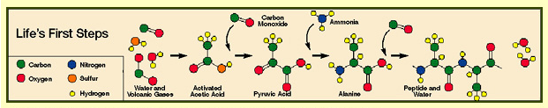

Figure: - A proposal for the combination of molecules resulting in simpler biomolecular compounds.

Source: - (Ellis, 2001).

## ***Protobiology view***

This protobiology view is one of the recent views which suggest the importance of non-canonical amphiphiles (Lancet et al., 2018). This view suggests that the assemblies of non-canonical and heterogeneous amphiphiles were the initial replicator molecules that must have been replicated. The fission of such replicated molecules would have resulted in cell-like reproduction (Lancet et al., 2018). The graded autocatalysis replication domain (GARD) model supports the view which has the basis that the replication or reproduction of the information stored in the amphiphile molecules is similar to the sequence information (Kahana& Lancet, 2019). It is argued by the graded autocatalysis replication domain (GARD) model that the non-equilibrium assemblies of the amphiphiles exhibit catalysis-based homeostatic growth which has been followed by the occasional fission. The evolution of the graded autocatalysis replication domain (GARD) pre- RNA is supported by the selection of various composers due to several simultaneous chemical changes in a small suitable ecosystem which also denies the claims that graded autocatalysis replication domain (GARD) assemblies cannot evolve(Kahana& Lancet, 2019). Present-day genotype and respective phenotype which are two separate yet related domains are represented by the composers in protobiology. These composers behave as the dissipative system which is one of the major characteristics of life. This is backed by the fact that the amphiphile molecules exhibit transition from random associations to self-organized composers which have a negative change in the entropy (Lancet et al., 2018). The revised graded autocatalysis replication domain (GARD) model is known as metabolic GARD (M-GARD). In this model, the lipid covalent changes are made by the action of different lipid catalysts which are non-enzymatic (Markovitch, &Lancet, 2012). The modified model fills the missing spaces suggesting true metabolism in the basic GARD model which is supported by the lipid-based mutually catalytic network. The M-GARD model is criticized as it quantitatively shows the protocells with the systematic reproduction of lipid bilayer and the inner cell lumen contents (Lancet et al., 2018). The GARD analysis has suggested the probability of the origin of life in the context of the planet(Markovitch& Lancet, 2012). The other features of the graded autocatalysis replication domain (GARD) model have also suggested and argued the shift to the protobiology view of the origin of life and thus suggested a shift from the conventional theories (Lancet et al., 2018).

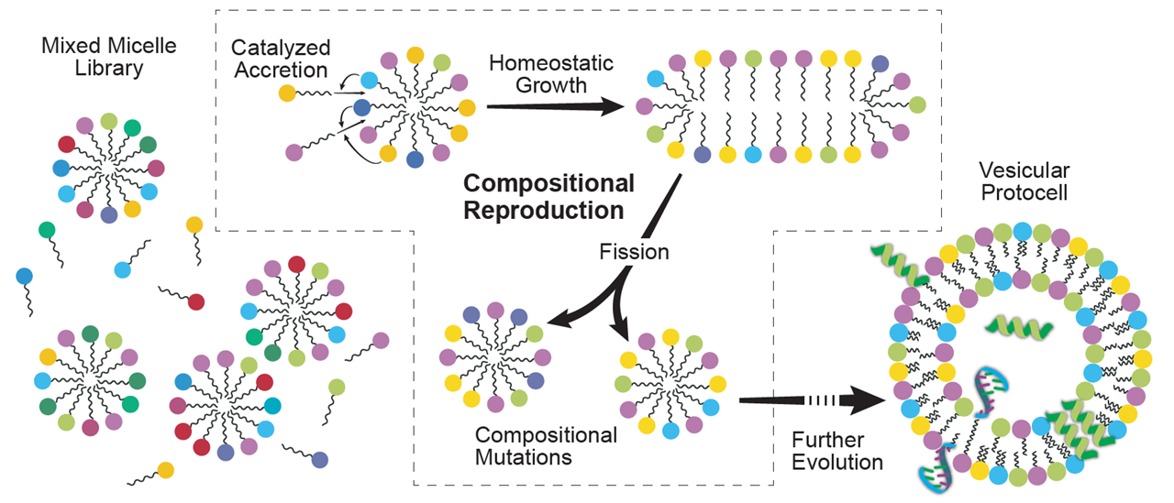

**Figure: - Protbiology view**

**Source: - (**Weizamnn Institute of Science, 2022).

## ***Mica Hypothesis***

The Mica hypothesis is one of the recent hypotheses about the origin of life which talks about the prebiotic organisms. The space between the mica sheets is a suitable favorable environment that can form and grow in that compartment (Hansma, 2013). This type of environment is not provided by the surface of the ground, in clays, on the surface of ponds, or inside the vesicles. It has been assumed that these protobiotic organisms must have been covered by the membrane made of lipids which are stable on mica when present under some aqueous fluid or between the two mica sheets as well (Hansma, 2013). The formation of compartments is necessary for the initiation of the cell cycle and to start the speciation process. It is also suggested that the initial process of the first division of protocells would have started with the action of some inorganic catalyzing factors. These factors could also be the porous surface of mica (Hansma, 2013). Some have even argued after reaching a typical concentration the content would encapsulate. Mica’s hypothesis suggests that the division of protocells would have started due to the action of pressure built by the moving mica sheets. Mica is also thought to be the original compound for the cell wall which is maybe found around bacteria such as archaea and in plant cells as well (National Science Foundation, 2010).

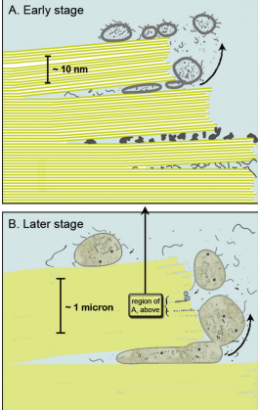

Figure: - Origin of life between mica sheets.

Source:- (Hansma, 2010).

The environment between the mica sheets shows various similarities between the characters. The nanometer-thickened sheets of mica are similar to the cell walls. The mica sheets act as the hydrophilic surfaces which are due to the bilayer of lipid (Hansma, 2009). The space between the sheets has resulted in reduced entropy as well and the surface of the sheets is anionic (Hansma, 2013). The placement of mica sheets close to each other is a probable reason for the compartmentalization and the possible reason behind the starting of life. The water in clay is not controlled as they swell or shirk when they met with wet and dry conditions respectively but in the mica sheets, the water ratio is controlled (Hansma, 2013). The anionic sheets of muscovite mica’s sheet are rich in K+ which helps in bridging the sheets and thus holding the sheets together with dimensions of one K+ per 0.5 nm on the hexagonal lattices of pairs of mica sheets (Hansma, 2013). This theory talks about the origin of K+ ions which is one of the important features of this hypothesis. This theory calls enzymes or any other bio-catalyst or biomolecules molecular machines (Hansma, 2013). These machines as the name suggest do all the mechanical work. For example, the enzyme lysozyme is said to have a hinge-like motion around the space between the sheets. The hypothesis believes that mechanical energy was the initial main source of energy which must have driven the origin of life (Hansma, 2013). This mechanical energy got replaced by chemical energy throughout evolution which has worked in giving the motion and helped in the action of enzymes and activating other biomolecules and thus must have resulted in a decrease in the availability of the mechanical energy (Hansma, 2009). Thus, it is suspected that the life must have been originated between the mica sheets due to the action of mechanical energy and movement of sheets but as the space between sheets get filled or occupied with protobiotic organisms, the chemical energy starts developing more and more which have then driven the further actions of enzymes resulting in further movements, therefore, the hypothesis suggesting that the origin of life must have begun between the sheets of muscovite mica (Hansma, 2013).

## ***Meteorites as the Source for the Origin of Life***

The third theory, which is also supported by the research person at NASA, suggests that meteorites may have added in the synthesis of prebiotic molecules such as RNA (Sousa, 2021). A team of researchers has found sugars in meteorites that make up the important constituent of biomolecules for the organism. The finding of the sugars in the meteorites has started the view that the asteroids, the parent body of meteorites, must have broken into meteorites that have come to earth by bombardment and thus had helped in bringing sugar to earth and subsequent origin of life (NASA, 2019). In the two different carbon-rich meteorites i.e. NWA 801 (type CR2) and Murchison (type CM2), various biomolecules along with sugars such as arabinose and xylose were found (NASA, 2019). As we all know today that ribose sugar is an important component of RNA i.e., ribonucleic acid that works as a messenger by transferring and copying the genetic information from the genetic codes present in the DNA i.e. deoxyribonucleic acid. The RNA delivers this information to the ribosome in the cell that reads the transferred information and then forms different proteins which are needed for various life processes (NASA, 2019).

Scientists have earlier found some other bio-molecules such as amino acids and nucleobases which are important components of the genetic material RNA and DNA but the sugars were always missing. Now with the shreds of evidence of sugar in the meteorites, it can be suggested that the extraterrestrial sugar (i.e. sugar from space) might have reached the surface of the earth and have reacted with other biomolecules present on the surface of the earth and resulted in the formation of RNA and have subsequently led the origin of life (NASA, 2019). It is also known to us now that both DNA and RNA are genetic materials and are important for various processes inside the cell. DNA is majorly the genetic material in organisms now but still, RNA is the better option for some because of its self-replication machinery which is absent in the DNA, making RNA a better choice. It is argued that initially when the life originated the RNA must have formed which have then been modified throughout evolution and have resulted in DNA (NASA, 2019). This is also supported by the fact that no deoxyribose sugar which is present in the DNA has not been detected (as of now) in the meteorites analyzed in the study thus also backing the RNA world and the RNA hypothesis which believes that RNA developed first and then DNA developed later (NASA, 2019). The gas chromatography-mass spectrometry technique has been used to analyze the powdered samples of the meteorites. This technique uses mass and electric charge to identify molecules. Sugars ranged from 2.3 to 11 parts per billion in NWA 801 and from 6.7 to 180 parts per billion in Murchison were found abundant in the meteorites powder (NASA, 2019). Some researchers argue that the sugars in the meteorites must have come from any sort of contamination but the chances of this happening are very less (NASA, 2019). This is also supported by the isotope analysis. The bio-molecules on the earth have lighter isotopes as they can be seen today easily. The study revealed that the isotope found in the meteorites were heavy isotopes suggesting they are extraterrestrial substances coming from space (NASA, 2019).

Further research to analyze the theory is also planned by analyzing more powdered meteorites to identify sugars. The nature of sugars is also been detected i.e. if they are right-handed or left-handed (NASA, 2019). On earth, the bio-molecules- right-handed amino acids and left-handed sugars are preferred. But the opposite might be true for the sugars in meteorites. If the opposite variety is favored in space, then it can also be concluded that the extraterrestrial sugar might have been a source for the variety present on the earth and have resulted in the origin of life (NASA, 2019).

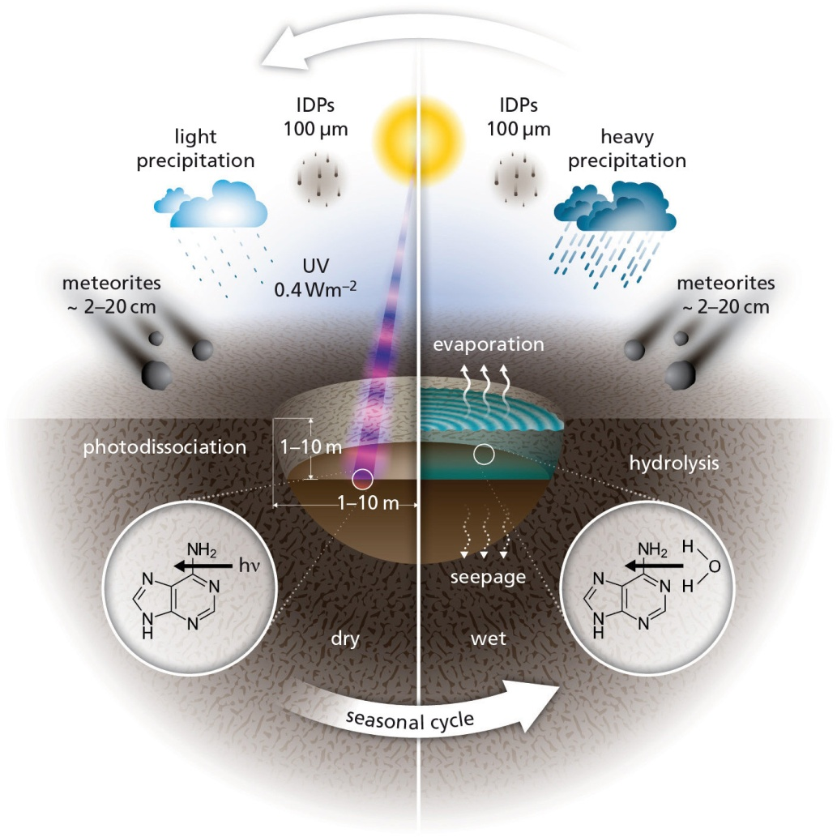

Figure: - Picture suggesting who meteorites have acted as source for origin of life.

Source: - (McMaster University, 2017).

## ***Multiple Origins of life***

The multiple origins of life are the new perspective which suggests that multiple origins have combined later on and have resulted in the origin of life (Kempes, & Krakauer, 2021). Numerous forms of extant life are present simultaneously on various physical substrates. The supporters of this hypothesis have organized all the theories in three different perspective domains which are extant centric, history centric, and principle centric (Kempes, & Krakauer, 2021). The first perspective emphasizes the features of the existing life and makes comparisons among them. The second perspective i.e. historic view emphasizes the defined evolutionary paths followed which have resulted in the origin of the extant life on the surface of the earth. The third perspective focuses on the common characteristics of all the possible evolutionary paths available and subsequent possible origins of life (Kempes, & Krakauer, 2021). In all three perspectives, the focus is being made on efforts and work done by some force that has driven the evolution. Life can be framed as an independent entity, not dependent upon the contingent evolutionary history. To support this, it is also considered that life can be evolved from non-terrestrial forms such as space objects (meteorites, etc.) and is not restricted to originate only on earth’s surface (Kempes, and Krakauer, 2021). In simple words, it can be considered that the internal structure and evolution can be studied independent of the physical evolution of the same i.e. by analogy hard and software can be described by independent logics and thus need not be always dependent on each other. For example, in the cell, the bimolecular microscopic activity can be studied independently from its molecular development methods in an organism. The hypothesis supports numerous possibilities which must have resulted in numerous origins in different systems (Kempes, & Krakauer, 2021). The old classic natural history view considers biology by both form and function while the modern biology view considers biology as a modern evolutionary process and molecular processes which categorize life into different lineages. Both of these views have some strengths and some drawbacks. For example, the natural history classic view does not have a unifying framework for the evolution by natural selection and is based on functional similarities which are termed as homoplasy in modern biology today (Kempes, & Krakauer, 2021).

The principle-centric view for the origin of life believes that there might be various origins of life along the path of evolution. It is also possible that some of these origins might have intersected on their way (Kempes, & Krakauer, 2021). Some of these paths are also mere transitions from non-living to living or vice versa, inorganic to organic, etc. This can be explained with the basic example of digital computers. Digital computers are created by humans (life) and are non-living entities that are simply the machines used to process various sorts of information. But now these can be used as a substrate for new forms of life through evolutionary stimulations or artificial intelligence (Kempes, & Krakauer, 2021). Here in the example, the living and non-living have developed and then both have intersected to evolve further life forms. This is in contrast to the old belief that life must have originated from a single form or cell via some chemical or spontaneous process and have spread over the earth. Instead, there must be multiple origins of life that have evolved multiple times (Kempes& Krakauer, 2021). Although it can still be agreed that the biological life based on the biochemical level must be having some peculiar source of origin but this is not true for the higher levels of organizations (Kempes, & Krakauer, 2021).

## ***Physics Theory of Life***

Physics theory of life is one of the recent cross-institutional theories which bridges the laws of physics and concepts of biology to explain the origin of life on earth. Physics considers one major difference between the living and the clumps of the carbon atom that living objects are better at capturing the energy from any source and in the same way can release it in the surrounding environment in the form of heat (Wolchover, 2014). An assistant professor at the Massachusetts Institute of Technology has derived a formula that indicates when external energy is acted upon any group of atoms then and the atoms are enclosed by a heat bath, then atoms will then go on to gradually restructure themselves and will result in a structure which will dissipate energy in increasing order (Wolchover, 2014). For example, if a group of atoms gained energy from the sun or any chemical fuel and is enclosed by the ocean and atmosphere acting as a heat bath, the atoms will restructure and will release energy into the system. This simply can be put as under some fixed conditions, matter rigidly takes the important physical characteristics associated with life. This theory believes in Darwin’s theory of evolution which talks at the gene and population level of evolution as it talks about the even before the natural selection and evolution happened. The second law of thermodynamics is one of the major parts of this theory (Wolchover, 2014).

The theory argues that some atoms must have clumped together which must have been surrounded by the heath bath at some temperature. The atom clumps then have re-arranged themselves to produce better vibrations by resonating better and with the sources of mechanical, electromagnetic, or chemical work in their respective environments (Wolchover, 2014). Reproduction is the biological process (or self-replication in general terms) that is the activity that is necessary for the evolution on earth. Reproduction is one such process in which energy is dissipated by the system that too increasingly over time. The theory suggested that the RNA must have been formed before by re-structuring of atoms and the RNA must have gone under various cycles of replication to start life which must have proceeded according to Darwin’s theory (Wolchover, 2014). Along with reproduction, the structural organization is also one of the processes by which the system releases energy into the environment. This could explain the enormous structural organization seen among living organisms. For example, a plat can easily absorb and dissipate energy into the system as compared to a bunch of clumped carbon atoms. Though this hypothesis is still in its research phase and still needs much more experimentation and results to conclude the origin of life (Wolchover, 2014).

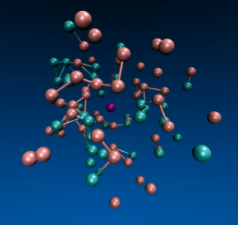

Figure: - System of particles confined inside a viscous fluid formed by more bonding force between them.

Source: - (Wolchover, 2014).

## ***Humic First Theory***

The Humic first theory talks about the humic substances which are thought to be the first substances that are active and have good catalytic properties needed for the initiation of life processes (Daei*et al.,* 2017). Since the early years, various theories have explained that life must have been originated in the primordial soup in which various organic matter have reacted and must have given rise to the organic materials thus beginning the life processes. There is still huge missing information of how small building blocks such as amino acids, lipid molecules, etc have given rise to the larger molecules which constitute the cell, the building blocks of the structural organization. It is also not possible or even not acceptable that some reactions have had happened accidentally in the primitive media which have given rise to the organic molecules which have initiated the life process on earth (Daei*et al.,* 2017). Even for this process to happen there was the requirement of two important substances that are organic and inorganic raw materials and some amount of energy. There was sufficient energy present on the surface of the earth in the form of sunlight but it was also known that no other organic molecules were present earlier has earth’s surface is nothing but just made by rocks with no fertility. It was found that a suitable amount of warm and wet clay mixed in fixed proportion with the humic substances along with maintaining pH can give all the necessary ingredients needed for the production of catalytic processes (Daei*et al.,* 2017). Harmful UV radiations can be turned into usable lights by the humic substances as they are fluorescent. A balance is present between the minerals and organic molecules which can be further transferred in form of chemical energy by the humic substances (Daei*et al.,* 2017). Humic substances also can accumulate more and more energy from the surrounding just like a modern living organism (Daei*et al.,* 2017). Various pieces of evidence suggest that humic substances are one of the ancient available resources on earth. The humic have also been founded in the vessels used by Miller in his experiment suggesting that humic materials can be produced by simple polarization of the organic molecules on early earth (Daei et al., 2017). It is also found in the study that all the essential elements have suitable affinity and work relation with the humic substances. Similarly, all the heavy metals react with the humic substance to form insoluble compounds (Daei*et al.,* 2017). There are also sufficient shreds of evidence that suggest that humic substances prefer to bind with left amino acids and right sugars (Daei*et al.,* 2017). All these shreds of evidence suggest that the humic substances are one of the ancient substances which could have acted as the mother of life on the planet Earth and thus have initiated the process of life (Daei*et al.,* 2017).

## ***Origin of Cell***

The origin of a cell is closely related to the origin of life as the cell is the structural and functional unit of life. There are various theories that are associated with the origin of cells. The first theory is that cells can be formed from pre-existing cells. Cells multiply through division (Cooper *et al.,* 2007). The cell divides by two processes which are mitosis in which the mother cell divides into two identical daughter cells and meiosis in which the mother cell divides into four daughter cells or the sex cells which is usually seen during the time of sexual reproduction (Cooper *et al.,* 2007).

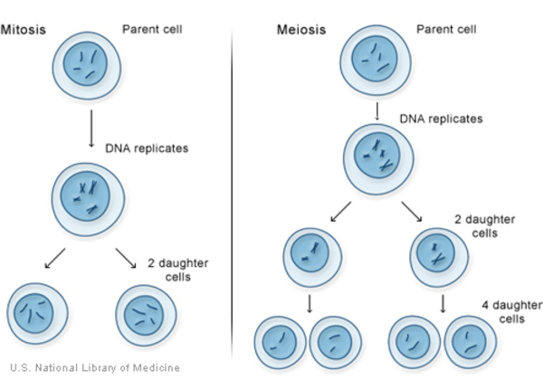

Figure: - Types of cell division i.e. mitosis and meiosis.

Source: - (National Library of Medicine, 2022).

The first theory for the origin of cells was the theory of spontaneous generation which suggested that the cells arise from non-living objects such as mud, dust, etc. (Britannica, 2022). But this theory of the origin of the cell was disapproved by many scientists. Pasteur’s famous experiment proved that the cells come from pre-existing cells only and not by spontaneous generation (Britannica, 2022). The hot primeval soup is another theory that suggests that there were many smaller simpler units of molecules on the surface of the earth that must have then joined together to form polymeric complex organic biomolecules which must have then formed the cell (Delbert, 2020). The cells seem to be simple structures but are in turn made by many smaller units called cell organelles. These cell organelles are made by the complex biomolecules which have been formed by the processes during evolution. Some non-cellular entities are also found on earth such as viruses but there is still a dilemma about them being living and non-living that’s why they used the host machinery for reproduction (Cooper *et al.,* 2007).

It is known that new cells come from the former cells. But how the first cell must have formed is the main question of concern. Various theories of the origin of life suggest there must be a reaction between the available ingredients on the earth that must have resulted in the complex biomolecules. Once a substantial amount of these biomolecules was formed, they must have started to form clumps and re-arranged themselves forming some functional structures. These structures must be having the capacity to replicate themselves. A membrane must have formed around these complex biomolecules which must have then resulted in the first cell (Cooper *et al.,* 2007). Among all the complex biomolecules formed, some of them must be having the capacity to store information that can be used during further replication. These molecules are known as DNA and RNA now and they store information in the form of genetic code. It is known that the atmosphere on the surface of the earth was of reducing type (Zahnle*et al.,* 2010) indication there was more hydrogen, methane, ammonia, etc. which must have reacted have resulted in the formation of oxygen that has made the atmosphere oxidizing (Zahnle*et al.,* 2010). The complex biomolecules need a boundary that could maintain a favorable environment for them to function. This is provided by the cell membrane. It was found that some phospholipids can arrange themselves in layers (Schrum *et al.,* 2010). These layers have eventually evolved in the bilayer cell membrane and provide a suitable internal environment (Schrum *et al.,* 2010).

Endosymbiotic theory is the most acceptable theory that talks about the formation of various cell organelles in the eukaryotic cells. This theory argues that the eukaryotic cells must have originated due to the symbiotic association between the prokaryotic cells (Martin *et al.,* 2015). A prokaryotic cell must have grown into size multiple times and had folded multiple times as well. This structure is analogous to the modern nucleus. The folds in the membrane have helped in increasing and also maintaining the balance between the surface area and volume which can be used to store more enzymes and complex biomolecules needed to maintain the eukaryotic cell (Martin *et al.,* 2015). The prokaryotic cells resemble the mitochondria and chloroplast as both of them have their independent circular genetic material that stores the information for the production of proteins helping in maintaining and in the proper functioning of the organelles. Another similarity between mitochondria, chloroplast, and prokaryotic cells is that they are self-replicating (Martin *et al.,* 2015). The similarity in ribosomes between them is also seen as all the three have 70S ribosomes which are in contrast to 80S ribosomes of a eukaryotic nucleus (Martin *et al.,* 2015). The nucleic acids were the important biomolecules of the cell as they are involved in storing all the relevant information in the form of genetic code (Scitable, 2022). There are 64 codons in eukaryotes and each codon is formed by a combination of three nucleic acids which produces the amino acids and proteins eventually (Scitable, 2022).

# **Discussion**

Origin of life is a complex process and various theories in the past have been used to describe the process. If we talk about the commonality of all these theories, there emerges a point that there must be some forms of reactions had happened which had formed complex molecules that have resulted in the initiation. Now every theory, either the primitive models or new hypothesis, aims to figure out how the prerequisites of the reactions came on the earth. There are two major prerequisites, the simplex molecules which must have undergone the reactions, and the catalysts which have helped in the completion of reactions. Given the vast variety of chemical compounds and the enormous number of living diversity, it seems to be too good to be true that there is one unifying origin and a theory supporting the origin of life. Therefore the theory ‘multiple origins of life’ is the one that sounds most reasonable to me. Once the complex biomolecules are formed then by some mechanism a membrane had formed which has resulted in the formation of the first earliest cells. The cell theory has suggested that the cells arise from the pre-existing cells, thus new cells have been formed by the means of cell division. The cells must have provided the needed suitable environment for the enclosed complex biomolecules that are necessary for their suitable functioning and stability. The cell membrane must have been formed to protect and provide the internal stable atmosphere to the complex biomolecules and cell organelles. The cell organelles are formed by different processes. Though the research is still going on and there must be a possibility of finding some new perspective suggesting the unified origin of life and subsequent origin of the cell.

Figure: - Succession of origin of life.

Source: - Self

# **Conclusion**

Origin of life is the complex process that has given rise to life on Earth. Various theories suggest the origin of life. The earliest theories believe that there must be a spark or lightning which must have initiated the process. One theory believes ice has provided a suitable environment for initiation while others believe it is the high temperature of deep-sea vents. The modern theories consist of the mica hypothesis believing that life started between the mica sheets, iron sulfide theory which believes it’s the iron sulfide that acted as the catalyst for reactions, a cosmic theory that talks about the meteorites that played role in bringing life on earth, etc. One common point of all these theories is that some reactions had happened and have initiated the process and each theory tries to unfold the existence of the first molecules who had initiated the process which later must have been enclosed in some membranes and have given rise to the cell. During the formation of cells different cell organelles were also formed. The endosymbiotic theory suggests that the organelles such as mitochondria and chloroplast in the eukary

otic cells are formed by the symbiotic association of the prokaryotic cells.

**References**

Bernhardt, H. S. (2012). The RNA world hypothesis: the worst theory of the early evolution of life (except for all the others) a. *Biology direct*, *7*(1), 1-10.

Biology Exams 4 U. (2022). *Oparin Haldane Theory of Chemical evolution explained in 4 stages.* Retrieved on 31th March 2022, from <https://www.biologyexams4u.com/2021/06/oparin-haldene-theory-of-chemical-evolution-theory-stages-steps.html>

Britannica. (2022). *Spontaneous Generation.* Retrieved on 20th March 2022, from <https://www.britannica.com/biography/Louis-Pasteur/Spontaneous-generation>

Choi, C. Q. (2011). 7 Theories on the Origin of Life.

Cooper, G. M., Hausman, R. E., & Hausman, R. E. (2007). *The cell: a molecular approach* (Vol. 4, pp. 649-656). Washington, DC, USA:: ASM press.

Daei, M. A., Daei, M., &Daei, B. (2017, April). Humic First Theory: A New Theory on the Origin of Life. In *EGU General Assembly Conference Abstracts* (p. 2356).

Delbert, C. (2020). *Darwin Was Right: All Life Probably Comes From Primordial Soup*. Popular Mechanics. Retrieved on 20th March 2022, from <https://www.popularmechanics.com/science/a34649466/primordial-soup-theory-origins-of-life-darwin/>

Ellis, R. (2001). *Aquagenesis*. Chemistry is in the News. Retrieved on 31th March 2022, from <http://web.missouri.edu/~glaserr/216f01/group_3_project.html>

Ferus, M., Pietrucci, F., Saitta, A. M., Knížek, A., Kubelík, P., Ivanek, O., ... &Civiš, S. (2017). Formation of nucleobases in a Miller–Urey reducing atmosphere. *Proceedings of the National Academy of Sciences*, *114*(17), 4306-4311.

Ghose, T. (2013). Origin of Life: Did a Simple Pump Drive Process?. *Live Science*.

Hansma, H. G. (2009). Could life originate between mica sheets?: Mechanochemical biomolecular synthesis and the origins of life. *MRS Online Proceedings Library (OPL)*, *1185*.

Hansma, H. G. (2010). Possible origin of life between mica sheets. Journal of Theoretical Biology, 266(1), 175-188.

Hansma, H. G. (2013). Possible origin of life between mica sheets: does life imitate mica?. *Journal of Biomolecular Structure and Dynamics*, *31*(8), 888-895.

Kahana, A., & Lancet, D. (2019). Protobiotic systems chemistry analyzed by molecular dynamics. *Life*, *9*(2), 38.

Kempes, C. P., & Krakauer, D. C. (2021). The Multiple Paths to Multiple Life. *Journal of molecular evolution*, *89*(7), 415-426.

Lancet, D., Zidovetzki, R., &Markovitch, O. (2018). Systems protobiology: origin of life in lipid catalytic networks. *Journal of The Royal Society Interface*, *15*(144), 20180159.

lkouniv. (2022). *Theories of Origin of Life.* Retrieved on 20th March 2022, from https://www.lkouniv.ac.in/site/writereaddata/siteContent/202004261258144367alka_maths_Theories_of_life.pdf

Markovitch, O., & Lancet, D. (2012). Excess mutual catalysis is required for effective evolvability. *Artificial life*, *18*(3), 243-266.

Martin, W. F., Garg, S., &Zimorski, V. (2015). Endosymbiotic theories for eukaryote origin. *Philosophical Transactions of the Royal Society B: Biological Sciences*, *370*(1678), 20140330.

McMaster University. (2017). Evidence suggests life on Earth started after meteorites splashed into warm little ponds. Phys.Org. Retrieved on 31th March 2022, from <https://phys.org/news/2017-10-evidence-life-earth-meteorites-splashed.html>

Mcnally, J. (2021). *Life on Earth May Have Had an Icy Start*. Wired. Retrieved on 20th March 2022, from <https://www.wired.com/2010/09/icy-life-beginning/#:~:text=Cracks%20in%20ice%20could%20have,molecule%20capable%20of%20self%2Dreplication>.

NASA. (2019). *First Detection of Sugars in Meteorites Gives Clues to Origin of Life.* NASA. Retrieved on 20th March 2022, from https://www.nasa.gov/press-release/goddard/2019/sugars-in-meteorites

National Library of Medicine. (2022). *How do cells divide?* Retrieved on 20th March 2022, from https://medlineplus.gov/genetics/understanding/howgeneswork/cellsdivide/

National Science Foundation. (2010). *The Secret of Life May Be As Simple As What Happens Between the Sheets--Mica Sheets.* Retrieved on 20th March 2022, from <https://www.nsf.gov/news/news_summ.jsp?cntn_id=117405>

Neveu, M., Kim, H. J., & Benner, S. A. (2013). The “strong” RNA world hypothesis: Fifty years old. *Astrobiology*, *13*(4), 391-403.

Ouellette, J. (2021). *Scientists recreated classic origin-of-life experiment and made a new discovery*. ArsTechnica. Retrieved on 31th March 2022, from <https://arstechnica.com/science/2021/10/scientists-recreated-classic-origin-of-life-experiment-and-made-a-new-discovery/>

Pasteur Brewing. (2022). *Spontaneous Generation: Redi’s Experiment with Learning Objectives.* Retrieved on 20th March 2022, from <https://www.pasteurbrewing.com/spontaneous-generation-redis-experiment-learning-objectives/>

Pross, A., & Pascal, R. (2013). The origin of life: what we know, what we can know and what we will never know. *Open biology*, *3*(3), 120190.

Schrum, J. P., Zhu, T. F., &Szostak, J. W. (2010). The origins of cellular life. *Cold Spring Harbor perspectives in biology*, *2*(9), a002212.

Scitable. (2022). *Genetic Code*. Nature Education. Retrieved on 20th March 2022, from<https://www.nature.com/scitable/definition/genetic-code-13/#:~:text=The%20genetic%20code%20is%20a%20set%20of%20three%2Dletter%20combinations,and%20his%20colleagues%20in%201961>.

Sousa, C. (2021). Origin of Life: An Update on New Evidence & Theories. *The American Biology Teacher*, *83*(2), 76-79.

Tirard, S. (2017). JBS Haldane and the origin of life. *Journal of genetics*, *96*(5), 735-739.

Weizamnn Institute of Science. (2022). *Systems Protobiology*. Retrieved on 20th March 2022, from <https://www.weizmann.ac.il/molgen/Lancet/research-activities/systems-protobiology>

Whitfield, J. (2002). *New theory for origin of life*. *Nature*. <https://doi.org/10.1038/news021202-2>

Wolchover, N. (2014). A New Physics Theory of Life. QuantaMagzine. Retrieved on 20th March 2022, from https://www.quantamagazine.org/a-new-thermodynamics-theory-of-the-origin-of-life-20140122/

Yong, E. (2010). *A possible icy start for life. National Geographic*. Retrieved on 20th March 2022, from <https://www.nationalgeographic.com/science/article/a-possible-icy-start-for-life>

Zahnle, K., Schaefer, L., &Fegley, B. (2010). Earth’s earliest atmospheres. *Cold Spring Harbor perspectives in biology*, *2*(10), a004895.