**Kedleston University Network Design Report**

**Introduction**

Kedleston University has recently established a new building to provide several educational services to the students. The building has newly developed and a complete communicating network needs to be established by the network consulting team. The university campus has multiple departments including staff, admin, students, labs, support team, and others. All the components of the university need to be connected by installing an information communication network. In this report, a complete networking solution will be provided to the client based on the requirements of the client. Here, both the logical and physical network architecture will be developed by using appropriate networking devices and components. In the developed network designs, all the connections will be shown clearly. On the other hand, a complete IP addressing scheme for the university will also be provided. Based on the university requirements, an IP table will be given in this report. However, all the necessary elements for the university network will be introduced in this report.

# Proposed design

## Device selection

Several networking devices could be utilised during the network installation. Based on the client requirements and some other criteria, networking components need to be identified. Few parameters will be considered during the selection of networking components like cost, performance, expandability, features and services, and some other aspects (Friedland-Little *et al.* 2022). In this project, the network should be installed by considering the scalability and redundancy aspects. In the below table all the devices or networking components have been illustrated that could be utlised to design a networks for Kedleston university.

| ***Sl. No.*** | ***Device*** | ***Configuration*** | ***Cost ($)/unit*** | ***Quantity*** |
| --- | --- | --- | --- | --- |
| 1 | Router | TP-Link AC1760 Smart Wi-Fi Router (Arther A6) Dual Band Gigabit Wireless Internet Router, VPN enabled, 1760 Mbps high speed, multiple OS supported (Ding *et al.* 2019) | 63.55 | 4 |
| 2 | Switch | NETGEAR 24 port Ethernet switch (JGS324), with energy saving design. | 64.65 | 14 |
| 3 | PC | Acer Aspire C34 1641-UR25 AIO Desktop 23.6" Full HD IPS Display 10th Gen Intel Core i5-1125G4 Intel HD RAM 8GB DDR4 512GB | 558.78 | 10 |
| 4 | Laptop | Acer Helios 350 PH325-44-760V, RAM 16 GB, SSD 512GB, full HD display, Wi-Fi- 6 (Emerson 2019) | 1150.78 | 10 |
| 5 | Server | Intel NVC 11 NUC12PAHB7 Home & Office Desktop Main steam Kit, Barebones，Intel Core i7-1155G7 5-Core, 2.8 GHz–5.7 GHz Turbo | 762.67 | 4 |
| 6 | Printer | Canon wireless printer, USB, Auto-duplex, High speed printer | 150.20 | 10 |
| 7 | Access point | NETGEAR wireless router, Wi-Fi 6, upto 128 devices, dual band (Xia *et al.* 2020) | 89.45 | 2 |

**Table 1: Device selection for network**

Based on the client’s requirement, all the necessary have been identified in the above table. By considering cost, scalability, and redundancy in the network, all the networking components have been selected. A brief analysis of the given scenario has been conducted and then the networking components have been identified. University management will be able to expand their network infrastructure as the routers and switches will give scalability to the management.

## Cabling and connectivity

In this project, all the users will be able to communicate with each other as all the devices will be connected through a wired connection or wireless connection. Based on the devices and their features, all the connections will be done. During the network design for the Kedleston university, both wired and wireless devices will be used. Based on the type of the device, the connection will be established. There are different types of cables are available that could be utlised to make connections. In the below points, different cabling options have been illustrated:

* *Cat 6 cable:* This type of cable is used to provide a high-speed connection to the networking components. The twisted pairs are insulated from each other through a plastic core. A fire-resistant plastic sheet is also available that protects the cable (Chuy-Ramón *et al.* 2021).
* *Fiber optics cable:* Fiber optics is mainly used to provide an uninterrupted internet connection to the workstations. A high-speed internet connection could be achieved by the users if the connection is done by using fiber optic cables. Data and information sharing between the users will become faster if, fiber optic cables have been installed in the network.
* *Wireless connection:* Wireless devices like laptops, smartphone, or tablets will be connected to the network. These devices will be connected through a wireless connection. Wireless access points will be installed into the network to get the wireless connection (Ahn *et al.* 2018). This type of connection gives less speed than the wired connection. However, the users will be able to get mobility during work with the installation of wireless devices.
* *Ethernet cross through:* Ethernet cross through cables will be used to connect different kinds of device lines a router and a switch will be connected through an Ethernet cross through cable. This type of cable are being used for the last decades and all the devices will get a secure connection to the network.

However, in the designed network architecture for the Kedleston University, both the wired and wireless connections will be established. Wireless access points will give wireless connectivity to the wireless devices. On the other hand, Ethernet cross-through cables will be utlised to make the wired connection. Based on the available data and information sources for this project, some of the changes could be made by the university IT team in the future.

## Logical network design

In order to provide a complete networking solution to the Kedleston university, both the logical and physical network topology has been developed in this project. A complete overview of the network architecture of the university could be achieved by the university IT team from the developed network designs.

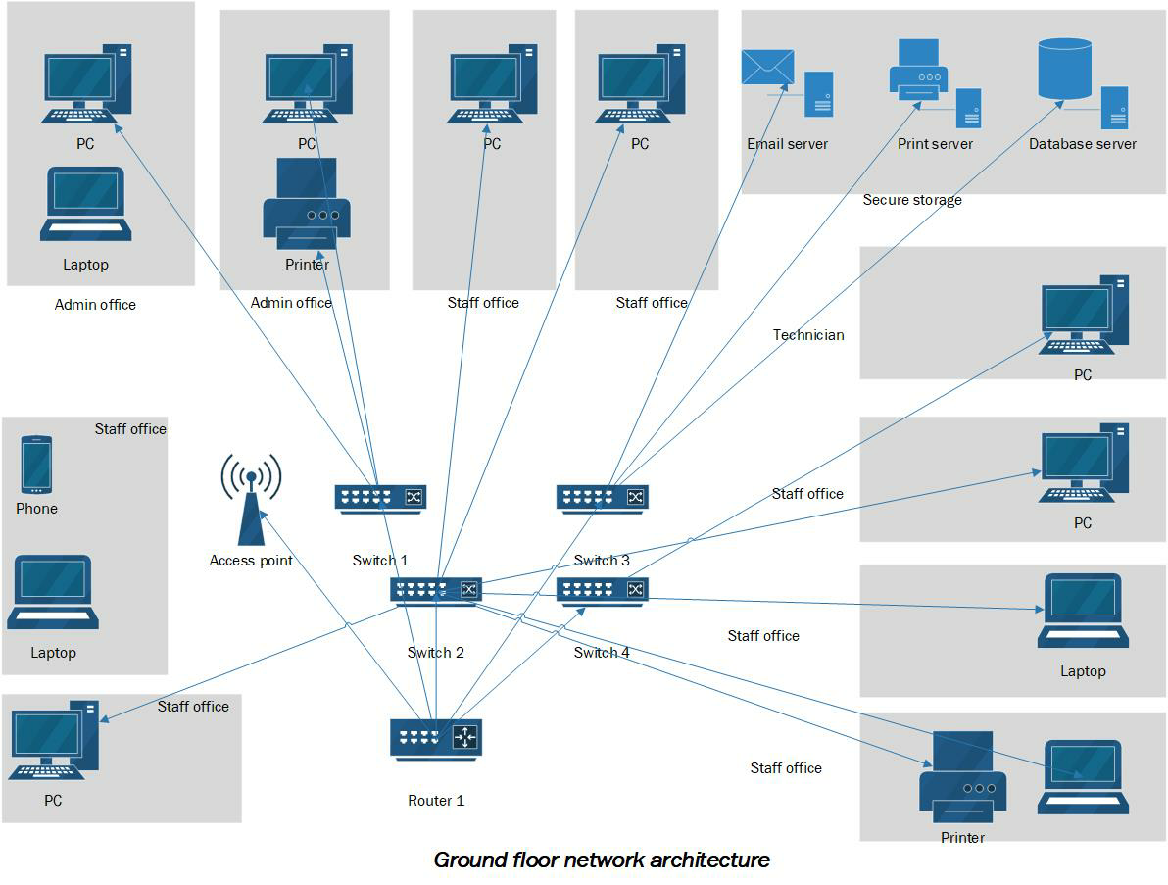

**Figure 1: Logical network architecture of ground floor**

(Source: Author)

In the above figure, logical network architecture has been developed for the ground floor of the university building. Different types of networking components have been utlised during the network design development. From a single router, four networking switches have been connected. From each switch, all the workstations, printers, servers, and other components have been connected. The ground floor consists of all the supporting IT devices and components. Here, the IT support team will be able to manage all the work and activities from this floor. All types of servers and storage have been installed on this floor. All the departments including admin, staff, and technicians will be able to get access to the servers and storage devices.

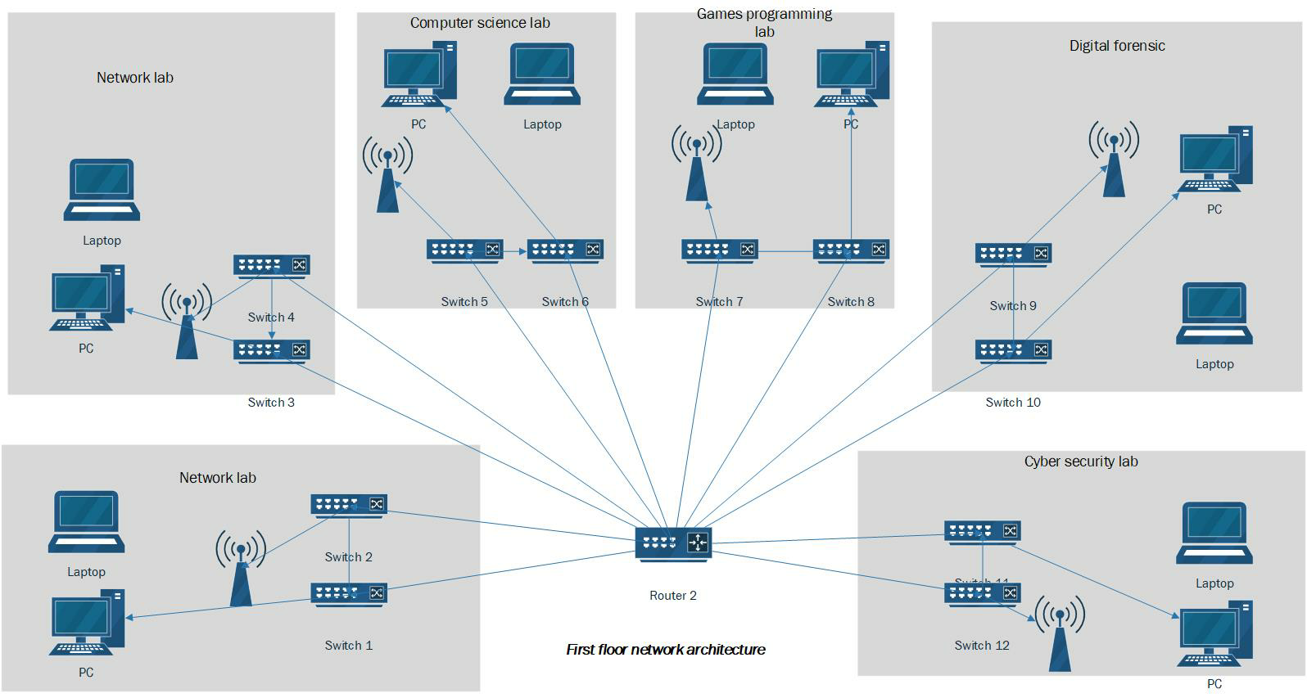

**Figure 2: Logical network architecture of the first floor**

(Source: Author)

In the above figure, the network architecture of the first floor of the university building has been designed. The first floor of the university mainly consists of the student laboratories. All the five labs are separately connected through switches. All the switches are connected to the core router. In each lab, both wired and wireless devices are available and for this purpose, access points have also been installed into each laboratory. Users from this floor will be able to make successful communication between each other and all the data and information sharing process could be done easily.

## Physical network design

A physical network design is mainly developed to get an overview of the entire network architecture of the organization. The connection between different entities could be shown through the physical network architecture of the organization. In this project, the physical network architecture has been developed to show the connection between the two floors of the building.

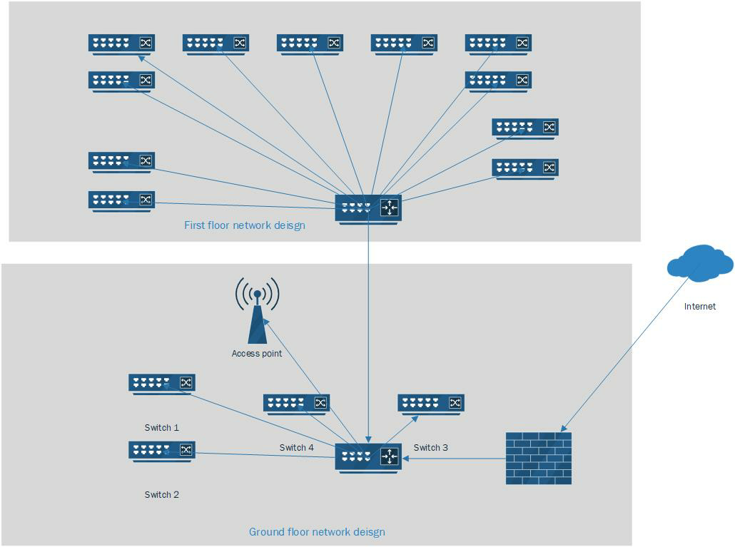

**Figure 3: Physical network architecture of the university building**

(Source: Author)

The above figure shows the physical network architecture of the university building. The two floors of the university are connected to each other and the internet connection is given to the ground floor router. A secure network architecture could be established by the management of the firewall is properly installed and configured between the border router and the internet provider (Datta *et al.* 2018). Based on the above network architecture of the university building all the basic requirements of the university management could be fulfilled. All the necessary equipment for the network architecture design has been included in the design.

# Logical connection and IP addressing

## IP addressing table

All the devices will be allocated with a proper IP addresses to establish successful communication between the devices. It is important to develop a proper IP addressing scheme for the developed network architecture of the Kedleston university. Here, the DHCP server will be configured that will also be able to allocate an IP address to the users.

|  |  |  |  |  |  |  |  |
| --- | --- | --- | --- | --- | --- | --- | --- |
| ***Subnet Name*** | ***Needed Size*** | ***Allocated Size*** | ***Address*** | ***Mask*** | ***Dec Mask*** | ***Assignable Range*** | ***Broadcast*** |
| ***Student*** | 700 | 1022 | 226.89.0.0 | /22 | 255.255.252.0 | 226.89.0.1 - 226.89.3.254 | 226.89.3.255 |
| ***General staff*** | 114 | 126 | 226.89.4.0 | /25 | 255.255.255.128 | 226.89.4.1 - 226.89.4.126 | 226.89.4.127 |
| ***Guest network*** | 112 | 126 | 226.89.4.128 | /25 | 255.255.255.128 | 226.89.4.129 - 226.89.4.254 | 226.89.4.255 |
| ***Admin Staff*** | 32 | 62 | 226.89.5.0 | /26 | 255.255.255.192 | 226.89.5.1 - 226.89.5.62 | 226.89.5.63 |
| ***Technician*** | 12 | 14 | 226.89.5.64 | /28 | 255.255.255.240 | 226.89.5.65 - 226.89.5.78 | 226.89.5.79 |

**Table 2: IP addressing table**

(Source: Author)

Based on the above IP addressing scheme, all the workstations will be allocated with IP addresses. Based on the data and information sharing architecture of the university, new devices and components will be allocated with IP addresses by the DHCP server automatically.

## IP addressing beenfits

There are several beenfits of IP addressing in the network architecture. In the university network, a number of devices will be installed and each device will be identified separately through the IP address. In order to divide the LAN network into multiple segments, IP addressing is an effective approach. However, the IP addressing into the network has several beenfits that are discussed below:

* *Improved standing:* With the allocated IP address, a proper standardised network architecture could be introduced by the developers.
* *Additional security:* An additional security layer could be enabled by the network engineers. IP address helps to make the access control into the network. Users are allowed or restricted to get access to the network if the IP address is properly configured (Chen *et al.* 2021).
* *Accurate data transfer:* Users will be able to make proper data and information sharing between different devices.
* *Secure communication:* secure communication between different networking components could be established by the developers.
* *Traffic volume control:* Network traffic could also be controlled by the network admins if the IP address in each device is properly allocated.

The above beenfits could be achieved by the university management if all the networking components have been allocated with a proper IP addresses.

## IP addressing methods

Computers use IP addresses to send messages and information over the web. The majority of IP addresses are numbers, however, as internet activity increases, certain domains have letters appended to them. Public, private, static, and dynamic IP addresses are the four types of network addresses. While the terms public and private reflect the network's position, private is used within a connection and access is used outside those, static analysis and dynamic denote permanency. A static IP address is created manually rather than being assigned automatically to the university devices. A static IP address is likewise permanent, but a dynamic IP address is allocated by a Dynamic Host Configuration Protocol (DHCP) provider and can modify (Lee and Fumagalli 2019). The most prevalent type of online network addressing is a dynamic Internet protocol. Dynamic IP numbers are only valid for a limited period of time before they expire. In this project, both the static and dynamic IP addressing scheme has been enabled for the networking devices. The IPv4 addressing scheme has been enabled for the developed network design.

# Summary

In this project, a complete network architecture for Kedleston University has been developed by considering its requirements. There are several networking components have been utlised and the diagram has been developed by using diagramming tool. An IP address table has also been developed to allocate all the devices with proper IP address. On the other hand, both the logical and physical network architecture for the university has been developed in this report. However, a complete networking solution has been developed in this report for the Kedleston University and the developed network architecture will give a suitable data and information transfer environment to the user.

# References

Ahn, J., Kim, Y.Y. and Kim, R.Y., 2018. Virtual reality-wireless local area network: Wireless connection-oriented virtual reality architecture for next-generation virtual reality devices. *Applied Sciences*, *8*(1), p.43.

Chen, Z., Wang, C., Li, G., Lou, Z., Jiang, S. and Galis, A., 2020, April. New IP framework and protocol for future applications. In *NOMS 2020-2020 IEEE/IFIP Network Operations and Management Symposium* (pp. 1-5). IEEE.

Chuy-Ramón, L., Zumalacarregui-de Cárdenas, L., Lobaina-Rodríguez, T. and Pérez-de la Concepción, H., 2021. CAT6 24AWG de HDPE LSZH chaqueta impermeable con cable de red. *Vaccimonitor*, *30*(1), pp.18-26.

Datta, R., Choi, S., Chowdhary, A. and Park, Y., 2018, October. P4guard: Designing p4 based firewall. In *MILCOM 2018-2018 IEEE Military Communications Conference (MILCOM)* (pp. 1-6). IEEE.

Ding, R., Xu, Y., Gao, F., Shen, X. and Wu, W., 2019. Deep reinforcement learning for router selection in network with heavy traffic. *IEEE Access*, *7*, pp.37109-37120.

Emerson, L., 2019. Anarchive as technique in the Media Archaeology Lab| building a one Laptop Per Child mesh network. *International Journal of Digital Humanities*, *1*(1), pp.59-70.

Friedland-Little, J.M., Joong, A., Shugh, S.B., O’Connor, M.J., Bansal, N., Davies, R.R. and Ploutz, M.S., 2022. Patient and Device Selection in Pediatric MCS: A Review of Current Consensus and Unsettled Questions. *Pediatric cardiology*, pp.1-12.

Lee, C. and Fumagalli, A., 2019, April. Internet of things security-multilayered method for end to end data communications over cellular networks. In *2019 IEEE 5th World Forum on Internet of Things (WF-IoT)* (pp. 24-28). IEEE.

Xia, J., Fan, L., Yang, N., Deng, Y., Duong, T.Q., Karagiannidis, G.K. and Nallanathan, A., 2020. Opportunistic access point selection for mobile edge computing networks. *IEEE Transactions on Wireless Communications*, *20*(1), pp.695-709.