Community Tourism Development

**Task Requirements (Question)**

Assignment is to be completed in groups but submitted individually. Each submission must include a title page with all group member's name and student ID number

10% of final grade

Due June 14th 11:59pm

Word Document submission only

Please follow APA guidelines and include in text citations and a bibliography

1500 words

Select an existing community tourism development of your choosing.

*Please make sure the development chosen matches the definition of community tourism development.*

Analyze the internal and external environment of your selected development using a SWOT analysis.

Provide a minimum of 5 recommendations for the development chosen by your group based on the data collected using the SWOT analysis.

Please submit the SWOT analysis and the recommendations.

**Answer**

# Introduction

Tourism is one of the most flourishing industries of the world today. Every year, millions of tourists travel to different destinations for reasons ranging from business to vacations. Modern tourism is not restricted to developed countries alone, but also third-world countries. It provides a much-needed source of livelihood to the people living in remote areas. The government of third-world countries has realized this and support tourism as it is a valuable source of foreign income. They develop the infrastructure around the tourist destination to facilitate travel and encourage tourists. One of the newer niches in tourism is eco-tourism, sustainable tourism, and community tourism. This paper will discuss the Korzok community tourism development project undertaken by WWF in partnership with the Indian the government (Anand et al., 2012), it will analyze the internal and external environment of Korzok community tourism using SWOT analysis and provide recommendations.

# Community Tourism

There has always been a market for tourists visiting cities, religious places, scenic spots, or places of historical importance. However, there has also been a growing demand from tourists who want to imbibe the culture and traditions of the place they visit. Community-based tourism (CBT) is subsets of sustainable tourism in which the people from local communities invite tourists to stay in their communities so that enjoy the authentic experience of local traditions and customs. They get to participate in the everyday activities of the locals such as picking tea leaves, and weaving baskets, and getting a deeper understanding of how the local people live and the hardships they face. These communities are generally rural and often poor and CBT provides those opportunities to become entrepreneurs, managers, service providers, or employees. Most importantly, as the tourists live with the villagers, they spend their money there and therefore the local communities reap the full benefit of their customers as the middle-man is eliminated (Gallagher, 2021).

According to the American Express poll tourists from America, Australia, Canada, Japan, and UK are aware of sustainable tourism. 72% want their tourism revenue to reach and help develop the local communities (American Express Travel, 2020).

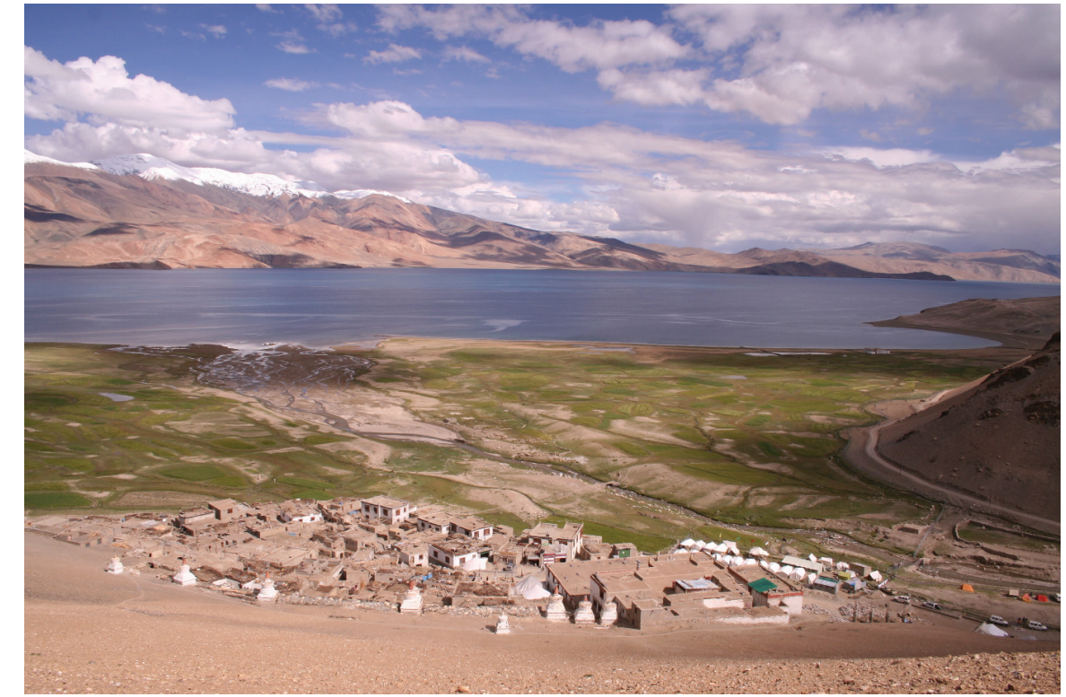

(Anand et al., 2012).

# KorzokHomestays, Ladakh, India

Ladakh is a province in India, is situated in the Himalayas. Korzak, which is a small village community is situated at the height of 4595 meters above sea level. It is known for being the highest permanent civilization on Earth. The Changpas live here. The nearest town Leh is 215 km away and is connected by a single-track road, which has limited accessibility during the winter months. There are 22 permanent households and 179 households are seasonal migrants who live in tents called Rebos. There is a primary health center and children study in the nearby Puga valley as there is no school in the community. The village gets electricity for 4 hours from a diesel-powered generator. 70% of villagers are agriculturalists and nomadic pastoralists. They grow wheat, barley, and peas and raise pashmina goats that give the famous pashmina wool (Anand et al., 2012).

Tourism in Ladakh started in 1974 to promote its biodiversity, breathtaking landscapes, and culture. It attracted adventure-seeking tourists. It was a joint initiative of the World Wide Fund for Nature (WWF) and the Indian the government. One of the projects was developing a tourist spot for the Changpa population living in Korzok near Lake Tsomoriri. The lake and its surrounding areas supported abundant bird life such as shelduck, golden eagle, redshank, and black-necked crane. Tourists could also spot the rare snow leopard on occasions. However, over the years it was observed that tourists often left non-biodegradable garbage. Tourists’ vehicles were causing water and noise pollution that was compromising the health of the delicate biodiversity. Tourism provided income earning opportunities to the people. It was also necessary to address these concerns. The Korzak homestay initiative was launched in 1999 again with the WWF India partnership. The Changpa have traditions of reciprocities, an absence of distinctive class hierarchies, and having a locus of authority within the village, these qualities were leveraged to form homestays. As the villagers were assured of earning an income without major investment, they too were interested. They were further trained on a wide range of subjects such as hygiene and waste segregation, creating marketing strategies, handling finance, and preparing guidelines for tourists. Youths were trained to become wildlife guides, women’s café. The training program also stressed ecological conservation and livelihood sustenance and 10 homestays were approved in the area. The Tsomoriri Conservation Trust was formed that would oversee the project and would ensure among other things keeping traditions like making pashmina shawls alive and conserving and maintaining the high-altitude lake ecosystem (Anand et al., 2012).

# SWOT Analysis

|  |  |
| --- | --- |
| **Strength** | **Weakness** |
| The project has been operational since 1999 and has completed 23 years | The project is only limited to 15 homestays, they get the bulk of the income. The rest of the villagers only provide service |
| During the season the occupancy rates are at 80% and each family earns $ 700 to $1200 every year (Anand et al., 2012). | There is a severe lack of facilities such as hospitals or continuous electricity. These are necessary if tourists face a medical emergency. |
| The CBT project has a clear vision and management strategy. It has taken care to train the villagers in the art of tourism hospitality | Children are taught in the nearby Puga valley, they may not be interested in running the homestay when they grow up as they are alienated from their roots |
| **Opportunities** | **Threats** |
| The Indian the government and WWF have initiated the project and have a vested interest in keeping it going on profitably for years. | Despite the project being 23 years old, the infrastructure is still limited to a single-track road. Part of the problem is the high altitude of the area that limits construction. |
| The tourism industry is once again booming after the 2 years of negative growth during the pandemic | Ladakh is on the Indo-Pak border and is near the disputed area. There is always the danger of terrorist activity that can discourage tourists |
| There have been a number of innovations in the construction industry and IT industry that can be used to develop Korzok | There is an increasing competition for CBT in India as more than 125 villages are in the market. Moreover, these villages are easily accessible than Korzok (Prasad, 2021) |

# Recommendations

From the study of the SWOT analysis, Korzok CBT seems to have ticked all the right boxes. The SWOT also shows that some issues are beyond control while others are. The two areas where there is little control are the Indo-Pak border dispute. The geographical height of the village from the mean sea level. These two threats/ weaknesses ensure that development will be slow.

At the same time, these recommendations are suggested to improve the business and ensure it long-term sustainability.

Need for a proper hospital: There is only one primary health center in the community (Anand et al., 2012). There has to be a hospital in the village for the following reasons. There is extensive permafrost and the temperatures can plummet to -40o C. As there is just a single-track route (Anand et al., 2012) in harsh weather conditions lives of tourists and the community can be endangered. Therefore, it is necessary to have a proper hospital to take care of people during emergencies. This measure will also increase tourist’s confidence.

Need for school in the village: The children in the village are studying in a centralized school in Puga valley (Anand et al., 2012). As they are away from their parents, their cultural and traditional links could be diluted and they may not want to go back to their village and continue with the same life. Outmigration could be a threat to the village tourism industry.

Lack of connectivity: While it is a challenge to construct roads in the high mountain ranges. Internet connectivity and telecommunication services should not prove to be a huge issue. Tourists need to be connected with the outside world so that they can post images on social media and refer the site to their friends.

Introduction of green energy solutions: The village gets electricity for 4 hours through diesel energy (Anand et al., 2012). The introduction of solar panels and photovoltaic cells will introduce green energy and also provide much-needed continuous electricity to the community.

Scalability of operations: Over the past 23 years the number of homestays has increased from 10 to 15. There is a need to include more homestays so that the community can compete in the market.

# Conclusion

This paper discussed the Korzok community tourism development project undertaken by WWF in partnership with the Indian the government. It analyzed the internal and external environment of Korzok community tourism using a SWOT analysis. On the basis of the SWOT analysis the following recommendations are suggested:

1. Need for a proper hospital in the community,
2. Need for a school for the local children
3. Increasing connectivity (Internet and telecommunications)
4. Introduction of green energy solutions
5. Scalability of operations

# References

Anand, A., Chandan, P., & Singh, R. B. (2012). Homestays at Korzok: Supplementing rural livelihoods and supporting green tourism in the Indian Himalayas. *Mountain Research and Development*, *32*(2), 126-136. <https://doi.org/10.1659/mrd-journal-d-11-00109.1>

Gallagher, K. (2021, May 14). *What is community-based tourism? Definition and popular destinations*. Treehugger. <https://www.treehugger.com/what-is-community-based-tourism-5181555#citation-4>

Prasad, R. (2021, June 15). *Community based tourism in Kullu, Himachal Pradesh, India*. HubPages. <https://discover.hubpages.com/travel/Community-Based-Tourism-in-Kullu-Himachal-Pradesh-India>