# Student Assessment Survey Analysis

# Level 1 Assessment:

* Two schools were involved in the assessment, that is, Kongoni primary school (95 pupils) and St. Joseph primary school (52 pupils).
* A total of 147 pupils participated in the assessment, 69 males and 78 females from the two schools as shown in the table below.

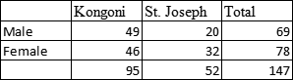

***General performance by Gender and School***

* Pupils from St. Josephs primary school performed better generally than pupils from kongoni primary school pupils.
* The general performance of females in the two schools is also observed to be better than their male counterparts.

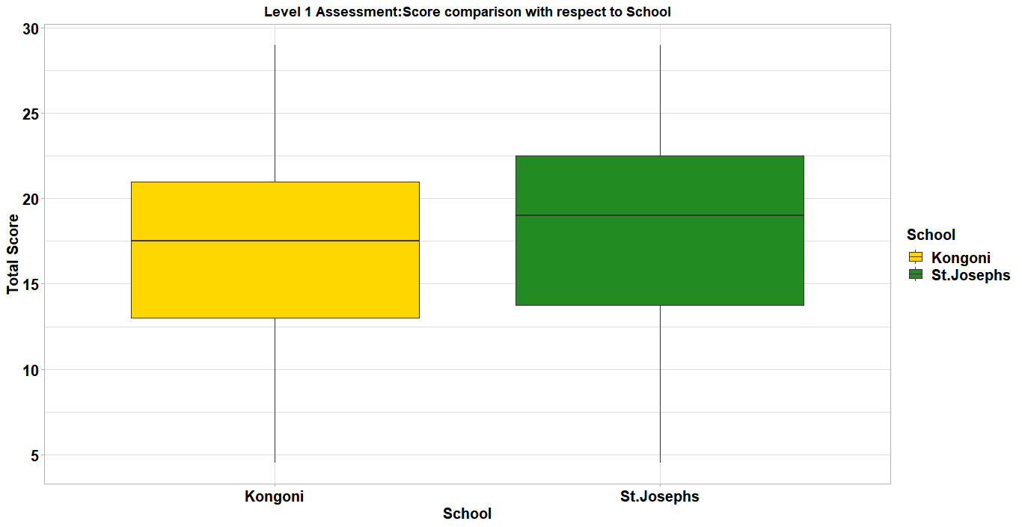

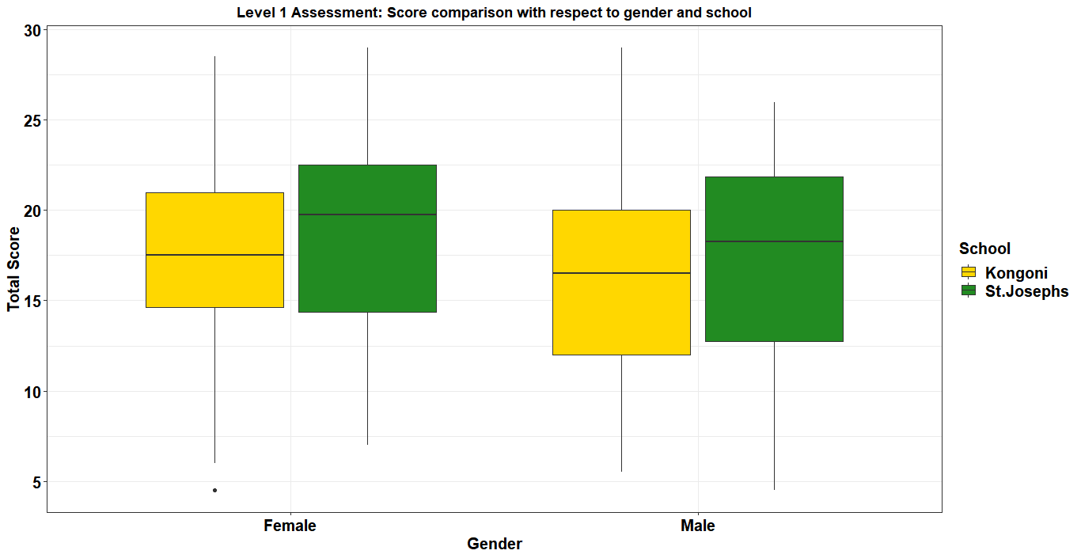

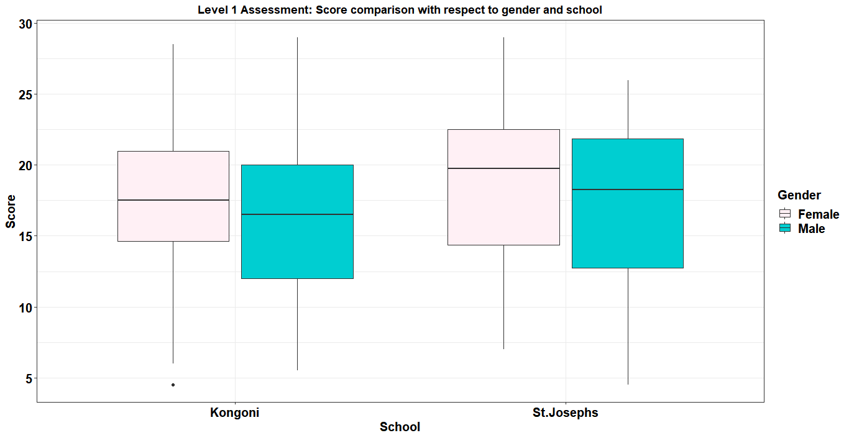

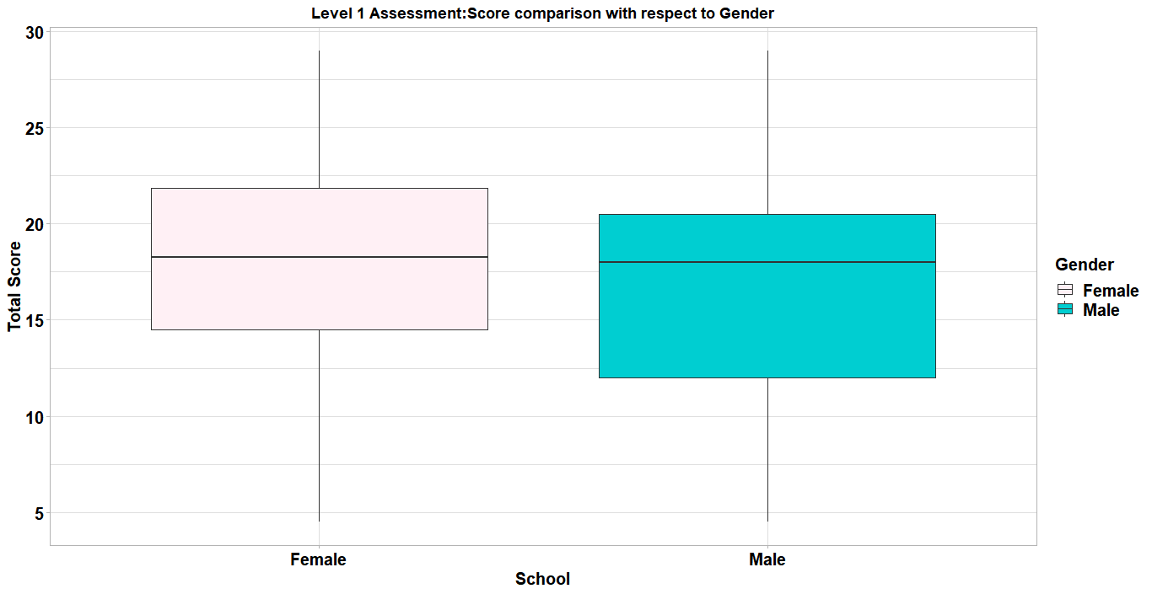

***Math performance***

* There is slight difference in math performance by gender but females have a better performance than male.
* Kongoni school doing better in math on average than St. Josephs
* MathQ8 being highly performed and MathQ4 being the least performed as shown in the table below.

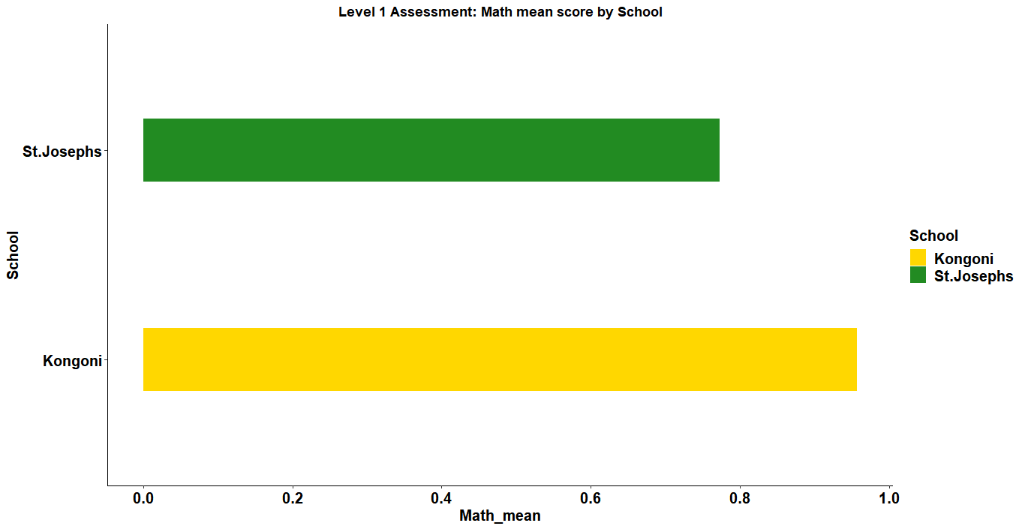

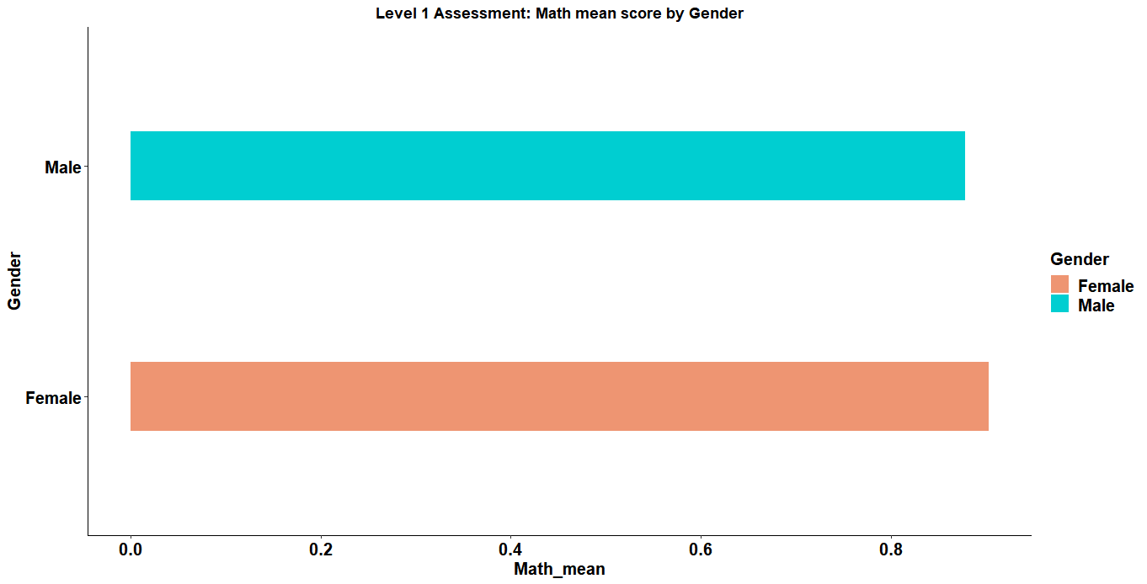

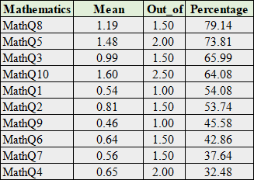

*Student performance on each math questions.*

***Science performance***

* Females doing better than males in science.
* St. Joseph performing highly better than Kongoni in Science.
* *SciQ4 being highly performed and SciQ3 being the least performed as shown in the table below.*
* Generally, the pupils performed poorly in science compared to math.

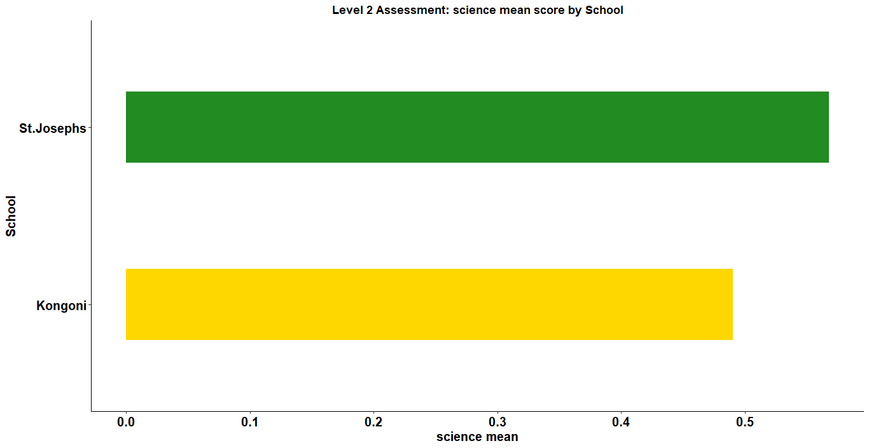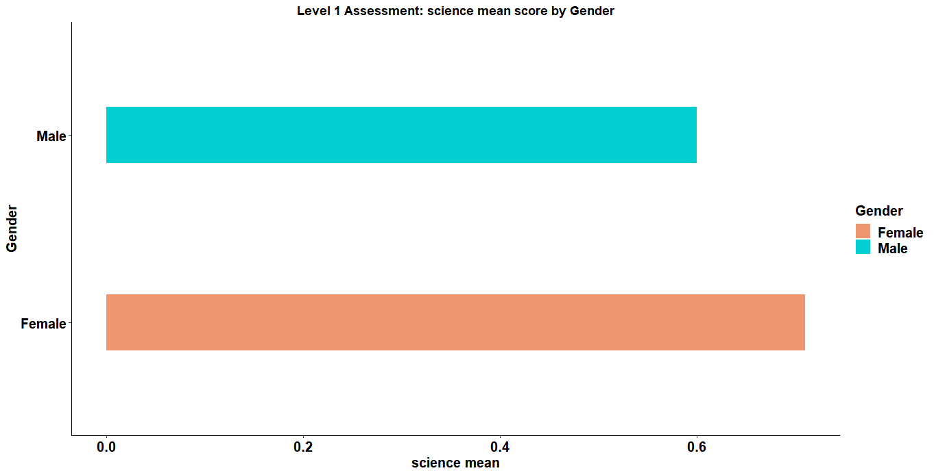

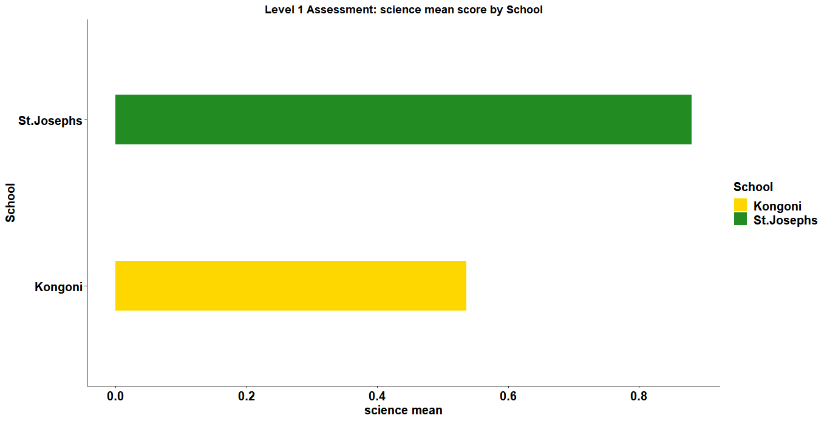

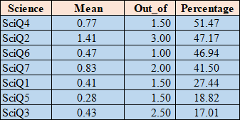

*Student performance on each Science questions.*

***Literacy performance***

* There was slight difference in math performance in both by gender and school but males performed better than the females and St. Joseph performed better than Kongoni respectively.
* *LitQ5 being highly performed and LitQ4 being the least performed as shown in the table below.*

There was slight difference in math performance in both by gender and school but males performed better than the females and St. Joseph performed better than Kongoni respectively 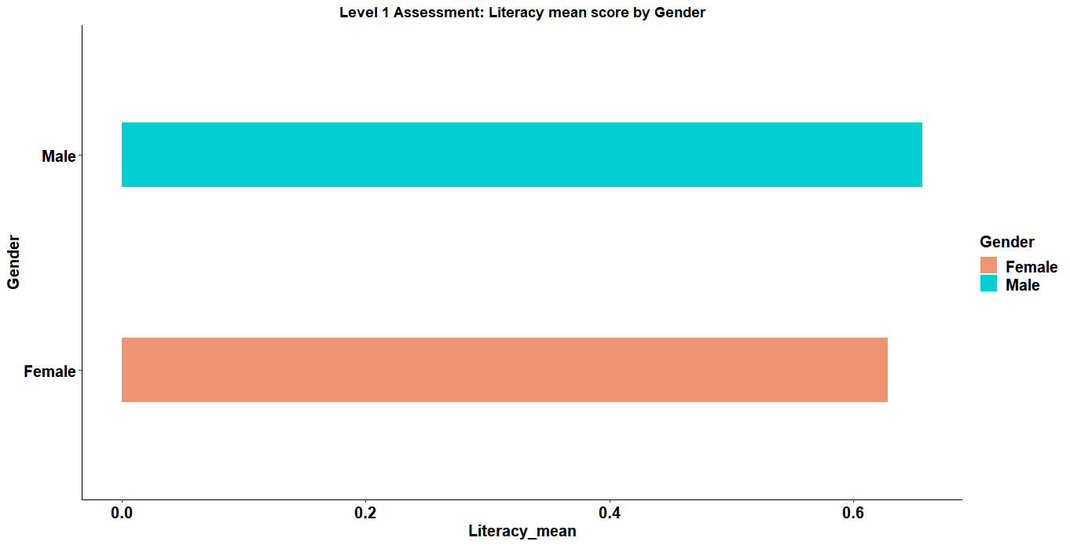

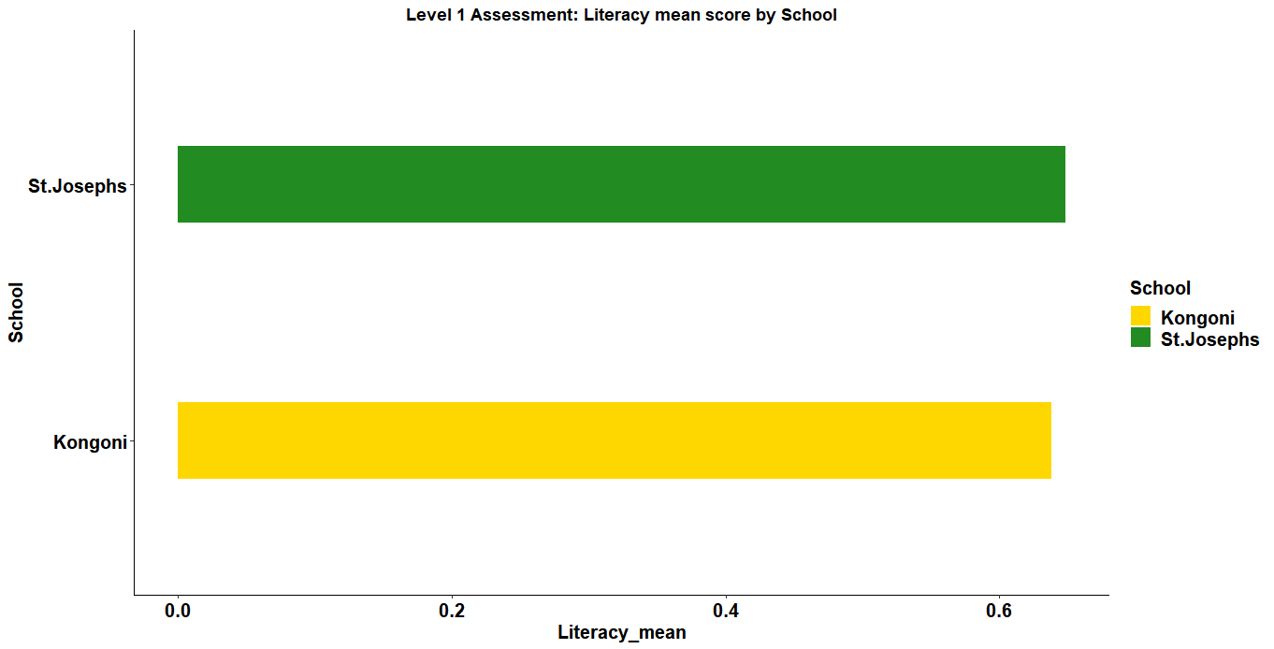

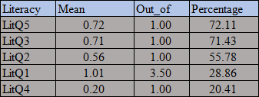

*Student performance on each Literacy questions.*

***Skills performance***

* There was a slight difference in the mean score in males and females but the females performed better.
* St.Joseph are performing highly in skills better than Kongoni primary.

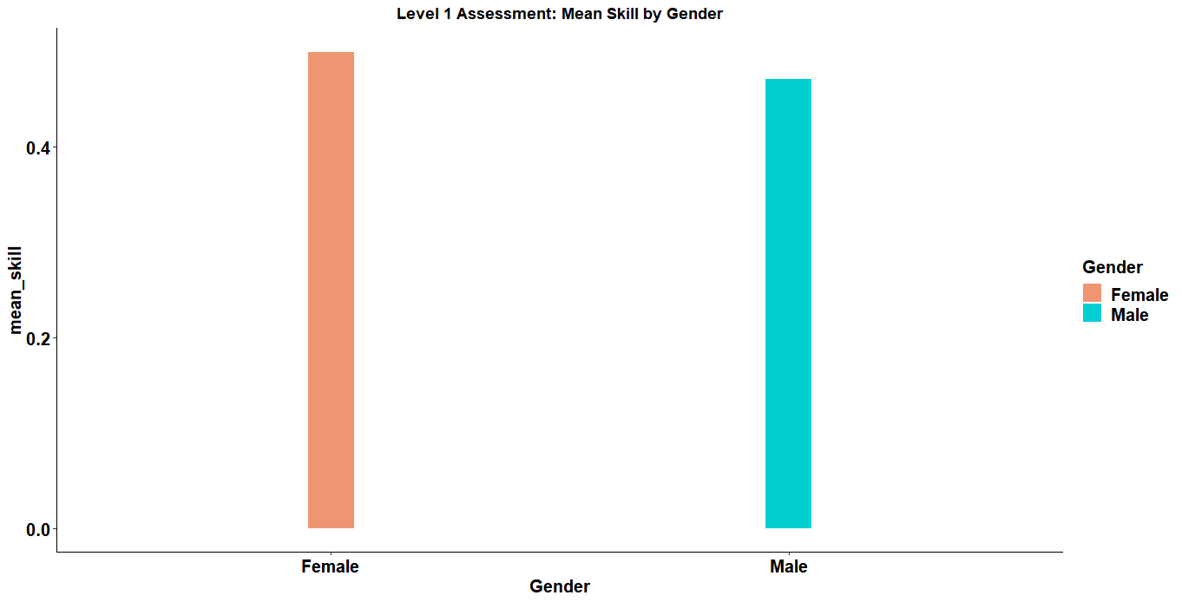

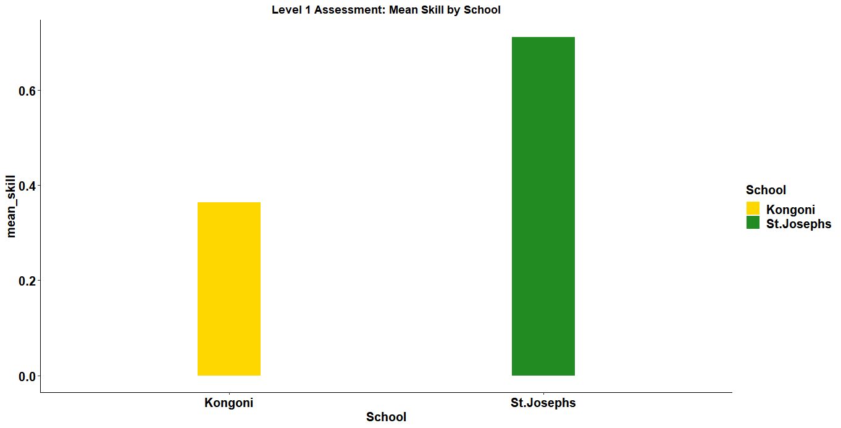

**Level 2 Assessment:**

* The assessment was done by two schools, St. Joseph Primary(72 pupils) and Kongoni Primary(112 pupils)
* It was done by a total of 184 pupils with 94 being females and 90 males as shown below.

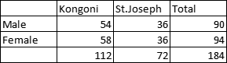

***General Performance***

* There is a slight difference in total performance across the two gender groups.
* The mean score for males in both schools is almost the same though the variation is bigger in St. Josephs.
* Female performance is still higher than that of males in both schools.

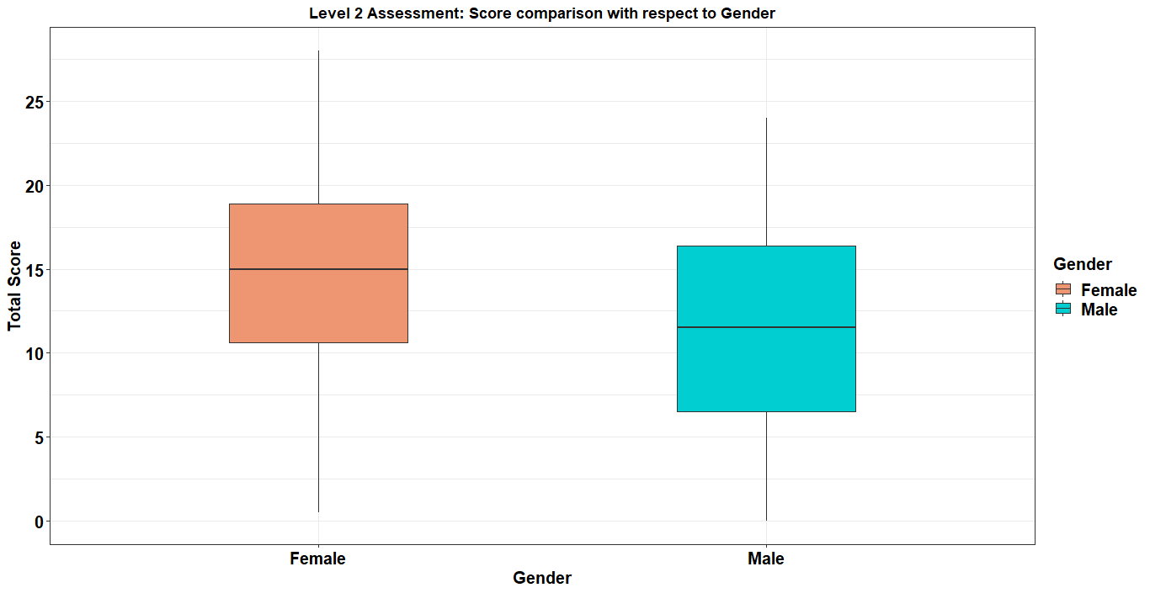

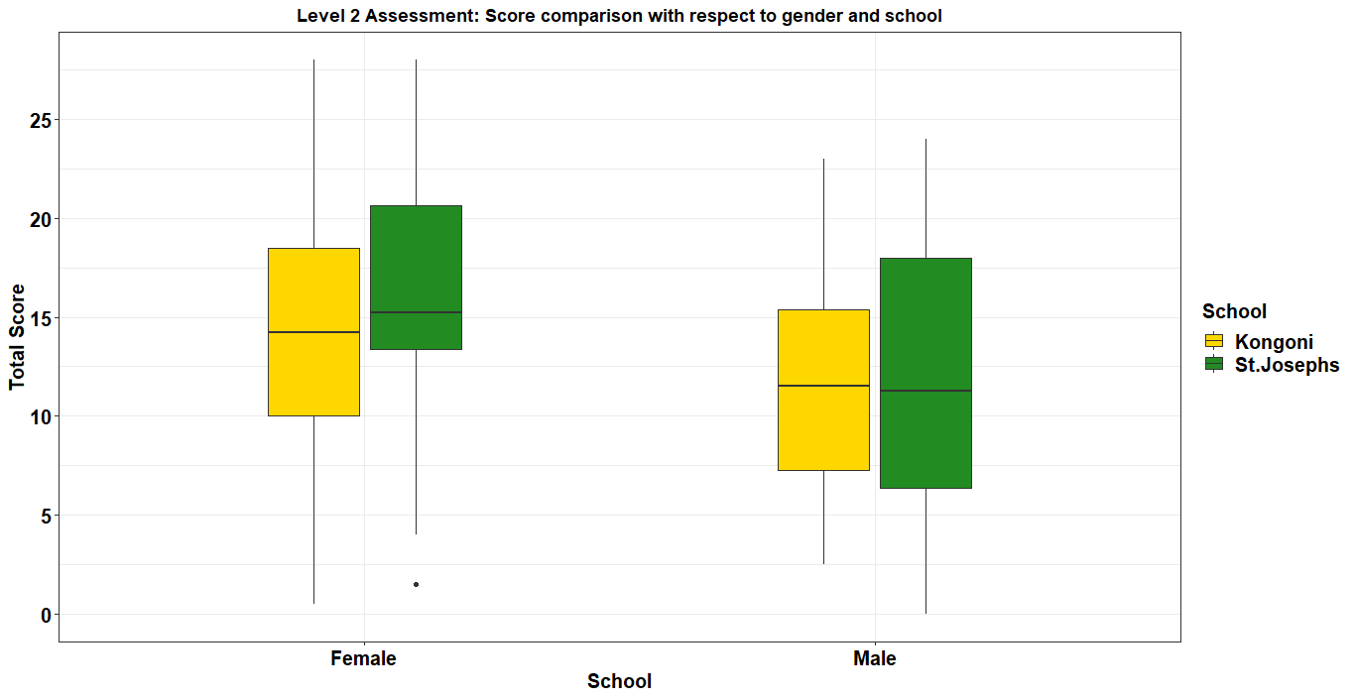

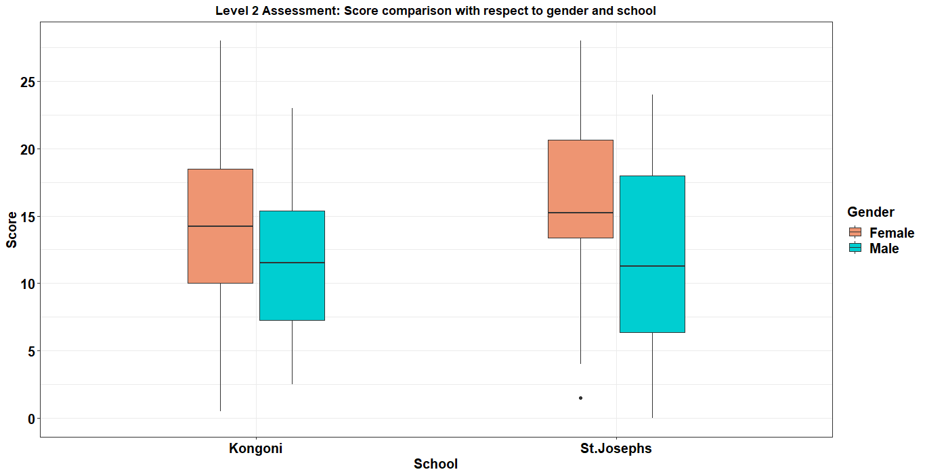

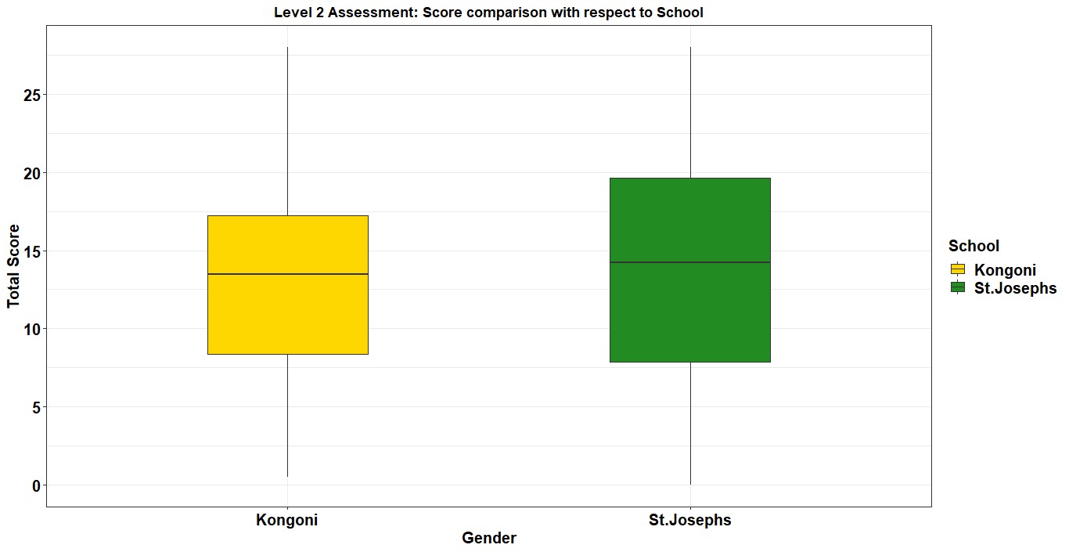

***Math performance***

* Female performed better in mathematics than the males.
* The mean average between the two schools was the same.
* *MathQ10a being highly performed and MathQ3 being the least performed as shown in the table below.*

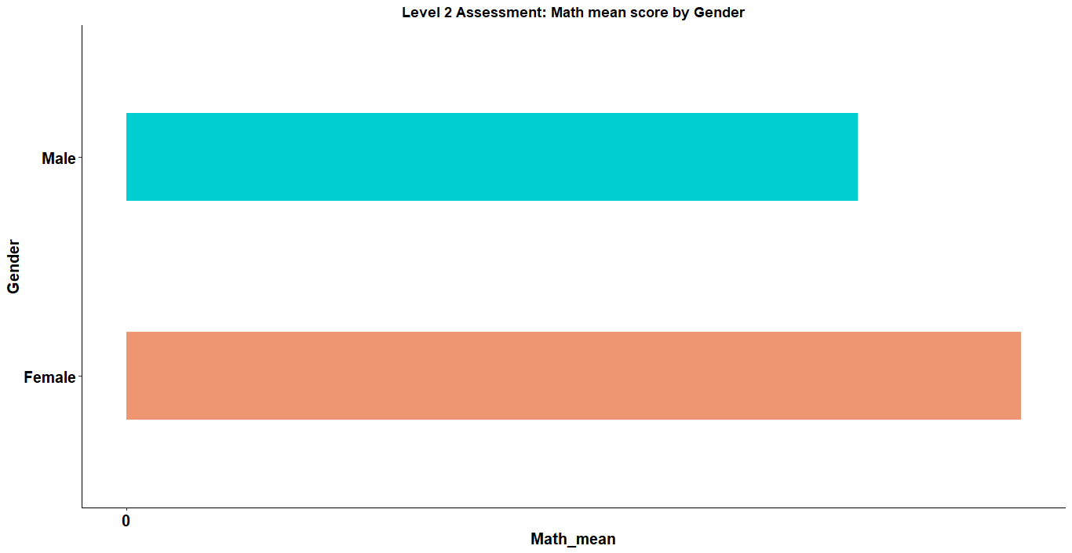

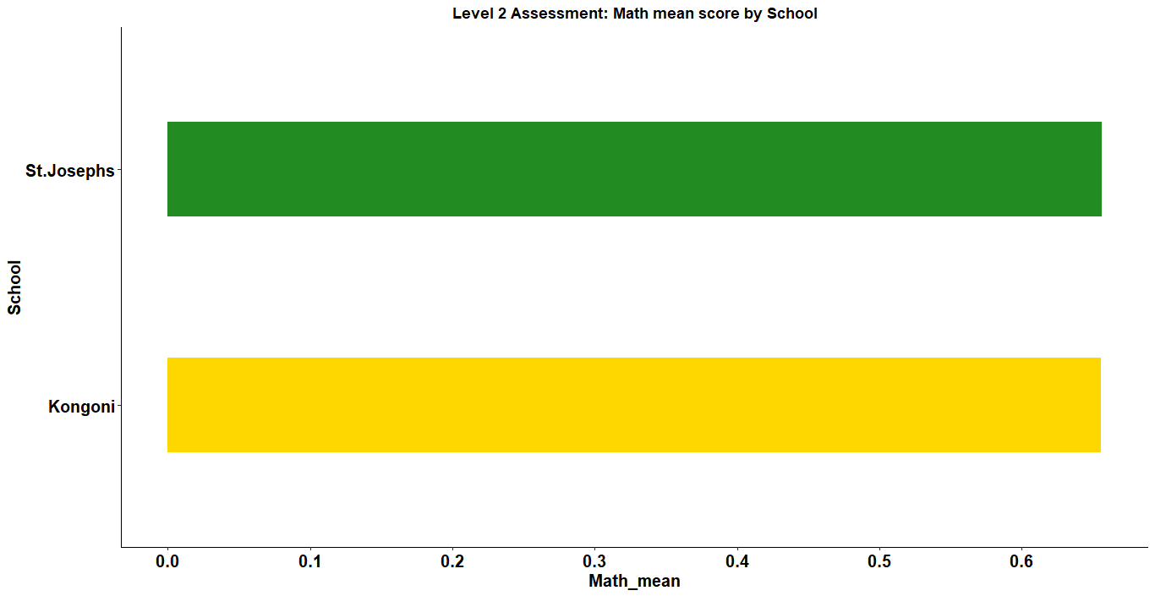

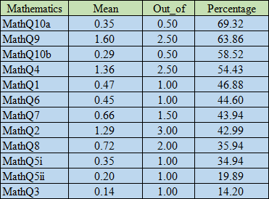

*Student performance on each mathematics questions.*

***Science performance***

* Females performed highly in science than the males in science.
* St.Josephs performed had a high mean score in science better than Kongoni.
* *SciQ2 being highly performed and SciQ7 being the least performed as shown in the table below.*

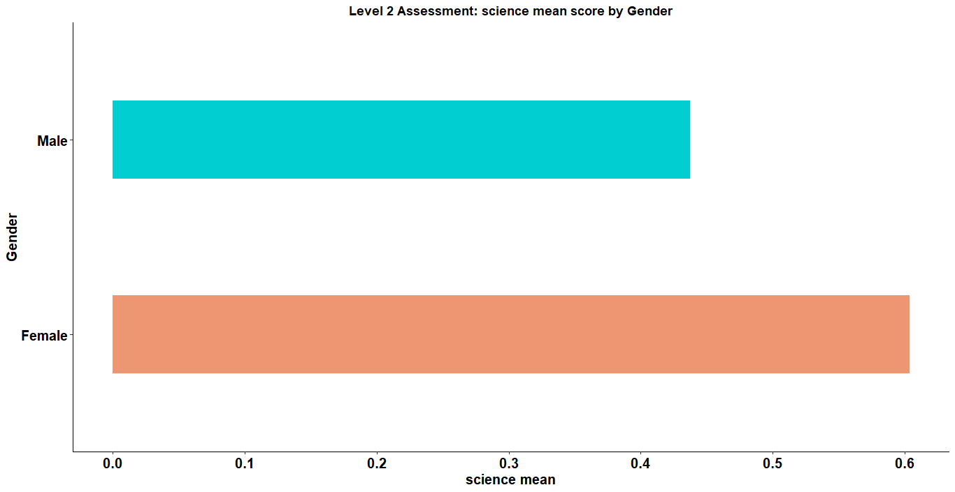



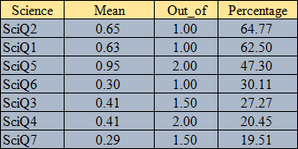

*Student performance on each Science questions.*

***Literacy performance***

* Females performed highly than the males.
* There was a slight difference in the mean average in literacy performance in both schools but Kongoni performed better.
* *LitQ5 being highly performed and LitQ4 being the least performed as shown in the table below.*

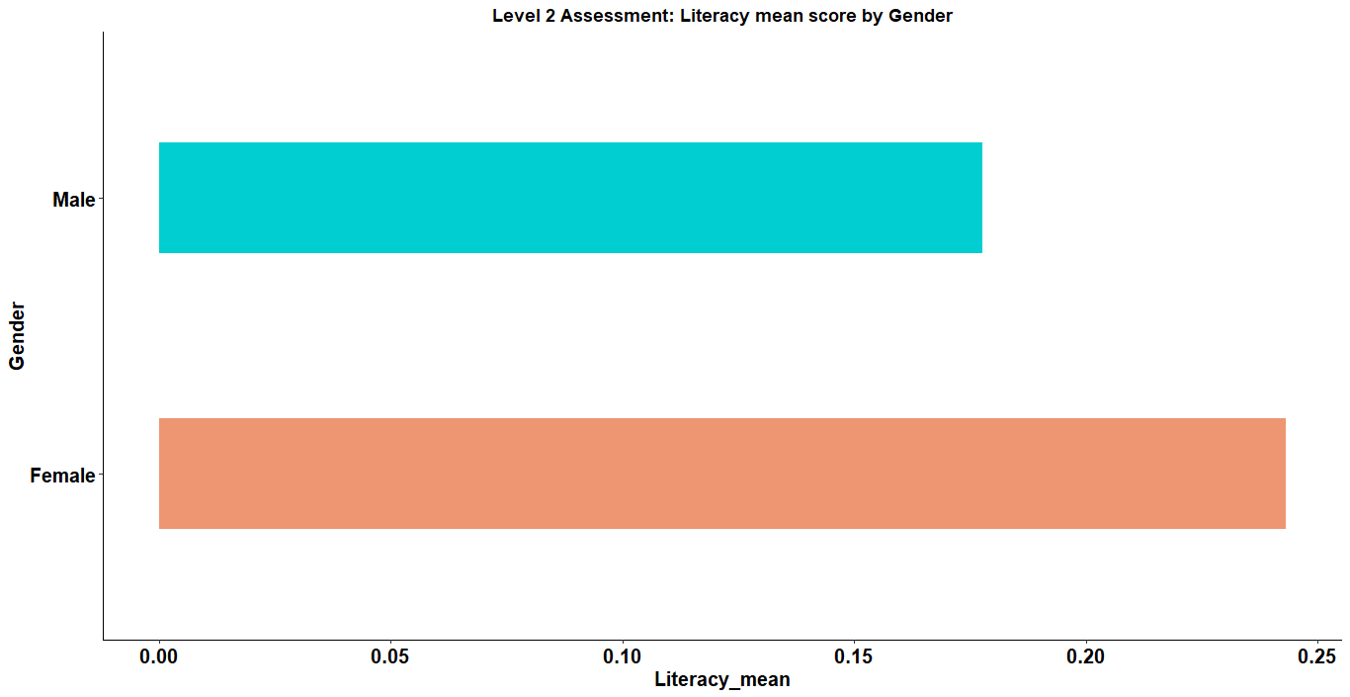

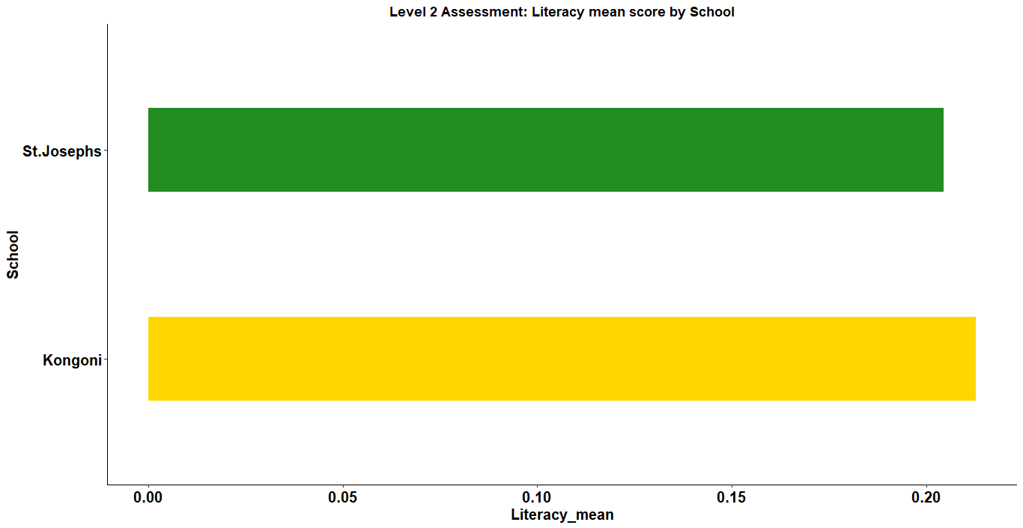

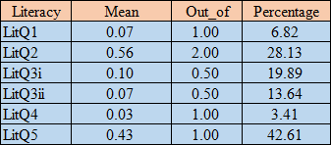

*Student performance on each Literacy questions.*

***Skill performance***

* Females from both schools performed better in skills than their male counterparts.
* St.Josephs had a higher mean in skills performance than Kongoni.

