EDWARD YOHANA
BIT/2024/53391
Project title: UNIVERSITY STUDY PLANNER
Introduction
A university study planner is an organizational tool or system designed to help college students manage their coursework, deadlines, and exam preparations. It bridges the gap between big-picture degree requirements and daily, actionable to-do lists, helping students balance academics with personal commitments to reduce stress.
Objectives
- Task & Deadline Management: Centralizing all exams, group projects, and assignment due dates to ensure timely completion and avoid rushed work.
- Workload Breakdown: Decomposing heavy, overwhelming syllabi or massive reading lists into bite-sized, actionable chunks per study session.
- Goal Setting: Applying SMART criteria (Specific, Measurable, Achievable, Relevant, Time- bound) to your learning sessions to monitor progress and identify knowledge gaps.

Challenges
- Poor user adoption
- Students may forget to use the planner regularly.
- Some prefer paper planners or phone reminders instead.
- Low engagement reduces the effectiveness of the system.
- Complex schedules
- University timetables often change due to room allocations, lecturer availability, or special events.
- The planner must handle timetable updates without confusing students.
- Integration difficulties
.Inconsistent data formats may cause synchronization problems.
- Notification overload
- Too many reminders can annoy users.
- Students may start ignoring important alerts if notifications become excessive.
  - Data accuracy
- Incorrect assignment dates, exam schedules, or class times can lead to missed deadlines.
- The system requires reliable and timely data updates.
  - Internet and device dependency
- Students without stable internet access may struggle to use a cloud-based planner.
- Device compatibility issues can occur across phones, tablets, and laptops.
  - Privacy and security concerns
- Student schedules, personal notes, and academic records must be protected.
- Weak security can expose sensitive information.
8. Usability problems
- A cluttered interface can make planning difficult.
- New users may need training to use advanced features effectively.
9. Cost and maintenance
- Developing and maintaining the system requires funding.

INSTALLATION PROCESS:
SDK Component installation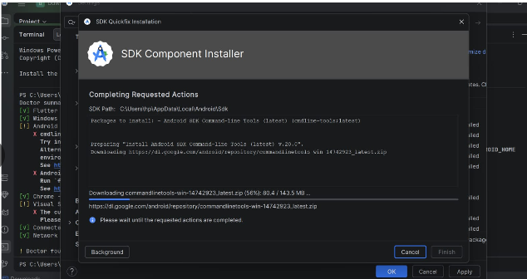
Project Name & android language
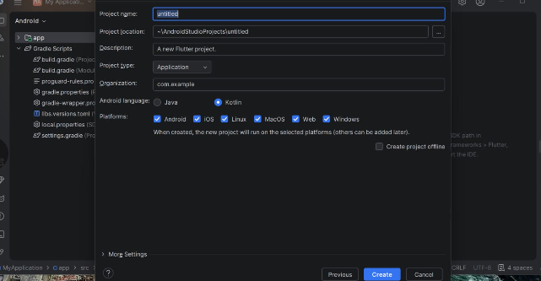

Android App
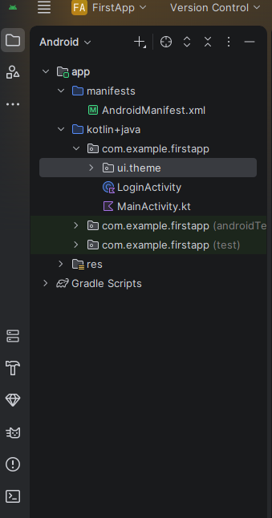
Activity login
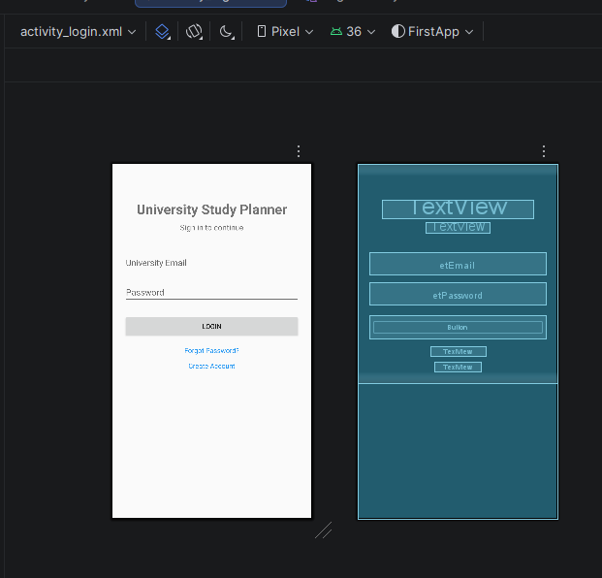

Login Activity
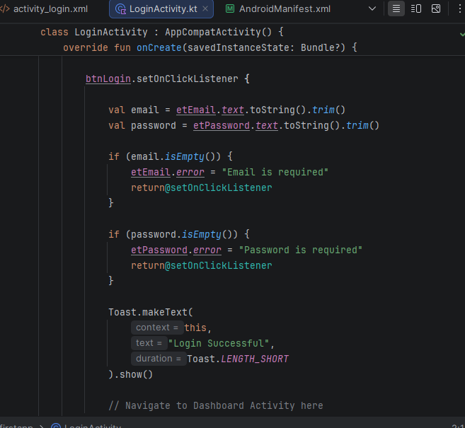
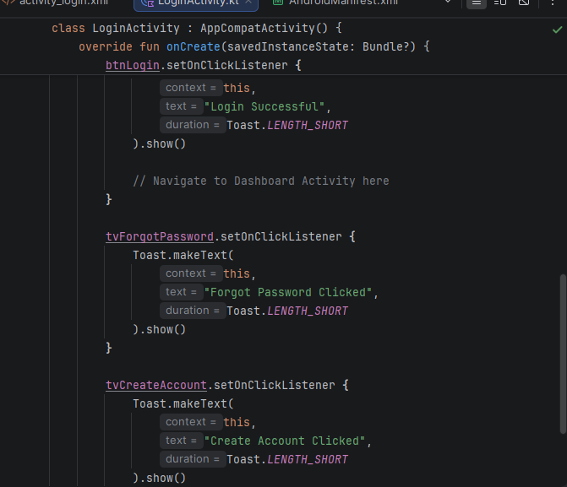

FIGMA
DESIGN
