Name: Edward Pascual-Bautista

ID: 801209596

Assignment: HW0

Github link: https://github.com/Edward-Cloud9/ECGR4105_Linear_Regression.git

1. The linear model for X1 theta0 and theta1: 5.9279 and -2.0383 respectively.

The linear model for X2 theta0 and theta1: 0.7198 and 0.5639 respectively.

The linear model for X3 theta0 and theta1: 2.7804 and -0.4845 respectively.

1. 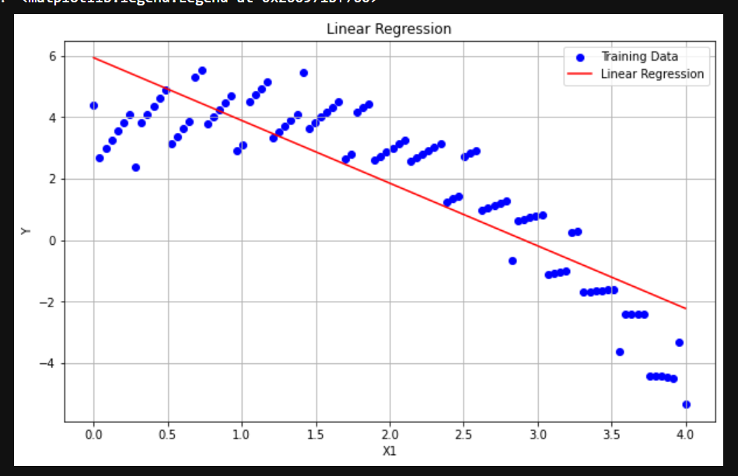

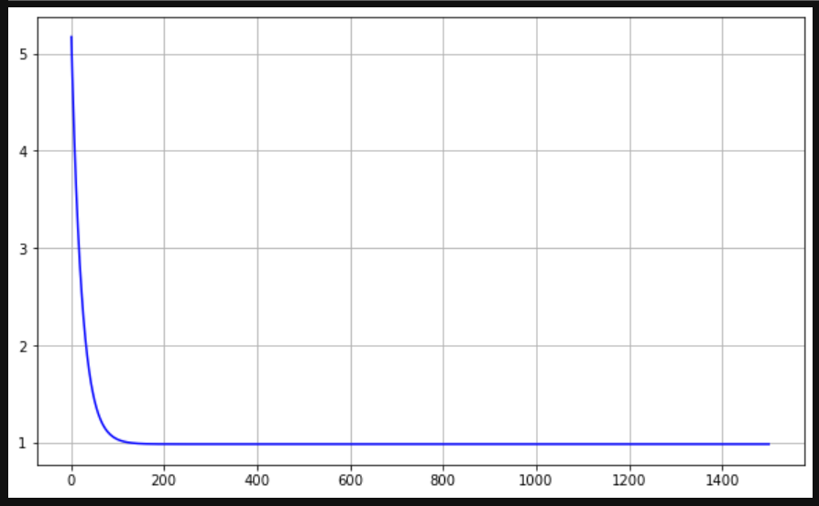

Regression model and Loss over iterations for X1

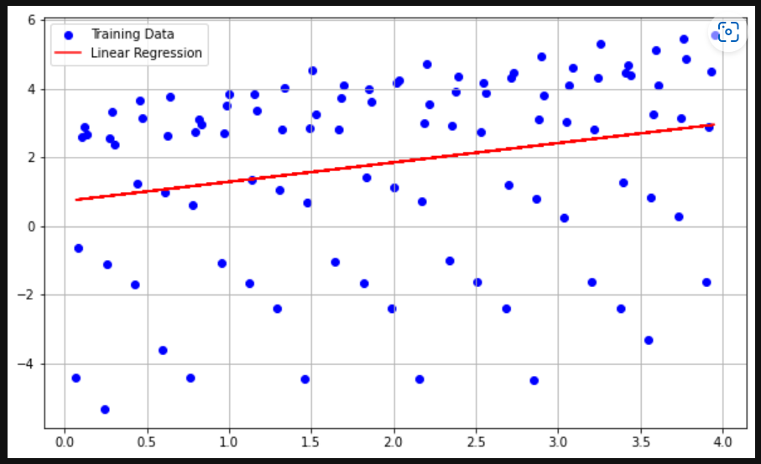

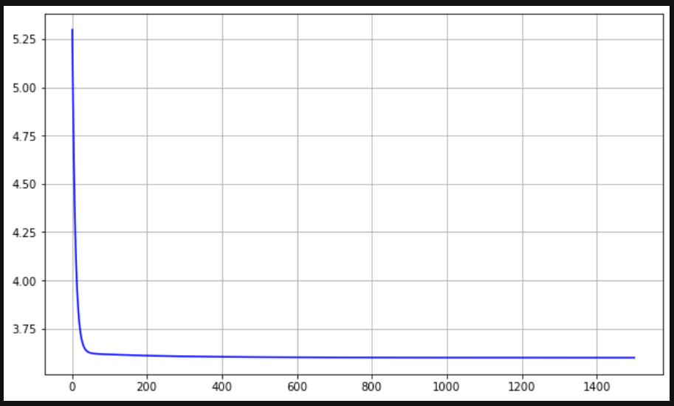

Regression model and loss over the iterations for X2

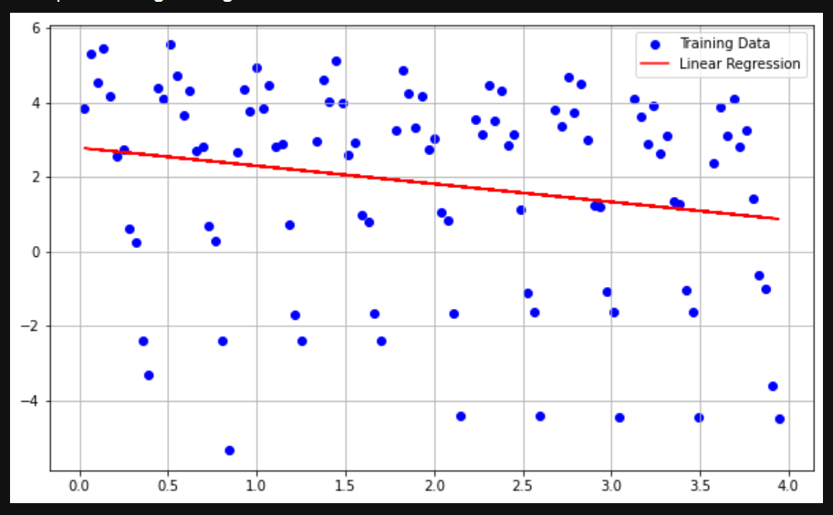

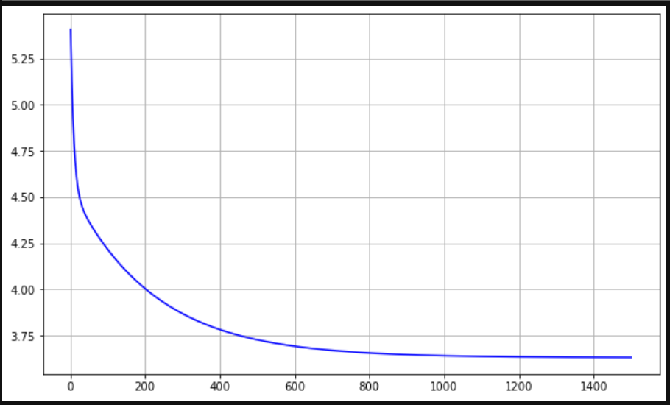

Regression model and loss over the iterations for X3

1. X2 has the lower cost over iterations as it comes closer to the lesser error over a short period of time. X1 would have the 2nd fastest in terms of less iterations to achieve a lower error rate, while X3 takes more iterations to achieve less loss.
2. Increasing the rate from 0.01 to 0.1 allows the loss to be lowered at a short amount of time and increasing the iterations much longer plateaus after 1000 roughly.

Part B

1. Linear model for X of theta0, theta1, theta2, theta3: 4.1511, -1.8394, 0.7247, and -0.09513 respectively.
2. 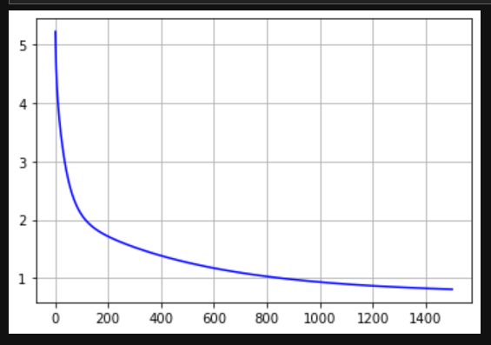

Plot of J (loss) over iterations

1. Increasing the iterations makes the loss approach closer as the passes goes on, but increase the rate from the starting point of 0.01 aids in reaching a lesser cost of loss early in the iterations.
2. H(1,1,1) = 3.5774

H(2,0,4) = 0.509922

H(3,2,1) = 0.10253