Link to github:<https://github.com/Edward-EH-Holmes/CS5346-2023-24-Quiz>  
Question a

1. The number of earthquakes for 5 different countries (your choice of which 5) over the years

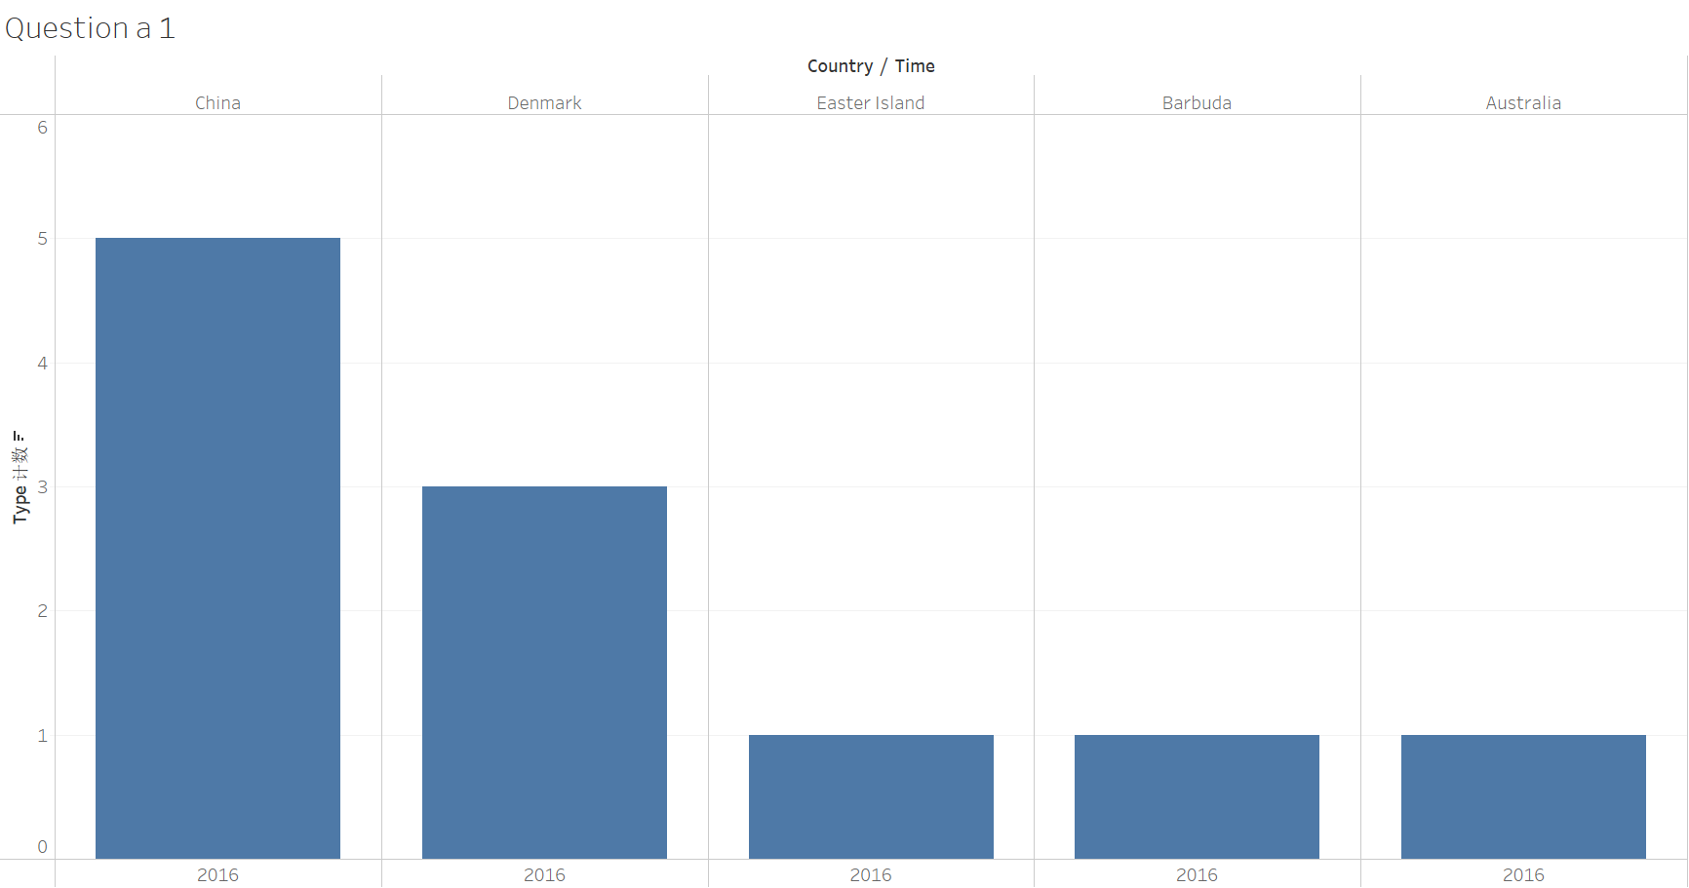

2. The average earthquake magnitudes for 5 different countries (your choice of which 5) over the years

6. The times at which earthquakes occurred in a given country

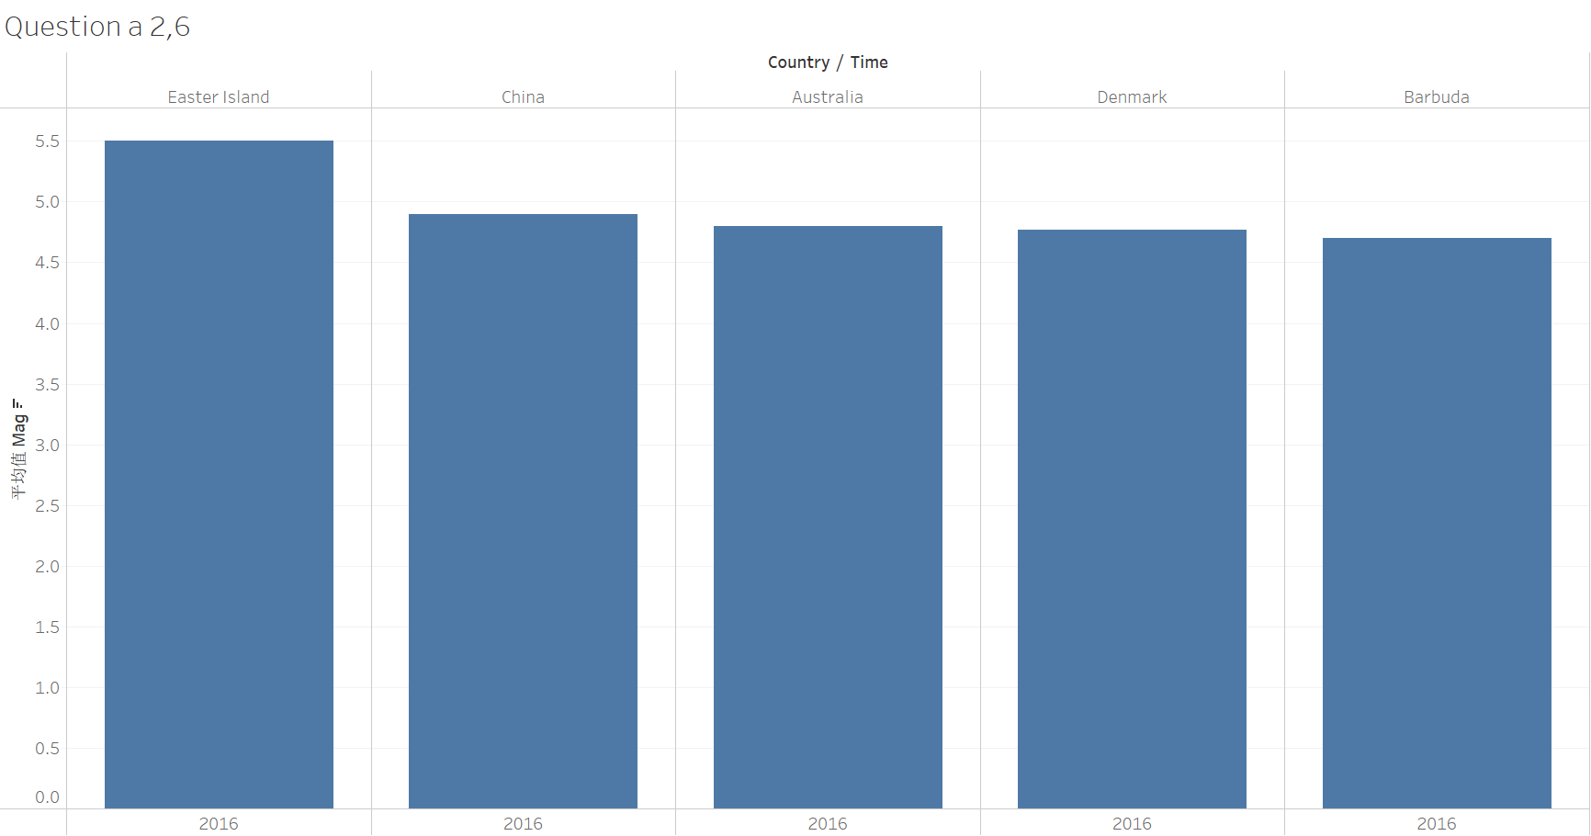

4. The locations of the highest and lowest magnitude earthquakes (you are allowed to define “highest” and “lowest”)

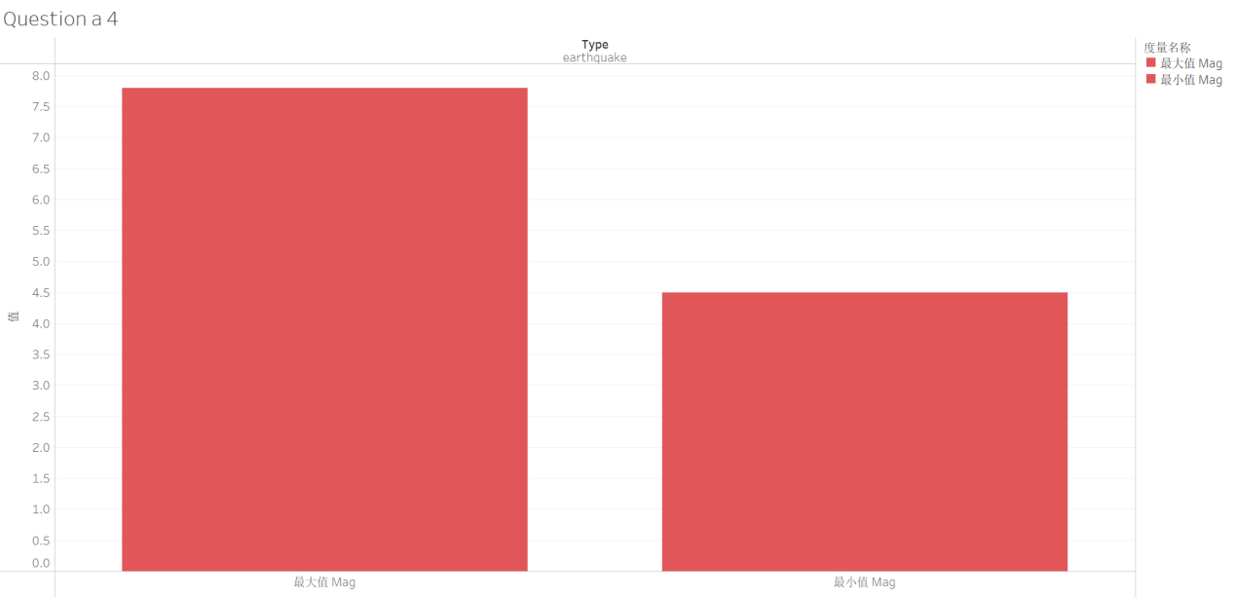

5. The relationship between the magnitude of earthquakes and their frequency

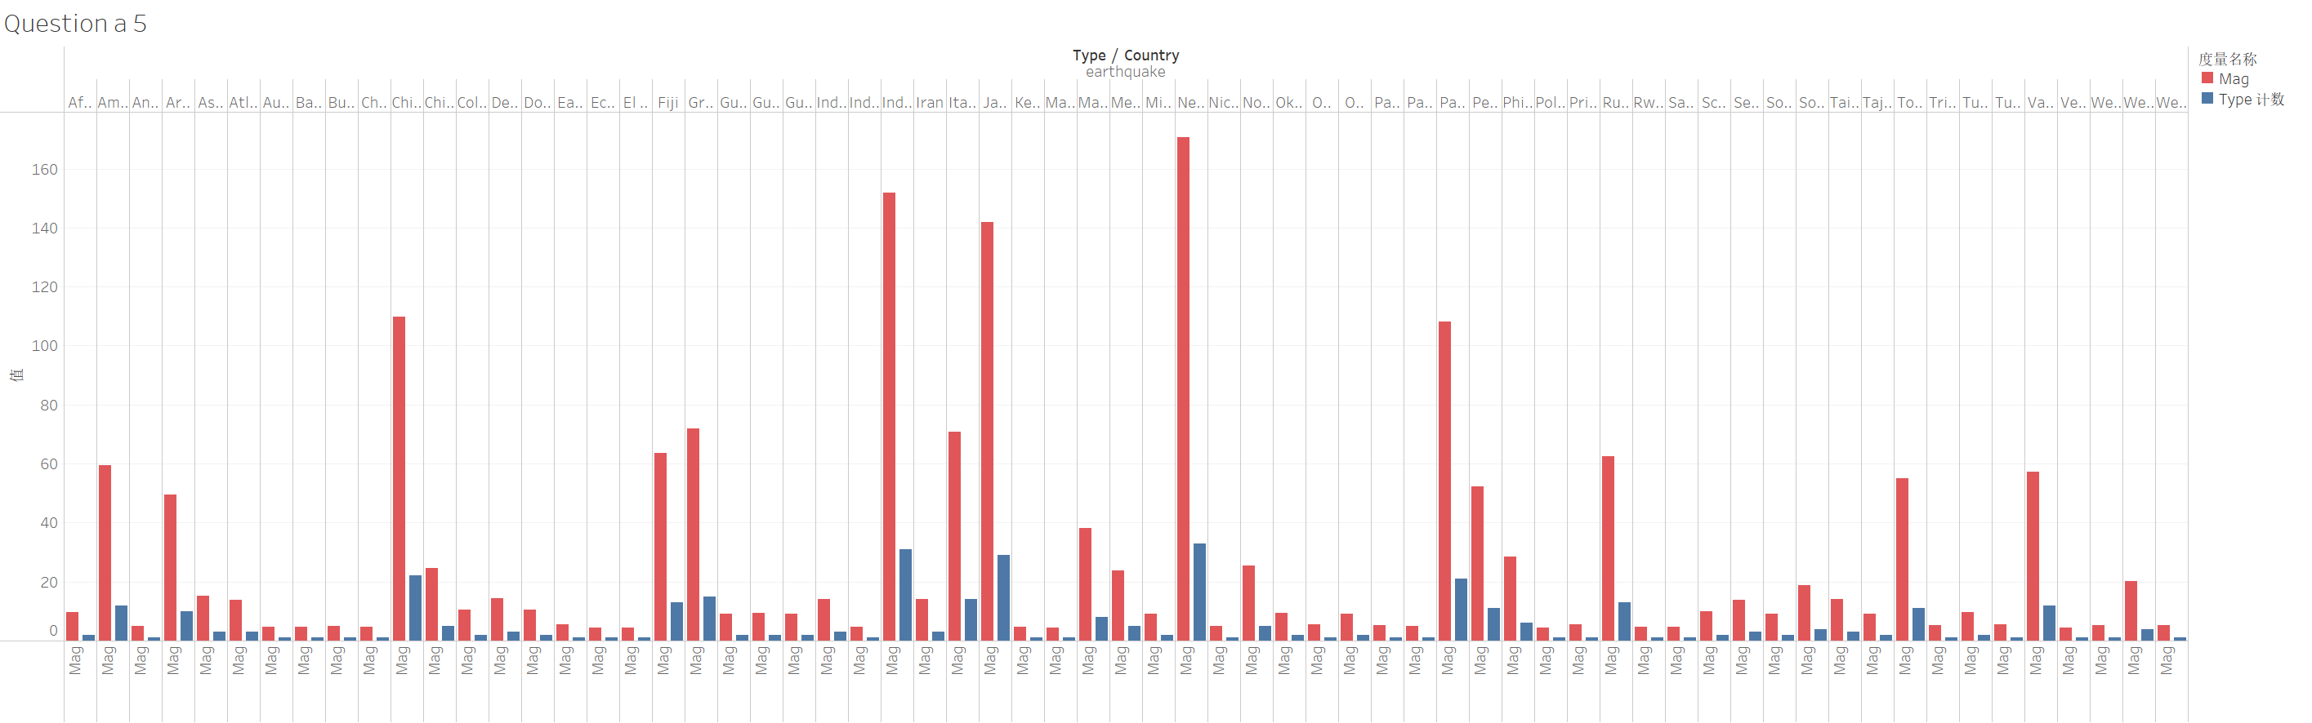

Seems weak cooperation.

7. The top 10 countries which experience earthquakes most frequently

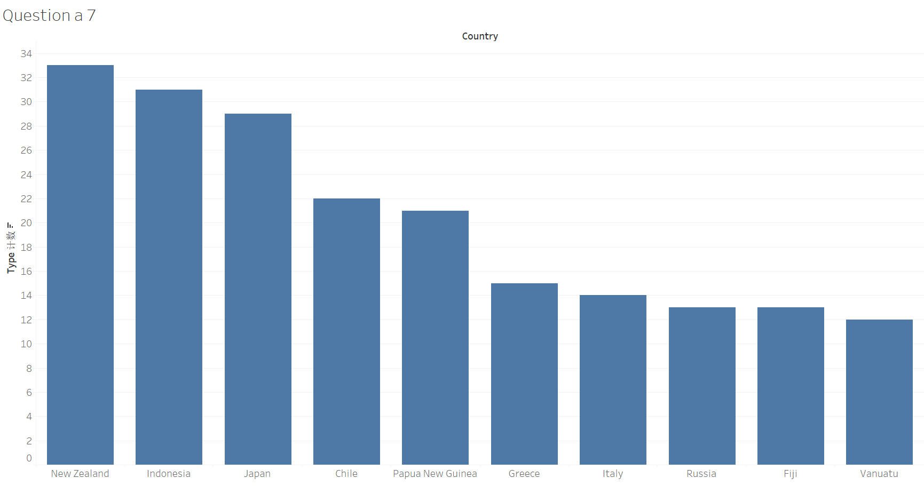

Question b