AML Transaction & Fraud Analysis – Business Insight Report
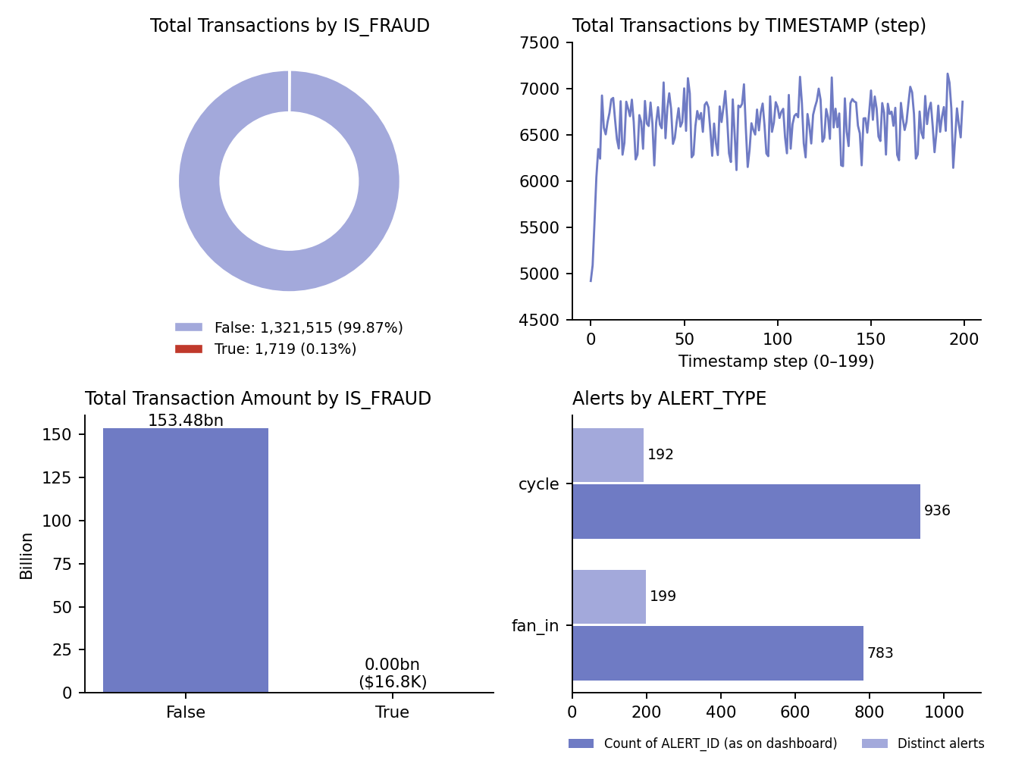
Figure 1: Key visuals of the AML dashboard, rebuilt from the data in DATA_SET_5.pbix

1. Dashboard Overview
The Power BI file contains three report pages: KPI CARDS (six KPI cards and four charts), INTERACTIVE DASHBOARD (the same KPIs and charts plus two slicers, ALERT_TYPE and IS_FRAUD) and TOOL TIP (a hover page showing Total Transaction Amount, Total Transactions and Fraudulent Transactions). Together they give an overview of Anti-Money Laundering (AML) transactions, fraud status, transaction activity and alert types, and help users identify suspicious activity.
Note: Every figure in this report was calculated directly from the three data tables inside the .pbix file using the dashboard’s own DAX measures, so the numbers match what the dashboard shows. Where the data suggests a measure may be misleading, this is called out.

2. Overview of the AML Dataset
The data model contains three related tables used to analyse financial activity, identify potential fraud and monitor suspicious transaction patterns:
Table | Rows | Key fields
transactions | 1,323,234 | TX_ID, SENDER_ACCOUNT_ID, RECEIVER_ACCOUNT_ID, TX_TYPE, TX_AMOUNT, TIMESTAMP, IS_FRAUD, ALERT_ID
accounts | 10,000 | ACCOUNT_ID, CUSTOMER_ID, INIT_BALANCE, COUNTRY, ACCOUNT_TYPE, IS_FRAUD, TX_BEHAVIOR_ID
alerts | 1,719 | ALERT_ID, ALERT_TYPE, IS_FRAUD, TX_ID, SENDER_ACCOUNT_ID, RECEIVER_ACCOUNT_ID, TX_TYPE, TX_AMOUNT, TIMESTAMP

Relationships: alerts to transactions is one-to-one on TX_ID (filtering both ways); transactions to accounts is many-to-one on SENDER_ACCOUNT_ID (active); the link on RECEIVER_ACCOUNT_ID is inactive. The dashboard uses IS_FRAUD, TIMESTAMP, ALERT_ID and ALERT_TYPE together with six DAX measures.
A few characteristics of the data are worth knowing: all 10,000 accounts are US individual accounts (ACCOUNT_TYPE “I”), every transaction is of type TRANSFER, and TIMESTAMP is a whole-number step from 0 to 199 rather than a calendar date. Accounts fall into five equal behaviour groups of 2,000. These traits suggest the data is simulated, so results illustrate monitoring methods rather than real customer behaviour.
The main purpose of the dashboard is to monitor transaction volumes, compare fraudulent and non-fraudulent transactions, analyse alert categories, and support financial institutions in identifying activities that may require further investigation.

3. KPI Interpretation
The dashboard displays six key performance indicators (KPIs).
KPI | Dashboard Value | Interpretation
Fraudulent Transactions | 1,719 | Transactions flagged IS_FRAUD = TRUE, which is 0.13% of all transactions.
Total Transaction Amount | 153.48 billion | Sum of TX_AMOUNT (153,479,506,205). Heavily inflated by a small number of extreme values (see below).
Total Transactions | 1.32 million | Exact count is 1,323,234 transactions.
Total Accounts | 10,000 | Distinct accounts in the accounts table.
Average Transaction Amount | 115.99K | Mean TX_AMOUNT (115,988). The median transaction is only 156.71, so the mean is not representative.
Total Initial Balance | 2.80 million | Sum of opening balances (2,801,186); about 280 per account on average, ranging from 100 to 600.

These KPIs give a quick overview of transaction activity and potential fraud. The number of fraudulent transactions shows the scale of detected fraud, while total and average transaction amount describe the financial activity in the dataset.

Why the amount KPIs need caution
- Extreme values dominate. Only 15,911 transactions (1.2%) are above 1 million, yet they make up 97.0% of the total transaction amount. Typical transactions are small: 68% fall between 100 and 1,000, and the median is 156.71.
- A ceiling value appears. 3,053 transactions have exactly the same amount, 21,474,836.47. This equals 2,147,483,647 cents, the maximum value of a 32-bit integer, so it is probably a system cap or overflow rather than a genuine amount. These transactions alone account for 42.7% of the total (65.56 billion). Excluding them, the total falls to 87.92 billion and the average to about 66.6K.
- Scale mismatch. Total transaction amount is roughly 55,000 times the total initial balance of all accounts. Money of this size cannot be moved by accounts holding 2.8 million in total, which further indicates the large amounts are a data or simulation artefact.
Note: Before using these KPIs for formal reporting, confirm how the large amounts were generated, and consider adding a Median Transaction Amount measure beside the average.

4. Fraud Status Analysis
The donut chart compares transactions according to the IS_FRAUD field.
- False: 1,321,515 transactions (99.87%) are classified as non-fraudulent.
- True: 1,719 transactions (0.13%) are classified as fraudulent.
The column chart of total transaction amount by fraud status shows the non-fraudulent category holding virtually the entire value, 153.48 billion. The fraudulent category totals only 16,783 (about 0.00001% of the total), which is why it appears as zero on the chart.
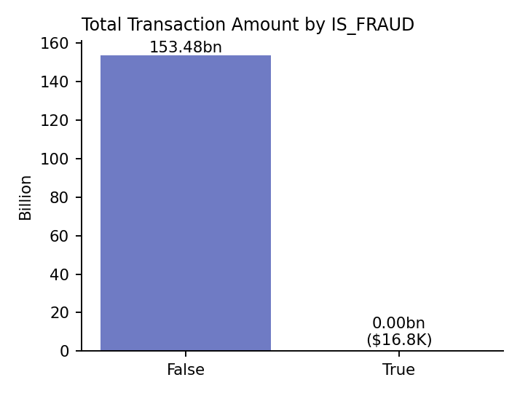
Figure 2: Total transaction amount by IS_FRAUD
Fraudulent transactions are also very small individually: they range from 2.54 to 19.92, with an average of 9.76 (the median is 10.60). No transaction above 20 is flagged as fraud, which means detection in this dataset is tied to small-value transfers, whereas the very large transfers are all classified as non-fraudulent.
At account level, 1,685 of the 10,000 accounts (16.85%) are flagged as fraudulent. Every fraudulent transaction was sent from one of these accounts. Flagged accounts are spread across all five behaviour groups, from 14.6% in group 1 to 19.9% in group 5.
Insight: A low fraud percentage does not mean the risk is insignificant, and a low fraud value does not mean the activity is harmless. Small, structured transfers are a classic AML pattern, while the large non-fraud transactions are the larger unexplained exposure and deserve review.

5. Transaction Activity Analysis
The line chart displays transaction volume by timestamp step (0 to 199). After an initial rise over the first five steps (from 4,920 to about 6,350), volumes fluctuate in a narrow band of roughly 6,100 to 7,200. The average is 6,616 transactions per step, and the busiest step is 191 with 7,161.
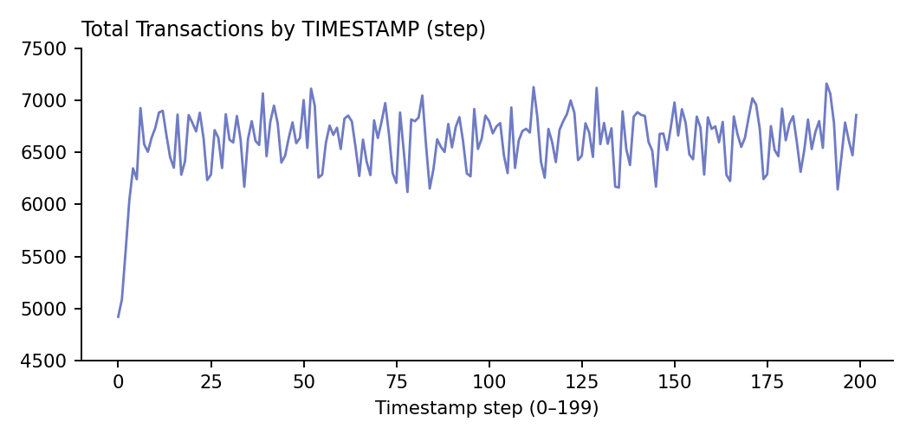
Figure 3: Total transactions by timestamp step
Volume is therefore very stable, but value is not. Total transaction amount rises sharply across the period, while the median transaction stays flat at about 156 in every step:
Timestamp steps | Transactions | Total amount | Average per transaction
0 – 49 | 326,374 | 205.4 million | 629
50 – 99 | 331,187 | 1.90 billion | 5,745
100 – 149 | 332,518 | 18.98 billion | 57,074
150 – 199 | 333,155 | 132.39 billion | 397,383

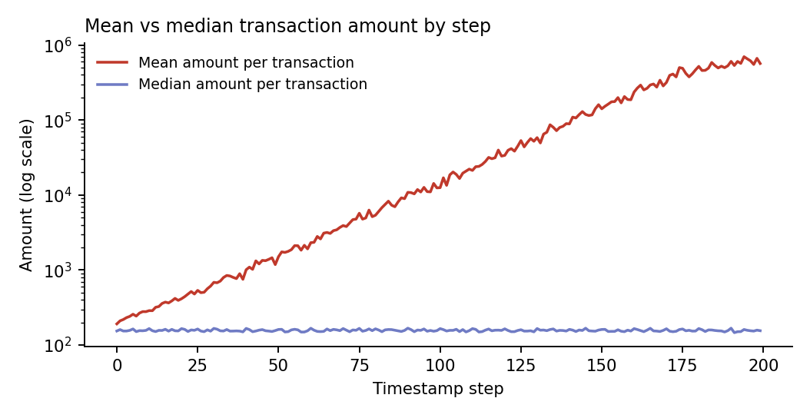
Figure 4: Mean versus median transaction amount per step (log scale)
The final 50 steps contribute 86.3% of the total value, and all but one of the 3,053 ceiling-value transactions occur between steps 149 and 199. Amounts therefore grow roughly tenfold every 50 steps even though the number of transactions does not change. A small group of large transactions is driving the increase, and this pattern would be a priority to investigate in a real monitoring environment.
Insight: Volume monitoring alone would miss this pattern. AML teams should track value, median and high-percentile amounts alongside transaction counts.

6. Alert Analysis
The horizontal bar chart plots Count of ALERT_ID by alert type. Because the alerts table holds one row per transaction in an alert, the chart counts transactions inside alerts rather than distinct alerts:
Alert type | Dashboard count (rows) | Distinct alerts | Total alerted amount
cycle | 936 | 192 | 13,869
fan_in | 783 | 199 | 2,914
Total | 1,719 | 391 | 16,783

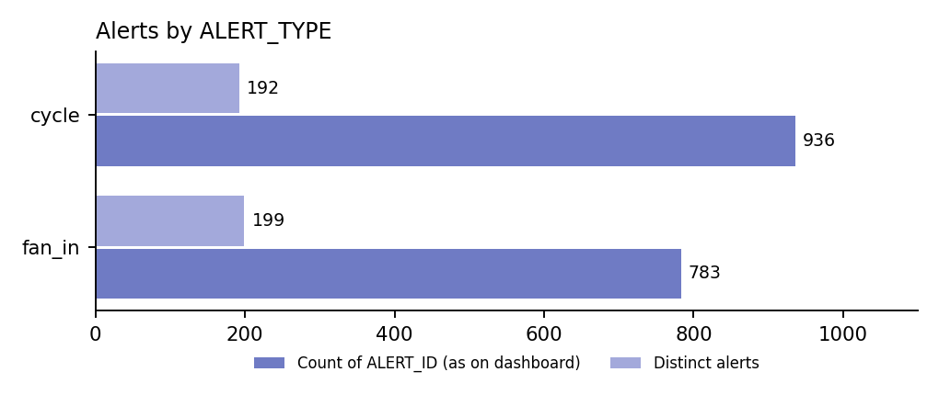
Figure 5: Alert counts by type, as shown on the dashboard and as distinct alerts
On the dashboard measure, cycle alerts are higher (936 against 783). Counted as distinct alerts, however, fan_in is slightly more frequent (199 against 192). The difference arises because a cycle alert typically contains 5 transactions (183 of 192 alerts) and a fan_in alert 4 transactions (190 of 199 alerts). Cycle activity involves more transactions and larger amounts (average 14.82 against 3.72), but fan_in generates slightly more alerts.
In AML monitoring, cycle patterns may involve funds moving through a sequence of accounts and returning to the start, while fan-in patterns involve funds from several sources converging on one account. Each fan_in alert in this data has exactly one receiving account. Both types appear evenly across the 200 steps, so neither is concentrated in a particular period. These patterns can have legitimate explanations, so an alert should be investigated rather than treated automatically as proof of fraud.
The alerts cover 1,639 distinct accounts, all of which are flagged fraudulent. A further 46 flagged accounts do not appear in any alert transaction. Every alert transaction is marked fraud, so the data contains no false positives, which means the alert rules cannot be evaluated for accuracy from this file.
Insight: Both alert types need review. Cycle alerts carry the larger transaction count and value, while fan_in alerts are marginally more numerous. Prioritise by transaction details, risk level and supporting evidence rather than by the chart count alone.

7. Filter-Based Analysis
The INTERACTIVE DASHBOARD page includes two slicers that allow users to explore the data.

Alert Type filter
The ALERT_TYPE slicer (built from the alerts table) lets users select cycle or fan_in. Because alerts and transactions are linked one-to-one, selecting a type narrows every chart and card to the transactions in that alert category, for example 936 transactions for cycle and 783 for fan_in.

Fraud Status filter
The IS_FRAUD slicer is built from the accounts table, not the transactions table. Selecting True therefore shows all transactions sent by flagged accounts (278,026 transactions), of which only 1,719 are themselves flagged as fraud. This differs from the IS_FRAUD field used in the donut and column charts.
Based on the model relationships, Total Accounts and Total Initial Balance would not change when a chart value or the ALERT_TYPE slicer is selected, because filters pass from accounts to transactions and not the other way. These behaviours should be confirmed in Power BI Desktop, and the slicer should be switched to transactions[IS_FRAUD] if the intention is to isolate fraudulent transactions.

8. Key AML Insights
- Low proportion of fraudulent transactions: Only 0.13% (1,719) of transactions are classified as fraudulent, compared with 99.87% non-fraudulent.
- Large transaction volume: The dataset contains 1,323,234 transactions across 10,000 accounts, which makes automated monitoring essential.
- Headline value is distorted: The 153.48 billion total and 115.99K average are driven by 1.2% of transactions, including 3,053 at an apparent system ceiling of 21,474,836.47. The median transaction is 156.71.
- Fraud is small-value: Fraudulent transactions total only 16,783, between 2.54 and 19.92 each, and 16.85% of accounts are flagged.
- Steady volume, escalating value: Transactions per step stay near 6,600, but total amount grows roughly tenfold every 50 steps, with 86.3% of value in the final quarter.
- Alert counts depend on the measure: Cycle leads on transactions (936 against 783), while fan_in leads on distinct alerts (199 against 192).
- Filter logic needs checking: The IS_FRAUD slicer filters by account flag, not transaction flag.
- Further verification is necessary: Dashboard indicators support investigation but are not proof of confirmed money laundering or fraud.

9. Recommendations
- Validate the amount data: Investigate the 3,053 transactions at 21,474,836.47 and the 15,911 transactions above 1 million. Confirm whether they are genuine, capped or overflow values before reporting totals.
- Improve KPI design: Add a Median Transaction Amount and a Fraud Rate % measure, and consider showing totals with and without extreme values. The average alone is misleading.
- Fix the alert measure: Use DISTINCTCOUNT of ALERT_ID so alerts are counted once, and show transactions per alert as a separate measure.
- Correct the fraud slicer: Base the IS_FRAUD slicer on transactions[IS_FRAUD], and test that every card and chart responds correctly to each filter.
- Strengthen monitoring beyond volume: Track value, median and high-percentile amounts by step, with alerts for sudden growth, as transaction counts alone hide the escalation.
- Investigate high-priority alerts: Review cycle and fan_in alerts using transaction histories, account relationships and supporting evidence, prioritising by risk rather than chart size.
- Examine large non-fraud transactions: Since all transactions above 20 are labelled non-fraud, review whether detection rules are missing large-value suspicious activity.
- Review flagged accounts without alerts: Examine the 46 flagged accounts that appear in no alert transaction, and the behaviour groups with higher flag rates (groups 4 and 5).
- Test alert quality: Add non-fraud alerts to the data, or link investigation outcomes, so false positives can be measured and rules refined without weakening controls.
- Maintain proper records: Document alert investigations, decisions and evidence to support accountability and compliance.

10. Conclusion
The AML Transaction & Fraud Analysis dashboard gives a useful overview of transaction activity, fraud classification and alert patterns. It shows that 99.87% of the 1.32 million transactions are classified as non-fraudulent, with 1,719 flagged as fraudulent, all of them small transfers linked to 391 alerts. It also shows stable transaction volumes alongside rapidly rising transaction values.
The main finding of this analysis is that the amount KPIs overstate typical activity. The 153.48 billion total and 115.99K average are driven by a small number of extreme and apparently capped values, while the median transaction is only about 157. Alert counts and the fraud filter also behave differently from what their labels suggest. Correcting these points will make the dashboard more reliable for financial risk management and compliance.
Overall, the dashboard can help analysts identify unusual patterns for further investigation. However, dashboard alerts are indicators for investigation, not conclusive proof of money laundering or fraud.

