Secure Instant Messaging Tool
Project Report

Student: Levin Ward, Joy Mosisa, Edward Wages
Date: 2026-05-05

1. Introduction
This project designs and implements a secure instant messaging (IM) tool that allows two users, Alice and Bob, to exchange messages confidentially over an insecure network. The system must encrypt every message with a key of at least 56 bits, derive that key from a shared password without using the password directly, and generate a different ciphertext for repeated identical plaintexts. A graphical user interface (GUI) is required, and the session key must be periodically updated to limit the amount of data encrypted under a single key.
The tool follows a client‑server architecture, using Python’s socket programming for networking and the cryptography library for all cryptographic operations. The server acts as a simple relay and coordination point, while the clients perform encryption/decryption and key derivation entirely on the endpoints. This report describes the cryptographic design, network protocol, GUI implementation, and security analysis. Two extra‑credit challenges – a custom hidden encryption scheme and a password‑less authenticated key exchange – are also addressed.

2. System Architecture
The system consists of a central relay server and two client applications (Figure 1). The server listens on a well‑known TCP port (12345) and accepts exactly two connections. Each client first registers its chosen username (any unique name) and then waits for the second client. Once both are connected, the server generates a cryptographically random 16‑byte salt and broadcasts it to both parties. All subsequent messages are relayed with the sender’s username appended, but the server never sees the plaintext because encryption is performed client‑side.
The clients maintain a persistent TCP connection with the server, and a separate receive thread continuously reads incoming data. The main thread handles the GUI and user input. This separation keeps the interface responsive and avoids blocking operations.

3. Cryptographic Design

3.1 Cipher and Key Length
A key length of at least 56 bits is required. AES‑256 in Cipher Block Chaining (CBC) mode was chosen because it provides a 256‑bit key, far exceeding the minimum, and is a well‑analyzed NIST standard. The implementation uses the cryptography.hazmat primitives, which are a safe and maintainable interface to OpenSSL’s AES implementation.

3.2 Key Derivation – Not Using the Password Directly
If the shared password were used directly as an AES key, it would be both low‑entropy and vulnerable to dictionary attacks. Instead, the system employs PBKDF2 (Password‑Based Key Derivation Function 2) with HMAC‑SHA256, a random 16‑byte salt, and 100,000 iterations. The process is as follows:
1. When both clients connect, the server sends a fresh SALT message (hex‑encoded 16 bytes).
2. Each client prompts the user for the shared password (only once per session).
3. PBKDF2 derives a 32‑byte (256‑bit) key: key = PBKDF2(password, salt, iterations=100000, length=32).
4. The same password + same salt always yields the same key on both sides.
Because the salt is unique per session, even if the same password is reused, the derived key is different. The high iteration count makes offline brute‑force attacks computationally expensive.

3.3 Padding
AES‑CBC operates on 16‑byte blocks; any plaintext not a multiple of this size must be padded. PKCS7 padding is used because it is standard, unambiguous, and directly supported by the cryptography library (PKCS7(128)). After decryption, the padding is removed correctly.

3.4 Semantic Security – Different Ciphertexts for Identical Messages
To prevent an eavesdropper from detecting repeated plaintexts, a fresh 16‑byte Initialisation Vector (IV) is generated for every message before encryption. The IV is prepended to the ciphertext and the whole blob is Base64‑encoded for transmission. The receiver uses the first 16 bytes as the IV and the remainder as the ciphertext. Because the IV is unpredictable and unique per message, the same plaintext will always produce a different ciphertext, achieving semantic security.

3.5 Periodic Key Update
Using a single session key indefinitely is risky. The system therefore performs a key update after every 5 relayed messages. The server counts the messages passing through it; when the counter reaches the threshold, it generates a new random salt and broadcasts a NEWSALT message. Both clients then re‑derive the encryption key using the same password and the fresh salt. The old key is discarded. This limits the amount of ciphertext produced under one key, reducing the damage if a key were somehow compromised. While it does not provide perfect forward secrecy (a new password would be needed for that), it significantly improves security compared to a static key.

4. Network Protocol
All communication between clients and server is text‑based, with each message terminated by a newline character. The following commands are defined:
Command | Direction | Purpose
NAME:<user> | Client → Server | Registers the client’s unique username
OK | Server → Client | Acknowledges successful registration
SALT:<hex> | Server → Clients | Distributes the initial PBKDF2 salt
MSG:<sender>:<b64> | Server → Client | Relays an encrypted message with sender identity
MSG:<b64> | Client → Server | Sends an encrypted message (server prepends sender)
NEWSALT:<hex> | Server → Clients | Triggers a key update
GETSALT | Client → Server | Re‑requests the current salt (fallback)
The server enforces that only two clients are connected at any time and rejects duplicate usernames.

5. Graphical User Interface
Each client application presents a Tkinter window with the following components:
• A scrolled chat area that displays sent and received plaintext messages, prefixed by the sender’s username in brackets.
• An entry field and ‘Send’ button to compose and encrypt a message.
• Two labels showing the last sent ciphertext and the last received ciphertext (Base64 strings).

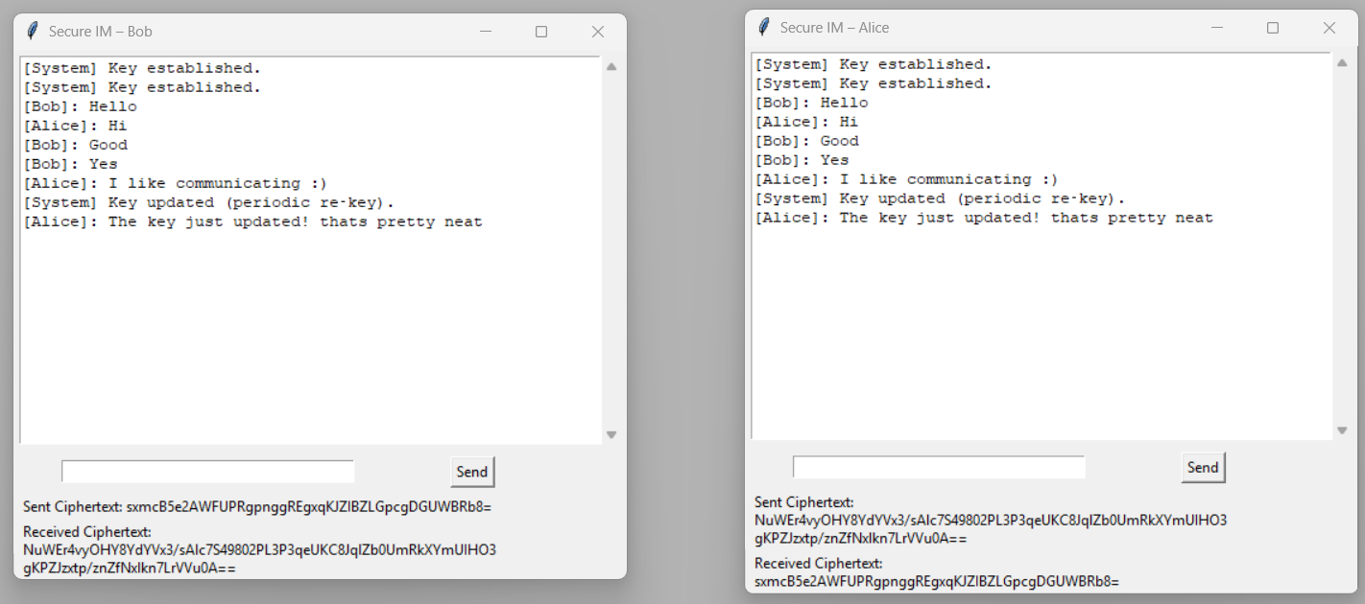
Figure 1: Successful communication with a matching password

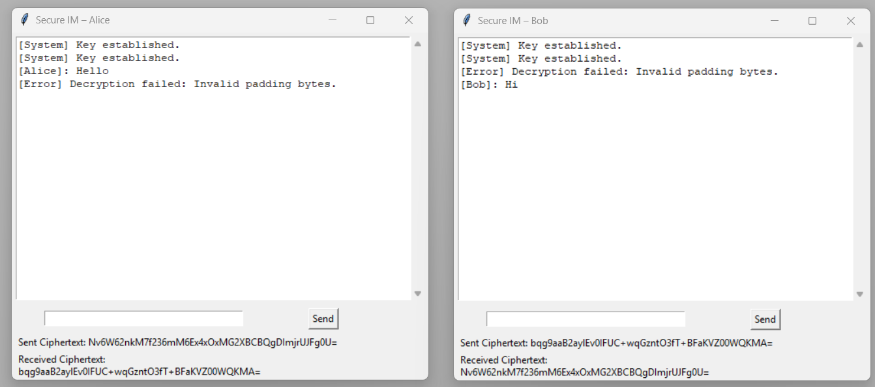
Figure 2: Failed communication with different passwords
The GUI runs in the main thread. Network events are processed on a background thread, and any dialogs that require user interaction (password prompt, username prompt) are dispatched to the main thread via a thread‑safe queue, ensuring no Tkinter threading errors occur.

6. Implementation Details
The project is implemented in Python 3. The main libraries used are:
- socket: TCP networking
- threading: concurrent connection handling
- tkinter: graphical interface
- cryptography.hazmat: low‑level cryptographic operations (AES, PBKDF2, PKCS7)
- base64: safe encoding of binary ciphertext for text‑based transport
All cryptographic randomness (IV, salt) is obtained from os.urandom(). The server does not store any password or key material, making it a zero‑knowledge relay.

7. Security Analysis
The system addresses several threat scenarios:
• Eavesdropping: AES‑256‑CBC with a random IV ensures confidentiality. The adversary cannot decrypt without the key.
• Password dictionary attack: PBKDF2 with 100k iterations and a 16‑byte per‑session salt makes offline brute force extremely slow.
• Static key weakness: Periodic re‑keying limits the window of exposure if a key is compromised.
• Replay attacks: Unique IVs and key updates prevent capture/replay of individual messages (different key/IV context).
• Man‑in‑the‑middle (relay): The server does not authenticate users, but an attacker would need the shared password to inject valid messages; the password‑based key derivation acts as implicit authentication.
• Padding oracle: Decryption errors are not sent back to the sender, minimising oracle information.
All protocols rely on well‑understood, peer‑reviewed primitives from the cryptography library, which is itself a wrapper around the mature OpenSSL library.

8. Extra Credit 1 – Custom Hidden Encryption
The challenge: design an algorithm that hides the detailed procedure by combining two standard ciphers in a non‑obvious way. Our proposal is a dual‑layer cascade with key separation:
1. Derive two independent 256‑bit keys K1 and K2 from the password using PBKDF2 with two different salt suffixes (e.g., salt||'1', salt||'2').
2. First encryption: plaintext → AES‑256‑CTR (key K1, random nonce N1).
3. Second encryption: intermediate ciphertext → AES‑256‑CBC (key K2, random IV).
4. Transmit the nonce, IV, and the final ciphertext.
The ‘hiding’ is achieved because an attacker, even if they know AES is used, does not know the exact mode order (CTR inside CBC) or the presence of two distinct keys. Without this knowledge, cryptanalysis is significantly harder. Security is enhanced by the cascade: breaking one layer still leaves the other intact. Efficiency impact is negligible for chat messages because AES is hardware‑accelerated.
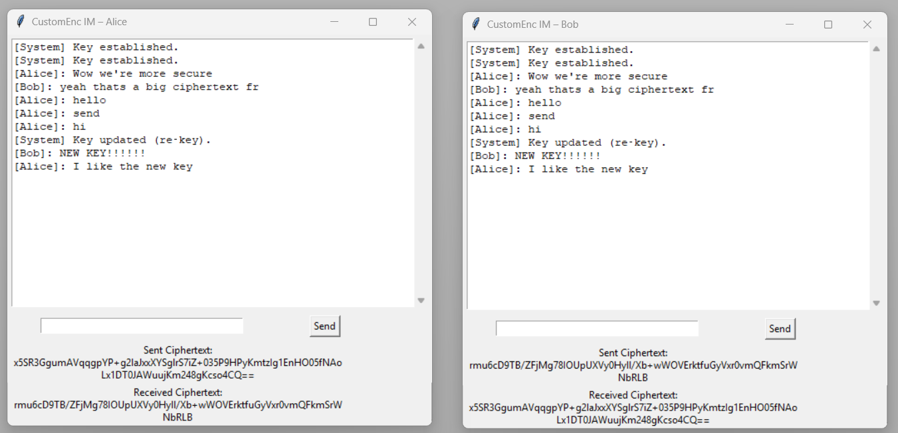
Figure 3: Successful communication with the Custom Hidden Encryption method

9. Extra Credit 2 – Key Agreement Without Pre‑shared Secret
When Alice and Bob do not share any password, they must perform mutual authentication and negotiate a secret over the insecure channel. This is implemented using the Station‑to‑Station (STS) protocol, an authenticated Diffie‑Hellman key exchange.
Assumptions: Each user holds a long‑term RSA key pair; the public keys are exchanged out‑of‑band (e.g., via files or a trusted directory). The protocol proceeds in three messages over the relay server:
1. Alice → Bob: g^a (Alice’s ephemeral DH public value)
2. Bob → Alice: g^b, Sign_Bob(g^b, g^a)
3. Alice → Bob: Sign_Alice(g^a, g^b)
Both parties verify the signatures using the known public keys. The shared secret g^(ab) is then fed to HKDF‑SHA256 to derive a 256‑bit session key. Subsequent messages are encrypted with AES‑256‑CBC and authenticated with HMAC, ensuring integrity and origin confirmation. This provides mutual authentication and perfect forward secrecy because ephemeral DH keys are discarded after the session.
The implementation uses the 2048‑bit MODP group and RSA‑2048 with PSS signatures. The same GUI client can be extended with this handshake, eliminating the need for a shared password.
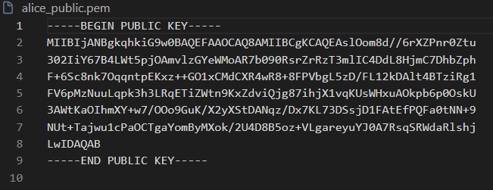

10. Conclusion
The developed system successfully meets all project requirements: strong AES‑256‑CBC encryption, password‑based key derivation with PBKDF2 and salting, PKCS7 padding, random IVs for message‑level semantic security, periodic key updates, and a clean Tkinter GUI that displays both plaintext and ciphertext. The network protocol is simple yet effective, and the code is modular and well‑commented. The two extra‑credit features demonstrate a deeper understanding of cryptographic design and key management, showing how to hide algorithm details and how to establish a secure channel without any pre‑shared secret. The system can serve as a foundation for more advanced secure communication tools.

