Weather Information Processing System:
Assignment 1 Report
Edward Wagstaffe
UOW ID: 8762697

$>./csci251_a1.app
OR
$>make run

A simple flowchart of my program: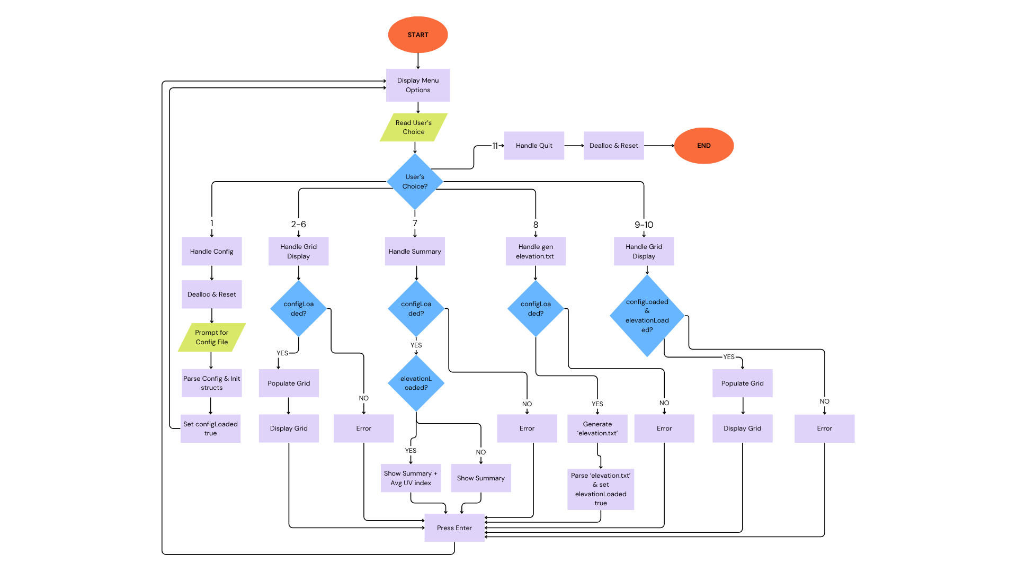

Quick overview of the modules.
The systems architecture is organized into modular components, handling a specific aspect of functionality. Key modules include:
- City Location Management (cityStruct.cpp, cityStruct.h, citylocation.cpp, citylocation.h): Manages city data using a city struct with dynamic arrays for coordinates.
- Weather Data Management (weatherData.cpp, weatherData.h, weatherDataStruct.h): Processes and stores any weather data (cloud cover, pressure, elevation) in dynamic arrays of weatherData structs.
- Grid Management (gridStuct.cpp, gridStruct.h): Implements a 2D array with adaptable ranges that use offset calculations for coordinate mapping.
- Configuration File Handling (configHandler.cpp, configHandler.h): Parses configuration files to initialize the grid and load data.
- Weather Summary (weatherSummary.cpp, weatherSummary.h): Produces a dynamic forecast summary based on what data has been provided.
- Added Features (addedFeature.cpp, addedFeature.h): Handles UV index calculations based on generated elevation data.
- Utilities (utils.cpp, utils.h) : Offers helper functions for data processing, for example the provided tokenizeString function.
- Menu Interface (menu.cpp, menu.h) Provides a simple UI.
- Global Variables are defined in globals.cpp, to facilitate data sharing across the modules using globals.h

- Important data structures: The program uses four structs to organize the data from the config file efficiently:
- CoordinatePair (coordinatesStruct.h): A very primitive struct that holds the x and y integers for the grid position, embedded into the City and weatherData structs for consistency.
- Grid (gridStruct.cpp/gridStruct.h) : Stores a 2D string array (array2D) for displays, grid bounds (minX, maxX, minY, maxY), and relevant variables derived from the grid bounds such as (rows, cols, area) as they are frequently referenced throughout the program. It includes a constructor to allocate array2D with new, a deconstructor to free it with delete, clear2DArray() to clear the grid and displayGrid() to print the beautiful grid.
- City (cityStruct.cpp/cityStruct.h): Holds the city’s unique number, name and a dynamic array of coordinates structs associated with that city.
- weatherData ( weatherDataStruct.h): Stores the weather percentage value as well as grid point coordinates. This is reused for cloud cover, atmospheric pressure, and elevation data reducing code duplication.

- Globals: I use global variables and pointers (globals.cpp/globals.h) to make certain data accessible across all parts of the program:
- grid: The Grid struct pointer.
- cityDataArray, cloudDataArray, pressureDataArray, elevationDataArray: Pointers to arrays of City or weatherData structs.
- cityCounter, cityAndPerimeterCount: Integers that track array sizes.
- configLoaded, elevationLoaded: Boolean flags that track what data has been loaded.

- How many 2D arrays do I use? I use a single 2D array (grid->array2D) for all displays whether its for cities, cloud cover, pressure, elevation or UV index. Functions such as populateGridWithCities() (citylocation.cpp) or populateGridWithUVIndex() (addedFeature.cpp) fill it using coordinates and displayGrid() prints the beautiful grid to the CLI. This saves memory and simplifies logic as opposed to creating multiple 2D arrays.

- Flexible grid size: The grid supports any range (e.g. X: 0-8, Y: 0-8 or X: 1-10, Y: 3-10) even if not starting at (0, 0). The grid struct calculates rows as (maxY – minY + 1) and cols as (maxX – minX + 1). Functions map coordinates to array indices by subtracting the offset (minX and minY), for example, point (1,3) becomes array2D[0][1] for X: 1-10, Y: 3-10.

- Configuration File Handling: In configHandler.cpp, parseConfigFile() expects exactly 5 lines of interest: It reads in the config file, ignores comments and empty lines, removes any leading or trailing whitespaces and tokenizes each line (aided by the utils.cpp module) to extract the grid ranges and weather data file paths. This setup allows for flexible file naming, allowing for names with whitespaces, various file extensions, or no extension at all. If the file is invalid or has more data than expected, it shows an error. deallocateAndReset() frees existing arrays before loading a new configuration, enabling the user to change the config file while the program is running. Additionally, since the grid ranges are always read-in first (line 1 & 2) , we are able to initialize the grid and determine the grid bounds before reading the city (line 3) and weather data (line 4&5). During the parsing of city and weather data (processCityData(), processWeatherData()), any coordinates that are found to be out of bounds are excluded. This design eliminates the need for additional boundary checks later in the program.

- Dynamic Arrays: Since the sizes of certain elements such as the grid, number of cities, and coordinates per city are unknown at compile time, dynamic memory allocation is required to handle them at runtime. It felt wrong to make an educated guess and hardcode the size, for example:
coordinatePair* coordinates = new cordinatePair[50];
Instead, arrays have been coded to be dynamic, an example of this can be found in cityStruct.cpp
This code uses a dynamic array to store coordinates, with a counter (coordCount) tracking the number of coordinates added and a capacity variable (coordCapacity) determining the current array size. When adding new coordinates, the program checks if resizing is needed by comparing coordCount to coordCapacity. If resizing is required, the capacity is doubled, old values are copied to a temporary array, the old array is deallocated, and the pointer is updated to the new array address.
Similar dynamic array resizing techniques, like the one implemented in the City struct as shown above for coordinate management, are utilized across various components of the program such as for the cityDataArray and weatherDataArray to ensure efficient handling of variable-sized data structures.
- Memory Safety: Dynamic memory allocated with new within structs is automatically deallocated by their destructors. While other dynamically allocated resources such as the cityDataArray are explicitly freed using dedicated functions (deallocateCityData()) that invoke delete.

- The getCityAndPerimeter() function in weatherSummary.cpp: Thought I would include this here since its a little more compilated. Given a city number, it returns an array containing the citys grid points and adjacent non-city perimeter points. This function assumes that different cities cannot be adjacent to each other but does allow for non-rectangular cities (e.g L shaped cities) .
A brief overview of the algorithm:
- Initialization: Creates a 2D boolean array (isIncludedGrid) to track processed points, preventing duplication.
- City points: Adds the city’s coordinates to a temporary array and marks them as included.
- Perimeter Detection: For each city point, the eight adjacent points are examined
Adding those points that are:
- Within the grid boundary.
- Not part of the city
- Not yet included

- About the added feature (addedFeature.cpp, addedFeature.h):
I did not want to reinvent the wheel with this one, so I checked out https://www.weather.gov.sg/home/ for some inspiration and came across the UV index. After digging around for a bit, I learned that the UV index is mostly affected by factors such as elevation, cloudiness, and season. Since the cloud cover was already provided, all that was left was to generate some elevation for the grid and figure out the season from the system month. This added feature piggybacks on existing code, which showcases how modular the design is.
Menu option 8 generates ‘elevation.txt’ and mimicking data provided by the weather station(generateElevationFile()). The resulting ‘elevation.txt’ matches the format of other weather data: [x, y]-value
This lets me reuse the same weatherData struct and process it with the existing processWeatherData() function.

Menu option 9 populates the grid with elevation data and displays it (nothing crazy going on here, done the same way as cloudCover and pressure).

Menu option 10 calculates the UV index and shows it.
I wanted the UV index calculation to be reasonably realistic:
- Base UV Index: Fixed at 9, representing a standard maximum UV level under clear skies.
- Elevation Factor: Derived from elevation data (1–5), increasing UV by 15% per level above 1.
- Seasonal Factor: Adjusted monthly (e.g., 0.9 in summer, 0.2 in winter), based on the current system month.
- Cloud Modifier: Reduces UV based on cloud cover (0–100%), with 100% cover cutting UV by 75%.
The calculation uses functions like calculateUVIndex() and getSeasonFactor(), leveraging global variables such as elevationDataArray and cloudDataArray.

Although not obvious, if you were to use menu option 7 after loading the elevation data, it will show the average UV indices for each city, calculated using the city and its perimeter (like the other weather averages) alongside a little ASCII bar for risk levels. A quick screenshot in case you miss this one...
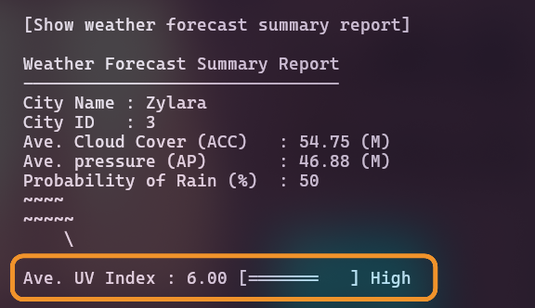

Some minor enhancements for a better user experience: In menu.cpp some very basic error checking has been done in the form of if-else statements. Before running options like displaying the grid or printing the weather summary the program checks if the configLoaded flag is true and displaying an error message with cout if it isn't loaded. For the added feature, it checks whether elevationLoaded is true, preventing access if the data is missing. These checks improve the user experience by avoiding crashes from uninitialized data. (Please refer to the flow chart)

Some challenges faced:
Making the switch from Python to C++ was challenging especially since C++ is a lower-level language. Python allows for functions to return multiple values easily, but C++ functions can return only one. To overcome this, I used structs to bundle related data and passed some variables by reference e.g. parsing functions in the configHandler.cpp to update global arrays directly via pointers.
Additionally, I struggled with data access before finding out that global variables were permitted. Without globals, passing these large data structures like the grid or the cityDataArray to every function was complex and prone to errors. Once I adopted global variables and global pointers, declared in globals.cpp and globals.h the data became easily accessible across files. This significantly reduced function arguments.
I also encountered header files for the first time. I was unsure how to best split my program across files like menu.cpp, gridStruct.cpp, utils.cpp and so on... or whether there was a “correct” way to organize them. After consulting with Mr Tian, he clarified that there was not necessarily a “correct” way, just as long as the organization made sense.

Possible improvements:
In our recent lectures, we explored try, throw and catch for exception handling. Looking back now at A1, I would replace the numerous if-else checks with this approach to create a more robust error handling system.

