Enterprise 2D
Assignment 2 Report
Edward Wagstaffe
UOW ID: 8762697

$>./csci251_a2.app
OR
$>make run

A simple flowchart of my program:
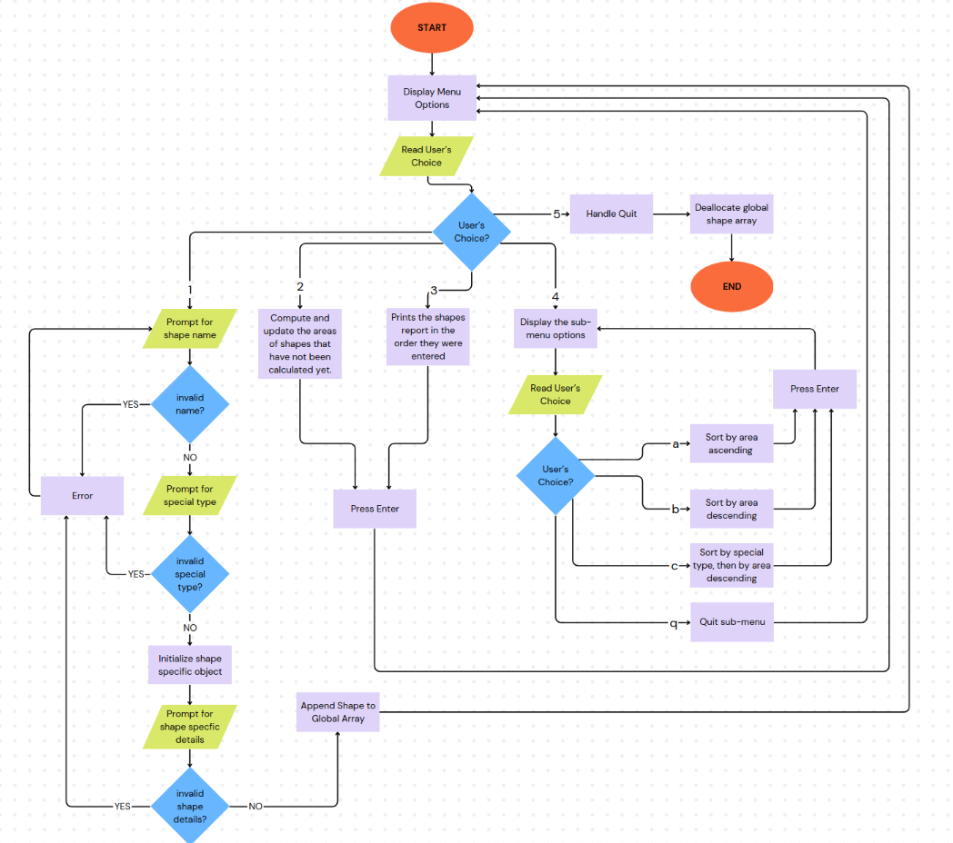

Quick overview of the modules.
- Shape Base Class (ShapeTwoD.cpp, ShapeTwoD.h): Defines the abstract base class for all 2D shapes, including common attributes like name, ID, area, and constainsWarpSpace flag with virtual methods for polymorphism.
- Derived Shape Classes (Circle.cpp, Circle.h; Square.cpp, Square.h; Rectangle.cpp, Rectangle.h; Cross.cpp, Cross.h): Implements specific shapes inheriting from ShapeTwoD, handling input/output operators, area computation, point detection, and geometry validation.
- Point Management (Point.cpp, Point.h): Manages coordinate points used across shapes, with overloaded operators for sorting and string representation.
- Utilities (utils.cpp, utils.h): Provides helper functions like string trimming and uppercasing for input processing.
- Shape Manager (shapeManager.cpp, shapeManager.h): Handles shape creation, validation, storage in a global vector, area updates, printing, and sorting.
- Menu Interface (menu.cpp, menu.h): Provides a user-friendly console menu for input, computation, reporting, sorting, and quitting.
- Main Program (Assn2.cpp): Starts the menu loop and integrates all modules.

- In addition to the 5 compulsory classes, I introduced a supporting Point class (Point.cpp/Point.h): A simple struct holding x and y integers, with overloaded operators for output (<<), string representation and crucially, comparison (< for sorting) This sorting capability was essential for consistently identifying vertices bottom left to top-right ordering, this enabled the geometric calculations like finding the area or finding points on the shape etc. It's embedded in shapes for centers, vertices, and point lists.

- More about ShapeTwoD (ShapeTwoD.cpp/ShapeTwoD.h): I added a static int nextID class member which is auto incremented with each new ShapeTwoD is instantiation to assign the unique Shape IDs eg( Shape[3]) I also added a double area attribute as all 2D shapes inherently have some sort of area. Furthermore, I defined three additional virtual functions
- virtual vector<Point> getEnclosingPoints();
- virtual vector<Point> getPointsOnShape();
- virtual vector<Point> getPointsInShape();
For any given shape, getEnclosingPoints() will return all the points found within the shape’s bounding box. This function primarily serves to iterate over nearby points, allowing getPointsOnShape() and getPointsInShape() to avoid exhaustive searches over the entire grid which would be highly inefficient.
GetPointsOnShape() and getPointsInShape() use the compulsory virtual functions, isPointOnShape() and isPointInShape()respectively. These accept x and y values as arguments and return boolean indicating whether the point lies on the perimeter or inside the shape.
- Derived Shapes: Each inherits ShapeTwoD with shape-specific data, e.g., Circle has center (Point) and radius (int); Square/Rectangle/Cross have vertices (vector<Point>); They override virtual methods and add validation like isSquare() or isRectangle().
The insertion operator << is overloaded for all shapes in conjunction with the virtual toString() function enabling elegant printing of shape details through polymorphism.
The extraction operator >> is overloaded for each shape class to read shape-specific data from std input cin (eg cin >> *newCircle;) It creates a dialog by prompting the user for vertices or measurements, validates input and throws exceptions for invalid data, triggering retries. I took inspiration from the lecture s4g slide 19 for this part. Please refer to any shapes friend function eg in Circle.cpp , istream& operator>>(istream& sIn, Circle& obj)

- Error handling
- No negative integers: The extraction operator ensures the x and y coordinates and sizes such as radius are positive integers.
- Valid shape names: validateName() in shapeManager.cpp checks if the shape name is one of the implemented shapes (circle, square, cross, rectangle, ellipse)
- Valid special types: validateSpecialType() ensures the type is “WS” or “NS”
- Shape validation: Functions like isSquare() or isRectangle() check if vertices form the specified shape.
If any of these checks fail, it will throw an error, display the relevant error message and prompt the user for input again, preventing crashes and invalid data. See flow chart.

- Added Feature: Ellipse Shape (Ellipse.cpp/Ellipse.h)
Enterprise2D’s sensor is now able to detect ellipses! This will improve enterprise 2D’s chances of navigating the electrical plasma storm. The Ellipse uses a center point, and two radii (x-radius, y-radius) to calculate area (PI * x-radius * y-radius). It reuses a lot of circle’s logic but adjusts for the different width/height.
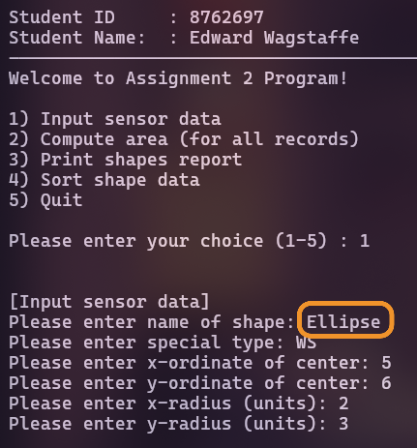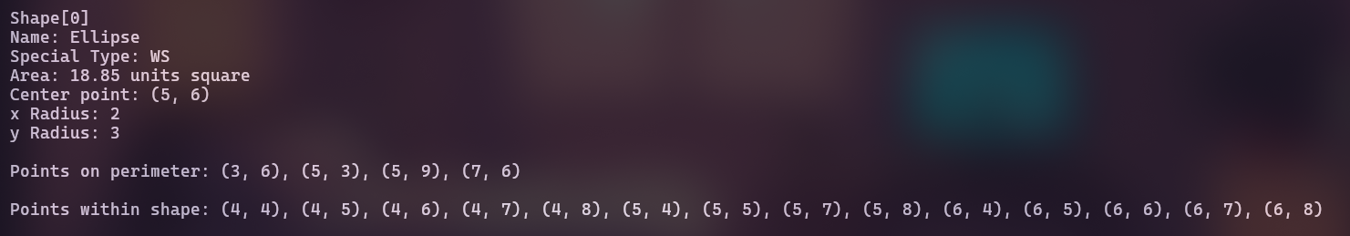

- Challenges faced/ Possible improvements/reflections:
I found this assignment a little easier than A1, as I’m already more familiar with C++ syntax and see quite a lot of crossover with Python’s OOP.
I already understood the concepts of inheritance, encapsulations and polymorphism. It was just a matter of figuring out how to implement that in c++. Operator overloading, for example, feels like Python’s dunder methods ... operator== works much like __eq__.
I’m still trying to grasp the best practices for using the const keyword, as it can be positioned in many different ways, slightly confusing to me.
I think it would have been really interesting to implement the actual pathfinding logic for the spaceship to navigate out of the maze. Unfortunately, there wasn’t enough time, I need to give my other module more attention.
If it weren’t for the strict UML diagram provided, I think I would have made Square inherit from Rectangle, and my added Ellipse class inherit from Circle. I believe this structure would have been more logical. Additionally, I think ShapeTwoD should have been an abstract class.

