Messy Records
Assignment 3 Report
Edward Wagstaffe
UOW ID: 8762697

$>./csci251_a3.app
OR
$>make run

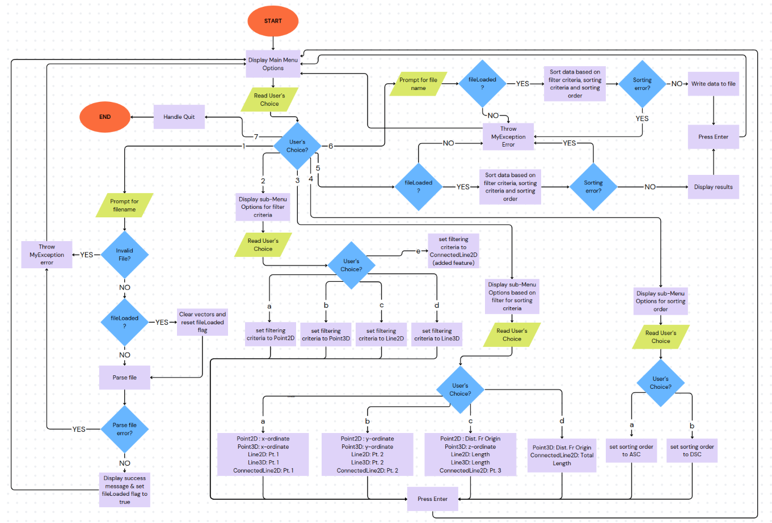Overview of the modules.
Handle file input/output (processIOFile.cpp, processIOFile.h):
- parseFile(): Reads files, creates objects and skips duplicates.
- processPoint2D(), processLine3D() .. etc: cleans coordinate strings
- generateOutputFile(): Outputs sorted data into desired filename
- Uses utils.h for parsing and sorting.h for sorting, data stored in global vectors.
Sorting and formatting objects for display(Sorting.cpp, Sorting.h) :
- sortAndDisplayData(): Sorts and displays based on filters/desired sorting.
- sortPoint2D(), sortLine3D().. Embedded in sortAndDisplayData(), tailored sorting based on the class name (filter criteria) Some containing different options.
- getPoint2DString().. Etc: Also embedded in sortAndDisplayData() , formats output strings, used for printing to the console as well as writing to output file.
Point 2D (Point2D.cpp, Point2D.h):
- Defines a 2D point, with x and y coordinates and a distance from origin.
- Point2D(int x, int y): Non default constructor that sets the coordinates and computes distFrOrigin.
- toString(): returns the string representation as shown in the assignment outline.
- Used in processIOFile.cpp for instantiation, Sorting.cpp for lambda functions and Line2D(aggregation).
Point3D(Point3D.cpp, Point3D.h):
- Inherits from Point2D, a z-coordinate is defined to make it a 3D point.
- Point3D(int x, int y, int z): Calls base class constructor to set x and y, sets z and computes distFrOrigin.
- toString(): returns the string representation as shown in the assignment outline.
- Used in processIOFile.cpp for instantiation, Sorting.cpp for lambda functions and Line3D(aggregation).

Line2D(Line2D.cpp, Line2D.h):
- Defines a 2D line that is made up of two Point2D objects.
- Line2D(Point2D pt1, Point2D pt2): Non default constructor that sets points and computes length.
- toString(): returns the string representation as shown in the assignment outline.
- Used in processIOFile.cpp for instantiation, Sorting.cpp for lambda functions and ConnectedLine2D(my added feature)
Line3D(Line3D.cpp, Line3D.h):
- Defines a 3D line that is made up of two Point3D objects.
- Line3D(Point3D pt1, Point3D pt2): Non default constructor that sets points and computes length.
- toString(): returns the string representation as shown in the assignment outline.
- Used in processIOFile.cpp for instantiation and Sorting.cpp for lambda functions.
Extra feature ConnectedLine2D.cpp (ConnectedLine2D.cpp, ConnectedLine2D.h):
- Defines a connected 2D line, made up of two Line2D objects ( they share a common point).
- ConnectedLine2D(Line2D l1, Line2D l2): Sets the lines and computes the total length of the two lines.
- ToString(): returns the string representation in the same style as the other classes.
- Used in processIOFile.cpp for instantiation and Sorting.cpp for lambda functions.
My own exception class(exceptionClass.cpp, exceptionClass.h):
- Provides custom exception handling, is derived from exception class.
- MyException(string msg): stores my desired error message.
- Overriden what(), returns the message.
Utilities(utils.cpp, utils.h):
- String manipulation for parsing and type conversion using provided template.
Menu(menu.cpp, menu.h):
- Handles main and sub menu printing and logic.
- In terms of file processing, not much has changed since A1. I’m still using tokenizeString() along with some other string manipulation to clean up the data. Instead of using output streams or stoi to convert from string to integer, I used the neat little present from Mr. Tian, template function (found in utils.h).

- For the uniqueness check, I initially thought about using a set<> container, but after doing a bit of research it seemed like more hassle than it was worth. In the end, I’d have had to move everything over to a vector anyway to use the sort() algorithm. So instead, I overloaded operator== in each class and used the find() algorithm, which just loops over the array to check if an element already exists. I know this isn’t the most optimal for large files since it runs in O(n), but I figured it was fine for this uni assignment.

- For sorting, I first considered overloading operator< like I did in Assignment 2, but quickly realized that only works for ascending order. Instead, I used lambda functions to define custom comparison logic. That meant going through all the filter/sorting permutations one by one, which was a bit tedious. Only later did I realize I could have probably used templates here as well.

- All classes (apart from my custom exception) have their insertion operator << overloaded. Combined with a toString() member function, this handles printing to the CLI or writing to a file.

- This time I also implemented my own exception class, MyException. It’s very simple: it inherits from std::exception, stores a message, and overrides what() to return that message. I use it around the program to handle custom errors. For example, in processIOFile.cpp (parseFile()), a MyException is thrown if the parser doesn’t see one of the expected class names like Point2D or Line3D... etc

- Additionally, after learning more about namespaces, I realized it’s not a good idea to define them in header files. That’s another improvement I made this time around.
- Since one of the learning outcomes of this assignment involves I/O manipulation, I applied it by using right together with setw() to control spacing and ensure proper column alignment. I also used fixed with setprecision(3) to format numerical output to three decimal places.

Extra Feature: ConnectedLine2D
For my extra feature, I created a new class called ConnectedLine2D. As the name suggests, this class represents two Line2D objects that share a common point. My intention was to extend the existing codebase by introducing another layer of aggregation.
I discussed this feature briefly in the Modules section, but here are the key details:
- Files: ConnectedLine2D.cpp, ConnectedLine2D.h
- Purpose: Defines a connected 2D line composed of two Line2D objects that meet at a shared point.
- Constructor: ConnectedLine2D(Line2D l1, Line2D l2) initializes the two lines and calculates their combined length.
- toString(): Returns a string representation of the object, formatted consistently with the other classes.
- Integration: This feature is used in processIOFile.cpp for instantiation and in Sorting.cpp with lambda functions for sorting.
I also included a sample dataset (extra.txt) to demonstrate this functionality.
Example entry:
ConnectedLine2D, [2, 12], [8, 5], [15, 9]

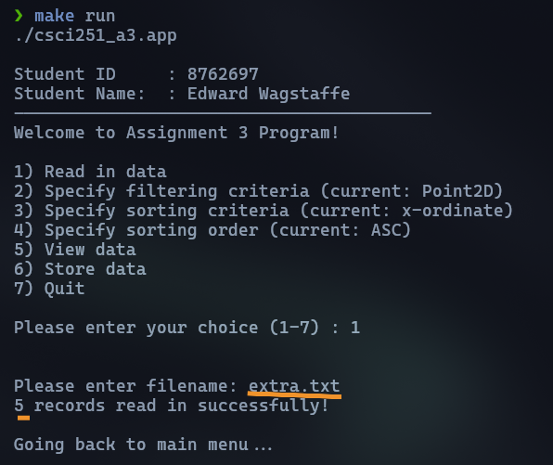
I loaded extra.txt into my program.

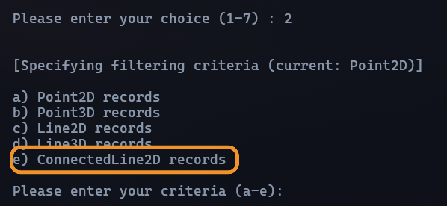
Set filter criteria to ConnectedLine2D.
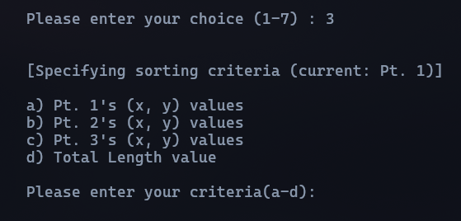
These are the options, for this demonstration I picked c, to sort by pt 3’s X then Y values.
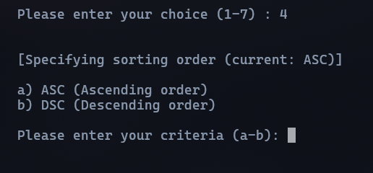
I selected descending.

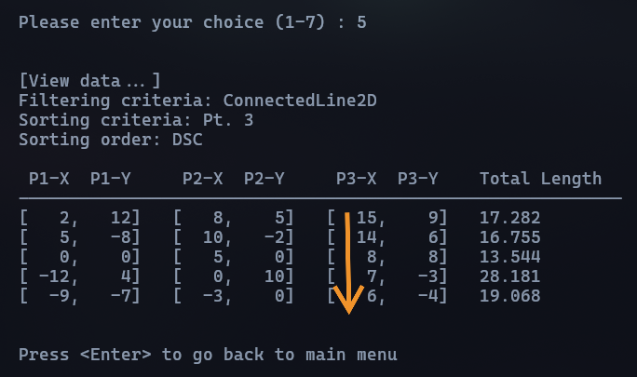
And it works as intended.

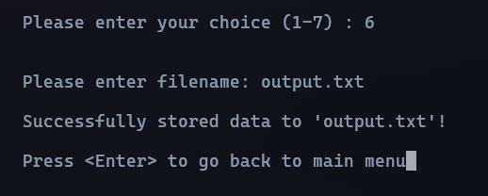
Stored the data into output.txt
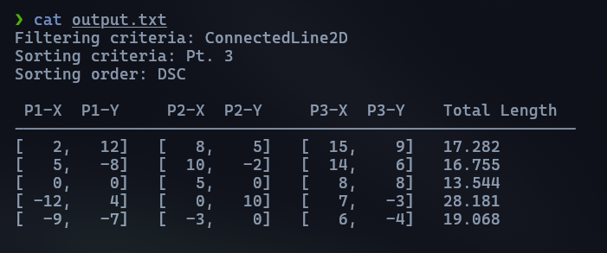
And used the cat command to show the contents of output.txt.

