Quick Start Guide for Young Single Adults
in the Kumasi Ghana University Stake
A practical guide to faith, friendship, academics, service, and personal growth
GUIDE TYPE  Conceptual + practical action steps | WHO IT SERVES  University students, graduates, and young professionals

Purpose
This guide helps young single adults (YSAs) get started in a balanced life of faith, friendship, education, service, and personal growth. It is written for university students, recent graduates, and young professionals who want practical ways to stay connected and make progress while managing busy schedules. The guide uses clear headings, plain language, direct instructions, and useful visuals, practices emphasized in LinkedIn Learning's technical-writing course (O'Flahavan, 2018).

Understanding Your YSA Community
Life as a YSA can involve classes, assignments, work, church responsibilities, friendships, and the transition to greater independence. Students may be living away from family for the first time, while graduates and young professionals may be adjusting to work and new responsibilities. These changes can create opportunities for growth but can also lead to stress, loneliness, or uncertainty.
Use three priorities to stay balanced:
- Strengthen your spiritual foundation.
- Build supportive friendships and serve others.
- Protect your academic, career, and personal well-being.

Start Here: Your First Week
You do not need to change everything at once. Complete these actions during your first week:
- Plan your week. Write down classes, deadlines, church commitments, institute, work, meals, sleep, and personal time.
- Connect with people. Introduce yourself to at least two YSAs and save the main ward or stake communication channel.
- Choose one spiritual habit. Set a daily time for prayer and scripture study.
- Attend one church or YSA activity. Look for an activity that combines fellowship, service, learning, or recreation.
- Identify support. Know who you can contact when you need academic, spiritual, emotional, or career guidance.
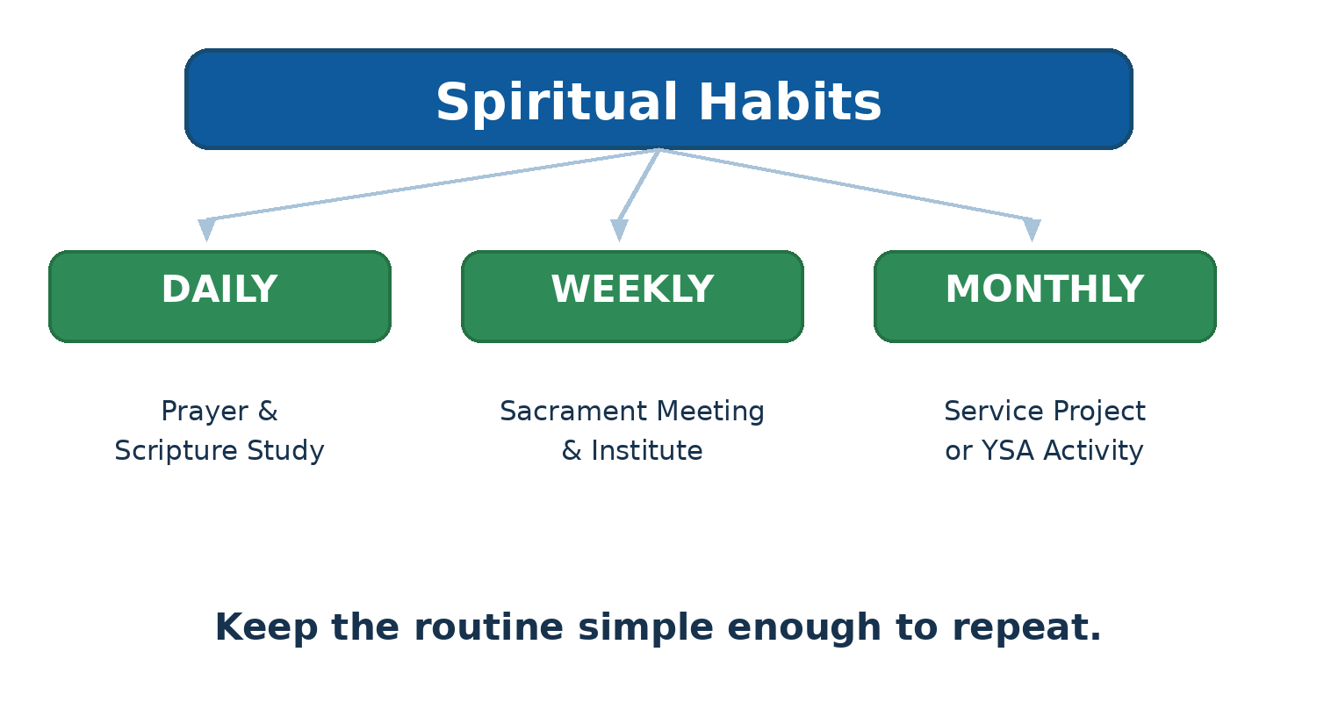
Figure 1. A daily–weekly–monthly rhythm for spiritual and community habits.

Strengthen Your Spiritual Foundation
Build your spiritual routine around habits that are realistic enough to continue. Start each morning with a short prayer and scripture study. Even 15 focused minutes can help you begin the day intentionally. The Gospel Library app provides scriptures, conference messages, manuals, music, and other study resources that can be accessed across devices (The Church of Jesus Christ of Latter-day Saints, 2026).

Use a Simple Rhythm
- Daily: Pray and study scripture.
- Weekly: Attend sacrament meeting and participate in institute or another gospel-learning opportunity.
- Monthly: Participate in a service project, YSA activity, or another meaningful opportunity to strengthen your connection with others.
Do not treat spiritual growth as another item to finish. Use these habits to build consistency and receive guidance as you manage school, work, relationships, and service.

Build Social Connections
Strong friendships do not usually happen by accident. Take small, repeatable actions that make connection easier.
- Attend ward and stake YSA activities regularly.
- Introduce yourself to someone you have not met.
- Join a study group or invite another student to study together.
- Volunteer for a service project.
- Accept a calling, committee assignment, or activity responsibility that fits your schedule.
Choose activities that give you more than entertainment. Service, learning, recreation, and friendship can work together. The goal is not to attend every event; it is to build meaningful relationships without creating an overloaded schedule.

Figure 2. Social connection can combine service, recreation, and friendship.

Manage Academics and Personal Growth
Your academic responsibilities matter, but academic success is harder when you ignore rest, health, and relationships. Plan your week before it becomes crowded.

Use This Five-Step Routine
- List all deadlines and fixed commitments.
- Block study periods for your most difficult courses.
- Schedule church, institute, exercise, meals, and sleep.
- Leave buffer time for unexpected tasks.
- Review and adjust the plan at the end of each week.
A balanced schedule includes classes and study time, church activities, and personal time for rest, exercise, and healthy relationships. An overloaded schedule often contains excessive study or work, too many commitments, and little or no downtime. The result can be burnout, missed activities, and poor self-care.
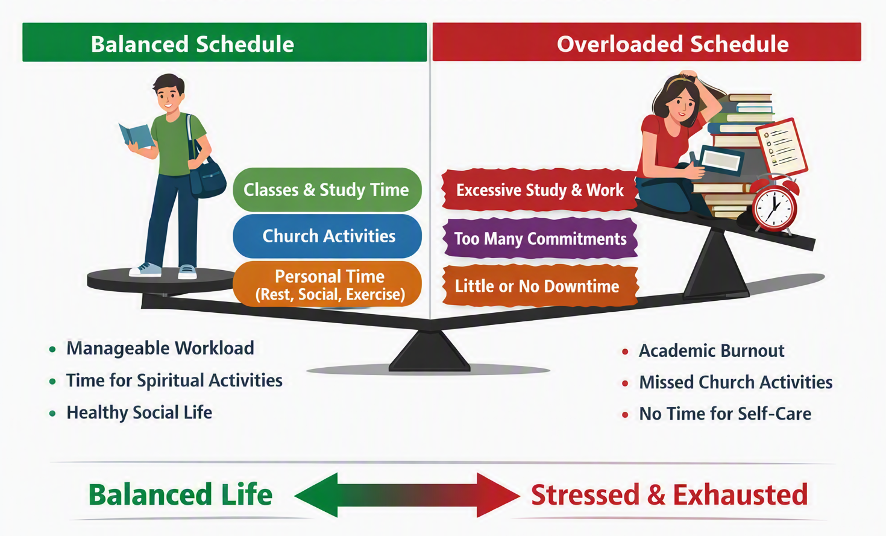
Figure 3. A balanced schedule protects academic progress, spiritual participation, and personal well-being.

Prepare for Your Career
Use university and church resources to prepare before graduation. Update your CV, practice interview answers, and build professional relationships. Kumasi Technical University's Guidance and Counselling Directorate provides academic, vocational, career-development, and other support services for students (Kumasi Technical University, n.d.).

Try a Monthly Career Routine
- Review one section of your CV.
- Learn one employability skill.
- Contact one mentor, lecturer, or professional.
- Look for an internship, national service, job, or networking opportunity.

Serve and Lead
Service gives you opportunities to help others while developing skills you can use at school and work. Look for manageable ways to contribute: teach a class, help organize an activity, support a service project, or assist with communication. Leadership experiences can strengthen teamwork, planning, communication, empathy, and problem-solving.
Start small. Choose one responsibility you can complete reliably rather than accepting more assignments than your schedule can support.

Use Digital Tools Wisely
Technology can make it easier to stay connected, but it should support your priorities rather than control your attention. Use the Gospel Library app for personal study. Use approved online platforms for virtual meetings or classes when needed. Check official ward or stake communication channels for announcements.
- Turn on reminders for important meetings and deadlines.
- Keep school and church commitments on one calendar.
- Save important contact information.
- Set aside specific times to check group messages instead of checking constantly.

When You Need Help
Asking for help is a strength, not a failure. Talk with a trusted friend, YSA leader, bishopric or other appropriate church leader when you need spiritual or social support. For academic or emotional concerns, use professional university resources when available. KsTU's Guidance and Counselling Directorate offers counselling and student-development services, including academic, vocational, stress-management, and psychological support (Kumasi Technical University, n.d.).
If a problem is affecting your safety, health, studies, or ability to function, seek appropriate professional help promptly.

Quick Success Checklist
☐ I have planned my week.
☐ I have a daily prayer and scripture routine.
☐ I know when and where I can attend institute or another gospel-learning opportunity.
☐ I have connected with at least one other YSA.
☐ I have scheduled study, sleep, meals, and exercise.
☐ I know where to get academic or counselling support.
☐ I have chosen one service or leadership opportunity.
☐ I will review my progress at the end of the week.

Conclusion
A successful YSA experience does not require doing everything at once. Start with a few consistent habits: strengthen your faith, connect with people, plan your time, care for your health, and ask for help when you need it. The Kumasi Ghana University Stake can be a place where YSAs grow spiritually, academically, socially, and professionally. Use this guide as a starting point, then adjust your routine as your responsibilities change.

References
Kumasi Technical University. (n.d.). Guidance and counselling unit. https://kstu.edu.gh/
O'Flahavan, L. (2018). Technical writing: Quick start guides. LinkedIn Learning. https://www.linkedin.com/learning/technical-writing-quick-start-guides
The Church of Jesus Christ of Latter-day Saints. (2026). Gospel Library. https://www.churchofjesuschrist.org/learn/mobile-applications/gospel-library

