

International School

**SOFTWARE PROJECT MANAGEMENT**

CMU-IS 432

**Project Proposal**

**Version 1.0**

**Date: December 12, 2024**

**Hotel management system**

**Created by**

*Khoa, Nguyen Tran Minh 28211101961*

*Minh,Nguyen Binh 28219027293*

*Trieu, Vo Van 28219025298*

*Vinh, Thai 28211150003*

*Quan, Do Hoang 28211147444*

*Cuong,Truong Manh 28211247724*

**Approval of Mentor:**

Name **Nguyễn Thái Hoàng** Signature Date

#### **PROJECT INFORMATION**

|  |  |  |  |
| --- | --- | --- | --- |
| **Project acronym** | **HotelManagement**  **HM** | | |
| **Project Title** | Online hotel booking and management tool | | |
| **Start Date** | 12 Sep 2024 | **End Date** | 21 Dec 2024 |
| **Lead Institution** | International School, Duy Tan University | | |
| **Project Mentor** | Hoang, Nguyen Thai | | |
| **Scrum master**  **/ Project Leader & contact details** | Khoa, Nguyen Tran Minh  Email: khoa123kd56@gmail.com  Tel: 0857720992  ID: 28211101961 | | |
| **Partner Organization** |  | | |
| **Team members** | Name | Email | Tel |
| 28211147444 | Quan, Do Hoang | dohoangquangl@gmail.com | 0378342249 |
| 28211150003 | Vinh, Thai | t.vinh.1109z@gmail.com | 0339464751 |
| 28211247724 | Cuong,Truong Manh | tmanhcuong2k4@gmail.com | 0853028999 |
| 28219027293 | Minh,Nguyen Binh | lalabinbin123456@gmail.com | 0329714275 |
| 28219025298 | Trieu,Vo Van | vantrieu0302gmail.com | 0777565207 |

**REVISION HISTORY**

|  |  |  |  |  |
| --- | --- | --- | --- | --- |
| **Version** | **Date** | **Comments** | **Author** | **Approval** |
| 1.0 | 12/09/2024 | Initial Document | Tien Le Van |  |
|  |  |  |  |  |

**Table of Contents**

**1. Project Title** 1

**2. Project Overview** 1

**3. Project Background and Motivation** 1

**4. Proposed Solution** 2

**5. Related Works or Projects on the Market** 3

**6. Objectives and Deliverables** 4

**7. Methodology and Tools** 5

**8. Timeline** 6

**9. Project Team** 6

**10. Risk Management** 7

**11. Budget and Resources** 8

**12. Project constraints** 8

**13. Conclusion** 10

**14. References** 10

# **1. Project Title**

**HotelManagement**: Online hotel booking and management tool

# **2. Project Overview**

**HotelManagement** is a hotel management support system that offers useful features for easier hotel management and provides online booking capabilities. Guests who make reservations will have access to full information, including the room list, room status (vacant or in use), room review videos, and feedback from previous customers, facilitating the selection of their preferred room. With most hotel management tasks being performed directly on the system, hotel owners can save time and resources ,thereby helping to bring in more revenue

**3. Project Background and Motivation**

# At present, many hotels still use manual methods for management. While traditional, this approach is not very effective. To keep up with the latest trends, it's important to transition from manual to semi-automatic management. That's why the HM system was created. HM helps save time and human resources for hotels, leading to increased revenue. It makes the inherently challenging task of hotel management much easier.

# **4. Proposed Solution**

The proposed solution is HM, a website that allows hotel managers to manage all aspects of the hotel, including staff and room management, helping hotel reservations operate smoothly. In addition, it supports those who need to book hotels online and supports other services to them..

**Core Features and Functionalities:**

1. **Personnel management**:

* The manager will add employees when new employees join, or delete them when they leave. The manager will enter the working shift and hours, the system will automatically calculate the salary through the entered data.

1. **Hotel room management**:

* The manager will be able to manage the room list, which rooms are booked, which rooms are in use, which rooms are vacant, and which rooms have just been used. If any room has just been used, the manager will arrange for the cleaning staff to clean that room and after the room is cleaned, the manager will change the room status to vacant.

1. **Online hotel booking**:

* Customers will make reservations through the hotel's website. Before booking, customers can view information about the room they want to book and reviews from previous guests, helping customers easily choose the desired room.

**Technologies and Approach:**

* **Frontend**: The system will be built using Vue.js to ensure a responsive and intuitive user interface across web browsers on PC.
* **Backend:** PHP will handle the server-side logic, while MySQL will store user data, recipe information, and nutritional content..
* **Relational Database Management System - MySQL** **:**For storing structured data such as guest information, bookings, room details, and payment records.
* **Authentication Mechanisms OAuth**: To manage user authentication and authorization.
* **Integration Payment Gateways PayPal**: To process transactions for bookings and other services.

**System Context Diagram:**

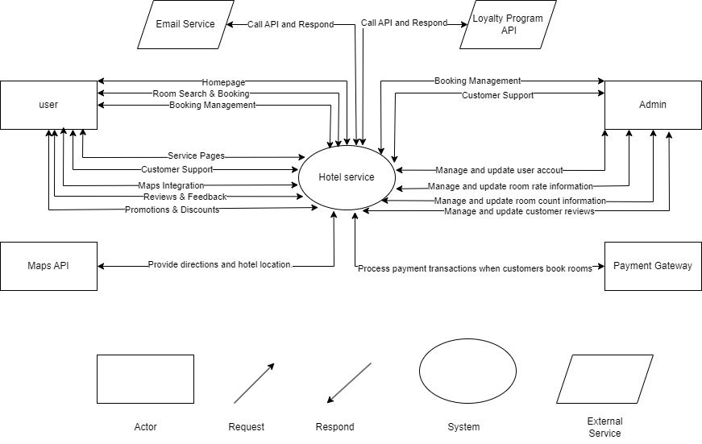

# **5. Related Works or Projects on the Market**

* Several hotel management systems, such as Opera PMS and Cloudbeds, already exist on the market. However, most focus either on basic room bookings or isolated operational tasks without offering a comprehensive approach to guest management. Our system will provide personalized guest experiences based on their preferences, offer detailed analytics on hotel operations, and help management maintain smooth operations across all departments—all in one platform, making it a more comprehensive solution for hotel operators looking to enhance guest satisfaction and operations efficiency.

# **6. Objectives and Deliverables**

**Objectives:**

* **Objective 1** Develop a fully functional web interface that allows hotel guests to book rooms online.
* **Objective 2**Implement analytics to track room availability to help hotel management run smoothly.
* **Objective 3**: Create an automated employee management, management, and payroll system.
* **Objective 4**: Implement billing and payment features that automate the payment process and ensure accurate financial records.

**Deliverables:**

* **Deliverable 1**: The web provides an easy-to-use interface.
* **Deliverable 2**: A backend system that stores customer profiles, preferences, and activity data to personalize the guest experience and improve hotel efficiency.
* **Deliverable 3**: Billing and payment features that automate financial transactions and ensure accurate records for both guests and hotel management.

# **7. Methodology and Tools**

**Project Management Approach**

* Agile Methodology: We will adopt an agile development methodology, using sprints to deliver features iteratively and gather feedback continuously. This ensures flexibility and responsiveness to changing needs, while promoting transparency and collaboration.

**Development Methodology**

* Scrum Framework: We will implement the Scrum framework within the agile approach, with defined roles (Product Owner, Scrum Master, Development Team) and events (Sprint Planning, Daily Scrum, Sprint Review, Retrospective). This provides a structured and efficient workflow.

**Technical Stack**

* + Programming language: Javascript, HTML, CSS,PHP.
  + Framework:Vuejs, Bootstrap.
  + Database: MySQL
  + Database Management System: MySQL Workbench.
  + Develop tools: Visual Studio Code.
  + Version Control System: Github.
  + Project Management: Trello.

# **8. Timeline**

|  |  |  |  |  |
| --- | --- | --- | --- | --- |
| **No** | **Task Name** | **Duration (days)** | **Start Date** | **End Date** |
| 1 | Initial | 11 | 12/09/2024 | 22/09/2024 |
| 2 | Development | 69 | 23/09/2024 | 30/11/2024 |
| 3 | Close | 10 | 01/12/2024 | 10/12/2024 |
|  | Duration | 11 | 11/12/2024 | 21/12/2024 |

*Table 1: Project Timeline*

# **9. Project Team**

|  |  |  |  |
| --- | --- | --- | --- |
| **Full Name** | **Phone** | **Email** | **Position** |
| Khoa, Nguyen Tran Minh | 0857720992 | khoa123kd56@gmail.com | **Scrum Master** |
| Minh, Nguyen Binh | 0329714275 | lalabinbin123456@gmail.com | **Product Owner** |
| Trieu, Vo Van | 0777565207 | vantrieu0302gmail.com | Developer |
| Vinh, Thai | 0339464751 | t.vinh.1109z@gmail.com | Developer |
| Quan, Do Hoang | 0378342249 | dohoangquangl@gmail.com | Developer |
| Cuong, Truong Manh | 0853028999 | tmanhcuong2k4@gmail.com | Developer |

# **10. Risk Management**

* **Risk 1**: Difficulty integrating third-party online booking and payment APIs.
  + **Mitigation**: Research and test third-party APIs earlier in the project. Prepare fallback API options and analyze additional buffers for rationalization and testing.
* **Risk 2**: Developing a personalized customer profile management system can be more complex and take longer than expected.
  + **Mitigation**: Break down the system development into small, manageable services. Develop a baseline version first and incrementally improve. Additional time for testing and tweaking.
* **Risk 3**: Technical issues during system deployment that could impact hotel operations.
  + **Mitigation**: Mitigation: Prepare fallback options and test the system in a virtual environment before going live. Ensure that technical support is available to handle issues immediately.

# **11. Budget and Resources**

|  |  |  |  |  |
| --- | --- | --- | --- | --- |
| **NO** | **Criteria** | **Prices (USD)** | **Amountours(Hours)** | **Tota(USD)** |
| 1 | Working hour | $2/hour | 3328 | **$4992** |
| **Total cost** | | | | **$4992** |

*Table 2: Total Cost Estimation*

|  |  |  |
| --- | --- | --- |
| **Description** | **Amount** | **Unit** |
| Number of members | 6 | Person |
| Number of working hours per day | 4 | Hour |
| The cost of working per hour per person | 2 | USD |
| The duration of the project | 3 | Month |
| The number of working day | **87** | **Day** |

*Table 3: Description Cost*

**Explain:**

* Amount of working hours = 6 members * 4 hours/day * 87 days = 2088 hours
* Cost of working hour: 2088 hours * $2/hours = $4176

# **12. Conclusion**

# HM is not just a hotel management system, but also a comprehensive solution for effectively managing hotel operations and staff. By providing modern features such as online booking, customer profile management, and employee performance tracking, HM brings convenience and transparency to both customers and managers.The system meets the growing demand for fast and personalized hotel services, making it easy for customers to search and book rooms online while supporting the tight management of customer information. HM not only improves the customer experience but also enhances the operational efficiency of the hotel. The HM project contributes to the field of Software Technology by combining real-time data processing and user-oriented design, while aiming at sustainable goals in optimizing resources and enhancing service quality in the hotel industry.

# **13. References**

*[1] Software Development Standards for the Guidance and Control Software Project* [*https://sw-eng.larc.nasa.gov/*](https://sw-eng.larc.nasa.gov/)

*[2] General Software Coding Standards and Guidelines* [*https://www.nws.noaa.gov/oh/hrl/developers_docs/General_Software_Standards.pdf*](https://www.nws.noaa.gov/oh/hrl/developers_docs/General_Software_Standards.pdf)

*[3] Scrum and best practices:*

[*https://docs.microsoft.com/en-us/azure/devops/boards/sprints/best-practices-scrum?view=azure-devops*](https://docs.microsoft.com/en-us/azure/devops/boards/sprints/best-practices-scrum?view=azure-devops)

*[4] The Scrum Guide:* [*https://www.scrum.org/resources/scrum-guide*](https://www.scrum.org/resources/scrum-guide)

*[5] Draw tool:* [*https://www.draw.io*](https://www.draw.io)