Politehnica University of Bucharest

Software Engineering

SKILLHUB
Software Design Document

Team:
FINICHIU Eduard-Adelin 1241EB
JERCAU Hadasa-Stefana 1241EB

Coordinator:  Prof. Dr. Ing Nicolae Goga | Date created:  Sunday, November 08, 2026

Delivery Report
(will be delivered along with the project)

Name Group Project implementation [%, reason] Signature

FINICHIU Eduard Adelin 1241 EB 50%(diagrams, review,information) FEA
JERCAU Hadasa Stefana 1241 EB 50%(chapter 3,4, Apendinces) JHS
Delivery date:
17.11.2025

Table of Contents

Delivery Report 2
Table of Contents 3
System Design 4
Document Change History 4
1. Introduction 4
1.1. Purpose 4
1.2. Target Public 4
1.3. Definitions, Acronyms and Abbreviations 4
1.4. Document Structure 5
2. References 6
3. Decomposition Description 7
3.1. Modules Description 7
3.2. Description of Concurrent Processes 8
3.3. Description of Data Modules 10
4. Dependency Description 12
4.1. Dependencies among modules 12
4.2. Dependencies among processes 13
4.3. Dependencies among data modules 14
5. Interface Description 16
5.1. Module Interfaces 16
5.2. Processes Interfaces Error! Bookmark not defined.
6. Detailed Design 22
6.1. Modules detailed design 22
6.2. Data Modules Detailed Design 28
Appendices 32
A1. Use cases diagrams 32
A2. Class diagrams 32
A3. Sequence diagrams 33
A4. Document evolution 34
A5. Conclusions on activity 40

System Design

According to the IEEE STD-1016-1998, IEEE Recommended Practice for Software Design Descriptions.

Document Change History
Depending on the chosen type of development, retention of all changes made to this document may be useful. For example, for a project using the Waterfall w/ milestones methodology, all the changes made between two project evaluation moments (milestones) will be retained. A chronological sorting of the list of changes is indicated.

Version | Date | The author/authors of the change | Details of changes
1.00 | 28.03.2004 | Prof Dr Nicolae Goga | Basic version (template)
1.10 | 10.11.2025 | FINICHIU Eduard-Adelin | Completed 1, 2
1.20 | 13.11.2025 | JERCAU Hadasa-Stefana | Completed 3,4
1.30 | 14.11.2025 | FINICHIU Eduard-Adelin | Completed 5,6
1.40 | 16.11.2025 | JERCAU Hadasa-Stefana | Completed Apendices
1.50 | 17.11.2025 | FINICHIU Eduard-Adelin | Review of Document + Sync info with SRS

1. Introduction

1.1. Purpose
The purpose of this document is to present the comprehensive software design of the SkillHub platform, a coursework project developed for the Software Engineering discipline. This document describes the system’s structure, its architectural components, the modules and processes it contains, and the interactions between them.Its goal is to provide a clear and detailed perspective on how the system implements the functional and non-functional requirements previously defined in the Software Requirements Specification (SRS).
The Software Design Document (SDD) ensures a common understanding of the system among all team members by detailing the system decomposition, module responsibilities, dependencies, interfaces, and data structures. It serves as a technical guide for the development, integration, and maintenance of the SkillHub platform.

1.2. Target Public
This document is intended for all members involved in the development and evaluation of the SkillHub platform. The target audience includes:
- Software designers and system architects, who require a detailed overview of the system’s structure and module interactions.
- Programmers, who use the module descriptions, interfaces, and data structures to correctly implement and integrate the system components.
- Project managers, who rely on this document to understand the system architecture, track design decisions, and coordinate development activities.
- Academic evaluators (course instructors), who analyze the system’s design quality, consistency, and alignment with the Software Requirements Specification (SRS).
The document is not intended for end-users or clients, as it focuses strictly on the technical design aspects of the SkillHub platform.

1.3. Definitions, Acronyms and Abbreviations
This section lists the main terms and abbreviations used throughout this document to ensure clarity and consistency. The definitions are provided so that the document can be understood by readers with varying technical backgrounds.
SkillHub – The software platform developed in this project, designed to connect clients with freelancers through job postings, proposals, and notifications.
SRS (Software Requirements Specification) – The document that defines the functional and non-functional requirements of the system.
SDD (Software Design Document) – This document, which details the system’s architecture, modules, interfaces, and data structures.
Client – A user who creates job postings and selects freelancers based on proposals.
Freelancer – A user who browses posted jobs and submits proposals (bids) for available work.
Module – A functional component of the system that encapsulates a specific set of responsibilities.
Process – A sequence of operations executed by the system, possibly running concurrently (e.g., sending notifications).
Data Module – A component responsible for storing, retrieving, and managing structured data used by the system.
DAO (Data Access Object) – A design pattern used to abstract and encapsulate all access to the database.
MVC (Model–View–Controller) – A software architectural pattern used to separate concerns in the system’s structure, where applicable.
API (Application Programming Interface) – A defined interface for communication between modules or external systems.
Notification – A system-generated message informing a user of an event (e.g., receiving a proposal, proposal acceptance).
Proposal/Bid – A structured offer submitted by a freelancer, containing pricing and a description for a specific job.
FR – Functional Requirement
HTTP – HyperText Transfer Protocol
NFR – Non-Functional Requirement
SRS – Software Requirements Specification

1.4. Document Structure
This document is organized into several chapters, each describing a specific aspect of the system’s design:
- Chapter 1 – Introduction
Provides the purpose, target audience, terminology, and overall structure of the Software Design Document.
- Chapter 2 – References
Lists the standards, documents, and external sources used as the basis for the system’s design.
- Chapter 3 – Decomposition Description
Presents the system’s architectural breakdown into modules, concurrent processes, and data modules. Each component is described in terms of purpose, operation, and dependencies.
- Chapter 4 – Dependency Description
Details the relationships and interactions among the identified modules, processes, and data components, supported by diagrams where appropriate.
- Chapter 5 – Interface Description
Specifies the interfaces exposed by the system’s modules and processes, including inputs, outputs, and operational behavior.
- Chapter 6 – Detailed Design
Elaborates on the internal structure of each module and data component, including classes, methods, algorithms, and design patterns applied.
- Appendices
Contain supporting diagrams (use case, class, and sequence diagrams), document evolution notes, and conclusions regarding the development activity.
This structure ensures an organized and comprehensive representation of the SkillHub system, facilitating both implementation and evaluation.

2. References
List of references used in this paper, possible legislation that governs the application domain of the project/document.

[1] IEEE STD-1016-1998, IEEE Recommended Practice for Software Design Descriptions.
This standard provides the structural guidelines and recommended practices followed throughout this document.
[2] IEEE STD-830-1998, IEEE Recommended Practice for Software Requirements Specifications.
Used as a reference for structuring and validating the Software Requirements Specification (SRS) of the SkillHub system.
[3] SkillHub – Software Requirements Specification (SRS), internal project document.
Defines the functional and non-functional requirements that this design document implements.
[4] Gamma, E., Helm, R., Johnson, R., Vlissides, J. – Design Patterns: Elements of Reusable Object-Oriented Software, Addison-Wesley, 1994.
Referenced for the application of design patterns used in SkillHub (Factory Method, Singleton, Builder, Facade).
[5] Fowler, M. – UML Distilled: A Brief Guide to the Standard Object Modeling Language, Addison-Wesley.
Used as a reference for UML diagrams included in the appendices (use case, class, sequence diagrams).
[6] Goga Nicolae. *Software Engineering – Course Materials*. Politehnica University of Bucharest, 2025.
[7] Dobre, Iulian & Ioniță, Adrian. *Ingineria Programării: Fundamente și Aplicații*. Editura Politehnica Press, București, 2018. ISBN 978-606-515-945-7.
[8] Fiverr – Online Freelancing Platform. Available at: https://www.fiverr.com. Accessed: October 2025.
[9] Upwork – Freelancing Platform. Available at: https://www.upwork.com. Accessed: October 2025.

3. Decomposition Description
This article corresponds to chapter 6.2.1., Decomposition description, from [1].

3.1. Modules Description
Modules description according to 5.3.1 - 5.3.10, from [1]. The modules can be identified on the use case diagram(s) from the Software Requirements Specification.

The system is decomposed into three main functional modules, corresponding to the primary operations defined in the Functional Requirements (FRs).

3.1.1. Description of Module 1: Authentication & User Context

Name | Authentication & User Context
Type | React Context & UI Components
Purpose | Manages user identity, session state, and profile data (FR1, FR2).
Way of operating | Uses Firebase Authentication SDK to maintain a persistent user session via the AuthContext provider. Synchronizes user profile data (skills, title) with the users Firestore collection.
Components | AuthContext.jsx, Login.jsx, Register.jsx, Profile.jsx
Subordination | Core module used by the Presentation Layer
Dependencies | Firebase Authentication, Firestore (users collection)
Resources | React, Firebase SDK

3.1.2. Description of Module 2: Job Management & Discovery
Name | Job Management & Discovery
Type | React Page Components
Purpose | Allows clients to post jobs and freelancers to browse and filter available jobs (FR3, FR4, FR5).
Way of operating | Posting: PostJob.jsx writes new documents to the jobs collection. Searching: JobSearch.jsx performs a Firestore query where status = 'open' and applies client-side filtering (keywords, budget) to ensure instant UI feedback.
Components | PostJob.jsx, Dashboard.jsx, JobSearch.jsx
Subordination | Depends on Authentication & User Context module
Dependencies | Firestore (jobs collection)
Resources | React, Firebase Firestore

3.1.2. Description of Module 3: Proposal & Transaction System
Name | Proposal & Transaction System
Type | React Page Components
Purpose | Handles the core transaction flow of bidding, hiring, and completing jobs (FR6).
Way of operating | Bidding: Writes proposals into a sub-collection nested under a specific job. Hiring: Updates the job status to in_progress and the selected proposal to accepted. Completion: Updates the job status to completed.
Components | JobDetails.jsx
Subordination | Depends on Job Management & Discovery module
Dependencies | Firestore (jobs collection and proposals sub-collection)
Resources | React, Firebase Firestore

3.2. Description of Concurrent Processes
Description of concurrent processes according to 5.3.1 – 5.3.10, from [1]. The processes can be identified on the sequence diagram(s) from the Software Requirements Specification.

These processes operate independently or are asynchronously triggered by the main functional modules, ensuring timely execution of background and maintenance tasks as required by the system's Functional and Non-Functional Requirements.

These processes run in the background, triggered by system events or scheduled intervals, ensuring non-functional requirements are met.

3.2.1. Description of Process 1: NotificationProcess
Name | NotificationProcess
Type | Process
Purpose | To asynchronously generate and deliver internal and external notifications to users (sms or email) for important events such as new messages, new proposals, or job updates.
Way of operating | The process continuously monitors if a Job is posted, then it acceses the EmailService, sending SMS/Email notification, allowing Freelancers to receive notifications.
Subordination | None
Dependencies | UserDataModule
Resources | Message Queue (e.g., RabbitMQ or Redis) for asynchronous processing, External Email Service/API.

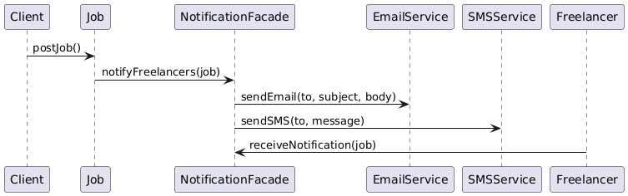
3.2.2. Description of Process 2: Job Process
Name | Job Creation Process
Type | Process
Purpose | To ensure all new and updated job postings are quickly indexed in the specialized Search Indexing Engine, which is necessary to support the high-performance search and filtering required by Providers (FR5, NFR1, NFR5).
Way of operating | This process is triggered when creating a job, which will be notified to all Freelancers so that can be aware of it. Freelancers can create proposals for specific jobs.
Subordination | None
Dependencies | JobDataModule (to read job data), JobSkillManagementModule (as the triggering component).
Resources | Dedicated Search Indexing Engine (e.g., Elasticsearch or similar), Message Queue for receiving index requests.
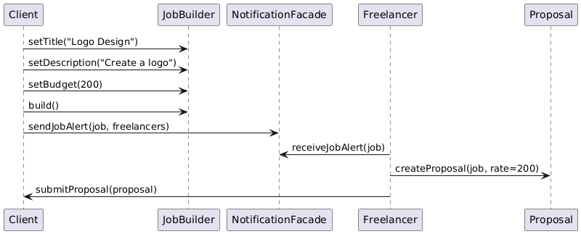

3.3. Description of Data Modules
Description of data modules according to 5.3.1 – 5.3.10, from [1]. The data modules can be identified on the use case diagram(s) from the Software Requirements Specification.

These modules define the logical structure and operation of the primary data stores required by the functional modules.

3.3.1. Description of Data Module 1: UserDataModule

Name | UserDataModule
Type | Data module
Purpose | To persistently store and manage all user-related information, including credentials, profiles, skills, and admin records (supporting FR1, FR2, FR11, NFR4, NFR10).
Way of operating on data from this module | Provides secure CRUD (Create, Read, Update, Delete) operations. Write operations for sensitive data (like passwords) are handled after the calling module (e.g., UserManagementModule) applies hashing. Read operations support authentication checks and profile viewing. Deletion operations must comply with GDPR (NFR10).
Subordination | None
Dependencies | UserManagementModule, NotificationProcess.
Resources | Relational data base (e.g., MySQL or PostgreSQL, SQL compatible), Secure Storage.

3.3.2. Description of Data Module 2: JobDataModule
Name | JobDataModule
Type | Data module
Purpose | To persistently store and manage all job postings, service listings, proposals, and associated metadata (supporting FR3, FR4, FR5, FR6).
Way of operating on data from this module | Provides CRUD operations for job postings (by Clients) and proposal submissions (by Providers). Supports complex read operations for searching and filtering based on keywords, category, and budget (required by FR5). Efficient indexing is necessary for high-performance searches (NFR1, NFR5).
Subordination | None
Dependencies | JobSkillManagementModule.
Resources | Relational data base (SQL compatible), Search Indexing Engine.

3.3.3. Description of Data Module 3: MessagingDataModule
Name | MessagingDataModule
Type | Data module
Purpose | To persistently store communication records, ensuring message history between Clients and Providers is maintained and accessible for moderation (supporting FR7, FR8, FR10).
Way of operating on data from this module | Primarily supports write operations for new messages and read operations to display conversation history. It must ensure that only authenticated and authorized users (the two parties involved, plus Administrators for moderation) can access the data. Data transfer and storage must be secure (NFR4).
Subordination | None
Dependencies | CommunicationModerationModule.
Resources | Relational data base or NoSQL store (e.g., MongoDB for high message volume).

4. Dependency Description
This chapter corresponds to chapter 6.2.2, Dependency description, from [1].

This chapter details the dependencies among the decomposed components (Modules, Concurrent Processes, and Data Modules) of the SkillHub system, as identified in Chapter 3.

4.1. Dependencies among modules
The dependencies identified in chapter 3.1 are detailed. Detailed diagrams are recommended.
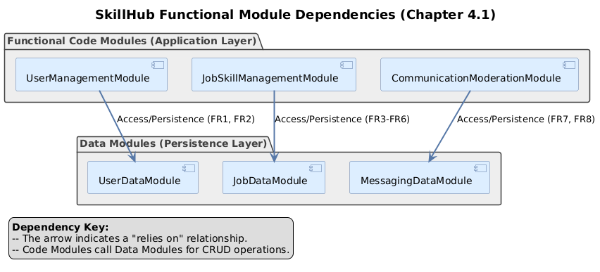

The functional Code Modules rely on the Data Modules for persistence. These dependencies represent direct calls from the application logic to the data access layer.

Dependent Module | Dependency Type | Target Module(s) | Description
UserManagementModule | Access/Persistence | UserDataModule | Requires access to store, retrieve, update, and delete user accounts and profile details (FR1, FR2, FR11).
JobSkillManagementModule | Access/Persistence | JobDataModule | Requires access to manage job postings, proposals, and perform complex searches on job/skill data (FR3-FR6).
CommunicationModerationModule | Access/Persistence | MessagingDataModule | Requires access to store and retrieve all user-to-user messages for conversation history and moderation (FR7, FR8, FR10).

4.2. Dependencies among processes
The dependencies identified in chapter 3.2 are detailed. Detailed diagrams are recommended.
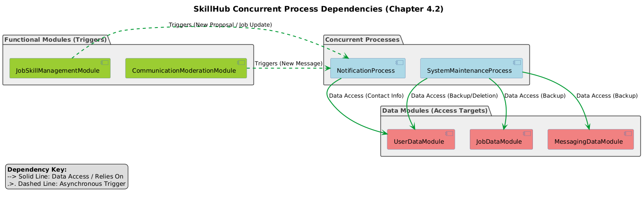
Concurrent Processes often interact with functional modules and data modules to perform background tasks, or they can trigger each other.

Dependent Process | Dependency Type | Target Component(s) | Description
NotificationProcess | Triggered By | CommunicationModerationModule and JobSkillManagementModule | The Notification Process is triggered when either the communication module records a new message (FR9) or the job module records a new proposal/job update.
NotificationProcess | Data Access | UserDataModule | Needs user contact information (e.g., email address) to send external notifications (FR9).
SystemMaintenanceProcess | Data Access | UserDataModule, JobDataModule, MessagingDataModule | Needs read access to all three data modules to perform daily backups (NFR6) and needs write access to the UserDataModule to handle GDPR-compliant permanent data deletion (NFR10).

4.3. Dependencies among data modules
The dependencies identified in chapter 3.3 are detailed. Detailed diagrams are recommended.
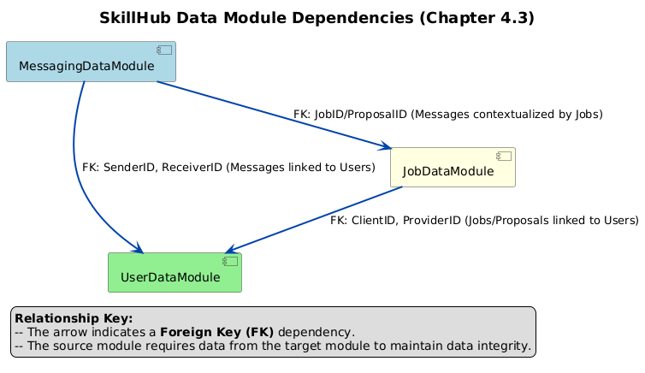

The next crucial step in your SDD is to detail the dependencies between the modules, processes, and data stores you defined in Section 3. This ensures the communication and integration points are clearly documented.
Here is the completed Chapter 4: Dependency Description for SkillHub.

Dependent Data Module | Relationship Type | Target Data Module(s) | Description
JobDataModule | Foreign Key (FK) | UserDataModule | Jobs must be posted by a registered Client (FK: ClientID). Proposals must be submitted by a registered Provider (FK: ProviderID).
MessagingDataModule | Foreign Key (FK) | UserDataModule and JobDataModule | Messages must be linked to the sending and receiving User (FK: SenderID, ReceiverID). Messages are usually contextualized by a Job or Proposal (FK: JobID/ProposalID).

5. Interface Description
This chapter corresponds to chapter 6.2.3, Interface description, from [1].

This chapter details the external and internal interfaces for the Modules and Concurrent Processes defined in Chapter 3. These interfaces define the specific function signatures, inputs, and outputs necessary for component interaction.

5.1. Module Interfaces
The module interfaces described in chapter 3.1 are detailed. Detailed diagrams are recommended.

The functional modules expose an Application Programming Interface (API) to the Presentation Layer (front-end) and other internal components.

5.1.1. Module 1 Interface: UserManagementModule
Name | UserManagementModule
Type | Code module
Purpose | To handle all user-centric operations: registration, authentication, profile management, and administration of user accounts.
Way of operating | Receives requests for registration, login, profile updates, and password reset. Validates credentials, interfaces with the UserDataModule for storage, and returns session tokens or profile data.
Interface 1 | result RegisterUser(email, password, role)
Input | email: string – Unique user email. password: string – User access password (will be hashed internally). role: enum ('Client' or 'Provider') – Initial user role.
Output | result: object/string – User ID and a success/failure status (e.g., {'status': 'OK', 'userID': 123}). Failure includes a reason (e.g., 'Email already exists').
Description | Handles the creation of a new user account. It verifies that the email is unique, hashes the password (NFR4), and persists the data via the UserDataModule.
Interface 2 | result Login(email, password)
Input | email: string – User email. password: string – User access password.
Output | result: object/string – Session token/ID and user details upon successful authentication, or a 'FAILED' status.
Description | Authenticates the user by comparing the provided password against the stored hash. If successful, it returns a token for subsequent secure access (FR1, NFR4).
Interface 3 | result UpdateProfile(userID, profileData)
Input | userID: integer – The ID of the user modifying the profile. profileData: object – Contains fields like name, description, skills (array of strings), and contact information.
Output | result: boolean – true if update was successful, false otherwise.
Description | Allows a user to edit their personal profile, skills, and contact details (FR2).

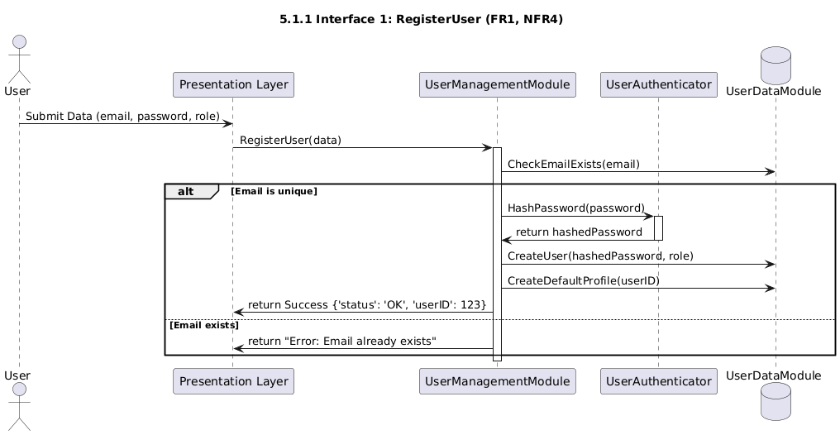

5.1.2. Module 2 Interface: JobSkillManagementModule
Name | JobSkillManagementModule
Type | Code module
Purpose | To manage the creation, modification, search, and submission of proposals for jobs and services.
Way of operating | Clients create/manage jobs (FR3, FR4). Providers search jobs (FR5) and submit proposals (FR6). Interfaces with the JobDataModule.
Interface 1 | result PostJob(clientID, jobDetails)
Input | clientID: integer – ID of the client posting the job. jobDetails: object – Includes title, description, budget: decimal, deadline: date (FR3).
Output | result: object/string – The newly created Job ID and a status (e.g., {'status': 'OK', 'jobID': 456}).
Description | Creates and publishes a new job posting by persisting the details in the JobDataModule.
Interface 2 | array SearchJobs(filterCriteria)
Input | filterCriteria: object – Contains search parameters like category: string, minBudget: decimal, keywords: string, etc. (FR5).
Output | array: An array of job summary objects that match the criteria.
Description | Executes a high-performance search query across the job listings. Must return results within the performance bounds (NFR1).
Interface 3 | result SubmitProposal(providerID, jobID, proposalDetails)
Input | providerID: integer – ID of the provider submitting the proposal. jobID: integer – ID of the target job. proposalDetails: object – Includes proposedPrice: decimal, deliveryTime: integer (days), description: string (FR6).
Output | result: boolean – true if the proposal was successfully recorded, false otherwise.
Description | Records a provider's bid for a specific job, persisting it in the JobDataModule and triggering a notification to the client (Dependency to NotificationProcess).

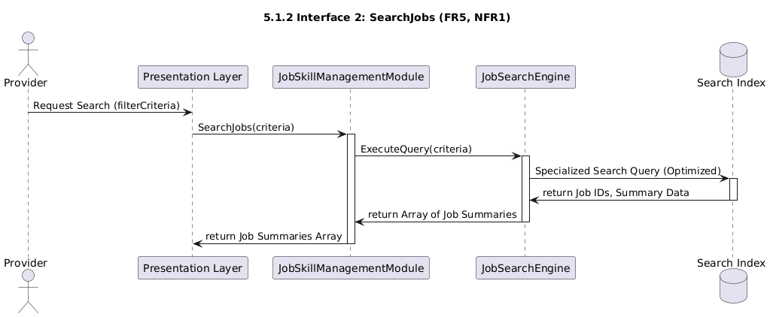

5.1.3. Module 3 Interface: CommunicationModerationModule
Name | CommunicationModerationModule
Type | Code module
Purpose | To handle direct messaging between users and to provide tools for Administrators to moderate content.
Way of operating | Manages secure message exchange (FR7, FR8). Administrators access tools to review and enforce rules (FR10).
Interface 1 | result SendMessage(senderID, receiverID, content, jobID)
Input | senderID: integer, receiverID: integer – IDs of the communicating users. content: string – The message body. jobID: integer – Contextual job ID (optional).
Output | result: boolean – true if the message was stored and notification triggered, false otherwise.
Description | Stores the message securely (NFR4) and uses WebSockets/APIs for potential real-time delivery. Triggers the NotificationProcess (FR9).
Interface 2 | array GetConversation(userID1, userID2, jobID)
Input | userID1, userID2: integers – IDs of the two users. jobID: integer – Contextual job ID.
Output | array: Array of message objects (sorted chronologically).
Description | Retrieves the secure message history between two users related to a specific job (FR7, FR8).
Interface 3 | result ModerateContent(adminID, contentID, action)
Input | adminID: integer – ID of the acting administrator. contentID: integer – ID of the message/proposal being reviewed. action: enum ('Remove', 'WarnUser', 'DeactivateUser').
Output | result: boolean – true if the action was successfully logged and executed.
Description | Exposes administrative tools to enforce platform rules (FR10) by reviewing and acting upon inappropriate content.

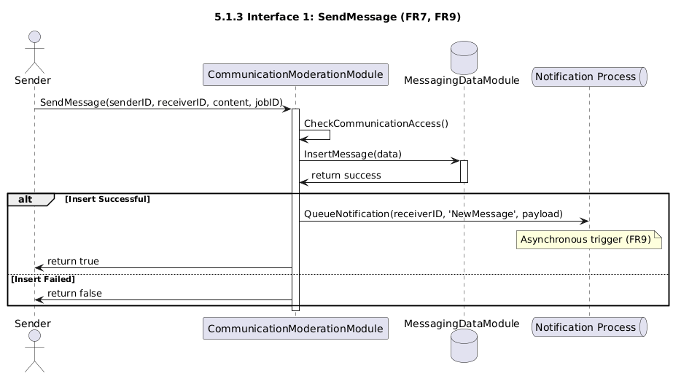

5.2. Processes Interfaces

5.2.1. Process 1 Interface: NotificationProcess

Name | NotificationProcess
Type | Process
Purpose | To asynchronously generate and deliver internal and external notifications (SMS or email) for important events.
Interface 1 | void QueueNotification(userID, type, payload)
Input | userID: integer – The target user ID. type: enum ('NewMessage', 'NewProposal', 'JobUpdate', 'NewJobPosted'). payload: object – Contextual data (e.g., job title, sender name).
Output | None (Void function).
Description | This is the generic internal trigger used by functional modules (e.g., Communication or Job Skill Management) to queue an alert. The process handles asynchronous delivery via email/SMS (as per the module description) after fetching user contact data from the UserDataModule.

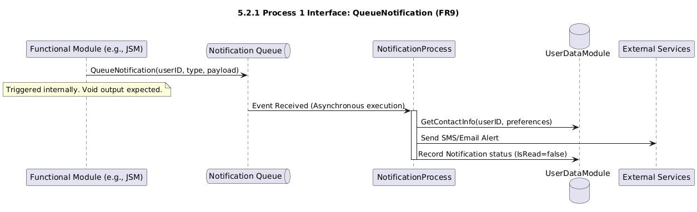

5.2.2. Process 2 Interface: Job Creation Process
Name | Job Creation Process
Type | Process
Purpose | To ensure new jobs are quickly indexed for search and to manage the broad notification of new jobs to all relevant Freelancers (Providers).
Interface 1 | void InitiateJobIndexingAndBroadcasting(jobID)
Input | jobID: integer – The ID of the newly created job.
Output | None (Void function).
Description | This interface is called by the JobSkillManagementModule immediately after a job is successfully posted. It queues the job for two concurrent actions: 1) Indexing in the Search Engine (for NFR1/NFR5 performance). 2) Broadcasting the 'New Job Posted' event, which triggers the NotificationProcess for applicable Freelancers.
Interface 2 | result SubmitProposalProcess(providerID, jobID, proposalDetails)
Input | providerID: integer, jobID: integer, proposalDetails: object (price, time, description).
Output | result: boolean – true if the proposal was successfully recorded, false otherwise.
Description | Although named a 'Process,' this interface is essentially the API for a Provider to submit a proposal, which is an asynchronous trigger to the job process to record the proposal and initiate subsequent notifications to the client. This mirrors the behavior described in the 'Way of operating' section (Freelancers can create proposals).

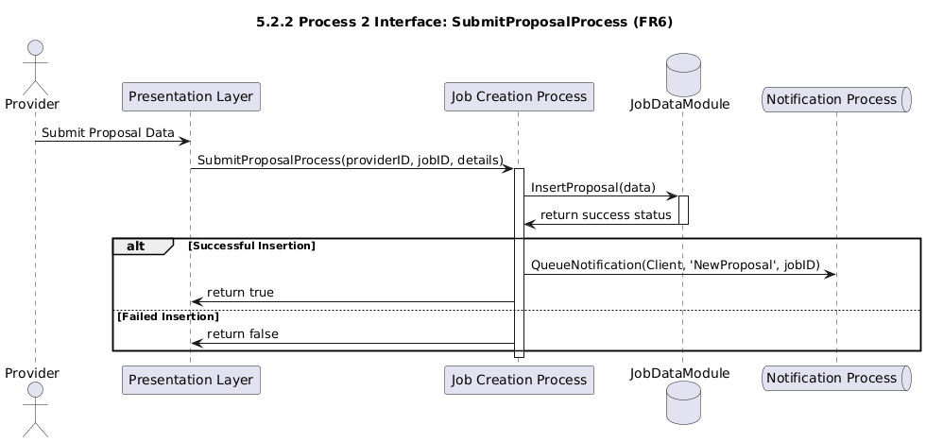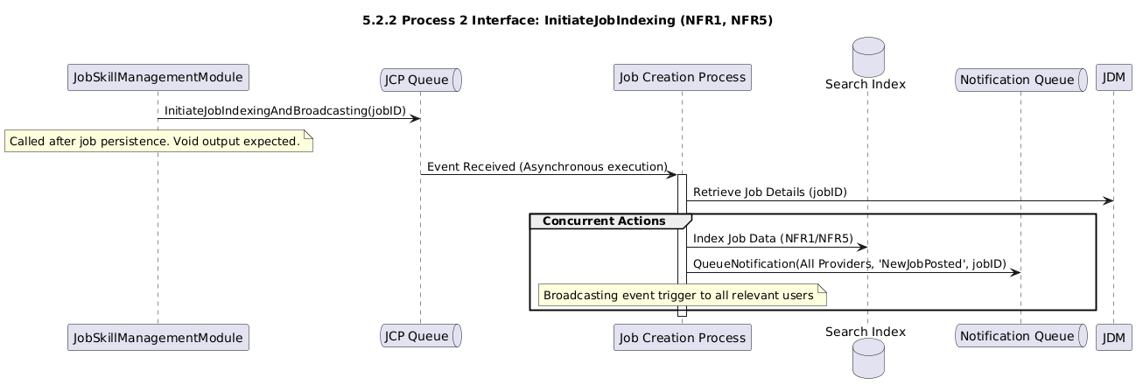

6. Detailed Design
This chapter corresponds to chapter 6.2.3, Interface description, from [1].

6.1. Modules detailed design
The modules described in chapter 3.1 are detailed. Detailed diagrams are recommended.

6.1.1. Module 1: UserManagementModule

Name | UserManagementModule
Type | Code module
Purpose | To handle all user-centric operations: registration, authentication, profile management, and administration of user accounts (FR1, FR2, FR11).
Way of operating | Receives API requests, validates data, delegates persistence to the Data Access Layer (DAL), and manages user state (session/token).
Classes | UserController, UserAuthenticator, UserProfileManager

6.1.1.1. Module 1, Class 1: UserController

Name | UserController
Purpose | Acts as the entry point for all external (API) user management requests. It handles input validation and delegates core logic to UserAuthenticator and UserProfileManager.
Members | authenticator: UserAuthenticator, profileManager: UserProfileManager, logger: SystemLogger
Methods | RegisterUser, Login, UpdateProfile, AdminManageAccount (Mapping to external interfaces from 5.1.1)

6.1.1.1.1. Module 1, Class 1, Method 1: RegisterUser
Name | RegisterUser
Purpose | To create a new user account with basic credentials and role.
Prototype | result RegisterUser(string email, string password, string role)
Input | email: string, password: string, role: string ('Client' or 'Provider')
Output | result: object/string – User ID and status.
Caller | Presentation Layer / API Gateway.
Calls | UserAuthenticator.HashPassword, UserDataModule.CreateUser, UserProfileManager.CreateDefaultProfile.
Algorithm | 1. Validate Input: Check for valid email format and password strength. 2. Check Uniqueness: Call UserDataModule.CheckEmailExists(email). If exists, return 'Email already exists'. 3. Hash Password: Call UserAuthenticator.HashPassword(password) (using bcrypt as per NFR4). 4. Create User: Call UserDataModule.CreateUser(email, hashedPassword, role). 5. Create Profile: Call UserProfileManager.CreateDefaultProfile(newUserID). 6. Return: Return new User ID and 'OK' status.

6.1.1.2. Module 1, Class 2: UserAuthenticator
Name | UserAuthenticator
Purpose | Handles all security-sensitive operations, specifically password hashing and user login verification.
Members | saltService: SecurityService
Methods | HashPassword, VerifyPassword, GenerateSessionToken
6.1.1.2.1. Module 1, Class 2, Method 1: VerifyPassword
Name | VerifyPassword
Purpose | To securely verify a user's login password against the stored hash.
Prototype | boolean VerifyPassword(string email, string inputPassword)
Input | email: string, inputPassword: string (password provided by the user).
Output | boolean: true if passwords match, false otherwise.
Caller | UserController.Login.
Calls | UserDataModule.GetStoredHash(email).
Algorithm | 1. Fetch Hash: Call UserDataModule.GetStoredHash(email) to retrieve the stored bcrypt hash. 2. Check Hash: If no hash is found, return false. 3. Compare: Use the bcrypt comparison library function to securely compare inputPassword against the stored hash (NFR4). 4. Return: Return the result of the comparison.
6.1.1.3. Module 1, Class 3: UserProfileManager
Name | UserProfileManager
Purpose | Manages the non-authentication-related user data, such as profiles, skills, and contact information.
Members | None
Methods | CreateDefaultProfile, UpdateProfile, RetrieveProfile, SanitizeProfileData

6.1.1.3.1. Module 1, Class 3, Method 1: UpdateProfile
Name | UpdateProfile
Purpose | To update a user's professional profile details, including name, description, and skills.
Prototype | boolean UpdateProfile(integer userID, object profileData)
Input | userID: integer, profileData: object (data fields for update).
Output | boolean: true if update successful, false otherwise.
Caller | UserController.UpdateProfile.
Calls | UserProfileManager.SanitizeProfileData, UserDataModule.UpdateProfileRecord.
Algorithm | 1. Authorization Check: Verify the userID is the owner of the profile being updated. 2. Sanitize Data: Call SanitizeProfileData(profileData) to clean input (e.g., prevent XSS attacks). 3. Validate: Check if all required fields are present and valid (e.g., skills are strings). 4. Persist: Call UserDataModule.UpdateProfileRecord(userID, sanitizedData) (FR2). 5. Return: Return success status from the persistence operation.

6.1.2. Module 2: JobSkillManagementModule
Name | JobSkillManagementModule
Type | Code module
Purpose | To manage the creation, modification, search, and submission of proposals for jobs and services (FR3, FR4, FR5, FR6).
Way of operating | Receives requests from Clients to post jobs and from Providers to search jobs and submit proposals. It validates project data and uses the JobDataModule for persistence.
Classes | JobController, JobPoster, JobSearchEngine

6.1.2.1. Module 2, Class 1: JobController
Name | JobController
Purpose | Acts as the entry point for all external API requests related to job postings and proposals. It delegates complex read/write logic to the JobPoster and JobSearchEngine.
Members | jobPoster: JobPoster, searchEngine: JobSearchEngine, logger: SystemLogger
Methods | PostJobAPI, ManagePostedJobsAPI, BrowseJobsAPI, SubmitProposalAPI

6.1.2.2. Module 2, Class 2: JobPoster
Name | JobPoster
Purpose | Encapsulates the logic for creating, editing, deleting jobs (Client side) and handling proposal submissions (Provider side) (Write operations) (FR3, FR4, FR6).
Members | dataAccess: JobDataModule
Methods | CreateJob, UpdateJob, DeleteJob, RecordProposal

6.1.2.2.1. Module 2, Class 2, Method 1: RecordProposal
Name | RecordProposal
Purpose | To validate and persist a Provider's proposal for a specific job, and trigger the client notification.
Prototype | result RecordProposal(integer providerID, integer jobID, object proposalDetails)
Input | providerID: integer, jobID: integer, proposalDetails: object (includes proposed price, delivery time, description).
Output | result: boolean – true if successful, false otherwise.
Caller | JobController.SubmitProposalAPI.
Calls | JobDataModule.GetJobStatus, JobDataModule.InsertProposal, NotificationProcess.TriggerNotification.
Algorithm | 1. Validate Job Status: Call JobDataModule.GetJobStatus(jobID). If the job is closed or awarded, return false. 2. Validate Proposal: Check for non-empty price, positive delivery time, and sanitize description. 3. Persist Proposal: Call JobDataModule.InsertProposal(providerID, jobID, details) (FR6). 4. Trigger Notification: If persistence is successful, call NotificationProcess.TriggerNotification(clientID, 'NewProposal', payload) to alert the client (FR9). 5. Return: Return persistence success status.

6.1.2.3. Module 2, Class 3: JobSearchEngine
Name | JobSearchEngine
Purpose | Manages the efficient searching, filtering, and retrieval of job postings, optimizing for performance and scalability (Read operations) (FR5, NFR1, NFR5).
Members | searchIndexClient: SearchIndexingService, dataAccess: JobDataModule
Methods | SearchJobs, GetJobDetails

6.1.2.3.1. Module 2, Class 3, Method 1: SearchJobs
Name | SearchJobs
Purpose | To quickly find and return available job postings based on complex filtering criteria, meeting response time and scalability requirements.
Prototype | array SearchJobs(object filterCriteria)
Input | filterCriteria: object – Includes category, minBudget, keywords, location, page, pageSize.
Output | array: A paginated array of brief job summary objects.
Caller | JobController.BrowseJobsAPI.
Calls | SearchIndexingService.ExecuteQuery.
Algorithm | 1. Index Query Construction: Convert filterCriteria into a specialized query language (e.g., Lucene query) suitable for the search index client. 2. Execute Search: Call SearchIndexingService.ExecuteQuery(query). This step must be highly optimized to return results $\leq 3$ seconds (NFR1) under heavy load (NFR5). The search index (not the primary database) is used for this step. 3. Retrieve Details (Optional): The search index returns primary keys (Job IDs). If summary data is missing, perform a batch lookup against the JobDataModule using these IDs. 4. Format Results: Apply pagination (page, pageSize) and structure the output array for the client. 5. Return: Return the array of paginated job summaries.

6.1.3. Module 3: CommunicationModerationModule
Name | CommunicationModerationModule
Type | Code module
Purpose | To handle secure direct messaging between users and provide tools for Administrators to moderate content (FR7, FR8, FR10).
Way of operating | Receives requests to send messages, stores them securely via the MessagingDataModule, retrieves conversation history, and exposes specific interfaces for Administrator oversight. It also triggers the NotificationProcess on new messages.
Classes | MessageController, MessageService, ModerationManager

6.1.3.1. Module 3, Class 1: MessageController
Name | MessageController
Purpose | Serves as the primary API endpoint for all user messaging functions (sending, receiving, and viewing history). It delegates core logic to MessageService.
Members | messageService: MessageService, moderationManager: ModerationManager
Methods | SendMessageAPI, GetConversationAPI

6.1.3.2. Module 3, Class 2: MessageService
Name | MessageService
Purpose | Manages the secure storage, retrieval, and delivery of messages. Ensures communication is tied to relevant users and jobs (FR7, FR8).
Members | dataAccess: MessagingDataModule, notificationProcess: NotificationProcess
Methods | StoreMessage, RetrieveHistory, CheckCommunicationAccess

6.1.3.2.1. Module 3, Class 2, Method 1: StoreMessage
Name | StoreMessage
Purpose | To securely validate, timestamp, and persist a new message between two users and trigger a notification.
Prototype | result StoreMessage(integer senderID, integer receiverID, string content, integer jobID)
Input | senderID: integer, receiverID: integer, content: string, jobID: integer (optional context).
Output | result: boolean – true if storage and notification trigger were successful.
Caller | MessageController.SendMessageAPI.
Calls | MessageService.CheckCommunicationAccess, MessagingDataModule.InsertMessage, NotificationProcess.TriggerNotification.
Algorithm | 1. Check Access: Call CheckCommunicationAccess(senderID, receiverID, jobID) to ensure both users are authorized to communicate (e.g., related to the same job). If not authorized, return false. 2. Sanitize Content: Filter out harmful content (basic XSS/SQL injection prevention). 3. Persist: Call MessagingDataModule.InsertMessage(senderID, receiverID, content, timestamp, jobID) (FR7, FR8). 4. Notify: If persistence is successful, call NotificationProcess.TriggerNotification(receiverID, 'NewMessage', payload) to alert the recipient (FR9). 5. Return: Return persistence success status.

6.1.3.3. Module 3, Class 3: ModerationManager
Name | ModerationManager
Purpose | Provides tools and logic for Administrators to review platform content (messages, proposals, profiles) and enforce platform policies (FR10).
Members | dataAccess: MessagingDataModule, userManagement: UserManagementModule
Methods | ReviewContent, ApplyAction

6.1.3.3.1. Module 3, Class 3, Method 1: ApplyAction
Name | ApplyAction
Purpose | To execute an administrative action (remove, warn, deactivate) against a piece of content or a user account (FR10).
Prototype | result ApplyAction(integer adminID, string contentType, integer contentID, string action)
Input | adminID: integer (must be authenticated Admin), contentType: string ('Message', 'Proposal', 'Profile'), contentID: integer, action: string ('Remove', 'WarnUser', 'DeactivateUser').
Output | result: boolean – true if the action was executed and logged.
Caller | MessageController (Admin interface endpoint).
Calls | MessagingDataModule.FlagContent (or DeleteMessage), JobDataModule.FlagContent, UserManagementModule.AdminManageAccount (for 'DeactivateUser').
Algorithm | 1. Admin Verification: Verify adminID has administrative privileges. If not, return false. 2. Action Delegation: Use a switch statement based on action: - If 'Remove': Call the appropriate Data Module to logically delete/flag the content. - If 'DeactivateUser': Call UserManagementModule.AdminManageAccount(targetUserID, 'Deactivate') (FR11). - If 'WarnUser': Log the warning and trigger a specific notification to the user. 3. Log Action: Record the adminID, action, and contentID for audit purposes. 4. Return: Return true.

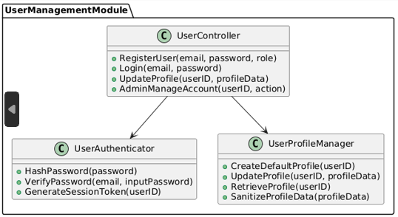
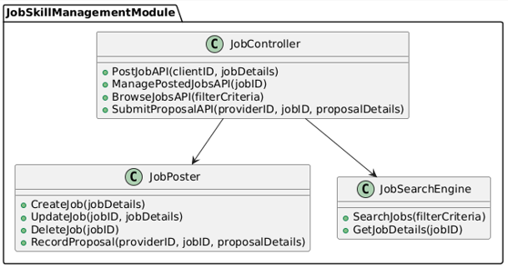
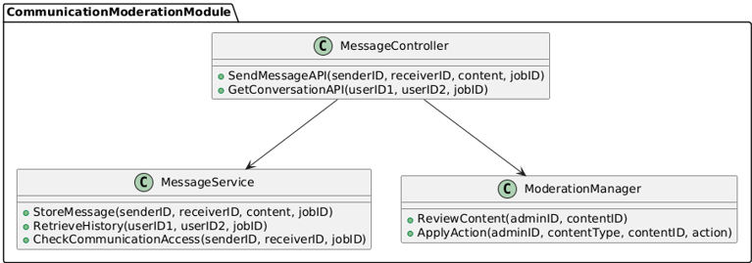
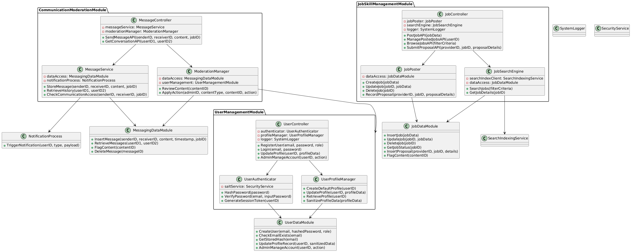

6.2. Data Modules Detailed Design
The data modules described in chapter 3.3. are detailed. Detailed diagrams are recommended.

This section details the internal structure and organization of the Data Modules, describing the key entities (tables), their attributes (columns), and the relationships between them.

6.2.1. Data Module 1: UserDataModule
This module manages all user accounts and profile information, supporting authentication and user management (FR1, FR2, FR11, NFR4, NFR10).
Entity (Table) | Purpose & Key Fields | Attributes (Columns) | Constraints / Notes
User | Stores core login credentials and user type. | UserID (PK), Email (Unique, Not Null), PasswordHash (Not Null), Role ('Client', 'Provider', 'Admin'), IsActive (Boolean) | NFR4: PasswordHash uses bcrypt. IsActive supports Admin deactivation (FR11).
Profile | Stores descriptive information for Client and Provider profiles. | ProfileID (PK), UserID (FK to User), Name (Not Null), Description, ContactInfo, Location, RegistrationDate | FR2: Supports user profile creation and editing.
Skill | Stores a list of specific skills or categories offered by Providers. | SkillID (PK), Name (Unique), Category | Used for taxonomy and search filtering (FR5).
UserSkill | Maps Providers to the Skills they offer (Many-to-Many). | UserID (FK, PK part), SkillID (FK, PK part), ExperienceLevel | Supports Provider profile skill listing.
AdminLog | Records all administrative actions for audit purposes. | LogID (PK), AdminID (FK to User), ActionType, TargetUserID, Timestamp | Supports platform moderation and oversight (FR10, FR11).

6.2.2. Data Module 2: JobDataModule
This module manages all job postings, service listings, and the associated proposals, supporting project initiation and searching (FR3, FR4, FR5, FR6, NFR1, NFR5).
Entity (Table) | Purpose & Key Fields | Attributes (Columns) | Constraints / Notes
JobPost | Stores job requests published by Clients. | JobID (PK), ClientID (FK to User), Title (Not Null), Description (Text), Budget (Decimal), Deadline (Date), Status ('Open', 'Awarded', 'Closed') | FR3: Supports job posting. Required fields are indexed for fast searching (NFR1, NFR5).
Proposal | Stores bids submitted by Providers for open jobs. | ProposalID (PK), JobID (FK to JobPost), ProviderID (FK to User), ProposedPrice (Decimal), DeliveryTime (Days), Description (Text), SubmissionDate | FR6: Supports proposal submission.
JobCategory | Stores the taxonomy used for job organization. | CategoryID (PK), Name (Unique), ParentID (FK to self) | Used for filtering job search results (FR5).
JobToCategory | Maps JobPosts to one or more Categories (Many-to-Many). | JobID (FK, PK part), CategoryID (FK, PK part) | Supports multi-category filtering.

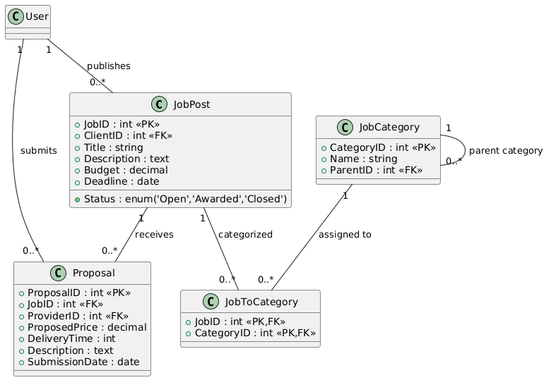

6.2.3. Data Module 3: MessagingDataModule
This module manages all communication records, ensuring security and accessibility for moderation (FR7, FR8, FR10, NFR4).
Entity (Table) | Purpose & Key Fields | Attributes (Columns) | Constraints / Notes
Message | Stores the content of direct messages between users. | MessageID (PK), SenderID (FK to User), ReceiverID (FK to User), Content (Text, Secured), Timestamp (Not Null), JobID (FK to JobPost, optional) | FR7, FR8: Supports client/provider communication. NFR4: Encryption may be applied to Content if required by legal standards beyond HTTPS.
Notification | Stores the history and status of system alerts. | NotificationID (PK), UserID (FK to User), Type ('NewMessage', 'NewProposal', etc.), Content, IsRead (Boolean), Timestamp | FR9: Supports the notification process.
ContentFlag | Records instances of inappropriate content flagged by users or system checks. | FlagID (PK), ReporterID (FK to User), ContentType ('Message', 'Proposal', etc.), ContentID, Reason, Status ('New', 'Resolved', 'Ignored') | FR10: Supports the moderation process.

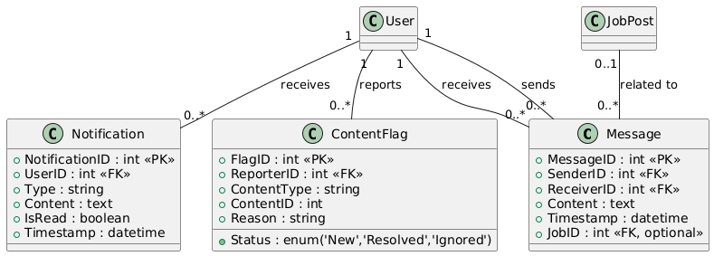

Appendices

A1. Use cases diagrams
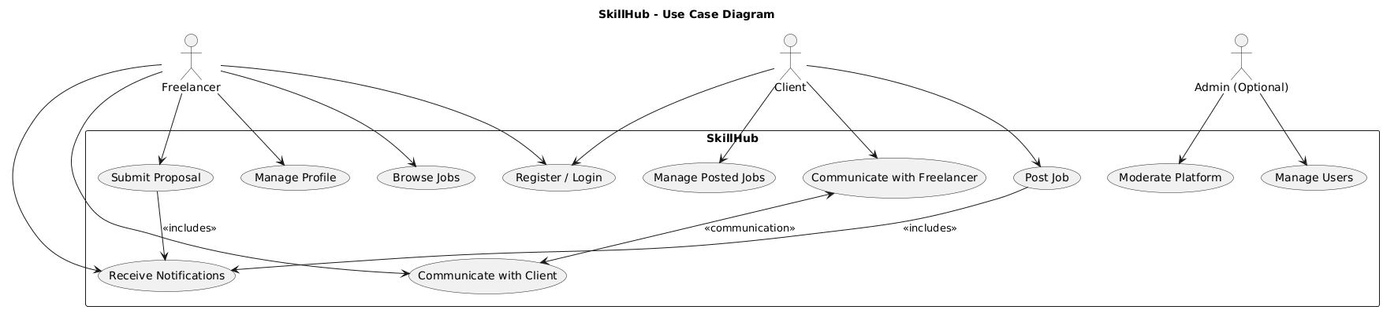

A2. Class diagrams
6.1.1

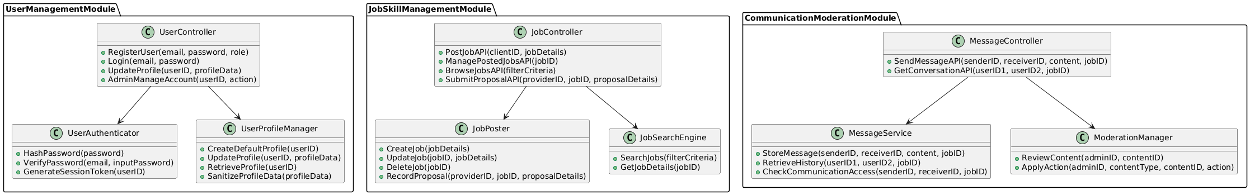

A3. Sequence diagrams

A4. System Diagram

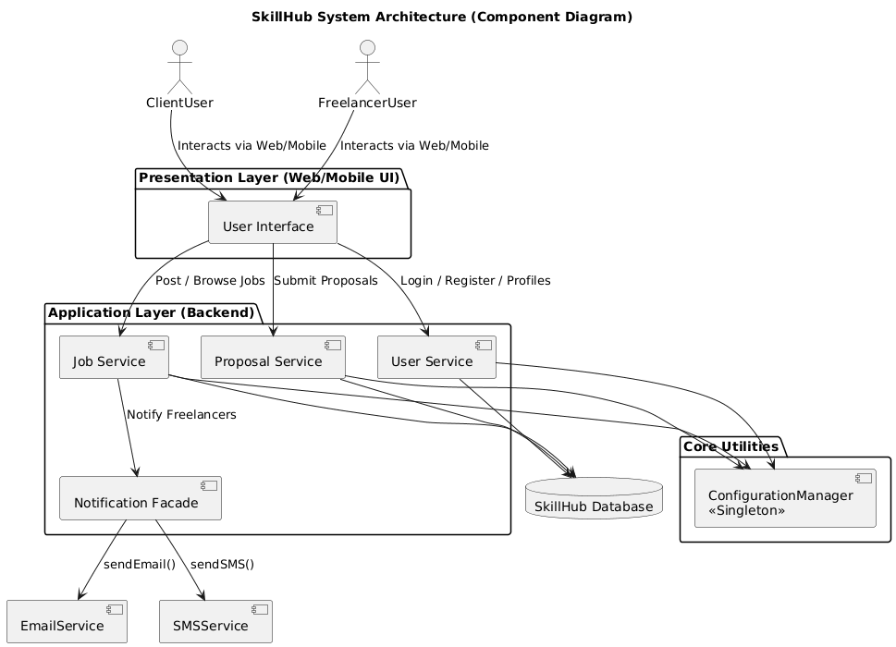

A5. Diagrams
4.1

4.2

4.3
5.1.1
5.1.2

5.1.3

5.2.1

5.2.2(1 and 2)

6.1

6.2.1
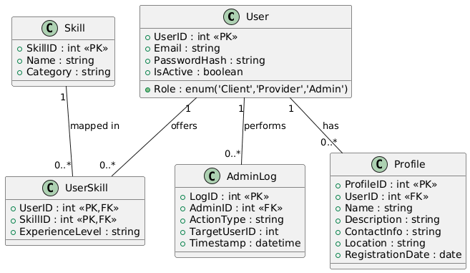

6.2.2

6.2
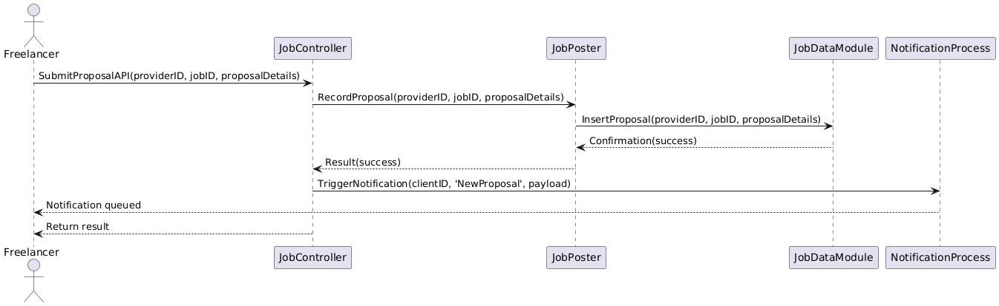

6.2.3

A6. Document evolution
The was finished on 17.Nov.2025. The evolution of the project can be observed on the 4th page.

A7. Conclusions regarding the activity
The activity has been very challenging but we successfully completed it, managing to creating a well structured document, well done diagrams and correct information.

