Politehnica University of Bucharest

Software Engineering

SkillHub
Software Requirements Specification

Team:
JERCĂU Hadasa-Ștefana, gr.1241EB
FINICHIU Eduard-Adelin, gr.1241EB

Coordinator:  Prof. Dr. Ing Nicolae Goga | Date created:  Saturday, November 07, 2026

Delivery Report
(will be delivered along with the project)

Name Group Project implementation [%, reason] Signature

JERCĂU H.Ș 1241EB __50% SRS completed document_ __JHȘ___
( point 1 to point 3)

FINICHIU E.A 1241EB __50% SRS completed document_ __FEA___
( Apendices)

Delivery date:
__________________________________

Table of Contents

Politehnica University of Bucharest 1
Software Engineering 1
Delivery Report 2
Table of Contents 3
Requirements Analysis 4
1. Introduction 4
1.1. Purpose 4
1.2. History 4
1.3. Scope 4
1.4. Definitions, Acronyms and Abbreviations 5
1.5. References 5
1.6. Structure 5
2. General description 7
2.1. Product Description 7
2.2. Product Functions 7
2.3. User description 8
2.4. Constraints 8
2.5. Assumptions and Dependencies 8
3. System Requirements 10
3.1. External Interface Requirements 10
3.2. Functional Requirements 10
3.3. Performance Requirements 11
3.4. Design Constraints 12
3.5. Software System Attributes 12
3.6. Other System Requirements 13
Appendices 14
A1. Interview with the customer 14
A2. System diagram 15
A3. Use Cases Diagrams 15
A4. Class Diagrams 16
A5. Sequence Diagrams 17
A6. State Diagrams 18
A7. Document Evolution 20
A8. Report regarding team meetings 20
A9. Conclusions regarding the activity 20

Requirements Analysis

According to the IEEE STD-830-1993, IEEE Recommended Practice for Software Requirements Specification.

1. Introduction

1.1. Purpose
The purpose of this Software Requirements Specification (SRS) document is to comprehensively describe all the functional and non-functional requirements of the SkillHub application in a clear, structured, and detailed manner. It aims to provide a shared understanding between all stakeholders, including developers, project managers, testers, and clients, regarding what the system is expected to accomplish and under what constraints it must operate.
This document serves as an essential reference point throughout the project lifecycle, guiding the design, implementation, validation, and long-term maintenance of the SkillHub platform. By defining precise objectives and requirements, it ensures consistency in development decisions and minimizes ambiguities that could lead to misinterpretations or system defects.
SkillHub is envisioned as an innovative freelancing platform designed to seamlessly connect skilled freelancers with potential clients and employers from all over the world. The platform facilitates collaboration by enabling users to showcase their expertise, publish projects, negotiate terms, and deliver services in a transparent and efficient environment. Its ultimate goal is to empower individuals to leverage their professional abilities while providing businesses with access to a global talent pool.

1.2. History
This document represents the first official version of the SkillHub project. The system has been developed as part of an academic initiative within the Software Engineering course, where the goal is to apply theoretical knowledge to a practical, real-world scenario. Since this is the initial release, the project does not have any prior iterations or versions from which it has evolved.
SkillHub was conceptualized and built from the ground up, based on current software engineering principles and methodologies. All requirements, features, and design decisions have been defined specifically for this version, following academic guidelines and industry standards to ensure both educational value and technical accuracy.
As an academic prototype, this first version serves as a foundation for potential future improvements. It lays the groundwork for future versions that may include additional functionality, refined interfaces, enhanced system performance, and integration with real-world freelancing platforms. Any subsequent versions will build upon this initial release, using the experience and feedback gathered throughout the development and evaluation of this academic implementation.

1.3. Scope
SkillHub is a web-based platform designed to facilitate meaningful interactions between individuals who wish to offer their professional skills and those seeking specific services. The platform serves as an intermediary environment where freelancers and clients can meet, collaborate, and exchange services in a secure and organized manner. It provides a structured ecosystem that promotes visibility, credibility, and efficiency in managing freelance activities.
The system allows users to create accounts and register as either service providers or clients, depending on their objectives. Once registered, users can create and personalize their profiles by adding details such as skills, experience, project history, and contact information. Freelancers can list the services they offer, set pricing models, and showcase portfolios, while clients can publish job offers, describe their project needs, and browse suitable candidates.
In addition to user registration and skill listing, SkillHub includes communication features that enable direct interaction between clients and freelancers. This may include private messaging, project proposals, or status updates, ensuring transparency and clarity throughout the collaboration process. The platform’s scope extends to managing user relationships, project tracking, and overall user satisfaction, aiming to create a trustworthy and efficient digital marketplace for skill-based services.

1.4. Definitions, Acronyms and Abbreviations
API – Application Programming Interface
DB – Database
FR – Functional Requirement
HTTP – HyperText Transfer Protocol
NFR – Non-Functional Requirement
SRS – Software Requirements Specification
Skill – Refers to a particular capability, talent, or service that a user offers through the SkillHub platform.
Client – Represents a user who requests specific services or skills on SkillHub.
Provider – Represents a user who offers services or skills on SkillHub.
Skill – Refers to a particular capability, talent, or service that a user offers through the SkillHub platform. A skill may represent a professional or creative ability, such as graphic design, software development, content writing, marketing, or other specialized competencies. Each skill entry defines what the user can provide to potential clients and helps establish a professional identity within the platform.
Client – Represents a user who utilizes the SkillHub platform to search for, evaluate, and request specific services or skills from other users. Clients can publish detailed job descriptions, review provider profiles, negotiate terms, and manage project progress through the platform’s interface. Their main objective is to find suitable professionals who can complete their projects efficiently and according to their requirements.
Provider – A user who offers one or more skills or services within SkillHub. Providers are freelancers or professionals who use the platform to promote their expertise, build reputations, and gain access to work opportunities. They can create service listings, set prices or hourly rates, communicate with clients, and deliver completed work through the system. The platform supports them in managing their engagements and expanding their client base.
SRS – Stands for Software Requirements Specification. This document defines the complete set of requirements, both functional and non-functional, that the SkillHub system must meet. It serves as a key reference for developers, testers, and project stakeholders to ensure that the final product aligns with the established expectations and objectives.

1.5. References

1.5 References
[1] IEEE Computer Society. *IEEE Recommended Practice for Software Requirements Specifications (IEEE Std 830-1998)*. IEEE, 1998. ISBN 0-7381-0332-2.
[2] Pressman, Roger S., and Maxim, Bruce R. *Software Engineering: A Practitioner’s Approach*, 8th Edition. McGraw-Hill Education, 2014. ISBN 978-0-07-802212-8.
[3] Goga Nicolae. *Software Engineering – Course Materials*. Politehnica University of Bucharest, 2025.
[4] Dobre, Iulian & Ioniță, Adrian. *Ingineria Programării: Fundamente și Aplicații*. Editura Politehnica Press, București, 2018. ISBN 978-606-515-945-7.
[5] Dumitrache, I., & Mihu, I. *Metode și Tehnici de Dezvoltare a Software-ului*. Editura Academiei Române, 2016. ISBN 978-973-27-2713-2.
[6] Moldoveanu, Florin & Grigoraș, Gabriela. *Analiza și Proiectarea Sistemelor Informatice*. Editura MatrixRom, București, 2017. ISBN 978-606-25-0235-9.
[7] Sommerville, Ian, et al. *Requirements Engineering: A Good Practice Guide*. Wiley, 1997. ISBN 978-0-471-97444-4.
[8] Fiverr – Online Freelancing Platform. Available at: https://www.fiverr.com. Accessed: October 2025.[10] Upwork – Freelancing Platform. Available at: https://www.upwork.com. Accessed: October 2025.[11] IEEE Computer Society. *Guide to the Software Engineering Body of Knowledge (SWEBOK)*, Version 3.0. IEEE, 2014. ISBN 978-0-7695-5166-1.

1.6. Structure
This Software Requirements Specification document is organized into several major sections, each serving a distinct purpose in outlining the development and understanding of the SkillHub system. The structure ensures a logical flow of information, beginning with a general introduction and progressing toward increasingly detailed technical content.
The first part introduces the project, describing its purpose, scope, and key definitions to establish a clear foundation for all readers. It also includes historical context, references, and an overview of how the document is organized. This helps stakeholders quickly identify relevant sections depending on their role in the development process.
The second part provides a general description of the system, focusing on its overall functionality, user characteristics, constraints, and dependencies. This section gives an abstract view of how the system operates within its environment and how users interact with it.
The third part presents the detailed system requirements, both functional and non-functional. It specifies all essential behaviors, data flows, and performance expectations that the SkillHub platform must satisfy. Each requirement is precisely stated to minimize ambiguity and to serve as a reference for implementation and testing.
Finally, the appendices include supporting materials such as diagrams, models, and interview summaries that were used during requirement gathering and system design. These elements provide additional context and evidence for the decisions made throughout the project. Together, these chapters ensure the document remains structured, comprehensive, and consistent with the IEEE SRS format.

2. General description

2.1. Product Description
SkillHub is envisioned as a web-based application accessible through any modern browser, allowing users to interact with the platform from various devices such as laptops, tablets, and smartphones. The system provides an intuitive interface designed to support smooth navigation, enabling users to manage their activities efficiently regardless of their level of technical expertise.
The primary functionality of SkillHub revolves around creating an interactive environment where users can register for accounts, create detailed profiles, and participate as either clients or service providers. Each user will be able to build a professional profile that highlights their skills, experience, portfolio, and other relevant information. Providers can list the services they offer, define categories, and establish pricing or hourly rates. Clients, on the other hand, will be able to search for services, filter results by skill type, experience, or location, and initiate collaboration with the most suitable providers.
SkillHub facilitates communication and interaction between users through integrated messaging tools and notification systems. These features support proposal exchanges, feedback sharing, and status updates throughout a project’s lifecycle. The system will also interact with external databases to securely store user information, project data, and transaction details. Furthermore, SkillHub is designed with scalability in mind, allowing potential integration with third-party services such as payment gateways for secure financial transactions or messaging APIs to enhance real-time communication.
Overall, the product aims to deliver a comprehensive digital ecosystem that supports freelance collaboration from start to finish—covering everything from account creation and skill presentation to communication, project management, and payment processing.

2.2. Product Functions
The SkillHub platform provides a range of core functions designed to support seamless interaction between clients and service providers, ensuring that both parties can achieve their objectives efficiently within the system.
User Registration and Authentication: The platform allows new users to create accounts by providing essential information such as name, email address, and password. Authentication mechanisms ensure secure access to the platform, protecting personal data and preventing unauthorized use. Users will also have the option to recover accounts or reset passwords, maintaining continuous and secure access to their profiles.
Profile Creation and Skill Listing: Once registered, users can build detailed profiles that showcase their abilities, experience, and previous work. Providers can add specific skills, categorize them, and provide examples or portfolios of completed projects. This function helps users present themselves professionally, making it easier for clients to identify suitable providers for their needs.
Search and Filtering of Skills/Services: Clients can browse and search the platform to find services that match their requirements. Advanced filtering options allow users to narrow results by skill type, experience level, availability, or ratings. This functionality ensures that users can efficiently locate the right service provider, reducing time spent on evaluation and improving the overall matching process.
Direct Messaging Between Users: SkillHub gives access to direct communication between clients and providers. Users can discuss project details, clarify requirements, negotiate terms, and provide updates in real time. This feature ensures transparency, improves collaboration, and fosters trust between users throughout the service delivery process.
Together, these functions form the backbone of the SkillHub platform, enabling it to operate as a complete and user-friendly freelancing ecosystem.

2.3. User description
SkillHub is designed to accommodate different types of users, each with distinct roles and responsibilities, ensuring that the platform operates smoothly and securely for all participants.
Users include both clients seeking services and providers (freelancers) offering skills. These users are assumed to have minimal technical knowledge, so the platform emphasizes a simple and intuitive interface that allows them to complete tasks without difficulty. Regular users can register and manage their accounts, create profiles, list skills or projects, search and filter services, and communicate with other users. The system is designed to guide them through each step with clear instructions and prompts, minimizing errors and ensuring a positive user experience.
By defining these user types, SkillHub ensures that the platform supports a diverse range of participants while maintaining security, usability, and effective management of all interactions and data.

2.4. Constraints
The SkillHub platform operates under several important constraints that influence its design, implementation, and usage, ensuring proper functionality, accessibility, and compliance with legal requirements.
Active Internet Connection: SkillHub is a web-based application, which means that all users must have an active and stable internet connection to access the platform. This constraint affects the design of features such as real-time messaging, profile updates, and project management, which rely on continuous connectivity to external servers and databases. The system must handle connectivity issues gracefully, providing users with appropriate notifications and options to retry actions when a connection is temporarily unavailable.
Compatibility with Modern Web Browsers: The platform must be fully compatible with current versions of major web browsers, including Chrome, Firefox, Edge, and Safari. This constraint ensures that users can access SkillHub from a wide range of devices and operating systems without encountering functionality or display issues. Developers must account for differences in browser rendering engines, implement responsive design, and perform thorough cross-browser testing to maintain a consistent and reliable user experience.
Compliance with Data Protection Regulations: SkillHub must adhere to relevant data protection and privacy regulations, such as the General Data Protection Regulation (GDPR) in the European Union. This constraint governs how user data is collected, stored, processed, and shared. The system must implement secure authentication, data encryption, consent mechanisms, and transparent privacy policies. Compliance ensures that users’ personal information is protected, builds trust in the platform, and reduces legal risks for the organization operating SkillHub.
Together, these constraints define the operational boundaries of the system, guiding development decisions while ensuring that SkillHub remains accessible, secure, and legally compliant.

2.5. Assumptions and Dependencies
The development and operation of the SkillHub platform rely on several key assumptions and dependencies that shape its architecture, functionality, and long-term scalability.
Database Dependency: SkillHub relies on Google Cloud Firestore, a flexible, scalable NoSQL cloud database, to store user data, job postings, and proposals. The platform assumes continuous connectivity to Google Cloud services for data retrieval and real-time updates.
Future Integration with Payment Gateways: Although the current version of SkillHub focuses primarily on connecting users and facilitating communication, it is assumed that future versions may require integration with external payment gateways. This dependency implies that the system’s architecture must be designed to accommodate secure payment processing, transaction tracking, and compliance with financial regulations. Preparing for this integration early ensures that the platform can scale and evolve without requiring major structural changes.
User Email Requirement: SkillHub assumes that all users possess valid email accounts for registration and account verification. This is essential for authentication, password recovery, notifications, and communication within the platform. The system relies on users maintaining access to their email addresses and providing accurate information during registration to ensure proper functionality and engagement.
By acknowledging these assumptions and dependencies, the SkillHub development team can anticipate potential challenges, design flexible solutions, and ensure that the platform operates reliably under expected conditions while remaining adaptable for future enhancements.
Authentication Dependency: The system relies on Firebase Authentication to manage user identity, secure sessions, and role-based access control (RBAC), removing the need for a custom-built password hashing backend.

3. System Requirements

3.1. External Interface Requirements

SkillHub interacts with several external interfaces that are essential for its operation, ensuring smooth communication between users, devices, and external systems. These interfaces are categorized into user interfaces, hardware interfaces, software interfaces, and communication protocols.

User Interfaces: The platform provides multiple user-facing pages designed for intuitive interaction and efficient navigation. Key pages include the login page for secure access, the profile page for creating and managing user information, the skill search page for browsing and filtering available services, and the messaging page for direct communication between clients and providers. Each interface is designed to be responsive, accessible, and user-friendly, allowing users with varying levels of technical expertise to interact with the system effectively.

Hardware Interfaces: SkillHub operates on standard user devices such as personal computers, laptops, tablets, and smartphones. The platform is hosted on a web server that processes requests, manages data storage, and serves content to users. Hardware requirements for both the server and user devices are taken into account to ensure compatibility, performance, and reliability. The system is optimized to work efficiently across different device specifications, screen sizes, and input methods.
Software Interfaces:
- Frontend Framework: The application is built using React.js (v18+) with Vite for optimized build performance.
- Styling: The User Interface uses Tailwind CSS for responsive, utility-first design.
- Backend-as-a-Service (BaaS): The system interacts with Firebase SDKs for:
  - Auth: Identity management.
  - Firestore: Data persistence.
- Email Client Integration: Communication is facilitated via mailto: protocol integration, leveraging the user's default email client for direct messaging.

Communication Interfaces: The system communicates using standard web protocols such as HTTP and HTTPS. HTTPS is used to secure sensitive data during transmission, protecting user credentials, personal information, and project details. These communication interfaces provide the foundation for reliable data exchange between the client devices, the web server, and any external services that may be integrated into the platform.

Overall, these external interface requirements ensure that SkillHub operates seamlessly across diverse environments, maintains secure interactions, and provides a consistent user experience while remaining adaptable for future enhancements.

3.2. Functional Requirements
ID | Requirement Name | Description
FR1 | Register / Login | The system shall allow users to register using an email and password, and to log in securely to access their accounts.
FR2 | Manage Profile | Each user shall be able to create and edit their personal profile, including name, description and skills.
FR3 | Post Job | Clients shall be able to create and publish job postings that include a title, description, budget, and deadline.
FR4 | Manage Posted Jobs | Clients shall be able to view and delete (if needed) their previously posted jobs.
FR5 | Browse Jobs | Freelancers shall be able to search and browse available jobs, with filtering options.
FR6 | Submit Proposal | Freelancers shall be able to submit proposals for posted jobs, including proposed price, delivery time, and description.
FR7 | Communicate with Client | Freelancers shall be able to communicate to clients regarding proposals or jobs.
FR8 | Communicate with Freelancer | Clients shall be able to communicate to freelancers regarding proposals or jobs.
FR9 | Receive Notifications | Users shall receive notifications for important actions such job status updates.
FR10 | Moderate Platform | Administrators shall be able to access to have an overview of the database (via an external admin panel of database) and delete or update data.
FR11 | Manage Users | Administrators shall be able to view, edit, and deactivate user accounts (via the external admin panel provided by the database provider)

3.3. Performance Requirements
The SkillHub platform must meet specific performance standards to ensure a reliable and responsive user experience under varying workloads and usage conditions. These requirements define the expected system behavior in terms of speed, capacity, and responsiveness.
ID | Requirement Name | Description (Measurable Form)
NFR1 | Performance  (Response Time) | The React Single Page Application (SPA) shall render page transitions in under 1 second by leveraging client-side routing, with data loading from Firestore completing within 2 seconds on average networks.
NFR2 | Availability (Uptime) | The system shall be available at least 99% per month, excluding scheduled maintenance periods.
NFR3 | Usability | A new user shall be able to register and post a job within 5 minutes without external assistance.
NFR4 | Security | User authentication shall be managed via Firebase Auth. All database transactions shall be secured via Firestore Security Rules
NFR5 | Scalability | The system shall utilize Cloud Firestore's auto-scaling capabilities to handle concurrent users without manual server provisioning.
NFR6 | Backup and Recovery | Database backups shall be performed daily, with a retention period of at least 7 days, and full restoration shall be possible within 30 minutes. This operation can be done manually by admin and will be implemented when product is finished and runs on the market.
NFR7 | Compatibility | The frontend shall be fully responsive across mobile and desktop devices, utilizing Tailwind CSS breakpoints to ensure layout consistency on Chrome, Firefox, Safari, and Edge.
NFR8 | Maintainability | The codebase shall be modular, allowing new features to be added within 2 working days, without modifying more than 3 existing modules.
NFR9 | Localization | The system shall support both English user interface.
NFR10 | Data Privacy | The system shall comply with GDPR, allowing users to delete their accounts and all personal data permanently upon request.

3.4. Design Constraints
The design and implementation of the SkillHub platform are subject to specific constraints that influence system architecture, development choices, and operational considerations. These constraints ensure compliance, compatibility, and maintainability throughout the project lifecycle.
Compliance with Legal and Academic Standards: SkillHub must adhere to applicable legal regulations, including data protection and privacy laws such as GDPR. Additionally, since this project is developed within an academic context, it must follow institutional guidelines, ethical standards, and best practices in software engineering. These constraints affect how user data is collected, stored, and processed, as well as how functionality and features are documented and justified. Compliance ensures that the platform operates legally, ethically, and responsibly, protecting both users and developers.
Browser Compatibility and Server Limitations: The platform must be compatible with modern web browsers, including Chrome, Firefox, Edge, and Safari, to ensure accessibility across a wide range of devices. Front-end design must account for differences in rendering engines, screen resolutions, and input methods. Server limitations, such as processing power, memory, and storage, also impose constraints on the system’s architecture. Developers must optimize performance and resource usage to maintain responsiveness and reliability, even under load.
By respecting these design constraints, SkillHub can deliver a secure, legally compliant, and accessible platform that meets both academic objectives and user expectations while operating efficiently within technical limitations.

3.5. Software System Attributes
The SkillHub platform is designed to meet specific software system attributes that ensure its effectiveness, security, and long-term viability. These attributes define the expected qualities of the system in terms of reliability, security, maintainability, portability, and fault tolerance.
Reliability: SkillHub shall maintain a system availability of at least 99%, ensuring that users can access the platform with minimal downtime. This includes robust server infrastructure, reliable database management, and effective monitoring mechanisms to detect and resolve issues promptly. High reliability is essential to maintain user trust and to support continuous operations for both clients and providers.
Security: User credentials, personal data, and sensitive information shall be protected through encryption and secure session management. The platform must implement secure authentication, password hashing, and access controls to prevent unauthorized access. Additionally, all data transmitted between clients and servers shall use secure protocols such as HTTPS, safeguarding information from interception or tampering.
Maintainability: The system architecture shall be modular and scalable, allowing developers to update, expand, or replace components without affecting overall functionality. Clear documentation, standardized coding practices, and separation of concerns facilitate easier maintenance, bug fixes, and future enhancements. This ensures that SkillHub can evolve over time while remaining robust and manageable.
Portability: SkillHub shall be compatible with multiple platforms, including modern web browsers and mobile devices. The design must support responsive layouts, adaptive interfaces, and cross-platform functionality, allowing users to access the system seamlessly from desktops, tablets, or smartphones.
Fault Tolerance: The system shall be capable of handling errors gracefully, ensuring that unexpected conditions or failures do not disrupt the user experience. Error detection, logging, and recovery mechanisms shall be implemented to maintain data integrity, notify users of issues, and allow the system to continue operating under adverse conditions.
By incorporating these attributes, SkillHub ensures a high-quality, secure, and resilient platform that meets user expectations, supports ongoing development, and provides a reliable environment for skill-based collaboration.

3.6. Other System Requirements
Additional system requirements for SkillHub will be identified and defined during the course of development iterations. These requirements may emerge from ongoing testing, user feedback, or evolving project goals, and they will complement the previously established functional and non-functional requirements.
As the platform is further refined, new features or improvements may be added to address specific user needs, enhance performance, or integrate additional services. For example, future requirements could include advanced reporting tools, analytics dashboards, support for multiple languages, or integration with external APIs such as payment gateways or third-party messaging systems.
Documenting these evolving requirements ensures that SkillHub remains adaptable and responsive to real-world usage. The iterative approach allows developers and stakeholders to review, prioritize, and implement changes systematically, maintaining alignment with user expectations and project objectives while ensuring the platform’s scalability, reliability, and maintainability over time.

Appendices

A1. Interview with the customer
The customer interview for SkillHub revealed several important insights regarding the platform’s desired functionality, usability, and overall goals. During the discussion, the customer emphasized the importance of creating a user-friendly interface that allows both clients and service providers to navigate the platform effortlessly, even with minimal technical experience. They stressed that the platform should simplify tasks such as account registration, profile creation, and skill listing, while providing clear guidance throughout the process.
The customer also highlighted the need for efficient communication tools, including direct messaging and notifications, to ensure timely interactions between clients and providers. They suggested incorporating features that allow users to track project progress and manage ongoing collaborations easily. Additionally, the customer expressed interest in a reputation system, where users can rate and review each other, which would help build trust and credibility within the SkillHub community.
Regarding system performance, the customer indicated that the platform should be responsive and reliable, with minimal downtime and fast loading times for pages and searches. They also mentioned potential future needs for payment integration, allowing clients to securely pay providers through the platform. The interview concluded with a discussion about compliance, emphasizing that SkillHub must respect data protection regulations, maintain security of user data, and operate ethically.
This interview provided valuable guidance for shaping the functional and non-functional requirements of SkillHub, ensuring that the platform aligns with the customer’s expectations and delivers a practical, secure, and engaging experience for all users.

A2. System diagram

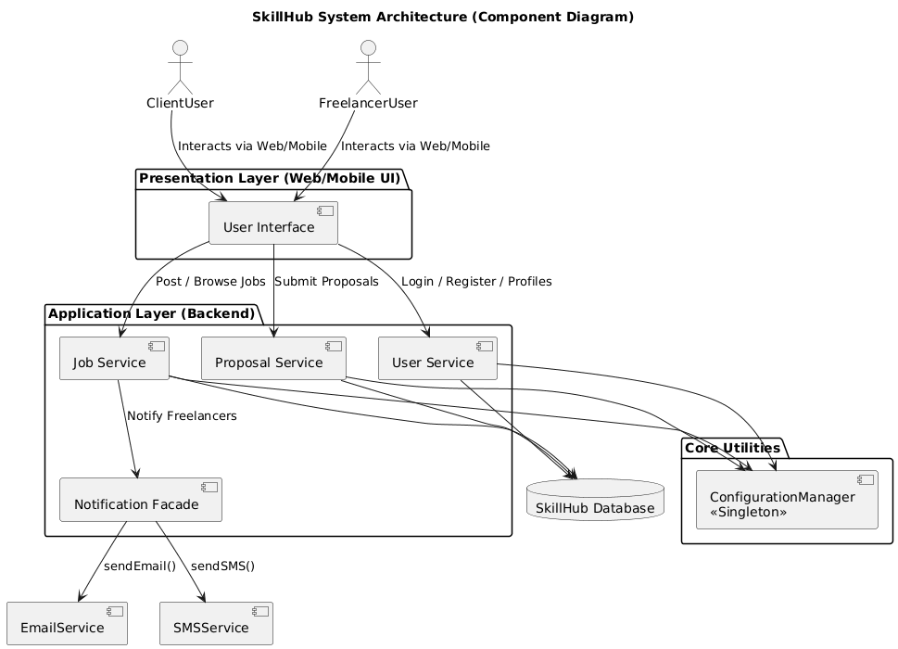

A3. Use Cases Diagrams
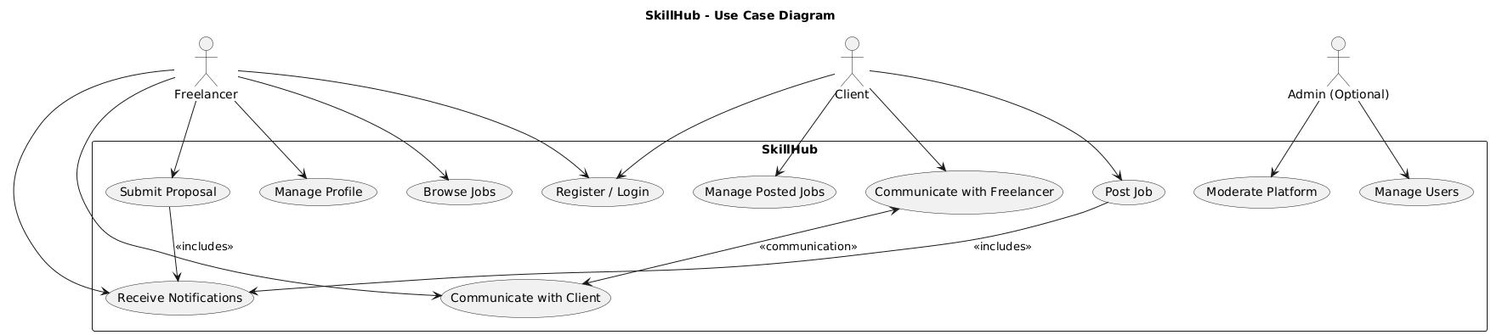

A4. Class Diagrams

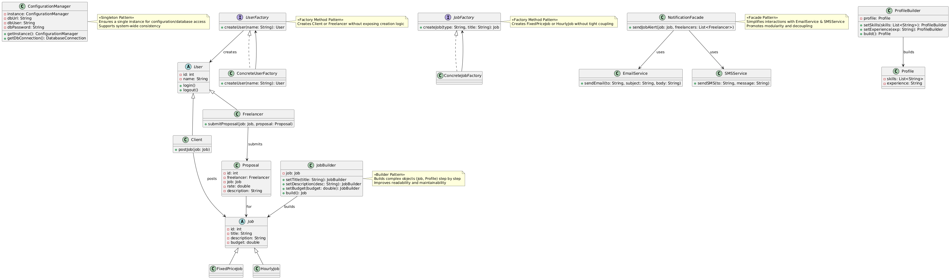

A5. Sequence Diagrams
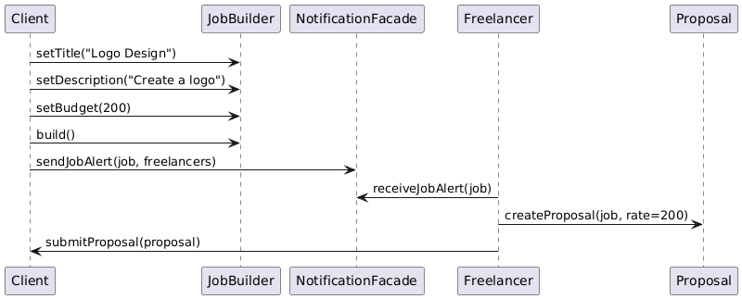
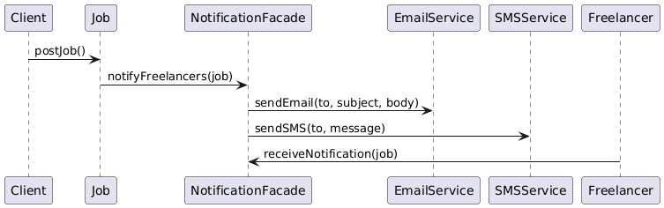

A6. State Diagrams
Job Posting State Diagram
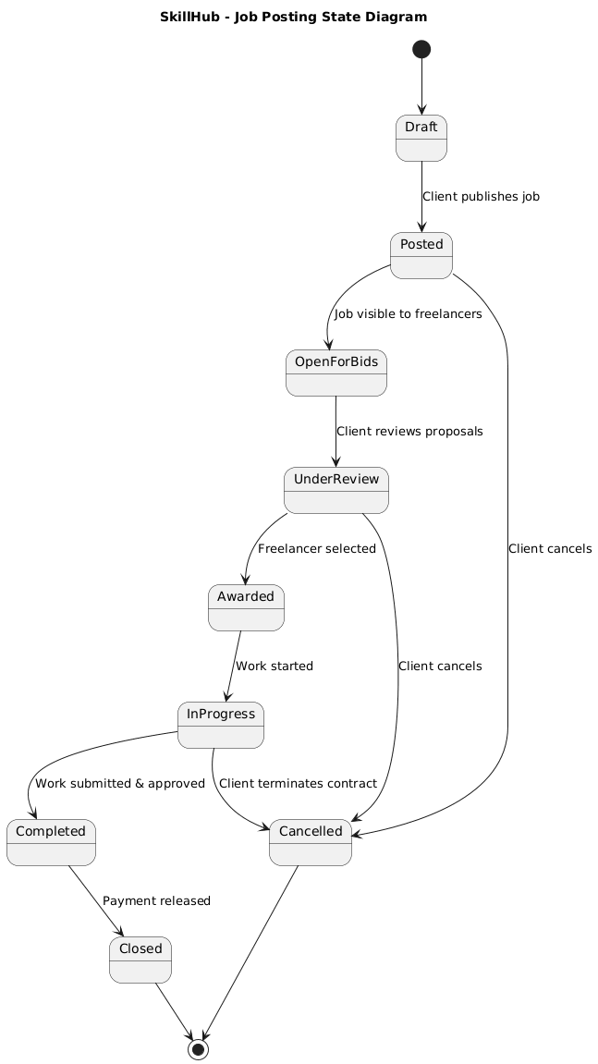

Proposal / Bid State Diagram
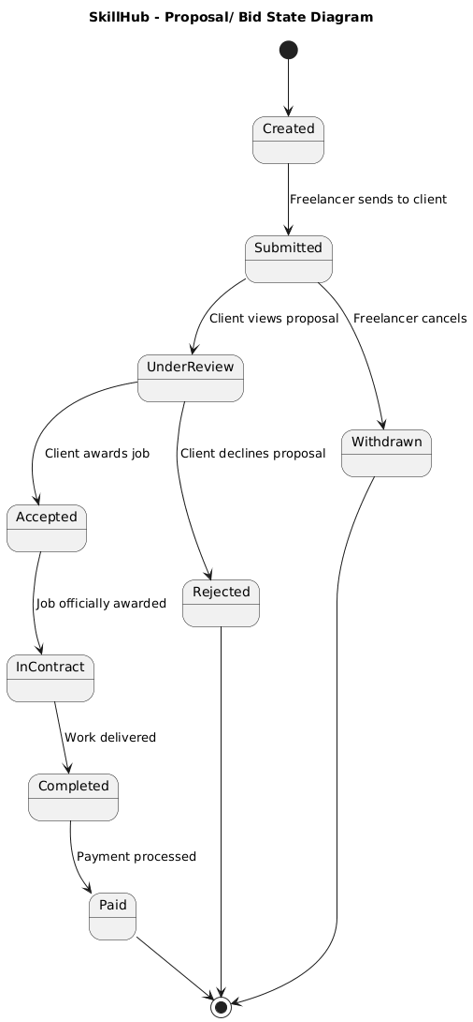

A7. Document Evolution
Version | Date | Author | Description of Change | Reason for Change
1.0 | 19.10.2025 | FINICHIU Eduard-Adelin, JERCĂU Hadasa-Ștefana | Initial version of the SRS document | Creation of the document to define project requirements
1.1 | 03.11.2025 | FINICHIU Eduard-Adelin, JERCĂU Hadasa-Ștefana | Updated: Abreviations, NFR, FR, References | Requested by Prof. Nicolae Goga in order to get complete grading

A8. Report regarding team meetings
Date: 14.10.2025
Location: Bucharest
Participants: FINICHIU Eduard-Adelin, JERCĂU Hadasa-Ștefana
Summary:
During this meeting, the team focused on finalizing the project topic and outlining the initial Software Requirements Specification (SRS) for the chosen system. Key decisions were made regarding the direction of the project and the technologies to be employed.
Activity Title: Debate
Description: The team engaged in a detailed discussion to evaluate potential project ideas, considering feasibility, academic requirements, and practical implementation aspects. After reviewing different options, the participants collectively decided on the specific type of platform to develop. The team also discussed which programming languages, frameworks, and tools would be most suitable for implementing the project efficiently.
Results:
The team reached a consensus to develop a freelancing platform named SkillHub. This platform will connect freelancers with clients, allowing for skill listings, profile creation, messaging, and other relevant functionalities. Additionally, the foundational structure of the SRS was established during this meeting, providing a roadmap for future documentation and development activities.
This meeting set the stage for subsequent planning, ensuring clarity of objectives and alignment among team members regarding the project’s scope and direction.

A9. Conclusions regarding the activity
The activity has been completed successfully, achieving all the planned objectives and producing results that meet the expectations of the team. The decisions made during the meetings, including selecting the project topic and defining the initial SRS structure, provide a solid foundation for the development of SkillHub.
The team demonstrated effective collaboration, clear communication, and careful consideration of technical and academic requirements. By reaching consensus on the platform concept, technology choices, and documentation approach, the participants ensured that the project is well-defined and ready for the next stages of development.
Overall, the outcomes of this activity are satisfactory, reflecting a productive planning process and establishing a strong starting point for the continued progress of the SkillHub project.

