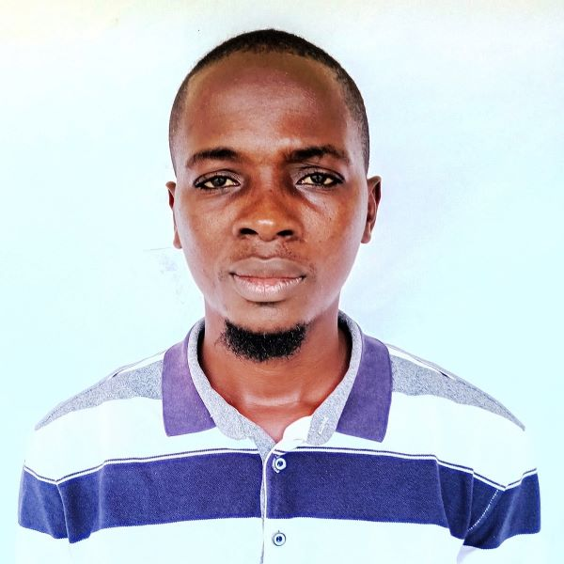

EDWARD | 099999 | @gmial.com

# About Me

It is my pleasure to recommend Mr. Emmanuel Turay for the Fall 2025 Biological Sciences graduate program at Southern Illinois University Edwardsville. As the Human Resource Manager at Magbenteh Community Hospital, I have worked closely with Emmanuel during his time as our Lab Scientist and have seen his outstanding abilities firsthand

# Work Exprience

**RAIC***2017_2021*SENIOR PROGRAMMER

# Work Exprience

**Ubutu***2019_2020*jenior preogrammer

# Skills

* programmer
* pythod developer
* java developer
* database manager