RMarkdown Visual Editor

Business Science

3/23/2021

# Making a Report

This is just a quick example of how to make a report using the **NEW RMarkdown Visual Editor!**

## Load Libraries

library(tidyverse)  
library(tidyquant)

## Dataset

The mpg dataset.

## # A tibble: 234 x 11  
## manufacturer model displ year cyl trans drv cty hwy fl class  
## <chr> <chr> <dbl> <int> <int> <chr> <chr> <int> <int> <chr> <chr>  
## 1 audi a4 1.8 1999 4 auto~ f 18 29 p comp~  
## 2 audi a4 1.8 1999 4 manu~ f 21 29 p comp~  
## 3 audi a4 2 2008 4 manu~ f 20 31 p comp~  
## 4 audi a4 2 2008 4 auto~ f 21 30 p comp~  
## 5 audi a4 2.8 1999 6 auto~ f 16 26 p comp~  
## 6 audi a4 2.8 1999 6 manu~ f 18 26 p comp~  
## 7 audi a4 3.1 2008 6 auto~ f 18 27 p comp~  
## 8 audi a4 quattro 1.8 1999 4 manu~ 4 18 26 p comp~  
## 9 audi a4 quattro 1.8 1999 4 auto~ 4 16 25 p comp~  
## 10 audi a4 quattro 2 2008 4 manu~ 4 20 28 p comp~  
## # ... with 224 more rows

## Make a Plot

Learn ggplot2 visualization - [Business Analytics with R (DS4B 101-R)](https://university.business-science.io/p/ds4b-101-r-business-analysis-r).

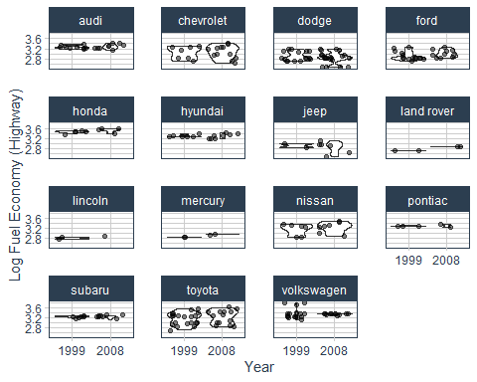

## Tables

Why Learn Data Science from Business Science

|  |  |  |
| --- | --- | --- |
| Following Business Science | Chance of Success | Speed of Learning |
| Yes | High | Fast |
| No | Low | Slow |

## Add an Image

Get the [Free R-Tips](https://mailchi.mp/business-science/r-tips-newsletter)!

