Processor Hardware/Software Interface EECS 113

Assignment 1: Fibonacci Series

Edward Ou

15561434

---------------------------------------------------------------------------------------------------------------------

8-bit Version:

Test case 1: N = 6, Result = 5 and is stored at memory location 0x45H

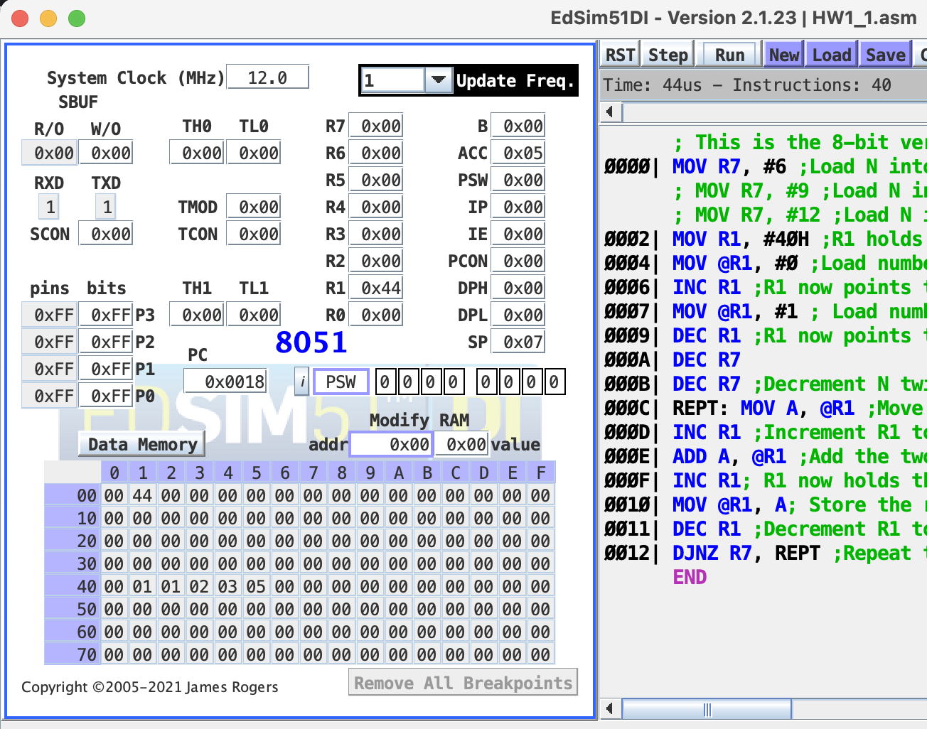

Test Case 2: N = 9, Result = 21 or 15H and is stored at location 0x48H

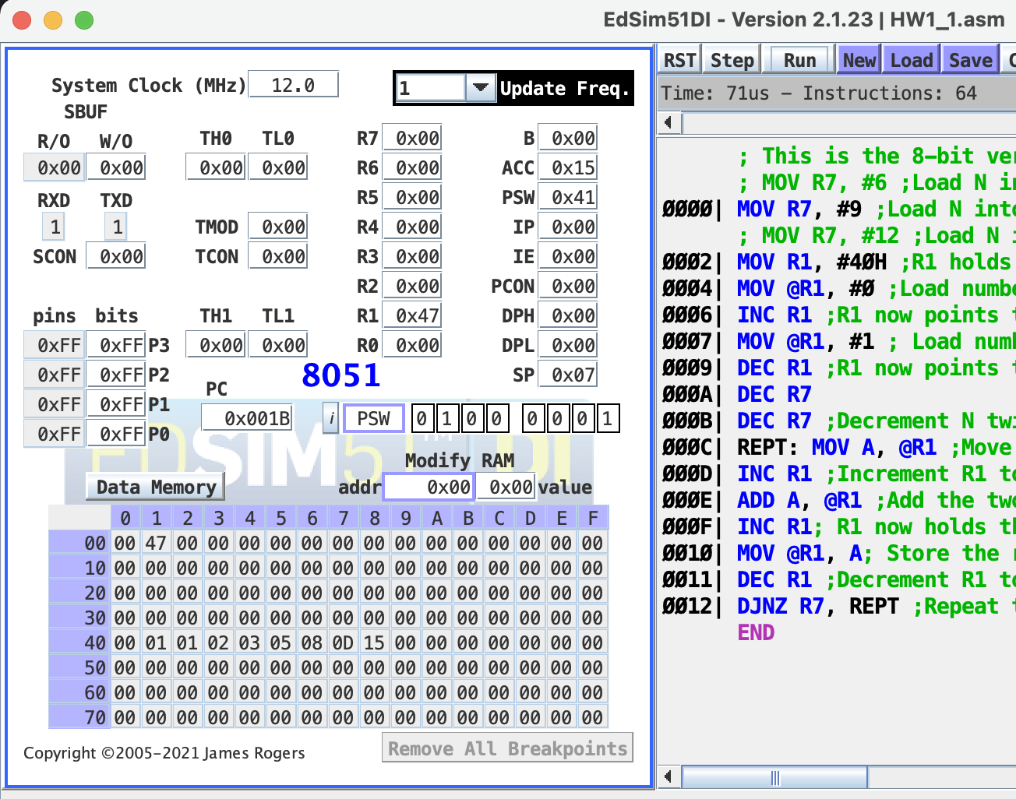

Test Case 3: N = 12, Result = 89 or 59H and is stored at location 0x4BH

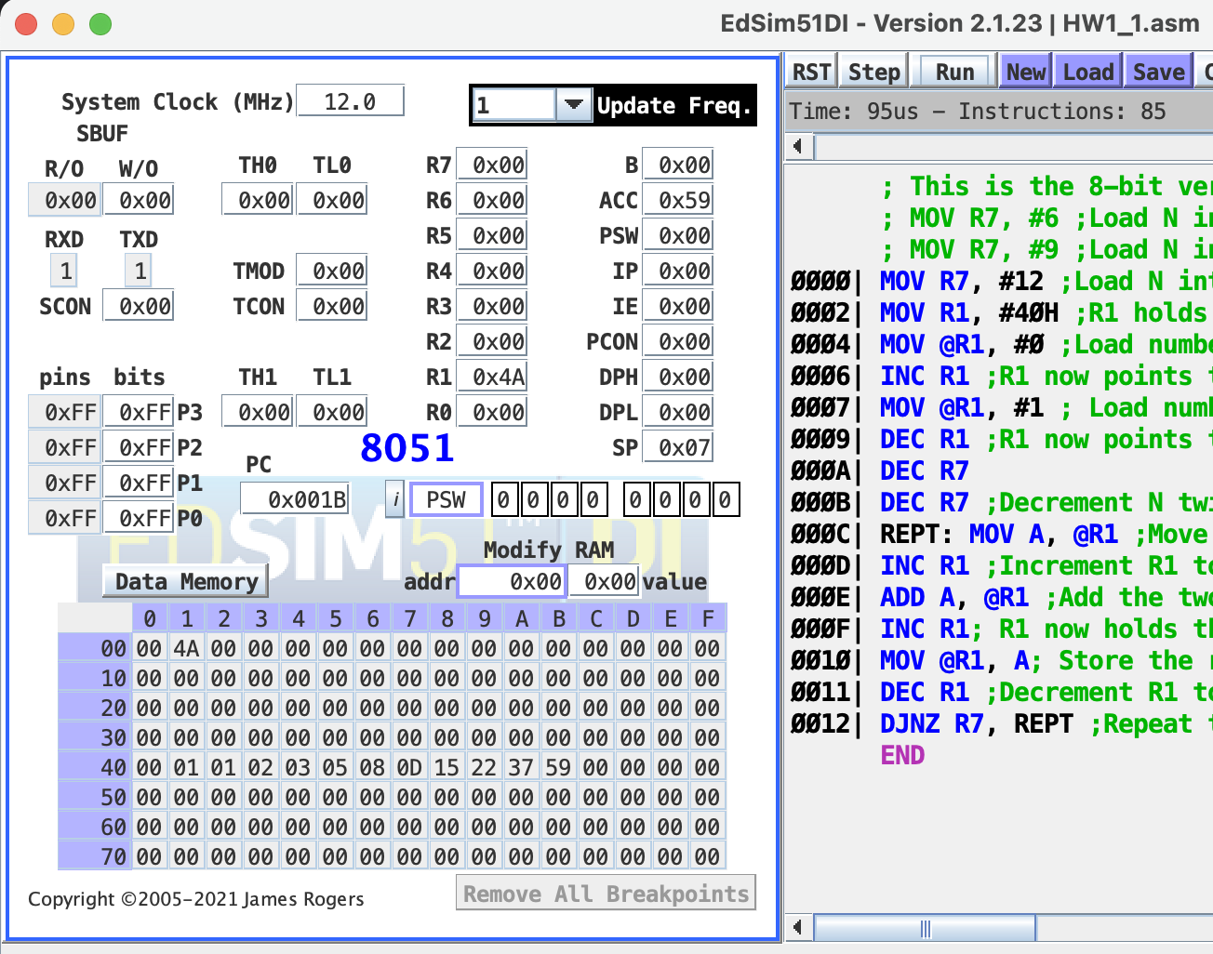

16-bit version:

Test case 1: N = 15, Result = 377 or 179H, the upper 8-bit is stored at location 0x5CH and the lower 8-bit is stored at location 0x5DH

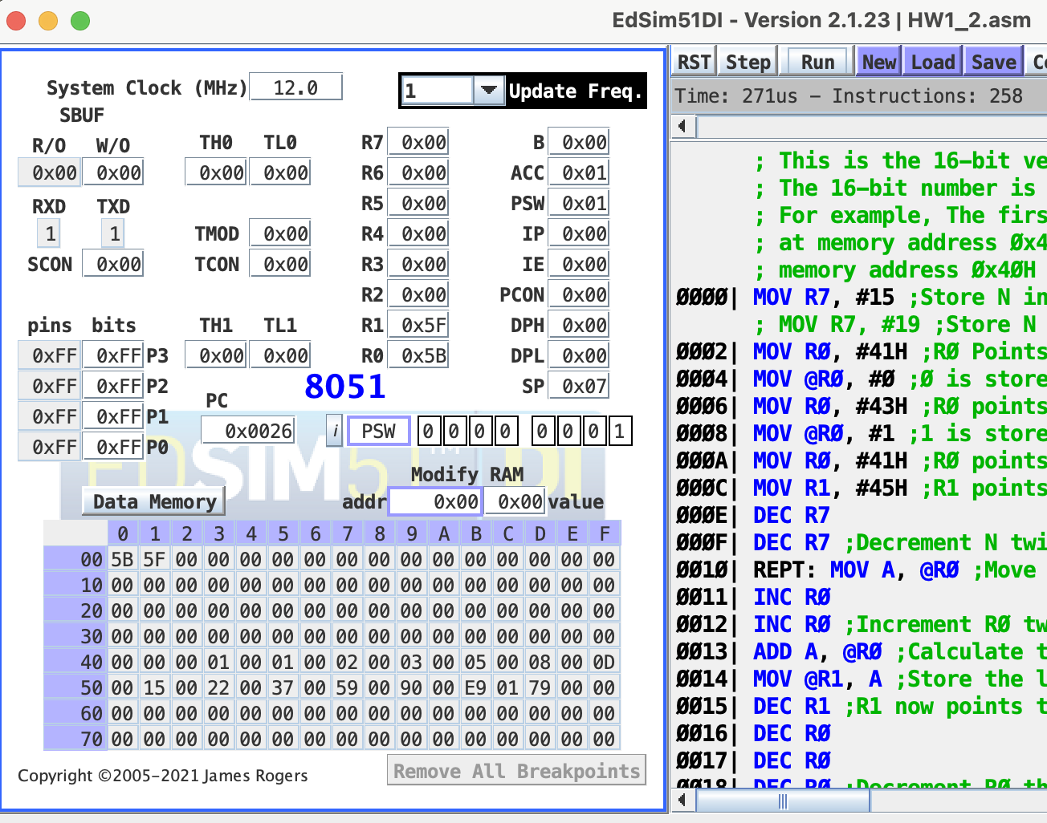

Test case 2: N = 19, Result = 2584 or A18H, the upper 8-bit is stored at location 0x64H and the lower 8-bit is stored at location 0x65H