Anne Arundel County Population Estimate Forecast

Rick Fisher

September 4, 2018

# Load needed library files

library(forecast)  
library(ggplot2)  
library(readxl)

# Import population data from Excel

aaPopR <- read_excel("C:/RStats/Forecast/Data/aaPop.xlsx")

# Preview first few columns of data to verify it was loaded into memory properly

head(aaPopR)

## # A tibble: 6 x 2  
## YEAR POP  
## <dbl> <dbl>  
## 1 1950 117392  
## 2 1951 123511  
## 3 1952 130385  
## 4 1953 140586  
## 5 1954 147333  
## 6 1955 157516

# Plot the data

aaPopPlot <- ggplot(aaPopR, aes(x = YEAR, y = POP)) +  
 geom_point() +  
 ggtitle("County Population Growth 1950-2017") +  
 scale_x_continuous(name = "Year") +  
 scale_y_continuous(name = "Population") +  
 theme_bw()  
print (aaPopPlot)

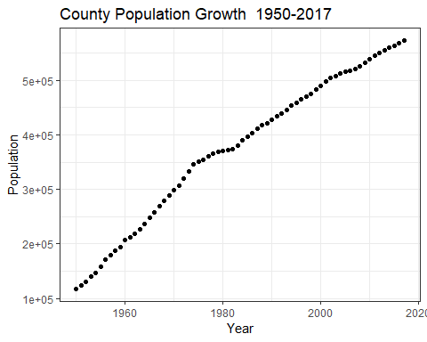

# Run a simple regression model plotting population vs year

aaPopReg <- lm(POP ~ YEAR, aaPopR)

# View regression model summary

summary(aaPopReg)

##   
## Call:  
## lm(formula = POP ~ YEAR, data = aaPopR)  
##   
## Residuals:  
## Min 1Q Median 3Q Max   
## -31352 -14705 3410 11793 35635   
##   
## Coefficients:  
## Estimate Std. Error t value Pr(>|t|)   
## (Intercept) -1.304e+07 2.179e+05 -59.84 <2e-16 ***  
## YEAR 6.763e+03 1.098e+02 61.57 <2e-16 ***  
## ---  
## Signif. codes: 0 '***' 0.001 '**' 0.01 '*' 0.05 '.' 0.1 ' ' 1  
##   
## Residual standard error: 17780 on 66 degrees of freedom  
## Multiple R-squared: 0.9829, Adjusted R-squared: 0.9826   
## F-statistic: 3790 on 1 and 66 DF, p-value: < 2.2e-16

# Visualize the regression model

aaPopPlot <- ggplot(aaPopR, aes(x = YEAR, y = POP)) +  
 geom_point(shape = 1) +  
 geom_smooth(method = 'lm', se = FALSE) +   
 ggtitle("County Population Growth 1950-2017") +  
 scale_x_continuous(name = "Year") +  
 scale_y_continuous(name = "Population") +  
 annotate("text", x=1985, y=300000, label = "R^2 == 0.983", parse=T) +  
 theme_bw()  
 print(aaPopPlot)

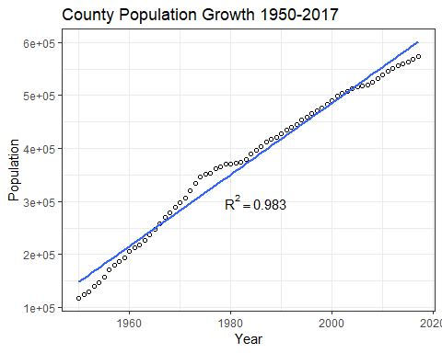

# Create a time series object

aaPopTs <- ts(aaPopR[2], start = c(1950,1), frequency = 1)

# Forecast a 20 year trend using Holt’s method

fcPopHolt <- holt(aaPopTs, h = 20)  
autoplot(fcPopHolt)

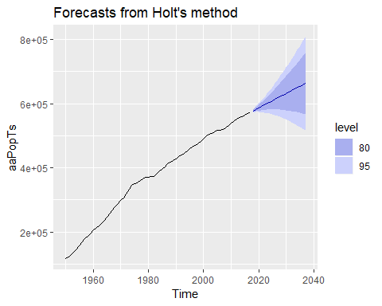

checkresiduals(fcPopHolt)

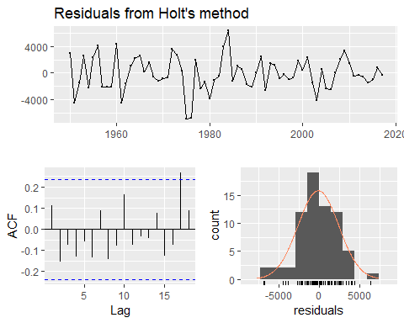

##   
## Ljung-Box test  
##   
## data: Residuals from Holt's method  
## Q* = 11.099, df = 6, p-value = 0.08537  
##   
## Model df: 4. Total lags used: 10

summary(fcPopHolt)

##   
## Forecast method: Holt's method  
##   
## Model Information:  
## Holt's method   
##   
## Call:  
## holt(y = aaPopTs, h = 20)   
##   
## Smoothing parameters:  
## alpha = 0.9999   
## beta = 0.5055   
##   
## Initial states:  
## l = 105320.1615   
## b = 9161.702   
##   
## sigma: 2571.861  
##   
## AIC AICc BIC   
## 1360.728 1361.696 1371.826   
##   
## Error measures:  
## ME RMSE MAE MPE MAPE MASE  
## Training set -135.3381 2495.072 1961.86 -0.03563866 0.7006412 0.288355  
## ACF1  
## Training set 0.1132046  
##   
## Forecasts:  
## Point Forecast Lo 80 Hi 80 Lo 95 Hi 95  
## 2018 577745.1 574449.1 581041.0 572704.3 582785.8  
## 2019 582255.1 576298.5 588211.7 573145.2 591364.9  
## 2020 586765.1 577854.1 595676.1 573136.9 600393.2  
## 2021 591275.1 579101.8 603448.3 572657.7 609892.5  
## 2022 595785.1 580056.8 611513.4 571730.7 619839.5  
## 2023 600295.1 580736.7 619853.5 570383.1 630207.1  
## 2024 604805.1 581157.9 628452.4 568639.8 640970.5  
## 2025 609315.1 581334.5 637295.8 566522.5 652107.8  
## 2026 613825.2 581279.0 646371.3 564050.1 663600.2  
## 2027 618335.2 581002.2 655668.1 561239.3 675431.0  
## 2028 622845.2 580513.6 665176.8 558104.6 687585.7  
## 2029 627355.2 579821.6 674888.8 554658.9 700051.5  
## 2030 631865.2 578933.8 684796.6 550913.6 712816.8  
## 2031 636375.2 577856.9 694893.5 546879.2 725871.3  
## 2032 640885.2 576597.0 705173.4 542564.9 739205.5  
## 2033 645395.2 575159.8 715630.7 537979.4 752811.1  
## 2034 649905.3 573550.3 726260.2 533130.4 766680.1  
## 2035 654415.3 571773.2 737057.4 528025.1 780805.4  
## 2036 658925.3 569832.8 748017.8 522670.1 795180.5  
## 2037 663435.3 567733.2 759137.4 517071.5 809799.1

# Validate the use of Holt’s forecast method by comparing results to ETS.

fitaaPop <- ets(aaPopTs)  
summary(fitaaPop)

## ETS(A,A,N)   
##   
## Call:  
## ets(y = aaPopTs)   
##   
## Smoothing parameters:  
## alpha = 0.9999   
## beta = 0.5054   
##   
## Initial states:  
## l = 105320.1597   
## b = 9161.7018   
##   
## sigma: 2571.861  
##   
## AIC AICc BIC   
## 1360.728 1361.696 1371.826   
##   
## Training set error measures:  
## ME RMSE MAE MPE MAPE MASE  
## Training set -135.3577 2495.072 1961.853 -0.03564391 0.7006366 0.288354  
## ACF1  
## Training set 0.1132628

autoplot(forecast(fitaaPop))

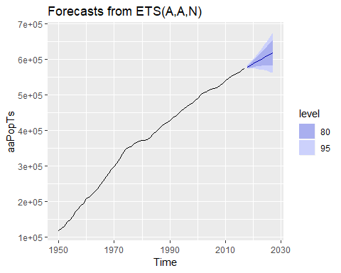

checkresiduals(fitaaPop)

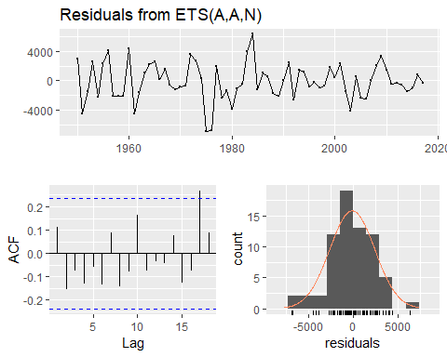

##   
## Ljung-Box test  
##   
## data: Residuals from ETS(A,A,N)  
## Q* = 11.099, df = 6, p-value = 0.08537  
##   
## Model df: 4. Total lags used: 10