CS 7646 Project 1 -Martingale

Guangqing Tai  
gtai3@gatech.edu

***Abstract—*** The goal of this report is to using python code to build a Simple Gambling Simulator and test with different scenarios. Numpy and Matplotlib libraries have been used to build and visualize the process.

# Introduction

## Martingale Betting

The Martingale betting strategy, implemented in Python programming, will demonstrate a short-term success in accumulating winnings. However, over an extended period, the strategy will fail to consistently generate profits due to the exponential increase in bet amounts following consecutive losses. The simulations will likely show initial periods of positive returns, but eventually, the player's funds will be depleted or restricted by a predetermined limit, such as reaching the target winnings or exhausting the available fund. Moreover, introducing a limited fund will further expedite the process of depleting the player's resources, highlighting the inherent risks associated with the Martingale strategy in gambling.

## Code Design

The code designed for Martingale betting strategy analyze its performance through multiple trails (10 and 1000) with $80/$256 bankroll respectively, then plot the results to evaluate short-term success and long-term limitations, and propose a hypothesis predicting initial gains followed by eventual depletion or restriction of funds due to the strategy’s inherent risks. A typical blackjack winning odd of 0.42 was used to test the strategy.

# Results

## 10 Trails with $80 funds

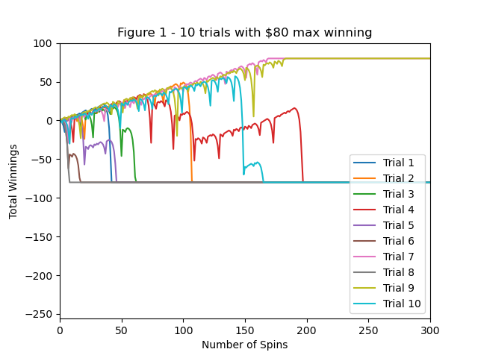

1. 10 trails with $80 as limitation

Figure 1 shows the 10 trails for Blackjack with $80 as the limitation for max winning as min losing threshold. We can see that 2/8 end up with winning $80 but all the rest end up with -$80 after 200 spins; while within 50 spins, 50% of trails have positive results.

## 1000 Trails with $80 funds (Mean)

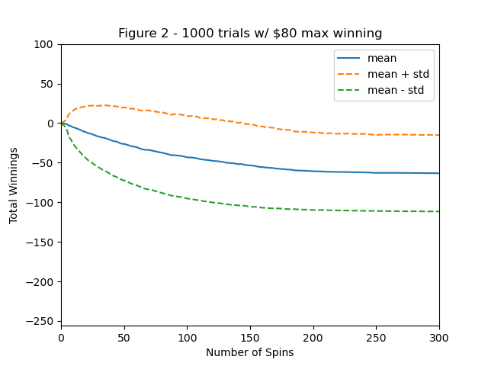

1. 1000 trails with $80 as limitation (Mean)

Figure 2 shows the 1000 trails for Blackjack with $80 as the limitation for max winning as min losing threshold. Only the Mean+Std shows positive growth in short-term, while Mean and Mean-Std shows negative trending in both short/long term gambling, i.e. losing money.

## 1000 Trails with $80 funds (Median)

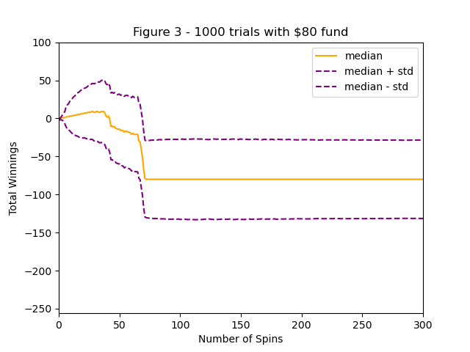

1. 1000 trails with $80 as limitation (Median)

Figure 3 with median datapoints shows similar results, i.e. sometimes good short-term return but eventually losing money.

## 1000 Trails with $256 funds (Mean)

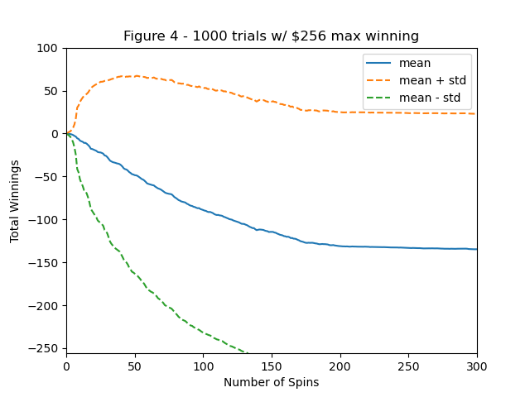

1. 1000 trails with $256 as limitation (Mean)

With increased bankroll, the short-term positive return takes longer time for the simulator losing money, but it ends up with the same conclusion.

## 1000 Trails with $256 funds (Median)

1. 1000 trails with $256 as limitation (Median)

Same finding like 2.4.

# Conclusion

## Martindale strategy

We tested Martindale betting strategy on Blackjack gambling with different scenarios. Regardless of number of trails, testing parameters (mean, median and standard deviation), this strategy might show positive returns in short-term perspective, but eventually ends up with negative results, which align with the set winning odd of 0.42.

## Additional questions

Question Set 1:

In Experiment 1, based on the experiment results calculate and provide the estimated probability of winning $80 within 1000 sequential bets.

Assume each winning will give $1 to the bankroll and loss does not decrease your fund pool, so this question could also be described as winning 80 times within 1000 sequential bets. This probability could be calculated by 1- P(at least 981 losses within 1000 sequential bets)= $1-{0.58}^{981}$, which is almost equals to 1.

So the odd for question 1 would be 100%.

Question 2:

In Experiment 1, what is the estimated expected value of winnings after 1000 sequential bets? Thoroughly explain your reasoning for the answer.

Assume the winning odd is 0.42, then the expected value for 1000 sequential bets would be 0.42*$1*1000=$420.

Question Set 3:

In Experiment 1, do the upper standard deviation line (mean + stdev) and lower standard deviation line (mean – stdev) reach a maximum (or minimum) value and then stabilize?

Yes, they both stabilized at around 250 bets.

Do the standard deviation lines converge with one another as the number of sequential bets increases? Thoroughly explain why it does or does not.

At the beginning of the process, the chance of winning and losing are kind randomized, which may cause large Stdev, while towards the end of the process, as bets number increases, the Stdev would tend to be stabilized. The main reason is as the set winning odd is 0.42, the more the simulator played, the higher chance they lose all money, which end up with the same results.

Question 4:

In Experiment 2, based on the experiment results calculate and provide the estimated probability of winning $80 within 1000 sequential bets. Thoroughly explain your reasoning for the answer using the experiment output. Your explanation should NOT be based on estimates from visually inspecting your plots, but from analyzing any output from your simulation.

So in experiment 2, we started with $256, and it would take us 9 times in a roll to lose the game. The probability of losing 8 times in a roll is (0.42)^8=0.097%, in this case to win $80, probability= (1-0.097%)^80=92.5%

Question 5:

In Experiment 2, what is the estimated expected value of winnings after 1000 sequential bets? Thoroughly explain your reasoning for the answer.

Expected value=$80*0.925-(1-0.925)*$256=54.8

Question Set 6:

In Experiment 2, do the upper standard deviation line (mean + stdev) and lower standard deviation line (mean – stdev) reach a maximum (or minimum) value and then stabilize?

Yes, once the simulator loses all 256 or win 80 would results in stable stdev.

Do the standard deviation lines converge with one another as the number of sequential bets increases? Thoroughly explain why it does or does not.

At the beginning of the process, the chance of winning and losing are kind randomized, which may cause large Stdev, while towards the end of the process, as bets number increases, the Stdev would tend to be stabilized. The main reason is as the set winning odd is 0.42, the more the simulator played, the higher chance they lose all money, which end up with the same results.

Question 7:

What are some of the benefits of using expected values when conducting experiments instead of simply using the result of one specific random episode?

Using expected values when conducting experiments offers the benefits of statistical robustness, reduced variability, improved decision-making, interpretability, and insights into long-term behavior compared to relying on the result of one specific random episode.