CS7646 Project 6 -Indicator evaluation

Guangqing Tai  
gtai3@gatech.edu

***Abstract—***Project 6 (Indicator evaluation) creates two processes which covers I. Theoretically Optimal Strategy (TOS) – simulate how best a strategy could do for certain stock AND II. Technical indicators – present 5 major indicators that could help/guide investors to buy/sell stock to increase the return/reduce the risk.

***Note: This work is a re-submission of Summer 2024 version, which may contain partial previous work.***

# TOS (theoretically Optimal strategy)

## Build strategy

Historical stock data of JPM from 2008-01-01 to 2009-12-31 was used to represent the portfolio of testing. I assume that we started with a value of 100,000 with no commission (transaction cost) and impact (transaction does not affect stock price) for this project.

The core of this strategy involves comparing the stock price each day. If the next day’s price is higher than the current day’s price, 1,000 shares will be bought (or up to 2,000 shares if closing a short position). Conversely, if the next day’s price is lower, 1,000 shares will be sold (or up to 2,000 shares if closing a long position). This strategy, which assumes perfect knowledge of future prices, aims to capitalize on short-term price changes while adhering to a holding constraint of either 1,000 shares long, 1,000 shares short, or 0 shares.

## Results and discussion

**Figure 1 TOS performance vs Benchmark**

As shown in Figure 1, there are two lines which represent benchmark performance (purple) and TOS performance (red). Unlike my designed TOS, benchmark strategy refers to a simple buy-and-hold approach, which described as you started with 100,000 value and invest in 1000 shares then hold (no trade).

TOS out-performed benchmark strategy all the way to the end, which suggests that if we could have powerful prediction tool in hand to analyst the future stock prices, actively trading with proper strategy would almost certainly give investors a much better return. But we also need to remember that, in reality, factors like transactional cost, market change, economic environment, etc. would always affect the stock market in their way. Thus, adaptive strategies would be required to achieve optimal investment.



**Table 1. TOS (portfolio) and benchmark performance metrics**

# Technical indicators

5 indicators were developed to help us find the best time to buy/sell stock using the JPM historical data between 2008-01-01 AND 2009-12-31.

## Bollinger Bands (BB)

BB represents a middle band and two outer bands given a stock with historical close price. Middle band is typically a 20-day moving average of the stock close prices, while the outer bands are negative/positive two standard deviations away from the middle band. Those bands dynamically adjust to volatility, expanding and contracting with price movements.

Equations for three bands:

Middle band (MB): 20-day SMA (simple moving average)

Upper band (UB): MB+ (2* SD over 20 days)

Lower band (LB): MB - (2* SD over 20 days)

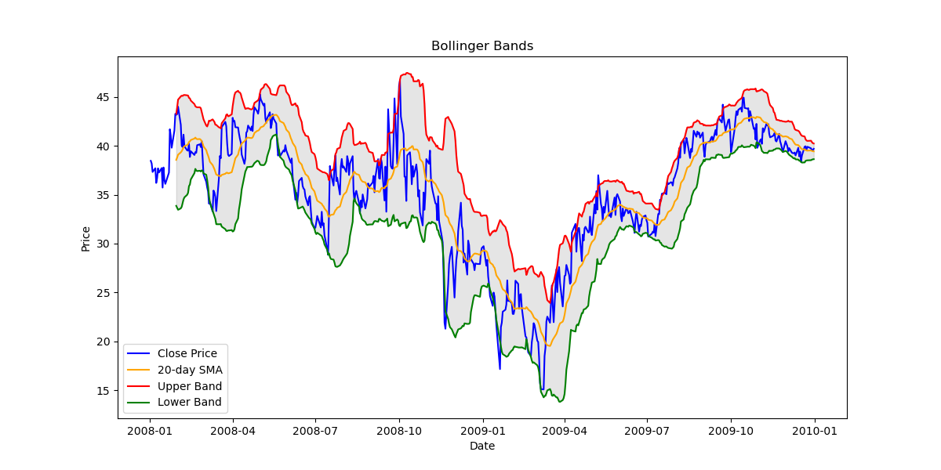Based on those equations and historical stock price of JPM, a BB python code with visualized BB bands were developed as below.

**Figure 2. Bollinger Bands of JPM**

Given the Figure 2, we could easily read the BB indicator by those methods: 1. When the stock price hit the lower band and tend to rebound, it would be a good signal to buy stocks (examples: green circle); while the red circle shows that when stock price hit the upper band and rebound, it tells us that it’s a good time to sell the stocks.

## Momentum

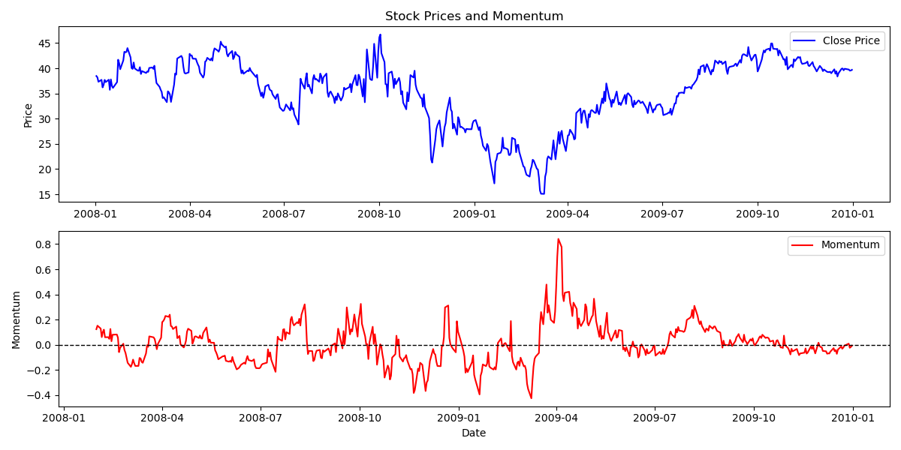Momentum measures the rate of change of a stock price over specific time period, which basically use this simple function: Momentum= Price(t)-Price(t-X), where t is today and X is how many days before. It directly shows the vector of stock price based on previous data and provides short-term investing suggestions.

**Figure 3. Stock price vs Momentum**

Illustrated by Figure 3, stock price and momentum were calculated side by side using the same X-axis (date). An obvious signal of buying could be seen in the green rectangle: momentum increasing, stock price increasing (based on existing data), which approves that simple indicator works in some cases. However, due to the complexity of real stock market, it may not be always working (e.g. red rectangle).

## RSI

Relative Strength Index (RSI) is a more accurate momentum indicator that measures the speed and change of stock price movement. It oscillates between 0 and 100 over a period of 14 days typically.

Equation:

RSI = 100 – 100/(1+RS)

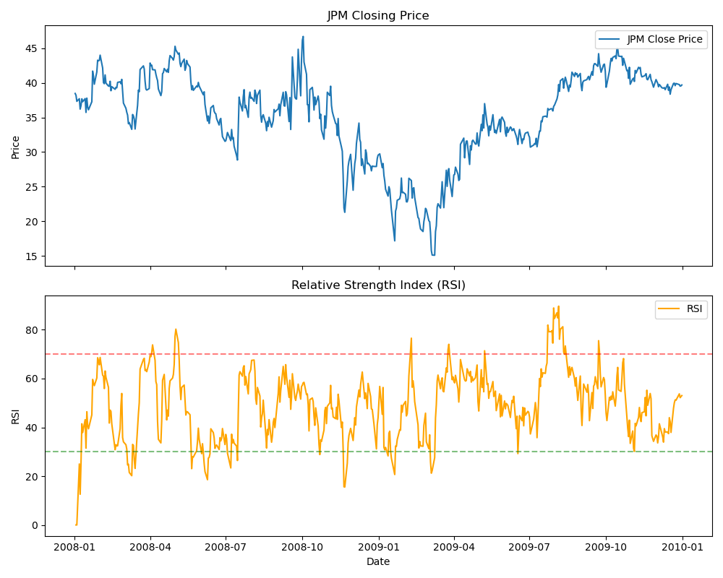 RS=Average of X days’ up closes/Average of X days’ down close

**Figure 4. Stock Price vs RSI**

Usually, when the RSI crosses the 30 bottom line and goes up, it’s the signal of buying (shown in green), when the RSI crosses 70 bottom line and goes down, that would be the opposite signal that you should sell you stock to gain maximum revenue and reduce the risk of stock price down.

The explanation for that strategy is: when RSI is low (e.g. 30), it means that the stock price keeps going down to its estimated bottom prices, and you should invest your money buying those stocks when RSI starts to go up; vise versa for RSI starts high.

## Fibonacci Retracement

Fibonacci Retracement is an indicator that can pinpoint the degree to which a market will move against its current trend, and the ratios used are 23.6%, 38.2%, 50%, 61.8% and 100%. (*IG Analyst, 2024*) Please note that it is an observation through years of stock prices movement instead of mathematical calculation.

Equation:

100%: Peak stock price

61.8%: Price – 0.618*(Peak price – bottom price)

50%: Price – 0.5*(Peak price – bottom price)

38.2%: Price – 0.382*(Peak price – bottom price)

23.6%: Price – 0.236*(Peak price – bottom price)

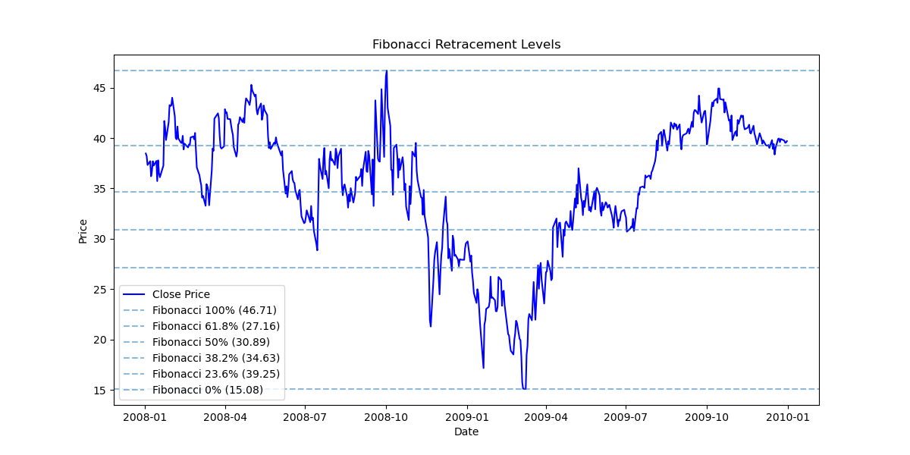0%: Bottom price

**Figure 5. Fibonacci Retracement**

Given the experience of years of trading, when stock price retraces to a Fibonacci Retracement (FR) level (e.g. 38.2%) after an uptrend, it usually means a potential buy signal; while if the prices hit a FB level after a downtrend, it usually indicates resistance and a sell signal.

## ADX

Average Directional Index (ADX) quantifies the strength of a trend irrespective of its direction. It works on a scale of 0 to 100 where a score of >25 would be considered a strong trend. ADX is calculated based on moving average of the 14 days stock prices.

Equation:

ADX= $\frac{\left(EMA of | DMI+-DMI\right)}{EMA of DMI++DMI}*100$

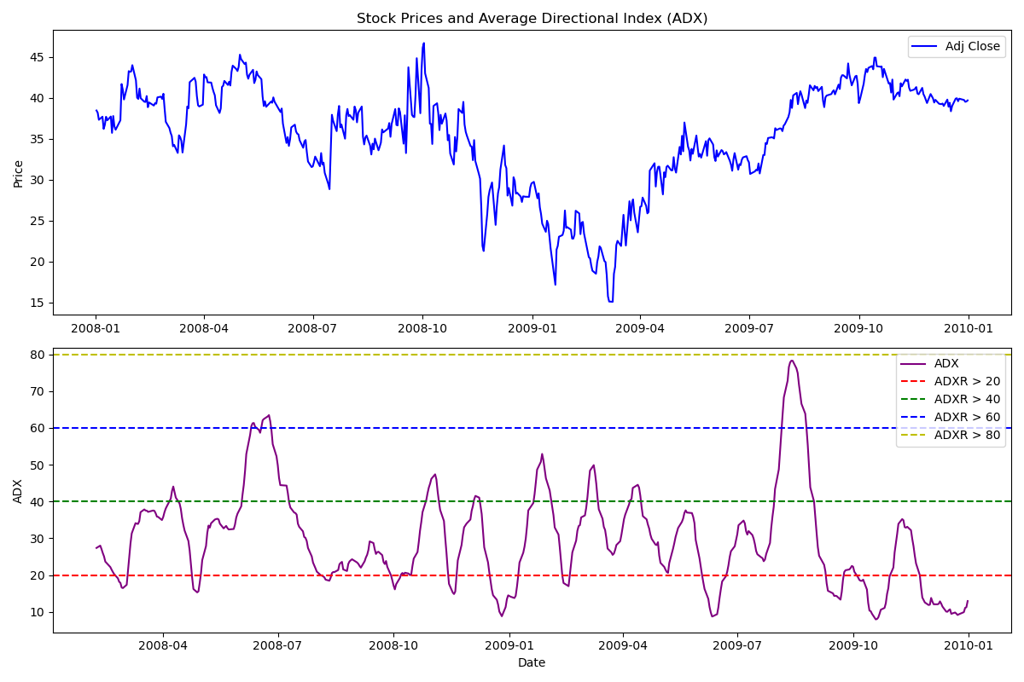Where DMI is directional movement indicators calculated by different stock prices, e.g. high, low, close, etc.

**Figure 6. Stock Price vs ADX**

Due to the fact that ADX only gives the strength of trend regardless of direction, we need to combine both historical stock price and ADX to understand how it works. As shown in Figure 6, the two green rectangles show two strong trend of the JPM stock, combined with the stock prices, they gave us a strong increase and decrease respectively. In reality, ADX along may be hard to predict the best buy/sell timing since we won’t have ‘historical data’ for future. Thus, we need to make use of other indicators like RSI to determine opportunities.

## Conclusion

Incorporating five technical indicators—Bollinger Bands, Momentum, RSI, Fibonacci Retracement, and ADX—provides a robust framework for identifying optimal buy and sell opportunities in the market. Each indicator offers unique insights into price trends, momentum, volatility, and trend strength. However, it's crucial to recognize that no single indicator captures the complete picture of market dynamics, and relying solely on one indicator may lead to misleading signals.

To maximize the effectiveness of these indicators, it is advisable to combine 2-3 indicators that complement each other. By integrating indicators that assess different aspects of price movements, traders can enhance their decision-making process and improve the likelihood of achieving favorable returns. This approach not only validates trading signals but also mitigates the risk associated with relying on a single indicator's perspective.

Ultimately, the synergy created by combining multiple indicators empowers traders to gain a deeper understanding of market conditions, identify high-probability trading opportunities, and optimize their trading strategies for consistent performance over time.

# References

1. 10 trading indicators every trader should know. IG. (n.d.). https://www.ig.com/en/trading-strategies/10-trading-indicators-every-trader-should-know-190604#bollingerbands