# Cover Page

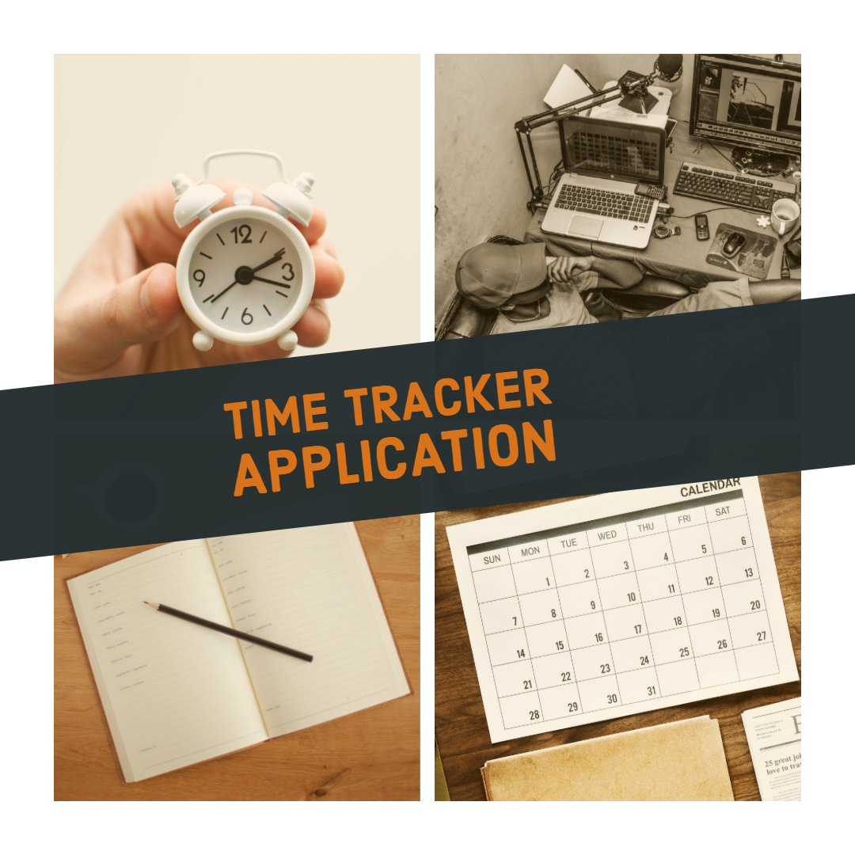

<https://spark.adobe.com/sp/design/post/c20d34b7-27b1-47d8-b586-49044e470f65>

# About the Project

# Time Management

# Time Management Issues

# Research & Development (R&D)

# The Data

# The Database

# The App

Some Findings (These are the calculations you run in the app)

Solutions To Time Management (This is additional research you have performed, and thought and solutions you have found or come up with for time management issues.)

References