Remote Data, Data Storage, & Data Sources

By: Edward Welborn

Date: June, 23rd, 2019

Link To Final Spark Page: <https://spark.adobe.com/sp/design/post/9902960a-bcf5-4fc4-b451-637bbf09672c>

## What is a Data Source

According to the contributors at Microsoft(2017), A data source is simply the source of the data. It can be a file, a particular database on a DBMS, or even a live data feed. The data might be located on the same computer as the program, or on another computer somewhere on a network. For example, a data source might be an Oracle DBMS running on an OS/2® operating system, accessed by Novell® Netware; an IBM DB2 DBMS accessed through a gateway; a collection of Xbase files in a server directory; or a local Microsoft® Access database file.

The purpose of a data source is to gather all of the technical information needed to access the data - the driver name, network address, network software, and so on - into a single place and hide it from the user. The user should be able to look at a list that includes Payroll, Inventory, and Personnel, choose Payroll from the list, and have the application connect to the payroll data, all without knowing where the payroll data resides or how the application got to it.

## App Feature With Multiple Data Sources

## What is Data Storage

Margaret Rouse(2005), mentions that Data storage is the collective methods and technologies that capture and retain digital information on electromagnetic, optical or silicon-based [storage media](https://searchstorage.techtarget.com/definition/storage-medium). Storage is a key component of digital devices, as consumers and businesses have come to rely on it to preserve information ranging from personal photos to business-critical information. Storage is frequently used to describe the devices and data connected to the computer through input/output (I/O) operations, including hard disks, flash devices, tape systems and other media types.

## Data Storage Solution 1

Peter Alexander(N.D**), explains that Network-attached storage.** Network-attached storage (NAS) provides fast, simple, reliable access to data in an IP networking environment. NAS solutions are suitable for small and mid-sized businesses needing large amounts of economical storage that multiple users can share over a network. And given that many small businesses lack IT departments, NAS solutions are easy to deploy, centrally manage and consolidate.

## Data Storage Solution 2

Peter Alexander(N.D), further explains **Online storage.** Services that provide remote storage and backup over the internet offer businesses a number of compelling benefits. By backing up your most important files to a secure, remote server, you're protecting the data stored at your place of business. You can easily share large files with clients, partners and others by providing them with password-protected access to your online storage service, thereby eliminating the need to e-mail those large files. And in most cases, you can log into your account from any computer using a web browser--a great way to retrieve files when you're away from your PC. Remote storage--especially during an initial backup session--can be slow, however: It's only as quick as the speed of your network access to that storage. For extremely large files, you may have to invest in higher speed network access.

## Data Storage Solution 3

Peter Alexander(N.D**), also mentions External hard drives.** A simple and relatively inexpensive way to add more storage is to connect an external hard disk drive to your computer. External hard drives directly connected to PCs have several disadvantages, however. Any files stored on the drive but not elsewhere need to be backed up. Also, if you travel for work and need access to files on an external drive, you'll have to take the drive with you or remember to copy the required files to a USB thumb drive, your laptop's internal drive, a CD or some other storage media. Finally, in the event of a fire or other catastrophe at your place of business, your data will not be protected.

## What is Remote Data

Remote data is any data source that is not located on the same physical computer that you are working on. Remote data could be a SQL database located on a server in the building, or it could a data source located on the internet

## Remote Data Example 1

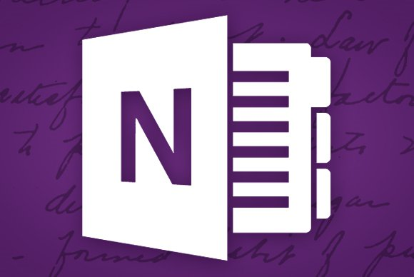

Michael Crider (**08.16.15** )<https://www.digitaltrends.com/computing/a-guide-to-microsoft-onenote-on-windows-10/>

Microsoft OneNote is an example of remote data, the application is stored locally on a computer, but the data is stored in a cluster of servers in various locations that Microsoft has setup.

The data is accessed on any type of application be it on computer, or a mobile device, via an application layer, the data is sought out on the remote server and transferred back to the user for manipulation.

## Remote Data Example 2



N/A(N.D) retrieved from <https://www.facebook.com/>

Facebook is another remote data example, using their website as the application to access their data via a browser.

## Remote Data Example 3



N.A(N.D) retrieved from <https://worldofwarcraft.com/en-us/>

World of Warcraft could be another example of remote data, since the application is store on a local computer, whereas the data is stored remotely on the blizzard data cluster.

## References

Contributors (01/18/2017), retrieved from <https://docs.microsoft.com/en-us/sql/odbc/reference/data-sources?view=sql-server-2017>

Margaret Rouse (09/21/2005), retrieved from <https://searchstorage.techtarget.com/definition/storage>

Peter Alexander(N.D), retrieved from <https://www.entrepreneur.com/article/172226>