## Application 1:

Geocaching by Groundspeak



Website: <https://www.geocaching.com/play>

Apple App Store: <https://apps.apple.com/app/apple-store/id329541503>

Google Play Store: <https://play.google.com/store/apps/details?id=com.groundspeak.geocaching.intro&referrer=utm_source%3Dgeocaching-website%26utm_campaign%3DQ1-2018-update-logged-out-home-page>

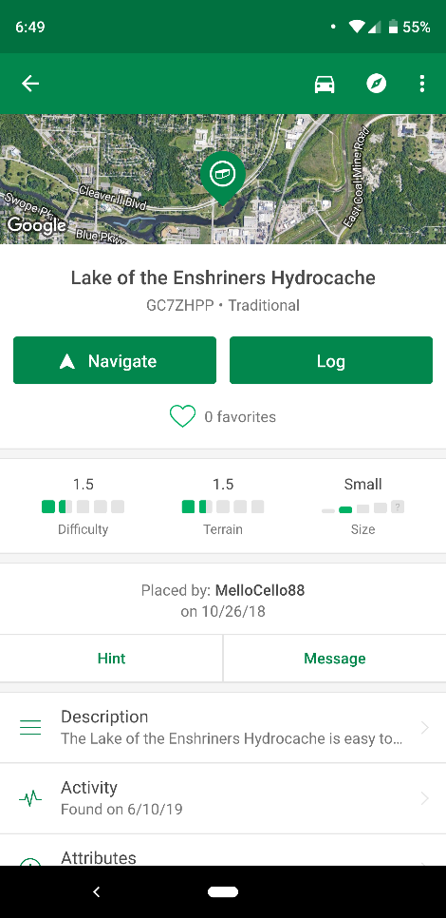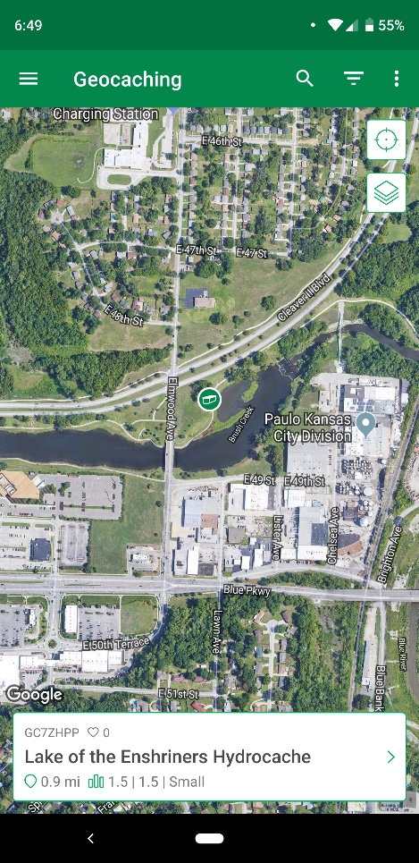

The application is very clean with minimum screen impact to take away from the users experience with the navigation and location for the geocache.

The program uses colors that make the user think they are in a forest looking for the cache as they navigate through their location.

#### According to Lifewire(2019) the things they like and don’t like about the application are:

#### What We Like

* Simple design makes it easy to understand.
* Caches not yet found are simple to spot on the map.
* Works with both Android and iOS devices.
* You can navigate to the cache with a different GPS app on your phone.

#### What We Don't Like

* Free features found in other apps are not free in this one.
* Can't submit new geocaches through the app.

## Application 2:

Cachly by Zed Said Studio LLC



Website: <http://www.cach.ly/>

Apple App Store: <https://apps.apple.com/us/app/cachly-geocaching/id645384141>

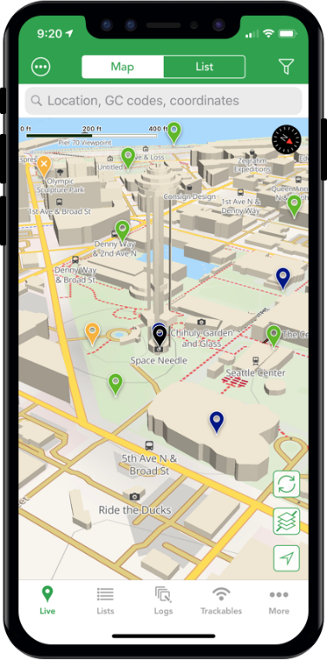

This application is only for iOS devices, but does work on apple watch,

* 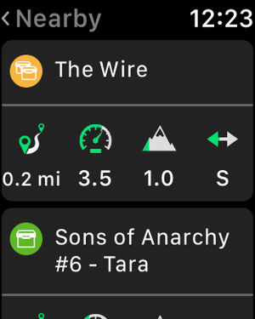

In the 2019 article on lifewire, the website reviewed their likes and dislikes for this application:

#### What We Like

* Closely resembles the official Geocaching app.
* There isn't a monthly payment requirement.
* Logging caches is easy with templates.
* Filtering options let you hide certain kinds of caches.
* Works with Apple Watch.

#### What We Don't Like

* The app isn't free.
* No Android version.

Application 3:

c:geo by c:geo team

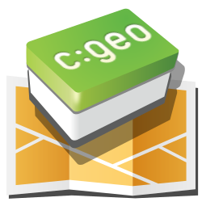

Website: <https://www.cgeo.org/>

Google Play Store: <https://play.google.com/store/apps/details?id=cgeo.geocaching>

Lifewire’s(2019) review of this application from there website with their likes and dislikes for this application:

#### What We Like

* Caches and maps can be saved for offline use.
* You can log caches without an internet connection.
* A signature template lets you log caches easier and faster.
* Your own favorite GPS navigation app can be used to find the cache.
* There isn't a fee or monthly payment to use it.

#### What We Don't Like

* Doesn't support iOS.

In summary, there are not a lot of applications that cross platform android AND iOS devices, and even less that work for apple watch or android watch devices.

Even though geocaching has become very popular here as of late, there is not a lot of applications to choose from, the ones that are out there are not really free, or have a subscription base.

## References:

Tim Fisher (July 08, 2019) retrieved from <https://www.lifewire.com/best-geocaching-apps-4171594>