For this discussion, I chose an application that I was doing a test on before they went live. The name of the application is **Tonit**. It is a social motorcycle application that have many interesting factors. It has a section to take pics and videos of your ride that people can give feedback to on a local as well as a global scale.

It also has a section for clubs that you can join or follow if you like. The best feature of this application is you can track your ride, and get other people to meetup and ride with you. One reason I enjoy this application is the social aspect of finding people to ride with, or go on events as you can.

The link to the google play store is: (It is only available for Android)

<https://play.google.com/store/apps/details?id=com.tonitmedia.tonit>

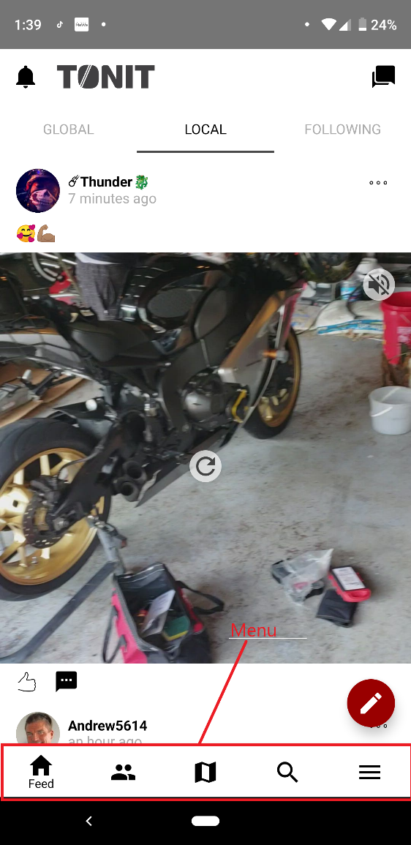

At the very bottom of each screen is a menu bar that has the community feed, clubs, navigation, search, and a settings menu

