A very basic spectrometer fully designed by EdwardZKW.

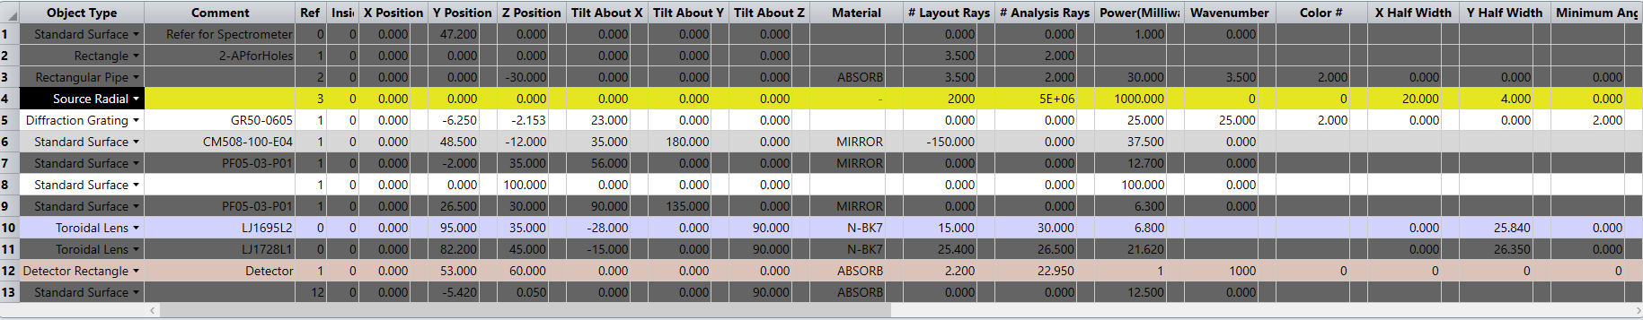

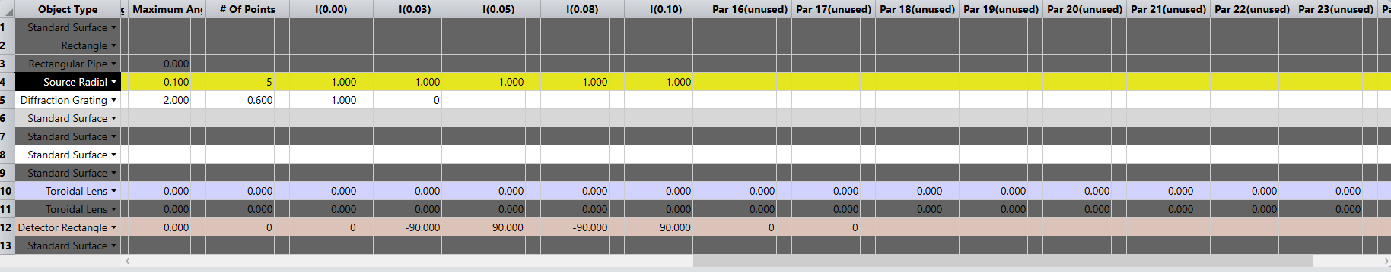

Zemax Nonsequential mode:

Source radial, input divergence (angle) can vary from 0 degree to several degrees depending on how many pixels the detector has.

The source is from free space so a rectangle tube (as collimator) can be used to make sure the largest angle of incident light is 3.5 degrees for example.

