**“Electronic Supplementary Material:**

**Online Resource 1**

**Journal Instructions**

**Submission**

Supply all supplementary material in standard file formats.

Please include in each file the following information: article title, journal name, authornames; affiliation and e-mail address of the corresponding author.

**Text and Presentations**

Submit your material in PDF format; .doc or .ppt files are not suitable for long-termviability.

**Spreadsheets**

Spreadsheets should be submitted as .csv or .xlsx files (MS Excel).

**Numbering**

If supplying any supplementary material, the text must make specific mention of the material as a citation, similar to that of figures and tables.

Refer to the supplementary files as “Online Resource”, e.g., "... as shown in the animation (Online Resource 3)", “... additional data are given in Online Resource 4”.

Name the files consecutively, e.g. “ESM_3.mpg”, “ESM_4.pdf”.

**Captions**

For each supplementary material, please supply a concise caption describing the content of the file.

**Processing of supplementary files**

Electronic supplementary material will be published as received from the author without any conversion, editing, or reformatting.”

**Supplementary Material for the article “Synergy theory for murine Harderian gland tumorigenesis after irradiation by mixtures of high-energy ionized atomic nuclei.” REBP.**

Edward Huang, Yimin Lin, Mark Ebert, Dae Woong Ham, Claire Yunzhi Zhang, others???, Rainer K. Sachs1,2

[sachs@math.berkeley.edu](mailto:sachs@math.berkeley.edu).

# Parts

# 1) Glossaries. Use Dae from Rad Res paper but edit heavily

# 2) Ion characteristics :issue of Bragg peaks – will never be resolved probably for mouse HG data; also background

# 3) New one-ion DERs

4) Simple effect additivity and its replacements

# 5) Implementation of scripts (Move this to 2 and shift the others down or move to 1.3.

6) The importance of experiments which have no low-LET components

# Bibliography

**Online Resource 1, part 2 Table 2.2.2.1 of main text repeated.**

|  |  |  |  |  |  |
| --- | --- | --- | --- | --- | --- |
| ion | *L* | Z | *β\** | KE/u | comments |
|  | keV/*μ* |  |  | MeV |  |
| H1 (p) | 0.4 | 1 | 0.614 | 250 | Chang |
| He4 | 1.6 | 2 | 0.595 | 228 | Alpen |
| Ne20 | 25 | 10 | 0.813 | 670 | Alpen |
| Si28 | 70 | 14 | 0.623 | 260 | Chang |
| Ti48 | 100 | 22 | 0.876 | 1000 | Chang |
| Fe56 | 195 | 26 | 0.793 | 600 | Alpen |
| Fe56 | 195 | 26 | 0.793 | 600 | Chang |
| Fe56 | 250 | 26 | 0.654 | 300 | Alpen |
| Nb93 | 464 | 43 | 0.793 | 600 | Alpen |
| La139 | 953 | 57 | 0.791 | 593 | Alpen |

Chang LET at mouse, Alpen at entering beam. Exception Alpen Entering beam changed to 195 since the data sets were found to be combinable, and were combined, in Chang et al. 2016[Chang 2016]

Exclude La and Nb till major paper because of range considerations; not needed for minor paper

Make crude range corrections for HE4 and Ne20 and Fe300 based on Fe 193 results

# Online Resource 1, part 3.

# New one-ion models were used instead of recent models based on modifications of Katz’ amorphous track structure approach [Katz 1988, Cucinotta 1999, Goodhead 2006, Cucinotta 2010, Cucinotta 2013, Chang 2016, Cucinotta 2017]. There were a number of reasons we considered new models, as follows.

# First, it has often been argued, e.g. in [Goodhead 2006], that when applied to experiments with complex biological targets the amorphous track structure approach loses some of the simplicity, elegant agreement with data, and biophysical credibility which it has when applied to experiments where the targets are emulsions or viruses.

# Second, NTE are conceptually completely different from delta rays as regards transmitting influences from a directly hit cell to neighboring cells [Hatzi 2015]. NTE involve endogenous cell signaling. We saw no reason why the biophysical reasoning that leads to the amorphous track structure models should be relevant to NTE.

# Third, the HZE models in [Cucinotta 2017] contain a factor interpreted as due to cell killing; we felt that the factor implicitly assumes cell repopulation after cell killing is strongly biased against repopulation of tumorigenic cells whereas unbiased repopulation or repopulation with the opposite bias is more likely to occur [Sachs 2005].

# Fourth, some models in [Cucinotta 2017] use an adjustable parameter that regression found to be not significantly different from zero even at the largest p-level, p ≤ 0.1 usually considered. We reasoned that since the hazard function formalism automatically takes into account the constraint that prevalence ≤ 100%, one might, in the interests of parsimony (i.e. Occam’s razor), be able to find models with fewer adjustable parameters, all significantly different from zero.

# Fifth, we felt models which used discontinuous jumps in effect level should either be replaced by stochastic process models or by non-stochastic models with continuous values, first derivatives and second derivatives – postulating that an infinitesimal dose increment can produce a finite jump in effect conflates stochastic process models and deterministic models in an unusual way.

# Sixth, the comparatively elementary version of IEA used in this paper assumes monotonic increasing one-ion DERs, while some previous models allow dose regions where the one-ion DERs are decreasing instead. Using one-ion DERs that are not monotonic increasing at all doses of interest would have required a far-reaching generalization of the elementary IEA formalism [Ham 2017], more challenging computationally than necessary for the present paper’s explanation of synergy theory.

The one-parameter fit to all the light ion data is shown in figure 3.1.1.

**Fig. A 3.1.1. Protons and alpha particles (placeholder –** needs error bars). Open circles are for proton data, solid circles are for alpha particles.

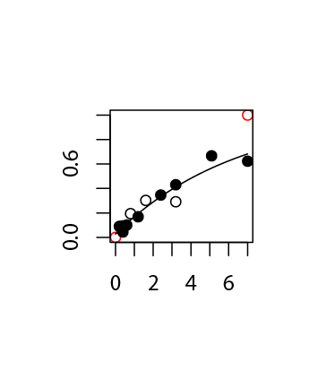 Modeling both fast protons and fast alpha particles by the same low-LET DER gave a tolerable fit, adequate for the present paper’s main purpose – using HG tumorigenesis data to illustrate mathematical/computational aspects of synergy theory. In addition, contrary to the emphasis in many recent NASA reports, we here want to emphasize HZE ions, whose extraordinarily high RBEs have long created concern. So the one-ion modeling of the two low LET radiations is in any case deemphasized compared with the models for HZE.

# However, all these arguments do not rule out the possibility that the amorphous track structure approach may have important advantages over the one-ion DERs we used here, for example perhaps much better goodness of fit for published and upcoming murine HG tumorigenesis data. Balanced comparisons have not yet been carried out.

**Fig.A 3.1. One-ion DERs.** 8 panels with data and error bars

The figure will look similar to the following but will refer to HG prevalence instead of the chromosome aberration data shown in this placeholder and will contain 8 panels for the 7 HZE ions in our present database instead and our low LET DER instead of the 6 panels shown in the place holder.

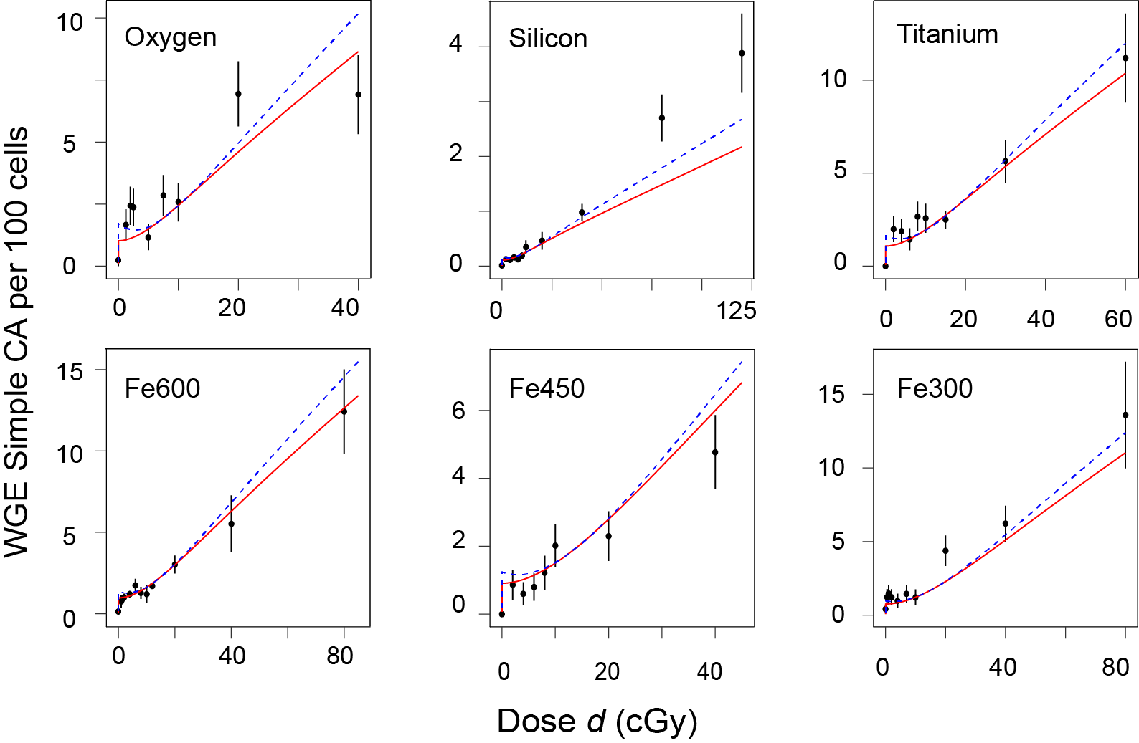

**Online Resource 1, part 4**

## Part 4. Remarks on SEA and its replacements

A simple effect additivity baseline mixture DER is always unreasonably large or small respectively if all component one-ion DERs are strictly concave or convex respectively. A very famous concomitant, reviewed in {Berenbaum, 1989 #41}, is the failure to obey what is called the “sham mixture principle”. For example suppose a one-ion beam has dose-effect relation *E = d*2. Regard the beam as a 50-50 mixture of two components, each of which happens to have the same one-ion DER, *E = d*2. Then calculating the simple effect additivity mixture DER for this sham mixture by simple effect additivity gives (*d*/2)2 + (*d*/2)2 = *d*2/2. But of course one cannot cut the beam’s toxicity in half by mental gymnastics: the one-ion DERs are curvilinear so simple-effect additivity should not be used to define absence of synergy/antagonism. Such problems with simple effect additivity are well known in pharmacometrics, toxicology, evolutionary ecology and other fields of biology {Foucquier, 2015 #225}. Alternatives are needed to plan and interpret mixture experiments.

In biology, there are now many different synergy theories. Some of the theories are described, reviewed and compared in {Zaider, 1980 #30;Berenbaum, 1989 #41;Zaider, 1990 #58;Lam, 1994 #56;Lorenzo, 2006 #227;Chou, 2006 #37;Zhou, 2006 #38;Boedeker, 2010 #71;Brun, 2010 #35;Tallarida, 2012 #43;Geary, 2013 #81;Foucquier, 2015 #225;Piggott, 2015 #77;Tang, 2015 #89;Siranart, 2016 #1746;Sollazzo, 2016 #208}. Generally no two of these theories are fully equivalent, though almost all give the same results for a mixture each of whose components’ one-ion DERs is LNT. To avoid confusion, which is rife in this area, it is important to characterize carefully the particular theory used {Foucquier, 2015 #225}.

### 4.2. Some comparisons.

Very detailed in Siranart web supplement. Continue in this vein. mainly on Lam: not a useful substitute – more trougle than it is worth. advantages of IEA.

**Online Resource 1, part 5.**

The data are sourced from [Chang 2016] and [Alpen 1993, Alpen 1994]and implemented as R dataframes throughout the calculations. A number of R packages from the CRAN repository were used, notably stats for non-linear regression, deSolve for solving differential equations, mvtnorm for Monte Carlo simulations, and ggplot2 as well as plot for plotting.

Our computational workflow with respect to R methods and functions is as follows. Various datasets on Harderian gland tumorgenesis are first implemented as R dataframe structures. Inverse variance weighted non-linear least square models are fitted over these dataframes using the Gauss-Newton algorithm inside the function nls from the package stats. Coefficients extracted from the models with coef are used to construct hazard functions in the form of a user-written R function. Standardized one-ion DERs are initialized from these hazard functions as user-written functions following the hazard function equation Eq. (2.2.4.1). These resulting one-ion DERs encompass various 1-ion beam variants (HZE, low-LET) and effect models (TE, NTE + TE).

Computing *I*(*d*) involves calling a user-written R function calculate_complex_id that applies IEA to mixtures of *N* ≥ 2 one-ion DERs, with at most one low-LET DER. calculate_complex_id takes an argument to specify use of either the NTE+TE or the TE-alone model. Calculation of *I*(*d*) requires construction of an R vector d*E* with elements corresponding to the derivative of each one-ion DER curve as a function of dose. A one-dimensional root finder uniroot is used to find the incremental effect of each one-ion DER. We construct dI, a vector corresponding to the numerical derivative of *I*(*d*) with respect to mixture dose *d* by applying Eq. (2.3.4.1) to each element of **d**E. A numerical ODE integrator from deSolve is used to integrate dI with a Radau method to return a R list of mixture DER entries.

Confidence intervals for the calculated IEA baseline mixture DER *I*(*d*) are found through Monte Carlo (MC) simulations. A vector of total-mixture dose points is chosen. For each MC iteration, a user-written function generate_ci initializes a vector of random parameter value samples for a particular dose from multivariate distributions determined during one-ion DER fitting. Our MC simulations use 500 total parameter samples over each selected dose point. These samples are drawn with the rmvnorm function from the mvtnorm package. An IEA dose effect relation is calculated at each selected dose point with calculate_complex_id and the sample parameters.

When the MC step is completed a 95% confidence interval is constructed at each dose point sorted by effect size. The naive confidence intervals are also computed within generate_ci by choosing parameters using each parameter marginal distribution instead of using variance-covariance matrices.

**Online Resource 1, part 6, the importance of experiments with no low LET components entering the beam upstream.**

**Online Resource 1, part 7, Bibliography**.

x

1. Alpen, EL, et al. (1993). "Tumorigenic potential of high-Z, high-LET charged-particle radiations." Radiat Res **136**(3): 382-391.

2. Alpen, EL, et al. (1994). "Fluence-based relative biological effectiveness for charged particle carcinogenesis in mouse Harderian gland." Adv Space Res **14**(10): 573-581.

3. Chang, PY, et al. (2016). "Harderian Gland Tumorigenesis: Low-Dose and LET Response." Radiat Res **185**(5): 449-460.

4. Cucinotta, FA, et al. (2017). "Non-Targeted Effects Models Predict Significantly Higher Mars Mission Cancer Risk than Targeted Effects Models." Sci Rep **7**(1): 1832.

5. Cucinotta, FA, et al. (2010). "Non-targeted effects and the dose response for heavy ion tumor induction." Mutat Res **687**(1-2): 49-53.

6. Cucinotta, FA, et al. (2013). "How safe is safe enough? Radiation risk for a human mission to Mars." PLoS One **8**(10): e74988.

7. Cucinotta, FA, et al. (1999). "Applications of amorphous track models in radiation biology." Radiat Environ Biophys **38**(2): 81-92.

8. Goodhead, DT (2006). "Energy deposition stochastics and track structure: what about the target?" Radiat Prot Dosimetry **122**(1-4): 3-15.

9. Ham, DW, et al. (2017). "Synergy Theory in Radiobiology." Radiat Res.

10. Hatzi, VI, et al. (2015). "Non-targeted radiation effects in vivo: a critical glance of the future in radiobiology." Cancer Lett **356**(1): 34-42.

11. Katz, R. (1988). "Radiobiological Modeling Based On Track Structure. Quantitative Mathematical Models in Radiation Biology, ed. J. Kiefer." Retrieved December, 2016, from <http://digitalcommons.unl.edu/physicskatz/60>.

12. Sachs, R, et al. (2005). "Solid Tumor Risks after High Doses of Ionizing Radiation." PNAS **102(37)**: 13040-13045.