26.4.2018

Stanislav Uschakow  
stanislav.uschakow@gmail.com

Matlab2Android

A quick tutorial

Inhalt

1. General Information 2

2. QuickStart 2

3. MATLAB part 3

4. Android Part 5

5. JNI Conversion 6

# General Information

This document describes how to convert a MATLAB script to a working c++ source code to be used in android NDK environment with JNI. I will show all steps necessary using a simple filter as an example. It is assumed the reader has a working MATLAB version with the MATLAB Coder toolbox and Android Studio installed. The key part for android to work with c++ code is the NDK (Native Development Kit) which will generate a native static lib (*.so) file which than can be used by the JNI. JNI stands for Java Native Interface. It allows the Java to access native functions of the OS such as DLL in windows or shared library (*.so) when running Linux. This, obviously will break the portability of the Java application unless the libraries are available on all target platforms. Often JNI is used to access code written in C++ which is used here [[JNI wiki](https://de.wikipedia.org/wiki/Java_Native_Interface)]. The NDK uses CMake as its primary environment building tool. [MathWorks webinar on Matlab to iPhone and Android Made Easy is the main source for this document.](https://de.mathworks.com/videos/matlab-to-iphone-and-android-made-easy-107779.html)

**This document is based on the following tool versions:  
MATLAB 2017b (9.3.0.713579)  
Android Studio 3.1.2  
 Build #AI-173.4720617, built on April 13, 2018  
 JRE: 1.8.0_152-release-1024-b02 amd64  
 JVM: OpenJDK 64-Bit Server VM by JetBrains s.r.o  
 Windows 10 10.0  
CMake 3.11.20180422-g0bfe7**

# QuickStart

First, I want to briefly describe all steps needed. Later, I will discuss these steps in more detail with code examples.

1. Create a MATLAB function which should be translated to c++.
2. (Optionally) Create a test environment with sample data for the coder to autogenerate the datatypes.
3. Run MATLAB coder
   1. Select the entry point (the function defined in 1)
   2. Define datatypes for the output code.
   3. Generate c++ source code
4. Start a new Android project. Don’t forget to check ‘C++’ when generating the project.
5. Copy the generated source code to the Android Studio project location where the autogenerated .cpp file is located.

Note: When compiling on a fresh setup machine Android Studio will ask you to install all tools needed like the NDK and CMake so no manual steps are required for this process.

1. Edit the CMakeLists.txt for NDK to know how to compile the files.
2. Call JNI functions from Java utilizing your shiny MATLAB generated c++ library.

# MATLAB part

Now let’s discuss the steps need to be done in MATLAB in more detail:

Prior to demonstrate on how to convert a simple filter, I want to discuss what is possible with the MATLAB coder toolbox. Despite MATLAB Coder can create C++ code and C++ is per definition an object-oriented language, MATLAB Coder can’t deal with MATLAB classes. So be aware to write procedural C-style code in MATLAB.

The webinar on MATLAB Coder states it’s possible to convert a trained neural network to C++. In theory it’s correct but I came across an issue when dealing with an ANN. I came across a fully trained multi-layer ANN exported in a *.mat file. Loading and working with his network in MATLAB worked perfectly, like expected. But when trying to generate a matrix calculation to be compatible with MATLAB Coder (it can’t auto-convert a snippet like:

Load(‘myAwesomeNetwork’);

Output = myAwesomeNetwork.network(feature_vector);

into useful c++ code). So genFunction(myAwesomeNetwork.network) it is. genFunction will generate a matrix style calculation based on the topology of the network. Whereas it still works like a charm in MATLAB, MATLAB coder can’t deal with cells which has been the style of the input data the generated function created. So, we need to remove all cells and cell-based calls to get it compatible with MATLAB coder. Since we know we only have one single feature vector at a time this part is to be made aware of but nothing too complicated if the programmer is comfortable around MATLAB.

To summarize the don’ts for the MATLAB coder before starting the actual do’s:

1. Don’t use classes. MATLAB Coder translates to C++, but it can’t handle MATLAB classes at all.
2. Don’t use cells. Just don’t do it if you want to incorporate the MATLAB coder and generate c++ code out of it.

Finally, let’s see how to generate useful MATLAB code and translate it into compileable c++ code:

1. First, we need a simple example in MATLAB to be converted to c++. I am using a simple smoothing filter. It is necessary that we have a function instead of a script since later it will serve as the entry point. It is possible to select several functions as well. The code below shows a simple function getting an input vector to be processed by the filter and returning the output of the filter:

core.m:

function output = core (input)

b = 1/3 * [1 1 1];

output = filter (b, [1], input);

end

1. For the autodetecting of the datatypes we need a testbench using the core function.

coreTestBench.m:  
input = [0 0 1 0 0 0 0 0 0 0 0];

output = core(input);

figure(1);

scatter(1:size(input,2),input, 'x'); hold on;

scatter(1:size(output,2),output);

Obviously, we can’t port functions like plot or scatter to android/c++. These functions do not interfere with the autodetection of the datatypes though. MATLAB coder will suggest a const double[16] input and double[11] output as parameters which is fine.

1. Starting the MATLAB coder select core.m as the entry point. 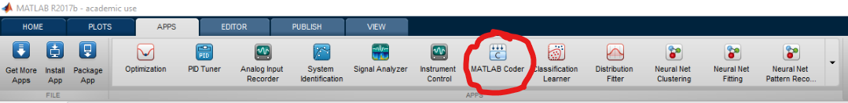

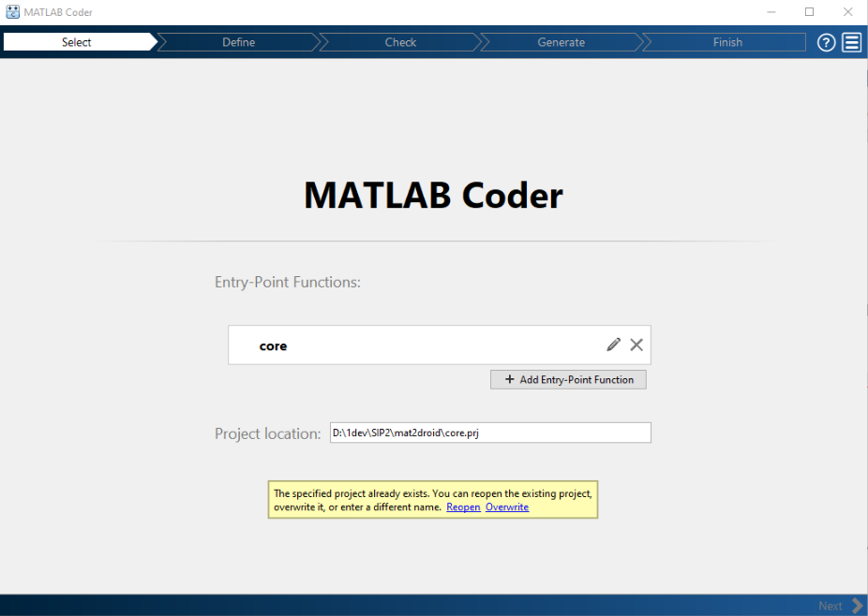

* 1. In the next step select coreTestBench.m as the reference and click the ‘Run Autodetection’ button for the datatypes. The generated definition should look something like:

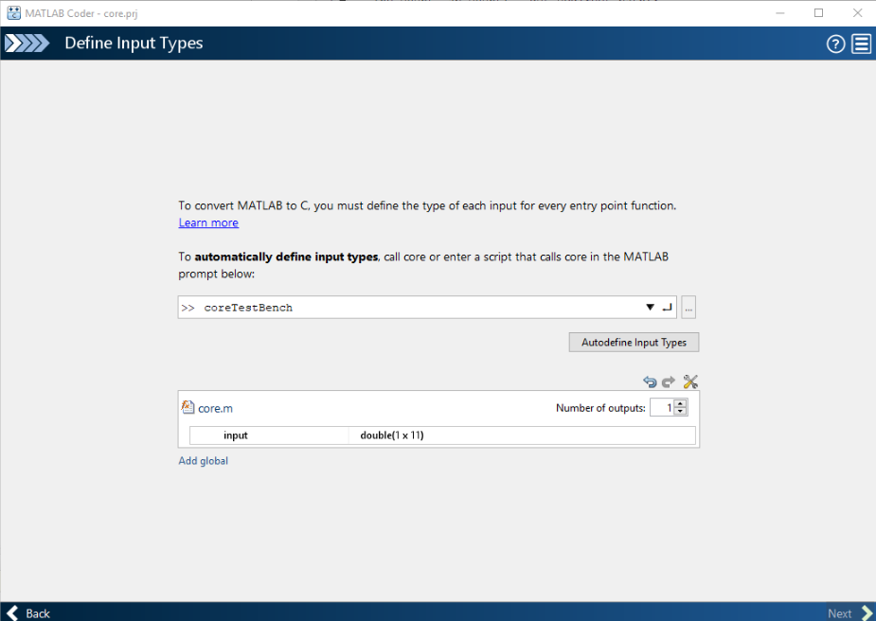

void core(const double input[11], double output[11]);

* 1. The advanced setup provides an extended configurator for the output code. We’ll stick with C++ and the default configuration.
  2. In the last step MATLAB will check for runtime errors in the C++ code and generate all necessary files to call the core() method. As far as I know it will not use any syscalls or similar dependencies to be portable.

# Android Part

1. Now, let’s create a basic Android project. Don’t forget to check the checkbox C++ otherwise Android Studio will not be able to utilize NDK for the C++ code. When generating a basic application, Android Studio also will create a sample native-lib.cpp file with a method call returning “hello from c++” as an example. This method we later will be using to interact with our core.
2. Copy all *.c/*.h/*.cpp files from the MATLAB output folder to the src/cpp/ folder of your Android Studio project. There are plenty of files defining custom datatypes which we all need.
3. In Android Studio under ‘External Build Files’ the CMakeLists.txt file is located. This file describes how the native lib (*.so) should be compiled. Here we need to add every file to the CMakeLists.txt. [Consult a CMake tutorial for further advice.](https://cmake.org/cmake-tutorial/)

CMakeLists.txt:   
cmake_minimum_required(VERSION 3.4.1)

set(SRC

src/main/cpp/core.c

src/main/cpp/core_initialize.c

src/main/cpp/core_terminate.c

src/main/cpp/rtGetInf.c

src/main/cpp/rtGetNaN.c

src/main/cpp/rt_nonfinite.c

src/main/cpp/native-lib.cpp

)

set (INC

src/main/cpp/core.h

src/main/cpp/core_initialize.h

src/main/cpp/core_types.h

src/main/cpp/core_terminate.h

src/main/cpp/rtGetInf.h

src/main/cpp/rt_nonfinite.h

src/main/cpp/rtGetNaN.h

src/main/cpp/rtwtypes.h

)

add_library( native-lib SHARED ${INC} ${SRC})

find_library(log-lib log )

target_link_libraries(native-lib ${log-lib} )

1. Now we can to include “core.h” and use the core-method declared.

# JNI Conversion

Let’s see how everything fits together in the Java side of the world. We want to incorporate the core function in our Android application. This will include passing data down to the shared library and retrieving the processed data from it.

Assuming the package name for our application is called com.example.app. Also, this package contains a class Baz. First, we need to load our shiny library inside the class. Now, we can link a method testMethod located in Baz to a native method in the library using the NJI naming convention. The following code snippets show how the java and native side can look like.

// Java/Android side of the application  
package com.example.app;  
Class Baz {  
 static {  
 System.loadLibrary("native-lib");  
 }  
 public Baz() {};  
  
 // Native-lib function declaration  
 public static native core_test(double *input, double* output);

public void test() // Java method to call the native lib  
 {  
 double* input = {1.0, 1.0, 1.0, 1.0, 1.0, 1.0, 1.0, 1.0, 1.0, 1.0, 1.0};  
 double* output = {0.0, 0.0, 0.0, 0.0, 0.0, 0.0, 0.0, 0.0, 0.0, 0.0, 0.0};  
 core_test(input, output); // Native method call  
 }

}

// C++/Native-lib implementation  
#include <jni.h>  
#include <core.h>

extern "C" JNIEXPORT void JNICALL  
Java_com_example_app_baz_core_test(JNIEnv *env, jobject instance, jdoubleArray input_, jdoubleArray output_) {  
 jdouble* input = env->GetDoubleArrayElements(input_, NULL);  
 jdouble* putput = env->GetDoubleArrayElements(output_, NULL);  
  
 env->ReleaseDoubleArrayElements(input, input, 0);  
 env->ReleaseDoubleArrayElements(output, output, 0);  
  
 core(input, output);  
 return;  
}

For passing native data such as a double array allocated in the library you need to convert them to objects Java can work with. Let’s say we want to return a double output[] to our Java class. The c++ method looks like:

extern "C" JNIEXPORT jdoublearray JNICALL  
Java_com_example_app_baz_getOutput(JNIEnv *env, jobject instance) {

const int size = 11;  
double cppDoubleArray[size] = {1.0};  
jdoubleArray out;  
out = env->NewDoubleArray(size);  
env->SetDoubleArrayRegion(cppDoubleArray, 0, size, out);

return out;   
}

The Java side would look like this:  
public native double[] getOutput();

However, more complex datatypes like structs are not as easily converted since for instance they can have pointers which is not supported in Java. For structs to be passed to Java we would need to write a wrapper Java class which will retrieve data from C++ and convert it to Java datatypes. **It’s recommended to keep data managing inside the library and only provide control mechanism to java as much as possible.**