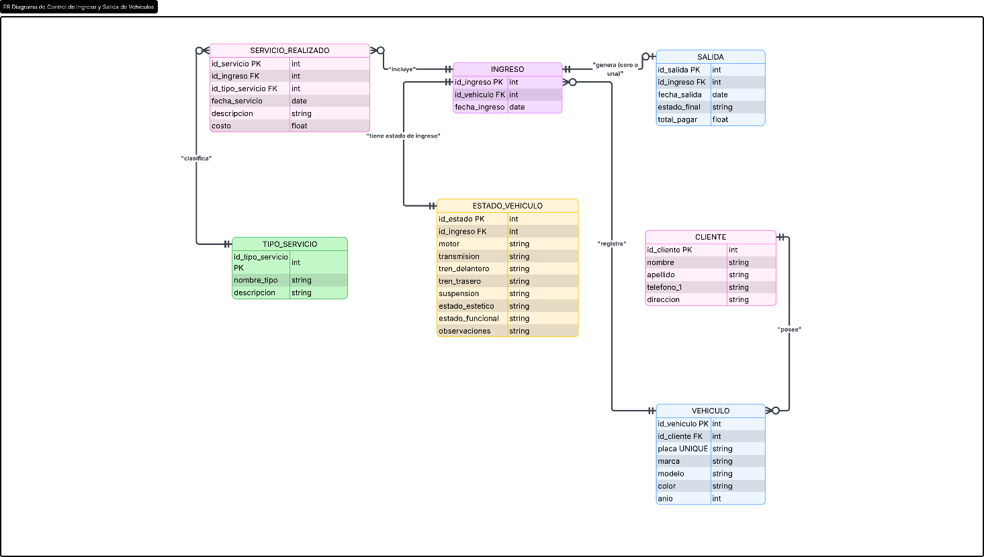
Edwin Castillo

https://lucid.app/lucidchart/79359aae-fba9-4ec1-9899-5d61e69d5a92/edit?viewport_loc=-1558%2C-2154%2C4772%2C1812%2CK4wQcgBhbc5w&invitationId=inv_241e4756-c76e-4989-b95d-086b8dda1e6a

