Portfolio

Content Screenshots/Gifs with Individual Write-ups/Descriptions
  - Checkpoint System

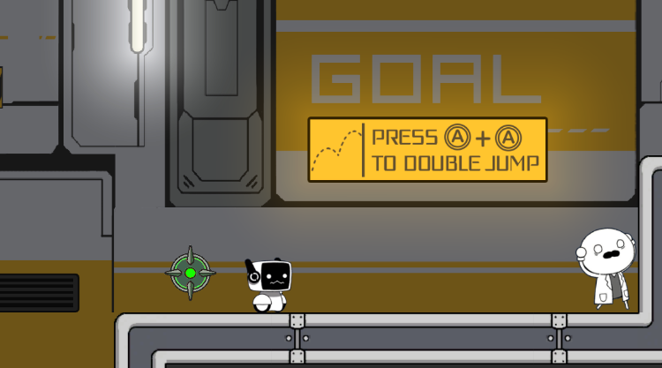
When the player passes the checkpoint, it turns green. After that, no matter how the player dies, they will respawn at this checkpoint.

  - Enemy Avoidance Using Raycast
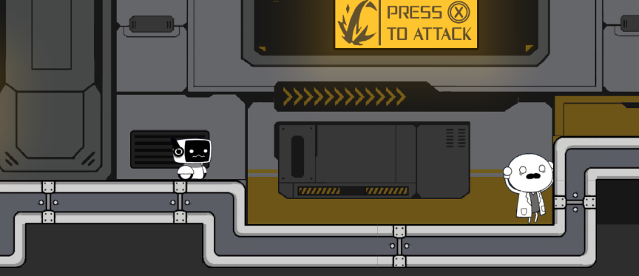

A raycast is used to check whether the player is near an enemy. If so, a fleeing animation is played, and the character runs away in the opposite direction.

  - Switch Interaction Using Collision Box
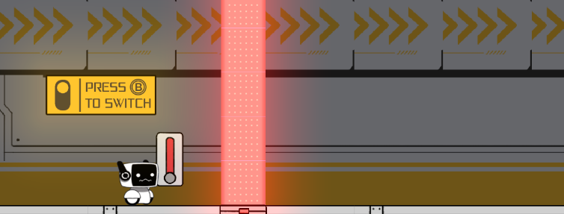
A collision box is used to check whether the player is within the switch’s range. If so, the player can activate or deactivate the switch.

  - Enemy Player Detection and Chase Behavior
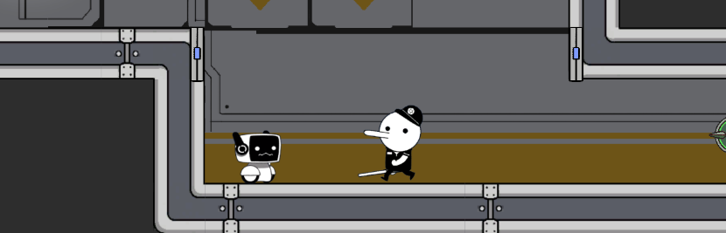
Similarly, a raycast is used to detect the player’s position. If the player is within the enemy’s detectable range, the enemy will run toward the player.

  - Enemy Attack Logic
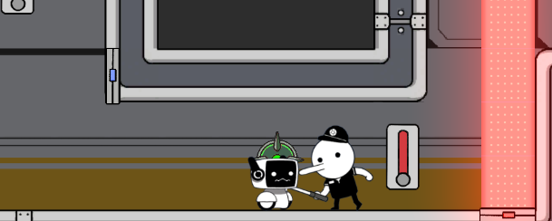
When the enemy reaches the player and enters attack range, it performs an attack. The attack is triggered only when both the chase condition and distance requirement are met, preventing the enemy from attacking from an unrealistic distance.

  - Energy System
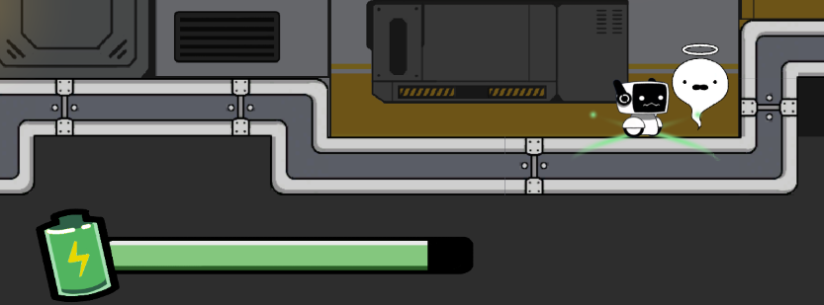
When the player kills an enemy, the system restores a portion of the player’s energy. This rewards aggressive gameplay and encourages engaging with enemies rather than avoiding them.

  - Double Jump and Dash
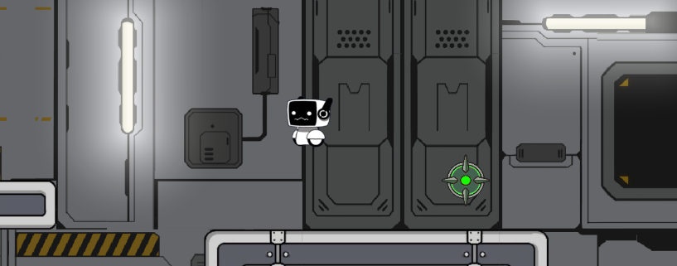
Implemented a double jump mechanic that allows the player to jump a second time while in the air. Also implemented a dash ability that lets the player quickly move a short distance in a chosen direction.

  - UI System
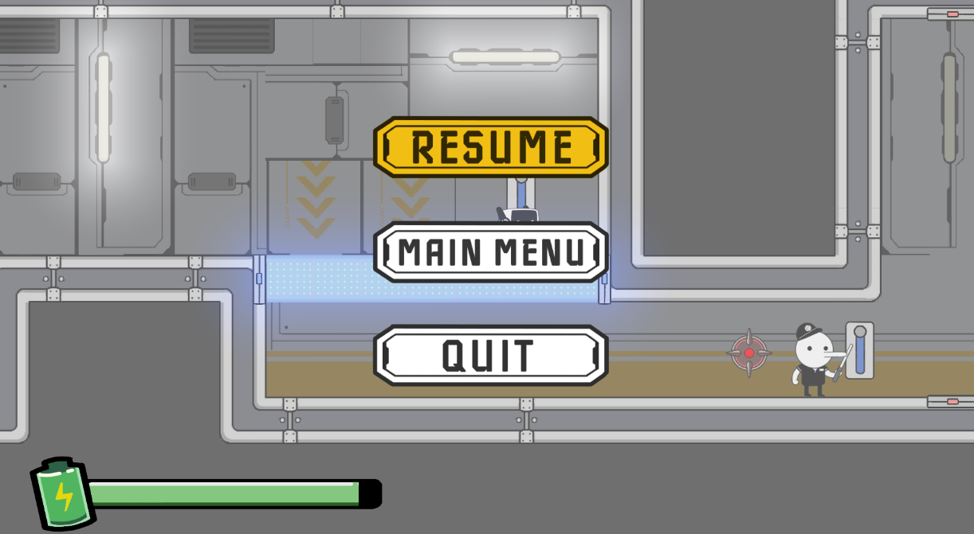

Created a pause menu that lets the player temporarily halt the game. When opened, the menu provides options to Resume, return to the Main Menu, or Quit.

Personal Roles and Responsibilities Write-up

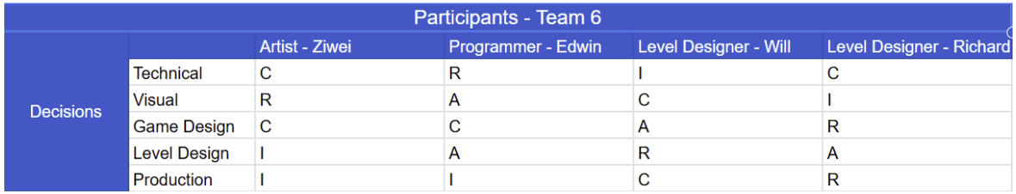
- Checkpoint system – implemented player respawn points, allowing checkpoints to activate and update the respawn location.
- Enemy AI behaviors – implemented enemy detection, chase, fleeing, and attack mechanics using raycasts and distance checks.
- Player controller– developed double jump and dash mechanics, including input handling and Rigidbody movement.
- Energy system – managed energy consumption for abilities and energy restoration upon defeating enemies.
- UI system – created a simple UI to display player energy and Menus.
- Pause menu – implemented a functional pause menu that disables player input and allows Resume, back to main menu, and Quit options.

Personal/Individual Postmortem Write-up
  - What Went Well
- I successfully implemented several game mechanics, such as player input handling
and basic AI behavior, and ensured they ran smoothly and reliably throughout the
project.
- During my work with the team, I had almost no issues with Perforce, such as
conflicts or overwrites. Even when problems came up, I was able to resolve them
quickly, keeping collaboration seamless.
- I was able to collaborate effectively with team members, sharing ideas and
solutions, which helped us stay aligned and complete tasks smoothly.
What Went Wrong
- My time estimates for tasks involving unfamiliar technology or complex integrations
were too optimistic, and the actual work took longer than expected. I should spend
more time researching technology before starting to code.
- I often underestimated the real difficulty of features that seemed easy at first,
especially when unexpected integration problems were discovered by team
members.
- I didn’t spend enough time testing, so some bugs were found later than expected. I
learned it’s important to plan enough time for testing to make sure features work
correctly.
What I Learned
- I have a clear understanding of how a game project develops from an initial idea,
through requirement analysis and pre-production, and then passes through several
defined milestones before finally launching.
- I learned how important it is to make timely and clear decisions to cut or features
when they are too complex to finish on time. This is not a problem for the project. By
reducing difficult features, I can spend more time improving existing work or adding
simpler features that enhance the overall user experience.
- I got a lot more comfortable using Unity. Over the course of the project, I learned
how to manage scenes, work with prefabs, organize components, and handle the
interaction between C# scripts and the engine.

Team-based Postmortem Write-up
  - What went well
- Listening to feedback from Stakeholders/Outside Professors on mechanics that would take a lot of time/out of scope, and cutting it early
- Inner Team conversation/communication was great. Usually after team meetings/SCRUM/dailies, gave each other instant feedback
- Problem solved together as a team, which was more efficient
- The team held true and stuck to our vision, tone, style, humor, of the game throughout the development
- Shipped game is fun, controls responsive and awesome
  - What went wrong
- Underestimate the difficulty of features and added many. Then when problems/bugs/issues came up, this created more work and ate up more time.
- Perforce Issues:
- team members not getting latest (renamed levels/project settings/double check out at the same time/check out conflict)
- renaming files that were already submitted, which ate up time.
- File management issues - File naming convention
- Putting personal preference above task priority. This wasted time.
- Didn't do enough planning during SCRUM planning. Ended up adding tasks that were not originally planned for.
  - What was learned
- How to collaborate in engine
- How to stay organized in our project
- That cutting early and cutting the grappling mechanic, actually allowed the team more time to focus on existing mechanics and go deeper on the mechanics we had
- Learned how to interpret advice/feedback from multiple sources. Then how and what to implement into the game. This helped to make the game more fun and still adhere to our original vision for the game
- Learned new game development skills, and we were able to go deeper within the unity engine.

