Report.html

Report.html file should be in point form and covers the following details:

* a link to the GitHub repo where you stored and collaborated on the project to show progress/history of your development work and see who made which commits at what times

<https://github.com/EdwinChooWL/group9friaswebsite/tree/master/FriasWebsite>

* the work that you have completed and any details required to test the site, including usernames, passwords, instructions if needed, outstanding issues
* 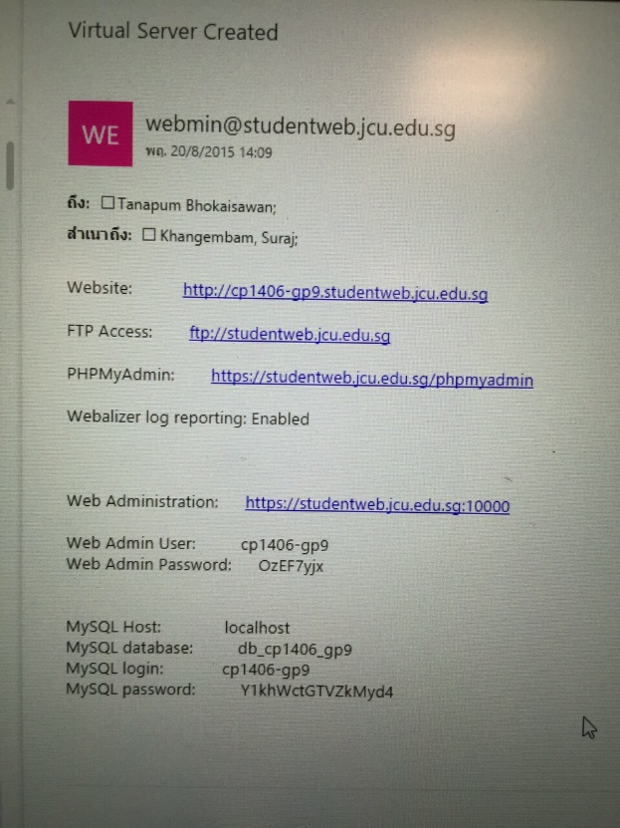summary of usability/accessibility testing done for your site
* references for any code, images or content that you have used that is not your own
* PMI - your group should spend some time reflecting on the process and describe here the Pluses, Minuses and Interesting aspects of your teamwork process and result