***Bar Graph :*** Gender Male are more Prone to leave the company compared to the Female Employess

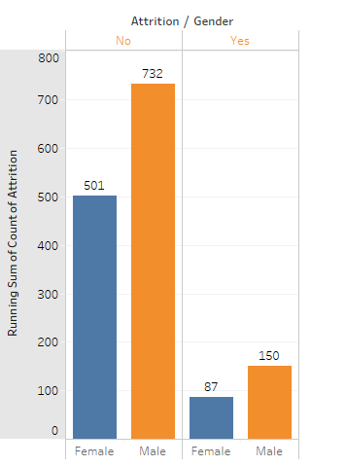

***Bar Graph*** between, overtime and Marital status. Looks married people are greater in population.

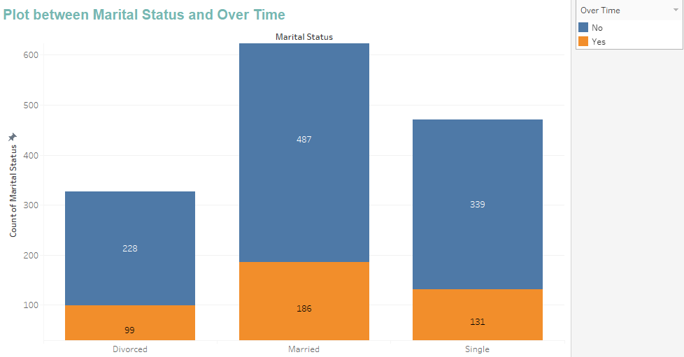

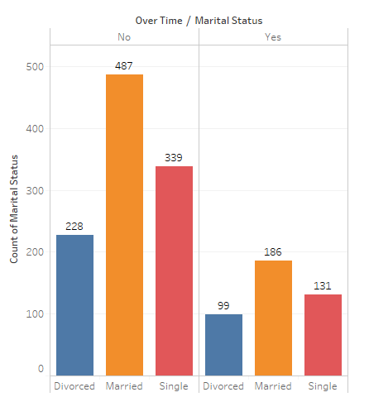

***Bar Graph :*** Married Employees doing Over time are move satisfied

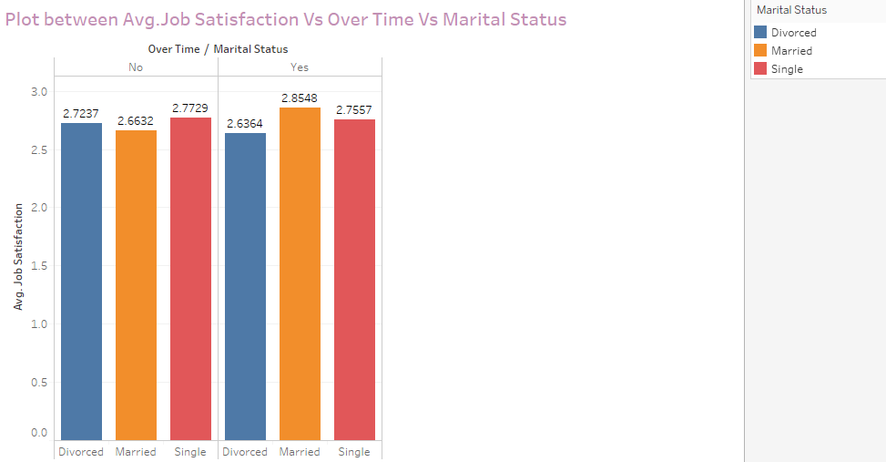

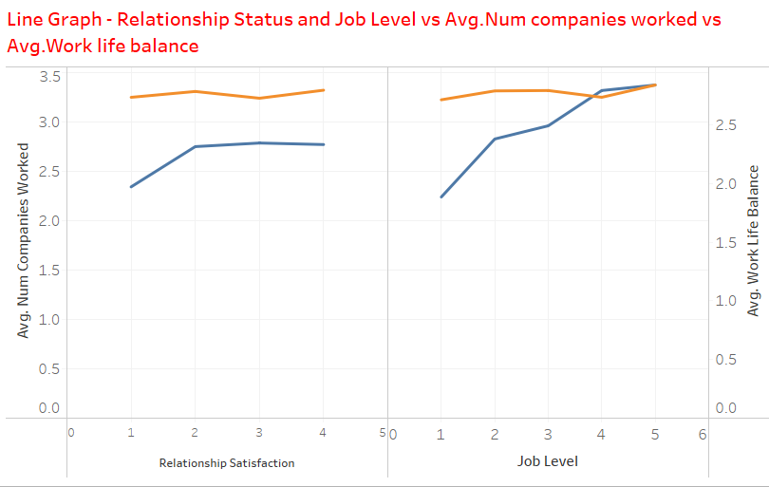

Line Graph between : Attrition Vs performance Rating and Percent salary Hike.

Greater the Performance Rating , Lesser the count of Attrition

Greater the Salary Hike, Lesser the Attrition count

