**MODULE SPEEDTEST**

# **Contents**

1. MODULE_SPEEDTEST.docx
2. MODULE_SPEEDTEST_MEDIA.zip

# **A1. Landing Page**

Create a landing page consisting of navigation bar, logo, menu with dropdown, hero section with heading text, and call to action (CTA).

# **B1. Masonry Layout**

In a centered container of 960px, you need to make a layout of 3 columns as shown in the image below.



# **C1. Line Chart**

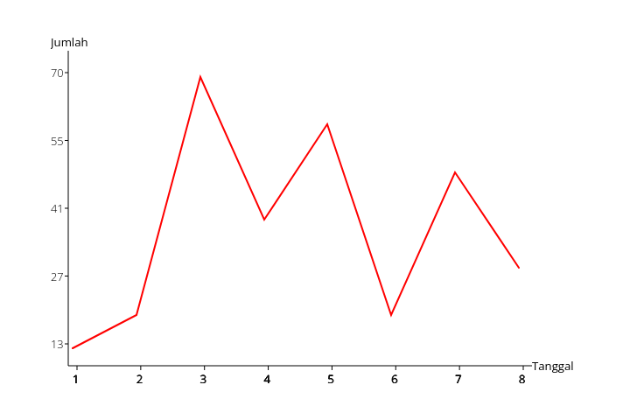

Make a line chart from the given data provided in media files. The canvas should be 600x400 in size and centered both vertically and horizontally in the browser. The vertical label, horizontal label, and the line should exist within the screen.

# 

# **C2. Compare Image**

Given an image in the media files, you need to draw the normal image and the grayscale version of the image. Users should drag the circle at the center to left and right in order to see the image difference. Please see the given video example provided in media files.

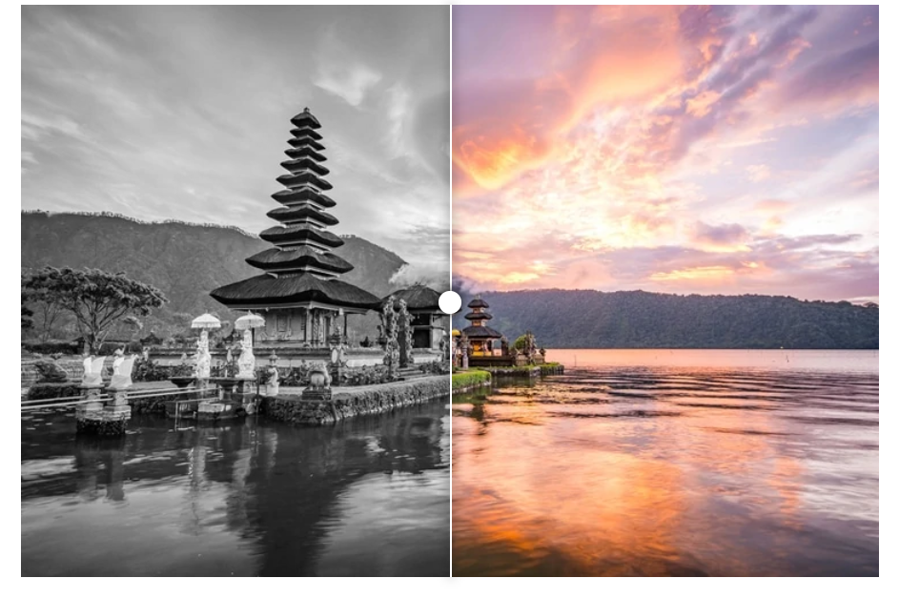

# **C3. Scope**

You need to make a hidden fullscreen-sized text, and a box of 400x400 on top of it. The user can not see the text, but they can see it through the box. The box can be moved by users by dragging it. See example.mp4 for more details.

# 

# **D1. Internationalization**

Provided a json file of languages, you need to translate the words that exist in the HTML file using PHP. There is a select form where user can change the language of the website.

# **D2. Chat Analytics**

Provided a JSON file of user messages, you need to make the analytics of the messages sent which is consist:

* Top 5 sent words
* Total messages sent
* Total messages received
* Average character length sent
* Average character length received

Example:

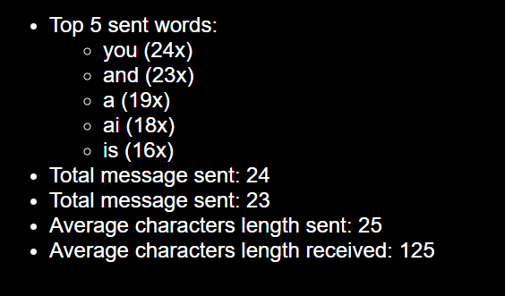

# 

# **D3. Watermark**

Given an image and a logo (png file), the web should output an image with a watermark in the top right.

| Point | Score |
| --- | --- |
| A1 | 2 |
| B1 | 2 |
| C1 | 2 |
| C2 | 2 |
| C3 | 2 |
| D1 | 1 |
| D2 | 2 |
| D3 | 1 |