1. Obtain smooth and correct miss detection probability vs. SNR curve using all of the eigenvectors from the covariance matrix (20%)

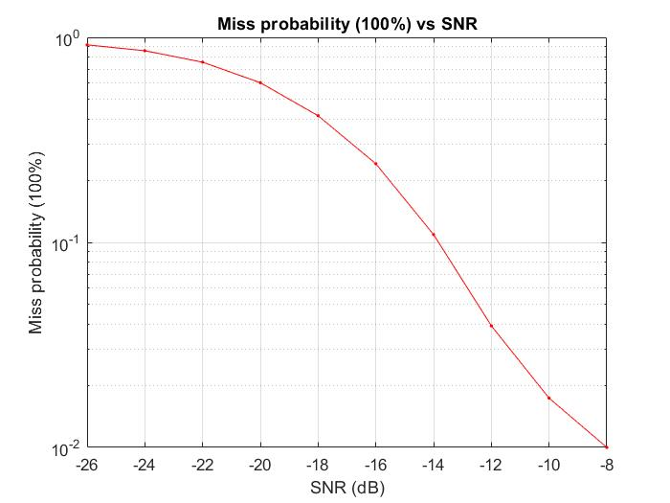

1. Implement algorithm using
   1. 10% of the total number of eigenvectors (10%)

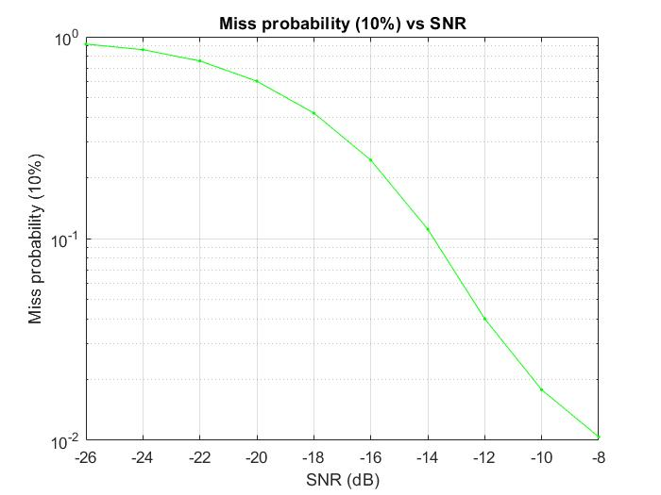

* 1. 1% of the total number of eigenvectors (10%)

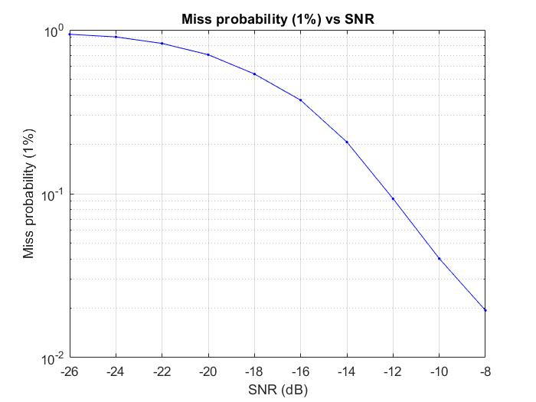

1. Answer question: how results for reduced number of eigenvectors are different from taking full set?(10%)

Ans: The 100% and the 10% curve are very similar, in fact, the detected face count difference is only 1 between these two, while the 1% curve has significantly higher miss probability, which makes perfect sense. This means that the bigger the matrix (G\*G’)’s eigenvalue is, the more important role its corresponding eigenvector plays when it comes to composing a face. In this case, the first 10% eigenvector can almost represent the whole eigenvector matrix, which is nice when we want to compress the data we need to recognize a face.

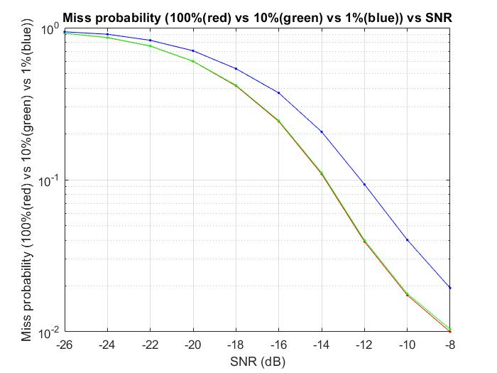

1. Plot miss probability error vs. SNR curve for all three cases(full set, 10% and 1% of the total number of eigenvectors).(10%)