**Clients Interview**

We interviewed several individuals regarding the problems associated with CNC machines GBRL control-software interfaces. Our population is CNC machine users, which can also include engineering students, HackerSpace Members, DIYers and hobbyists. We conducted a remote focus group with five interested participants to be interviewed about their experience using CNC control software. Three of the participants were engineering students and two of them were independent CNC owners/users. The meeting lasted about an hour and the conversation was focused on the main issues the users faced when using software (mainly based on GRBL protocol) to control CNC machines (Sarguroh and Rane, 2018).

We provided the participants with the following questions (Although the questions are written as features we always led and moderated the participants, so their responses always were referred more to the UI than the functionality):

1. Which GBRL Sender or interface do you use or have used in the past?
2. How easy or difficult you consider is to use the features of the actual interface you are using.
3. What features would you like to see or included in a new Interface Design?
4. What features would you like to see removed or redesign in a new Interface Design?
5. What features do you think would help the most in learning quickly to successfully operate CNC machines to newbies/beginners?

Users seem to be using a diverse variety of control software depending on their expertise and area of application. About 50% use the Universal G-Code Sender, one uses Match ¾ and the rest uses a variety. For question two we included a short poll for this question and again we received varying responses. Some participants responded slightly easy, other slightly difficult, another moderately difficult and two moderately easy.

Questions three to five provide more detail in the appendix but here is the summary of the most address points. The actual software the participants use as control interfaces are loaded with a lot of buttons and functions making it difficult for beginners. One of the participants said that it would be great if each button or feature had a tutorial on each feature/button w/pictures. The main issue for new users to understand, and the group agreed, was machine position vs work offset position. They also stated this is something difficult to be integrated with UI but they referred that maybe something visual about that would help.

Selection of Probe type should be a setting, not a requirement for each use, rapid positions should be better integrated into the jogging panel. Lastly, the two major points were an easier way for macro editing for GRBL commands and some way to show the GRBL command in more Human-readable information as GRBL settings are confusing for new users (for example $3=6).

**Current interface**

Computer Numerical Control (CNC) machines are very important to modern manufacturing. CNC machines are currently used by engineers and students alike for automated control of machines (da Rocha et al., 2010). There is a great variety of software used to control CNC machines and they come in many flavors. In our study, we have selected the Mach3 Interface which one of the oldest and robust in the machinery industry (Meza et al., 2018 ). Mach3 shines for providing both open- and closed-loop controls via a computer’s user interface (ArtSoft USA, 2008). One drawback from users in the CNC community and in our study is that this software uses the parallel port for data transmission for motion control and it works better in Windows XP versions.

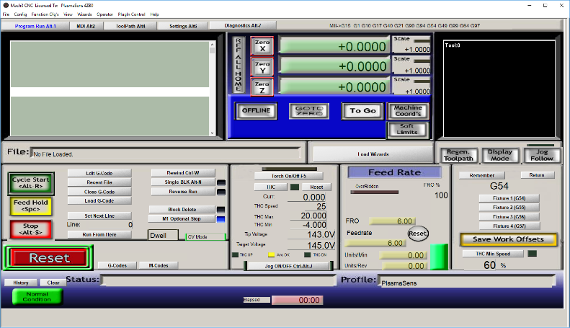

Figure 1. Mach3 Interface screenshot

Although this controller software provides value to CNC users, there is a lot of negative feedbacks and room for user interface improvement. A common complaint about the UI is that there is a lot of buttons and drop-down option. This can be very overwhelming for a beginner who might not understand what every button is doing or might not need every button/option right away.

For this project, we will work on a UI which is compatible with the GRBL protocol making the platform less hardware dependent based on the Mach3 characteristics. We are doing so, by applying several HCI principles and theories such as usability guidelines from Schneiderman's eight golden rules (Schneiderman, 2021), Nielsen’s heuristics (Nielsen and Molich, 1990), and Gestalt's principles (Todorovic, 2008). By using Schneiderman’s golden rules, we will improve the system by enabling the use of shortcuts for regular actions that should be performed quickly. We also will add keyboard shortcuts for repetitive user scenarios. Additionally, using Nielsen’s principle of minimalistic design, our interface will focus on highlighting core features that are commonly utilized by CNC users. Using information, we received from our user study, we will work on improving the UI by making common features easy to access and making less commonly used buttons/features as add-ons. Although many applications exist to control CNC machines via GRBL protocol such as Universal Gcode Sender and others none of them indeed provides a complete solution to all types of users. While many of them have done a great job, almost all of them assume that the user has advanced knowledge in using the UI.

**Research**

In (Muthupalaniappan et al., 2014) this paper, the authors promote CNC machine skills to provide access to quality manufacturing jobs. This paper states that oftentimes the machine and software to learn to use CNC is very expensive. They present the idea that a web-based learning platform would help make CNC learning “more affordable accessible and requires fewer resources.” They created a low-cost Arduino-based CNC lathe. The students can log into the system via a web-browser and unique credentials to interact with the machine. The user interface displays the CNC controls and an audio-visual feed of the actual machine.

This paper helps motivate the potential societal impact of decreasing the barrier of entry into learning to use CNC machines. It cites that “about 70% of manufacturing depends on CNC”. This paper does not provide a user study of the system but serves to point to the need of the system a potential solution to lowering the barrier of entry into an in-demand field. This paper also motivates us to consider a web-based design over downloadable software due to the flexibility and low-cost of a web-browser solution.

In (Yuan et al., 2019) this paper looks at the application of usability theory in industrial CNC. They also provide guidelines for assessing other CNC interfaces for usability. The leading theory used in this paper is the Usability correlation theory. They use a combination of eye-tracking and questionnaires to assess the usability of their touch-based user interface. They presented different layouts and asked users to locate various items and use eye-tracking to measure their success across different layouts.

Although this paper was focused on a touch screen interface, we can still use some of the information provided about the development life cycle for creating and testing a CNC interface. They also cited what was called the “Five Principles of the usability design of the CNC press touch interface: Consistency; Navigation efficiency; Clear vision; Smooth operation; Copywriting clear,” which we will keep in mind as we develop an upgraded CNC user interface.

In (Chang, 2002) this paper is about the Gestalt Principles and applying them to visual screen design. They conducted a study with a nursing class, where they redesigned their instructional multimedia site. They based the redesign off 11 gestalt principles. After conducting their study with the students, they found the gestalt laws to be beneficial for visual screen design and learning effectiveness.

This paper will help us with our design when thinking about elements of the interface to change. The principles focus on position, size, grouping, etc., all of which are important for our improvements of the interface. A goal of our interface is to make the learning curve for beginners shorter, so we will apply principles from this paper on visual designs that help make learning better.

In (Chao 2009) this paper summarizes research on usability design and test methods for interfaces. It first summarizes research on the users' emotions, satisfaction, and ability to learn when using interfaces. It then goes over testing methods like virtual testing or comparative testing. They then recommend usability principles to follow when designing interfaces. These principles focus on safety, satisfaction, ease of use, and predictability to name a few.

This paper will help in the design of our interface because it provides key focus areas to consider in the designing of our interface. We will use the research summarizations as areas of focus when brainstorming features of the new interface. We will use the principles outlined to keep us on track in the designing of our interface and make sure that we are providing a product that will be useful to CNC users.

In (Yusof 2004) this paper discusses a project on a visual interface for accessing CD information. They go over the design and thought process they went through and how they incorporated HCI principles.

This will be useful to our design because we will be providing a visual interface for CNC users. The data will be different but the HCI concepts will still apply.

**Proposed Interface Design**

For this project, we will work in working in a UI which is compatible with the GRBL protocol making the platform less hardware dependent based on the Mach3 characteristics. By using Schneiderman’s golden rules, we will improve the system by enabling the use of shortcuts for regular actions that should be performed quickly. We also will add keyboard shortcuts for user’s repetitive scenarios. Additionally, using Nielsen’s principle of minimalistic design, our interface will focus on highlighting core features that are commonly used by CNC users. Using information, we received from our user study we will work on improving the UI by making common features easy to access and making less commonly used buttons/features as add-ons.

Mach3 Interface Improvements:

* Getting rid of all the tab functions at the top
* Increase the area of the Drawing/Working interface
* Getting rid of all buttons and functions that are not essentials or less frequently used by a novice user.
* Provide a “Help” button from each function which gives information about the function.
* Provide bigger action buttons for accessibility and for actions that need to happen fast like stop.
* Enable shortcuts for repetitive functions.
* A visual way to represent actual vs relative machine position
* Easy access to create macros/buttons or functions

Something important that we are yet to discuss is how to represent G-Code in a more human-readable way. This visual representation will improve the UI. However, we are not sure yet how to make this possible.

**Sketch Design Interface**

Our preliminary concept sketch is drawn in figure 2. The design includes four(4) menus at the bottom each with three big buttons. One of the squares provides general information about the machine states. Each button has an icon that represents the function of that specific button. The user can find out what the function is for by hovering over the button. Just over the squares function in the main screen there are 5 main encapsulating functions (main, manual control, etc) meant for more advanced functions and advanced users. Clicking on any of them will change the functions and buttons of the squares. The main middle screen is dedicated mainly to graphics and design. The top menu will contain several icons representative of the function they perform, such as loading a file, settings, tools, and machine limits. Hovering on any of them will bring explanatory information to the user.

[**https://projects.invisionapp.com/freehand/document/3xxdkHxtL**](https://projects.invisionapp.com/freehand/document/3xxdkHxtL)

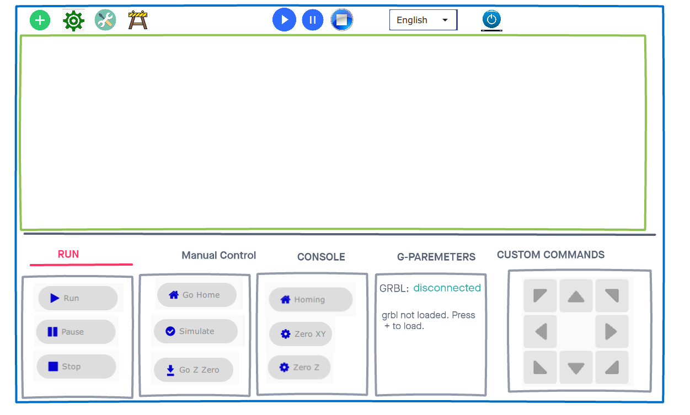

Figure 2 Interface Sketch

**Evaluation Plan**

In our study, we plan to recruit n=30+ participants from diverse backgrounds. Participants are expected to have previous experience using CNC machines. We are targeting CNC users, CNC owners, DIYers, hobbyists, and engineering students. We are going to advertise in dedicated CNC forums and websites, Gainesville hackerspace, and UF college of engineering.

Our research design will employ quantitative and qualitative methods to understand the degree of learnability, satisfaction and sustainability using a new GRBL control interface for CNC machines for CNC users. Participants will be provided with specific guided tasks to test included features of our design. They will test both the beginner-mode interface and the Advance mode Interface. A questionnaire 5-point Likert scale will be provided to the participants alongside the questionnaire to self-assess their degree of learnability, satisfaction and agreement with the tasks involved in the entire interface to control the CNC machine.

One open-ended question used in the interview will be included to assess the user perception on how our design will help new users in controlling CNC machines with this interface: What features do you think would help the most in learning quickly to successfully operate CNC machines to beginners. The Software Maxqda will be used to code the result from the open-ended question to inform the study what features participants found more relevant to help new users learn to control a CNC machine while using this interface.

The test will be conducted by participants via zoom, where they will be sharing the screen and following our instructions to complete the tasks and fill out the survey. Statistical analysis will be conducted for the self-assessment closed-ended questions in SPSS software. Due to the pandemic, one of the risks we face in our approach is not being able to get to the required number of participants so that our results can be quantitative relevant.

**AppendixInterview Transcript Summary**

The Meeting started with our team presentation and explaining the objective of the meeting. Following we requested to all participants introduce themselves and briefly describe their experience working with CNC machines and which software interface they usually use for controlling the machines.

Among our participants were three engineering students and two of them were CNC owners. The expertise was diverse as all the participants had used several machines and software for controlling them. Only one of the users did not use the machines for producing PCB for electronics circuits, his main use was with wood and plastic. Although our meeting was about CNC all the participants also mention having worked with 3D printers in the past or actually as 3D printer share the same working principles as CNC.

One of the users uses MACH3 software for the specific control because of the particular machine he was using. Although he is happy with the performance this particular software is tight to hardware using a machine with Windows XP which is not helpful for upgrades. He mentioned that calibrating the machine is tedious in this software and having some sort of calculator in-place in the UI would make life easier. Other users mentioned they use G-code sender, Chilleppr, and Flatcam as preparation software.

We created a poll in Zoom How easy or difficult you consider is to use the features of the actual interface you are using. (Extremely easy, Moderately easy, Slightly easy, Neither easy nor difficult, Slightly difficult, Moderately difficult, Extremely difficult) the responses were mixed. We think the responses depend on the user experience and the perception they have of using the machines. One of them chose Moderately easy, one Slightly difficult, two Moderately difficult, and one Slightly easy. One of them mentioned that for example working in 3D printers newbie users have problems as they don’t understand the layers of principles of how 3D printers works.

From there we let the participants discuss in-between the following questions only intervening for moderating when the discussion was going off-topic.

1. How easy or difficult you consider is to use the features of the actual interface you are using.
2. What features would you like to see or included in a new Interface Design?
3. What features would you like to see removed or redesign in a new Interface Design?
4. What features do you think would help the most in learning quickly to successfully operate CNC machines to newbies/beginners?

Although we make all the efforts so the participants did not focus on features it was inevitable because that is how users think. From that we get the following indications:

Features:

* Ability to pause in specific areas to Be able to change the type of bits for specific areas.
* ability to save current location after powering down and when powered back up it would have the ability to load the last location. Tab to show current profile being cut and display cutting path
* Feed rate override would be nice.
* Improved visualization of the GRBL being processed Improved behavior when MacOS night mode kicks in (and inverts luminance, kind of) Option for auto-connect to last connected machine, not have to confirm and click
* GRBL connectivity Gcode visualization
* A hardware pendant
* must be cross-platform Windows/Mac/Linux personally
* Better support for pendants, i.e., use of a gamepad (game controllers are already allowed) w/o the need for keyboard remapping
* Macro editing redesigned
* A current status, live updated, including basics such as 'not connected', or 'no file loaded'
* DRO Customizable buttons

UI Re-Design Improvement

* Include option for large font DRO display
* Tutorial on each feature of the Interface w/pictures
* Description of each configuration. To be able to visualize the tracing of these configurations.
* New users have trouble with the concept of machine position vs work offset position.
* Links to information for beginning users. Everything should have a help button.
* Human readable information. grbl settings are confusing for new
* Probing is a very confusing area.

**References**

* ArtSoft USA, 2008. Mach3 CNC Controller Software Installation and Configuration, USA.
* da Rocha, P. A. S., de Silva, R. D. , Souza e. and M. E. de Lima Tostes, 2010 "Prototype CNC machine design," 2010 9th IEEE/IAS International Conference on Industry Applications - INDUSCON 2010, Sao Paulo, Brazil, 2010, pp. 1-5, doi: 10.1109/INDUSCON.2010.5740068.
* Todorovic, D., (2008) Gestalt principles. Scholarpedia, 3(12):5345.
* Meza, G., Carpio, C. d., Vinces, N. and Klusmann, M., 2018, "Control of a three-axis CNC machine using PLC S7 1200 with the Mach3 software adapted to a Modbus TCP/IP network," 2018 IEEE XXV International Conference on Electronics, Electrical Engineering and Computing (INTERCON), Lima, 2018, pp. 1-4, doi: 10.1109/INTERCON.2018.8526429.
* Nielsen, J., and Molich, R. (1990). Heuristic evaluation of user interfaces, Proc. ACM CHI'90 Conf. (Seattle, WA, 1-5 April), 249-256.
* Sarguroh, S. S. and Rane, A. B., 2018 "Using GRBL-Arduino-based controller to run a two-axis computerized numerical control machine," 2018 International Conference on Smart City and Emerging Technology (ICSCET), Mumbai, 2018, pp. 1-6, doi: 10.1109/ICSCET.2018.8537315.
* Shneiderman, B., Plaisant, C., Cohen, M., Jacobs, S., and Elmqvist, N., Designing the User Interface: Strategies for Effective Human-Computer Interaction: Sixth Edition, Pearson (Feb 2021) <http://www.cs.umd.edu/hcil/DTUI6>
* Muthupalaniappan, N., Maruthupandi, A., Pandian, S., Antony, A. J. P., & Pandian, S. R. (2014, December). A low-cost web-based learning platform for CNC machining education. In 2014 Sixth International Conference on Advanced Computing (ICoAC) (pp. 9196).IEEE. <https://ieeexplore.ieee.org/abstract/document/7229753?casa_token=UHeoyjJ6IpIAAAAA:c3XN8PBRizIHyjHrV_tKmF3wfyY6wUYqeIxksEFrhvXvdNevuoruH99zSi1bJzg3a5GgCWj73QQ>
* Yuan, H., Hu, S. L., Lao, C. C., Zhang, Q. L., & Liang, B. K. (2019, December). Design and Usability of the Touch-based Interface of CNC Presses. In *2019 International Conference on Information Technology and Computer Application (ITCA)* (pp. 39-42). IEEE. <https://ieeexplore.ieee.org/document/9092490>
* Chang, Dempsey & Dooley, Laurence & Tuovinen, Juhani. (2002). Gestalt Theory in Visual Screen Design - A New Look at an Old Subject. Proceedings of the 7th World Conference on Computers in Education: Australian Topics, Volume 8. https://dl.acm.org/doi/pdf/10.5555/820060.820062
* G. Chao, "Human-computer interaction: The usability test methods and design principles in the human-computer interface design," 2009 2nd IEEE International Conference on Computer Science and Information Technology, Beijing, China, 2009, pp. 283-285, doi: 10.1109/ICCSIT.2009.5234724. <https://ieeexplore.ieee.org/stamp/stamp.jsp?tp=&arnumber=5234724>
* R. J. R. Yusof, R. Amin, R. Zainudin and O. F. Baker, "Human computer interaction (HCI) - aspect in developing information access system," *2004 IEEE Region 10 Conference TENCON 2004.*, Chiang Mai, Thailand, 2004, pp. 387-390 Vol. 2, doi: 10.1109/TENCON.2004.1414613. <https://ieeexplore.ieee.org/stamp/stamp.jsp?tp=&arnumber=1414613>