**Page 1** – Interview Clients (20 points) I think I can do the focus group and the interviews **(Edwin)**

* Interview clients to determine: their impressions of the problem you are trying to address existing solutions improvements the clients want clients’ solutions to the interface.
* Conduct a remote focus group of at least four clients. If there is a logistical reason why that is not possible (okayed by TA), you can email questions to clients.

**Page 2** – Current Interface (20 points) We can pick 1 or 2 from existing with help from interviews. (and our initial presentation). (Kenneth)

* Describe the current interface (5 points)
* Describe problems with the current interface (5 points)
* Describe existing solutions (5 points)
* Describe HCI guideline, principle, or theory you plan on applying to address the issue (5 points)

1. Study the current problem

2. Identify existing solutions

3. Why do existing solutions not address the problem?

4. What HCI concept are you applying to address the issue?

I suggest you take a look at [this GCode Sender](https://github.com/terjeio/Grbl-GCode-Sender/releases) for some ideas. I think it is the best out there and has done much to make the experience much more approachable. It works with and Grbl but shines with [grblHAL](https://github.com/terjeio/grblHAL" \t "_blank).

ioSender (<https://github.com/terjeio/Grbl-GCode-Sender/releases>) has a very rich interface yet is sometimes confusing

Take a look at CNCjs. It's almost perfect.

https://winder.github.io/ugs\_website/

**Page 3 and 4** – Research (30 points) 5 papers + HCI concepts. We can grab some from Presentation

(Jean / David)

* Summary and appropriateness of each paper (3 points)
* Integration of findings into your project (3 points)

Find supporting scientific literature. Identify 5 papers from SIGCHI, UIST, or an IEEE/ACM conference or journal. Other sources require TA review. For each paper, write one paragraph that encapsulates the results and one paragraph on how the paper impacts your design decisions. Include links to the papers.

**Page 5** – Proposed Interface Design (25 points)

* Describe how the research and client interviews impact your design - 10 points
* Describe your interface – 10 points
* Technical description (software, hardware, languages) of your design – 5 points

**Page 6 -** Sketch a design of your interface

**Page 7 -** Plan for remote user evaluation (n=30) given the Covid-19 restrictions - 5 points

* Describe your design. Explain how you are leveraging the literature references and client interview.
* Discuss the technology you will use, design decisions, risks identified in your approach

Default Report  
*New interface for NEW GRBL Sender*  
**February 16th 2021, 12:26 pm MST**

**Q1 - Which GBRL Sender or interface do you use or have used in the past?**

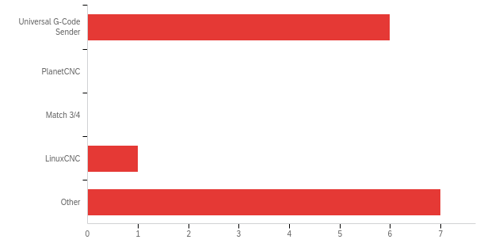

|  |  |  |  |
| --- | --- | --- | --- |
| # | Answer | % | Count |
| 1 | Universal G-Code Sender | 42.86% | 6 |
| 2 | PlanetCNC | 0.00% | 0 |
| 3 | Match 3/4 | 0.00% | 0 |
| 4 | LinuxCNC | 7.14% | 1 |
| 5 | Other | 50.00% | 7 |
|  | Total | 100% | 14 |

**Q2 - How easy or difficult you consider is to use the features of the actual interface you are using now for new users / beginners learning CNC Machine?**

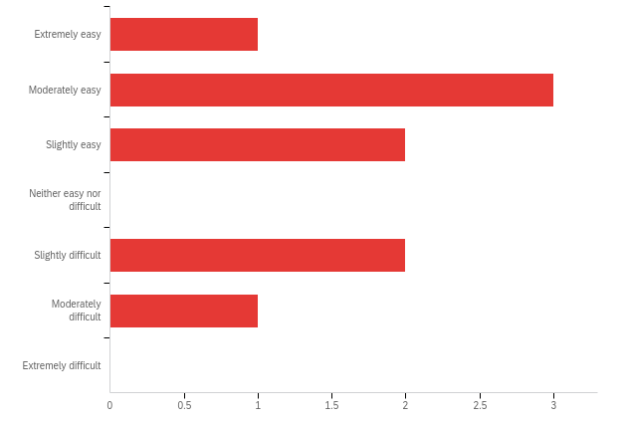

|  |  |  |  |  |  |  |  |
| --- | --- | --- | --- | --- | --- | --- | --- |
| # | Field | Minimum | Maximum | Mean | Std Deviation | Variance | Count |
| 1 | How easy or difficult you consider is to use the features of the actual interface you are using now for new users / beginners learning CNC Machine? | 1.00 | 6.00 | 3.22 | 1.62 | 2.62 | 9 |

|  |  |  |  |
| --- | --- | --- | --- |
| # | Answer | % | Count |
| 1 | Extremely easy | 11.11% | 1 |
| 2 | Moderately easy | 33.33% | 3 |
| 3 | Slightly easy | 22.22% | 2 |
| 4 | Neither easy nor difficult | 0.00% | 0 |
| 5 | Slightly difficult | 22.22% | 2 |
| 6 | Moderately difficult | 11.11% | 1 |
| 7 | Extremely difficult | 0.00% | 0 |
|  | Total | 100% | 9 |

**Q3 - What features would you like to see or included in a new Interface Design?**

|  |
| --- |
| What features would you like to see or included in a new Interface Design? |
| Ability to save current location after powering down and when powered back up it would have the ability to load last location. Tab to show current profile being cut and display cutting path |
| Be able to change type of bits for specific areas. |
| Feed rate override would be nice. |
| Improved visualisation of the GRBL being processed Improved behaviour when MacOS night mode kicks in (and inverts luminance, kind of) Option for auto-connect to last connected machine, not have to confirm and click |
| GRBL connectivity Gcode visualization Ability to add macros DRO Customizable buttons A hardware pendant |
| must be cross-platform Windows/Mac/Linux personally I don't like installing Java apps but if it is Java have the Java included. |
| Human readable information. grbl settings are terribly confusing for new users (for example $3=6). bitfields totally confuse people. Normally Open vs Normally Closed (NO vs NC) is a major point of confusion. Probing is an area that is very confusing. ioSender (https://github.com/terjeio/Grbl-GCode-Sender/releases) has a very rich interface yet is sometimes confusing. |
| Better support for pendants, i.e., use of a game pad (game controllers are already allowed) w/o the need for keyboard remapping |

**Q4 - What features would you like to see removed or redesign in a new Interface Design?**

|  |
| --- |
| What features would you like to see removed or redesign in a new Interface Design? |
| NA |
| The multi-path isolation routing on PCB adjusts for the distance between each copper path. |
| Macro editing redesigned |
| Take a look at CNCjs. It's almost perfect. |
| Include option for large font DRO display |
| Selection of Probe type should be a Setting, not a requirement for each use, rapid positions should be better integrated into the jogging panel. |

**Q5 - What features do you think would help the most in learning quickly to successfully operate CNC machines to newbies/beginners ?**

|  |
| --- |
| What features do you think would help the most in learning quickly to successfully operate CNC machines to newbies/beginners ? |
| Tutorial on each feature of the Interface w/pictures |
| -Description of each configuration. -To be able to visualize the tracing of these configurations. |
| A current status, live updated, including basics such as 'not connected', or 'no file loaded' |
| New users have trouble with the concept of machine position vs work offset position. I don't know how an interface can make this easier but maybe something graphic ? |
| **Links to information for beginning users. Everything should have a help button.** |
| Simple and consistent interface. |

**Q6 - would you be interested in trying our re-design sometime in March (2021)?**

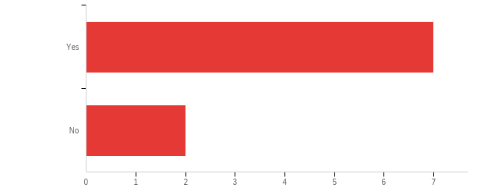

|  |  |  |  |  |  |  |  |
| --- | --- | --- | --- | --- | --- | --- | --- |
| # | Field | Minimum | Maximum | Mean | Std Deviation | Variance | Count |
| 1 | would you be interested in trying our re-design sometime in March (2021)? | 1.00 | 2.00 | 1.22 | 0.42 | 0.17 | 9 |

|  |  |  |  |
| --- | --- | --- | --- |
| # | Answer | % | Count |
| 1 | Yes | 77.78% | 7 |
| 2 | No | 22.22% | 2 |
|  | Total | 100% | 9 |