Realizar los siguientes ejercicios, hacer el informe (digital o escaneado) y subirlo a su repositorio en un archivo pdf

Porgramacion_2022_2/Laboratorio1/  
(usuario_unal.(pdf))

Último plazo para subir archivo al repositorio lunes 22 de agosto a las 24:00

**Ejercicios**

1. Averigua y escribe el código ASCII correspondiente, tanto en decimal como

en binario, a las letras de sus nombres y apellidos.

Distinguir entre mayúsculas/minúsculas, y sin acentos.

Crear una tabla donde las filas sean los caracteres del nombre y las columnas sean (caracter, Representación Decimal, Binario)

|  |  |  |  |  |
| --- | --- | --- | --- | --- |
| **Numero** | **Letras** | **ASCII** | **Decimal** | **Binario** |
| 1 | E | E | 69 | 1000101 |
| 2 | d | d | 100 | 1100100 |
| 3 | w | w | 119 | 1110111 |
| 4 | i | i | 105 | 1101001 |
| 5 | n | n | 110 | 1101110 |
| 6 |  | "Espacio" | 40 | 101000 |
| 7 | A | A | 65 | 1000001 |
| 8 | l | l | 108 | 1101100 |
| 9 | e | e | 101 | 1100101 |
| 10 | x | x | 120 | 1111000 |
| 11 | a | a | 97 | 1100001 |
| 12 | n | n | 110 | 1101101 |
| 13 | d | d | 100 | 1100100 |
| 14 | e | e | 101 | 1100101 |
| 15 | r | r | 114 | 1110010 |
| 16 |  | "Espacio" | 40 | 100000 |
| 17 | S | S | 83 | 1010011 |
| 18 | u | u | 117 | 1110101 |
| 19 | s | s | 115 | 1110011 |
| 20 | a | a | 97 | 1100001 |
| 21 | t | t | 116 | 1110100 |
| 22 | a | a | 97 | 1100001 |
| 23 | m | m | 109 | 1101101 |
| 24 | a | a | 97 | 1100001 |
| 25 |  | "Espacio" | 40 | 100000 |
| 26 | P | P | 80 | 1010000 |
| 27 | r | r | 114 | 1110010 |
| 28 | i | i | 105 | 1101001 |
| 29 | e | e | 101 | 1100101 |
| 30 | t | t | 116 | 1110100 |
| 31 | o | o | 111 | 1101111 |

1. Realiza la conversión a binario del número decimal 843, mostrar proceso.

|  |  |  |  |  |  |  |  |  |  |  |  |  |
| --- | --- | --- | --- | --- | --- | --- | --- | --- | --- | --- | --- | --- |
| **Decimal** | **2048** | **1024** | **512** | **256** | **128** | **64** | **32** | **16** | **8** | **4** | **2** | **1** |
| 843 | 0 | 0 | 1 | 1 | 0 | 0 | 1 | 0 | 0 | 0 | 1 | 1 |

1. Realiza la conversión tanto a decimal como a hexadecimal de los números binarios, mostrar proceso.
   1. 11100101011110.
   2. 1111111111111.
   3. 100000000001.
   4. 10101011110000.

|  |  |  |  |  |  |  |  |  |  |  |  |  |  |  |  |  |
| --- | --- | --- | --- | --- | --- | --- | --- | --- | --- | --- | --- | --- | --- | --- | --- | --- |
| Binario | 2^13 | 2^12 | 2^11 | 2^10 | 2^9 | 2^8 | 2^7 | 2^6 | 2^5 | 2^4 | 2^3 | 2^2 | 2^1 | 2^0 | Decimal | Hexadecimal |
| 11100101011110 | 1 | 1 | 1 | 0 | 0 | 1 | 0 | 1 | 0 | 1 | 1 | 1 | 1 | 0 | 14686 | 395E |
| 1111111111111 |  | 1 | 1 | 1 | 1 | 1 | 1 | 1 | 1 | 1 | 1 | 1 | 1 | 1 | 8191 | 1FFF |
| 100000000001 |  |  | 1 | 0 | 0 | 0 | 0 | 0 | 0 | 0 | 0 | 0 | 0 | 1 | 2049 | 801 |
| 10101011110000 | 1 | 0 | 1 | 0 | 1 | 0 | 1 | 1 | 1 | 1 | 0 | 0 | 0 | 0 | 10992 | 2AF0 |

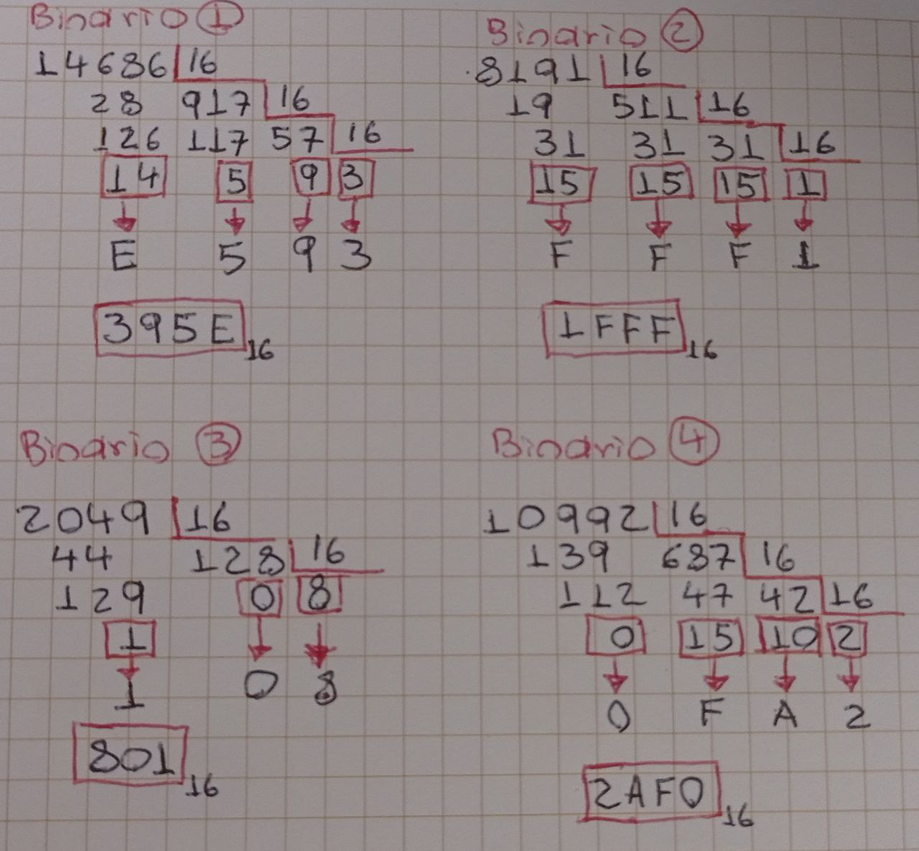

1. Construir una tabla con la representación de los 32 primeros números en los sistemas de numeración hexadecimal, decimal y binario.

|  |  |  |  |
| --- | --- | --- | --- |
| Numero | Hexadecimal | Decimal | Binario |
| 0 | 0 | 0 | 0 |
| 1 | 1 | 1 | 1 |
| 2 | 2 | 2 | 10 |
| 3 | 3 | 3 | 11 |
| 4 | 4 | 4 | 100 |
| 5 | 5 | 5 | 101 |
| 6 | 6 | 6 | 110 |
| 7 | 7 | 7 | 111 |
| 8 | 8 | 8 | 1000 |
| 9 | 9 | 9 | 1001 |
| 10 | A | 10 | 1010 |
| 11 | B | 11 | 1011 |
| 12 | C | 12 | 1100 |
| 13 | D | 13 | 1101 |
| 14 | E | 14 | 1110 |
| 15 | F | 15 | 1111 |
| 16 | 10 | 16 | 10000 |
| 17 | 11 | 17 | 10001 |
| 18 | 12 | 18 | 10010 |
| 19 | 13 | 19 | 10011 |
| 20 | 14 | 20 | 10100 |
| 21 | 15 | 21 | 10101 |
| 22 | 16 | 22 | 10110 |
| 23 | 17 | 23 | 10111 |
| 24 | 18 | 24 | 11000 |
| 25 | 19 | 25 | 11001 |
| 26 | 1A | 26 | 11010 |
| 27 | 1B | 27 | 11011 |
| 28 | 1C | 28 | 11100 |
| 29 | 1D | 29 | 11101 |
| 30 | 1E | 30 | 11110 |
| 31 | 1F | 31 | 11111 |

1. ¿Cuál es el siguiente número hexadecimal al 19F

RTA: 1A0