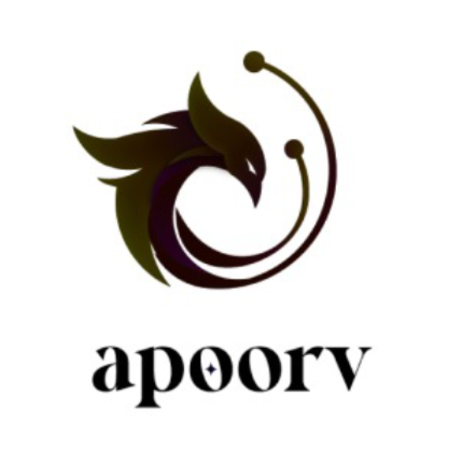

**Memorandum of Understanding (MoU)**

**IIIT Kottayam x MakeMyPass**

This MoU is made on 10th February 2025 between IIIT Kottayam (hereinafter referred to as the "Organizer") and MakeMyPass, a comprehensive event management platform (hereinafter referred to as the "Service Provider").

Where, IIIT Kottayam is organizing Apoorv ’25, a techno-cultural fest, on 7th-9th March 2025 at its campus.

Terms of Agreement:

1. MakeMyPass is Apoorv’s Platform Partner thus providing the platform required to conduct the events.
2. Team Apoorv of IIIT Kottayam will actively showcase MakeMyPass on their Instagram page, promoting the platform and its features.
3. MakeMyPass will provide 24/7 customer support, ensuring dedicated assistance for attendees and organizers. Virtual support will be available to facilitate the smooth execution of the event.
4. The platform will enable streamlined on-site check-in and badge printing for attendees. If requested in advance, MakeMyPass can provide volunteer training for attendee check-in and badge printing. If physical assistance is required, additional allowances will apply for the team’s support during the event.
5. To enhance audience participation, gamification and engagement features will be made available. If a television is accessible at the venue, it can be used to welcome participants during check-in. Additionally, organizers can use the networking game feature on[**hoogo**](https://hoogo.makemypass.com/)to enhance participant engagement.

Confidentiality:

1. Both parties agree to maintain the confidentiality of any proprietary or sensitive information exchanged during the collaboration.

Governing Law & Dispute Resolution:

1. This MOU is governed by Indian law. Any dispute arising hereunder shall be settled amicably through mutual discussion or mediation.

This MOU constitutes the entire agreement between the parties, superseding all prior or contemporaneous communications, representations, or agreements, whether oral or written.

This MOU is signed by the following representatives:

For IIIT Kottayam:

Name: Abhishek Naganaboyina

Designation: Apoorv Executive Head

Date: 10-02-2025

Signature: _______________________

For MakeMyPass:

Name: Adnan Kattekaden (+91 6238450178)

Designation: Growth Hacker

Date: _______________________

Signature: _______________________