DEEP LEARNING FOR VISUAL COMPUTING

Report 1st Assignment:

**Group 4:**

**Daria Lazic** and **Marcin Konefał**

*November 11.11.2018, Vienna*

**What is image classification:**.

In image classification an ML algorithm learns to predict the class of unseen samples based on extracted information and assigns a class value called label. In classification the number of class label values is finite and discrete.

**What is the purpose of the training, validation and test sets and why do we need all of them?**

The training set is used for classifier training. Hyperparameters are tested and selected using a validation set. Test set is used for the final estimate of performance. Accuracy of a classifier is based on the ability of predicting labels for UNSEEN data. Thus, observations present in the training set, must not be included in the validation or test set. The performance estimate is not valid, if the test set is used during training or validation.Not following these rules can lead to overfitting.

**How do knn classifiers work?**

The knn classifier computes the distance between a sample and its k closest neighbours. To identify the k closest neighbours of one sample x, the distance (either L1 or L2) to all other samples has to be calculated. As a distance measure either L1 or L2 (Euclidian) can be used. The distance is computed over all dimensions.

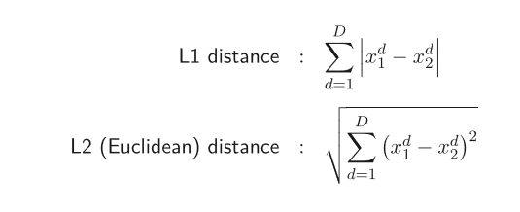

Then the classifier looks at the label of the k nearest neighbours and assigns the most frequent label to sample x. [If one wants to know how certain the classifier is,] (it is not really clear I guess we do not need that?) the frequency of each class label can be calculated among the k closest samples. Additionally, the largest value could be emphasized using the softmax function.

**Results**

In the following plot the validation accuracies for different k-values can be seen:

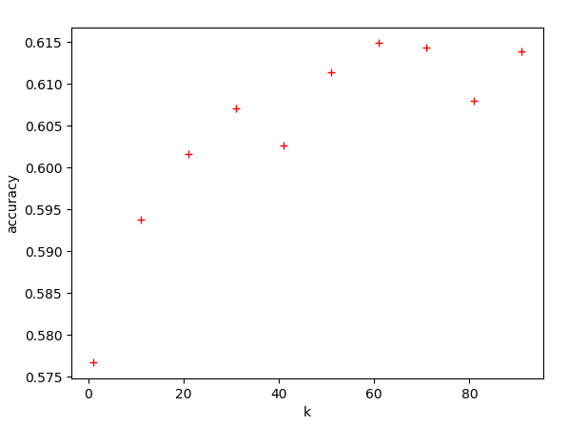

Best accuracy using validation set is: **0.6148946594806467** for k = **61**.

Accuracy using test set is: **0.6175** using best k of validation set.

**Conclusions**

The knn classifier performs poorly, because it is based on average image similarity. As feature vectors we use all pixels of an image. Thus the classifier has no understanding of the image. Dimension is large and input space is sparsely occupied, which is why distance measures become unintuitive. The solution here is the extraction of discriminative features such as gradients or background information.“””