Requirements Document: Case-Law Research Assistant (P4)
Software Engineering, Fall 2026-2027
Requirements Document (Delivery No. 1), due 24/10/2026
Team members: Yasser Hajj Youssef, Edwin Mouawad, Joe Bou Karam
Supervisor: Georges Salloum

1. Introduction
For our project we chose P4, the case-law research assistant. In this report we call it Verdicta. It is a website where someone can ask a legal research question and get an answer that is built only from real court decisions. Every sentence in the answer points to the passage it came from, and every case the system mentions is checked before the answer is shown.

1.1 Problem definition
More and more lawyers and students use AI chatbots for legal research. The problem is that these tools sometimes make up cases that do not exist. The citation looks correct (a case name, a volume and a page), so people trust it. The best known example is Mata v. Avianca (New York, 2023), where two lawyers were fined $5,000 because their brief cited fake cases that ChatGPT had generated [1]. Even paid legal tools have this problem: a Stanford study in 2024 found wrong or made-up content in about 17% of Lexis+ AI answers and 33% of Westlaw AI answers [2].
The reason is simple. A language model writes text that looks like a citation, but nothing checks whether the case exists or whether it came from the documents the system actually found. Our system adds that check, and it is also allowed to say "I don't know" when the decisions it found do not answer the question.

1.2 System description
Verdicta has two parts, and users must log in with the right role to use the second one.
The public part is the research page. A visitor types a question. The system searches a limited set of court opinions that we download from CourtListener, writes an answer where each sentence is linked to a retrieved passage, and checks every case citation against the CourtListener citation data. Citations that cannot be verified are removed, along with the sentences that depend on them. If the passages do not support an answer at all, the visitor sees a clear message: "Not supported by the retrieved opinions". This is different from a low-confidence answer, which is shown with a warning.
The admin part is a testing room for the operator. From there the operator can run the system on our list of test questions, see how many fake citations got through (the goal is zero), check how well the system decides when to abstain, look at the questions it refused to answer, change the abstention threshold, start a re-index, and follow statistics like number of queries, response time and failures.

1.3 Importance and motivation
In legal work one invented case is enough to lose a client's trust or get sanctioned in court. A research tool is only useful if its references can be trusted. That is our main motivation: we want a system that cannot show a fake citation by design, and that treats "not supported" as a correct answer when the evidence is missing. This is also the skill the P4 project is meant to teach us: faithfulness, citation verification and calibrated abstention.
The users who benefit are law students, lawyers and researchers (they get answers they can check in seconds), the operator (who can prove with numbers that the system works) and our supervisor (who will assess the system on measured results).

1.4 Objectives
- O1: Answer legal research questions using only passages from our court-opinion corpus.
- O2: Link each sentence of an answer to the exact passage that supports it, and show these passages.
- O3: Make sure no unverified case citation is ever shown to the user.
- O4: Abstain clearly when the retrieved passages are not enough, and keep this separate from a low-confidence answer.
- O5: Let the operator evaluate the system (test questions, groundedness, false-citation rate, abstention precision and recall, retrieval metrics before and after an improvement).
- O6: Let the operator run the system (statistics, list of abstained questions, threshold tuning, re-indexing).
- O7: Protect the admin part with role-based login.
- O8: Save the licence of every document when it is ingested.

1.5 Constraints
- C1: The system must be a website deployed online, reachable at the defense (localhost does not count).
- C2: We can only use CourtListener bulk data, unless the supervisor approves another source.
- C3: We must limit the data to one court or a date range, because the full opinions file is 44.8 GB compressed.
- C4: The CourtListener API needs a token, so we use the bulk files, which do not.
- C5: We follow the 12-week plan and its gates (weeks 1, 3, 6, 10 and 12).
- C6: We must use AI coding tools, commit SPEC.md before any code, and keep AI_LOG.md.
- C7: We must write at least 50 test questions ourselves, with at least 15 that have no answer in our data.
- C8: We are three students and each of us must be able to explain any part of the code.

2. Glossary
Term | Meaning
Abstention | When the system decides not to answer because the passages it found do not support an answer.
Abstention precision | Out of all the times the system abstained, how many were questions that really had no answer in our data.
Abstention recall | Out of all the questions that really had no answer, how many the system abstained on.
Adversarial set | Test questions we write on purpose to trick the system into inventing a citation.
Bulk data | The compressed CSV files that CourtListener publishes for free download.
Chunk | A small piece of an opinion (a few paragraphs) that can be searched and cited.
Citation | The standard reference to a court decision, e.g. "410 U.S. 113" (volume, reporter, page).
Citation map | The CourtListener file that lists which opinion cites which. We use it with the citation records to check that a citation exists.
Corpus | The set of court opinions we load into the system after filtering.
CourtListener | A free website by the Free Law Project that publishes U.S. court decisions.
Embedding | A list of numbers that represents the meaning of a text, used for semantic search.
Eyecite | A free library from the Free Law Project that finds legal citations in text.
False-citation rate | Number of fake citations shown divided by the total number of citations shown. Our target is 0.
Groundedness | How well a sentence is supported by the passage it cites.
Hallucination | When an AI model produces information that is not true or not in its sources.
LLM | Large language model, the model that writes the answer text.
Opinion | The written decision of a judge. Several opinions of one case (majority, dissent) form a cluster.
RAG | Retrieval-augmented generation: the model answers using passages that were searched first.
Re-index | Rebuilding the chunks and search indexes after the data or the chunking changes.
Regression run | Running the test questions again automatically after a re-index, to see if anything got worse.

3. Background
Before writing the requirements we looked at what already exists and how it deals with fake citations.

3.1 The problem in practice
In Mata v. Avianca, Inc., 678 F. Supp. 3d 443 (S.D.N.Y. 2023), the plaintiff's lawyers used ChatGPT to prepare a motion. It contained several cases that did not exist, with fake quotes inside them. When one of the lawyers asked ChatGPT if a case was real, it said yes. The court fined the lawyers $5,000 [1].
In 2024, researchers from Stanford RegLab and HAI tested commercial legal AI tools that use retrieval. In the updated version of their study, Lexis+ AI hallucinated in about 17% of queries and Westlaw AI-Assisted Research in about 33% [2][3]. The study also separates two kinds of error: an answer that states the law wrongly, and one that states it correctly but cites a source that does not support it [4]. This matches a warning in our project brief: checking that a citation exists is not the same as checking that it supports the claim.

3.2 Similar software
Lexis+ AI (LexisNexis) and Westlaw AI-Assisted Research (Thomson Reuters) are paid tools that answer questions from their own large databases and link answers to sources. Both companies said their tools avoid hallucinations, but the Stanford study still found the error rates above. Neither publishes a false-citation rate or a separate "not supported" answer as far as we could find.
General chatbots like ChatGPT answer from memory and do not search or check sources by default. This is where the Mata v. Avianca cases came from.
CourtListener itself has a search engine over U.S. case law. It only returns real decisions, but it does not write answers, so the user has to read everything and do the work.

3.3 What is different in our system
- The citation check is part of the answer path. An answer cannot reach the user without going through it, and failed citations are removed.
- The model only refers to passage IDs. The case name and citation that the user sees are filled in by our code from the data, so the model never types a citation the user reads.
- "Not supported by the retrieved opinions" is a real answer type, and we measure how good the system is at choosing it (precision and recall).
- We test the system with questions written to break it and report the false-citation rate in the admin dashboard.
- The data is public domain and the licence is saved for each document.
- We only cover one court, so we can say honestly when a question is outside our data. Commercial tools cover much more law; our goal is reliability inside a small, known scope.
To be clear about the brief's warning: at runtime we strictly check that each citation exists and points to a retrieved opinion. Whether the passage really supports the sentence is measured with a groundedness score, which is used in the abstention decision and in the evaluation.

4. User Requirements
We got the user requirements from the objectives and constraints in Section 1. Each requirement covers one functionality only. We have two kinds of users: the visitor, who uses the public page without an account, and the administrator, who logs in to the admin part.
For each requirement we give its type (F = functional, NF = non-functional) and its source. The sources are the project brief (with the section number), our team discussion, and our research on the Internet. Requirements marked with * are domain requirements, meaning they come from the legal domain or from the CourtListener data.

4.1 Functional requirements
Asking questions and getting answers
ID | Requirement | Type | Source
FR1 | The visitor shall be able to type a legal question and submit it. | F | Brief §5
FR2 | The system shall answer using only passages from the court opinions in our corpus. | F | Brief §1, §4
FR3 | The system shall link each sentence of the answer to the passage that supports it. | F | Brief §4
FR4 | The visitor shall be able to click a citation to open the cited passage in its opinion. | F | Brief §5
FR5 | The system shall show the retrieved passages next to the answer. | F | Brief §5
Citation verification
ID | Requirement | Type | Source
FR6* | The system shall check every case citation against the CourtListener citation data before showing the answer. | F | Brief §4
FR7 | The system shall remove any citation that fails the check, together with the sentences that depend on it. | F | Brief §4
Abstention
ID | Requirement | Type | Source
FR8 | The system shall show the message "Not supported by the retrieved opinions" when the passages do not support an answer. | F | Brief §4, §5
FR9 | The system shall mark weakly supported answers as low-confidence, in a way that looks different from the "not supported" message. | F | Brief §5
Login and roles
ID | Requirement | Type | Source
FR10 | The administrator shall be able to log in with a username and password. | F | Brief, common requirements
FR11 | The system shall allow only users with the administrator role to open the admin pages. | F | Brief, common requirements
FR12 | The administrator shall be able to create and disable user accounts. | F | Discussion
Evaluation (admin)
ID | Requirement | Type | Source
FR13a | The administrator shall be able to add a new test question. | F | Brief §6, §8
FR13b | The administrator shall be able to edit an existing test question. | F | Brief §6, §8
FR13c | The administrator shall be able to tag each test question as answerable, unanswerable or adversarial. | F | Brief §6, §8
FR14 | The administrator shall be able to run the test questions through the system. | F | Brief §6
FR15 | The system shall give each test answer a groundedness score. | F | Brief §6
FR16* | The system shall compute the false-citation rate of each run using the citation map. | F | Brief §8
FR17 | The system shall report abstention precision and abstention recall separately. | F | Brief §8
FR18 | The system shall compute retrieval metrics for each run. | F | Brief, common requirements
FR19 | The administrator shall be able to compare two runs (before and after a change). | F | Brief §8
FR20 | The system shall run the test questions automatically after every re-index. | F | Brief §6
Running the system (admin)
ID | Requirement | Type | Source
FR21 | The administrator shall be able to start a re-index. | F | Brief §12
FR22 | The system shall list the questions where it abstained, with the passages it found and their scores. | F | Brief §6
FR23 | The administrator shall be able to change the abstention threshold and see its effect on the test questions first. | F | Brief §6, §7
FR24 | The system shall show the number of queries over time. | F | Brief, common requirements
FR25 | The system shall show the response time over time. | F | Brief, common requirements
FR26 | The system shall show the failure rate over time. | F | Brief, common requirements
FR27 | The system shall list the questions it could not answer. | F | Brief, common requirements
FR28 | The system shall save every question with its result (answered, low-confidence, not supported, error). | F | Discussion
Data ingestion
ID | Requirement | Type | Source
FR29* | The system shall load opinions from the CourtListener bulk files, keeping only our chosen court and dates. | F | Brief §2, §3
FR30* | The system shall save the licence of each document when it is loaded. | F | Brief, common requirements
FR31 | The system shall split opinions into chunks following our documented chunking strategy. | F | Brief, common requirements
FR32* | The administrator shall be able to check if a given citation exists in the citation data. | F | Brief §3 (week 1 gate)

4.2 Non-functional requirements
Product requirements
ID | Requirement | Type | Source
NFR1 | The system shall show zero fake citations on our adversarial test set. | NF | Brief §7, §8
NFR2 | Every number or fact in an answer shall come from a retrieved passage. | NF | Brief §12.1
NFR3 | Abstention precision and recall shall each be at least 0.8 on our test set (our own target). | NF | Brief §8, Discussion
NFR4 | The system shall answer (or abstain) in less than 15 seconds for 95% of questions. | NF | Discussion
NFR5 | The website shall be online on a public HTTPS address, with data loaded, during the defense. | NF | Brief §10
NFR6 | The system shall not crash on unusual input such as empty, very long or off-topic questions. | NF | Brief §12
NFR7 | Passwords shall be stored hashed, never in plain text. | NF | Discussion
NFR8 | The server shall check the administrator role on every admin request. | NF | Brief, common requirements
NFR9 | Someone who did not build the system shall be able to run an evaluation and a re-index from the admin pages alone. | NF | Brief §6
NFR10 | The public page shall say that the system is a research aid and not legal advice. | NF | Internet, Discussion
NFR11* | The system shall only use CourtListener data marked as public domain. | NF | Brief §2, §14
NFR12* | The system shall not keep the full 44.8 GB opinions file after filtering; only the rows of the chosen court and dates shall be stored. | NF | Brief §3
NFR13* | It shall be possible to load a newer quarterly CourtListener release without changing the code. | NF | Brief §2
Process requirements
NFR14 to NFR17 do not describe how the software behaves. They are process requirements: they come from the course rules (constraints C5 to C7) and describe how the team must build and test the system.
ID | Requirement | Type | Source
NFR14 | SPEC.md shall be committed and tagged before the first code commit. | NF | Brief §11.1
NFR15 | AI_LOG.md shall record each important use of AI tools and the mistakes we found. | NF | Brief §11.2
NFR16 | The test question set (50+ questions, 15+ unanswerable) shall be committed by week 3. | NF | Brief §8, §9
NFR17 | All tests shall be written by the team. | NF | Brief §11.3

5. System Requirements
This section gives more technical detail for the developers (us). Each system requirement is linked to the user requirements it comes from. We start with the general non-functional requirements and then group the rest by part of the system. Numbers such as chunk size or top-k are starting values that we may tune later.

5.1 General non-functional requirements
ID | Description | Type | From
SR1 | The application shall be hosted on a cloud server and served over HTTPS. | NF | NFR5
SR2 | 95% of answers shall take at most 15 seconds, measured on the server. | NF | NFR4
SR3 | Questions shorter than 3 or longer than 1,000 characters shall be refused with a message, without calling the LLM. | NF | NFR6
SR4 | If the LLM does not respond within 30 seconds, the request shall be cancelled and logged as an error. | NF | NFR6
SR5 | One seed script shall load the data, the test questions and an admin account on a new server. | NF | NFR5
SR6 | Values like the court, the dates, the model names and the thresholds shall be in a config file, not in the code. | NF | NFR13
SR7 | Every public page shall show the footer "This is a research aid, not legal advice." | NF | NFR10

5.2 Data ingestion and citation lookup
ID | Description | Type | From
SR8* | The pipeline shall first download the courts, dockets, opinion clusters, citations and citation map files of the chosen release. | F | FR29
SR9* | The pipeline shall read the opinions file (either streamed, or downloaded first so that an interrupted download can be resumed), decompress it and keep only the rows of our court and date range. The full file shall be deleted once filtering is done. | F | FR29, NFR12
SR10 | For each opinion, the system shall store its ID, cluster ID, case name, court, date, type (majority, dissent...), and text. | F | FR29
SR11* | For each document, the system shall store the licence (Public Domain Mark) and the date it was loaded. A document without a licence shall be rejected. | F | FR30, NFR11
SR12* | The system shall build a citation table that maps volume, reporter and page to a cluster ID, for all clusters in the citations file. | F | FR6, FR32
SR13* | Reporter names shall be normalized with Eyecite so that "U. S." and "U.S." match. | F | FR6
SR14 | The citation lookup page shall say if a citation is in our corpus, exists outside it, is not found, or cannot be read. | F | FR32
SR15 | Each ingestion shall save a report with the number of rows read, opinions kept, chunks created and errors. | F | FR29

5.3 Retrieval and answer generation
ID | Description | Type | From
SR16 | Opinions shall be cut into chunks of about 250 to 400 words along paragraph boundaries, and each chunk shall keep its start and end position in the opinion text. | F | FR31, FR4
SR17 | Baseline search shall combine keyword search (BM25) and embedding search and keep the top 20 passages. | F | FR2
SR18 | The system shall use a reranker to select the best 8 of the retrieved passages. This is our planned improvement, and the evaluation shall compare results before and after it. | F | FR19
SR19 | The LLM shall receive the question and the passages labelled P1, P2... and must end each sentence with passage IDs, or reply NOT_SUPPORTED. | F | FR2, FR3
SR20 | The LLM shall reply in JSON (sentence + passage IDs). If the reply cannot be read, we retry once and then log an error. | F | FR3
SR21 | Case names and citations shown to the user shall be filled in by our code from the passage data, not written by the LLM. | F | FR3, NFR1

5.4 Verification and abstention
ID | Description | Type | From
SR22 | Every passage ID in the reply shall be checked against the passages that were actually sent for that question. | F | FR6
SR23* | Eyecite shall scan the generated text for any citation the model wrote anyway. Each one must match an opinion we retrieved, otherwise it is removed. | F | FR6, FR7
SR24 | A sentence left with no valid citation shall be removed. | F | FR7
SR25 | Every number or date in a sentence shall appear in the passage it cites, otherwise the sentence is removed. | F | NFR2
SR26 | The system shall compute a support score from the retrieval scores, the number of passages cited and the groundedness of the sentences. | F | FR8, FR9
SR27 | The result shall be "not supported" if the score is below the abstention threshold or no sentence is left, "low confidence" if it is between the two thresholds, and "answered" otherwise. | F | FR8, FR9
SR28 | A "not supported" result shall not contain any generated legal text, only the message and the passages that were found. | F | FR8
SR29 | Thresholds shall be tuned on part of the test set, and final results shall be reported on the other 20%. | NF | NFR3

5.5 User interface
ID | Description | Type | From
SR30 | The question page shall show a text box, a few example questions and which court and years are covered. | F | FR1
SR31 | Clicking a citation shall open the opinion in a side panel with the passage highlighted, plus a link to CourtListener. | F | FR4
SR32 | The three results shall be told apart by text and icon, not only by colour. | F | FR8, FR9

5.6 Login and security
ID | Description | Type | From
SR33 | There shall be two roles: visitor (no login, public pages only) and administrator. | F | FR11
SR34 | Passwords shall be hashed with bcrypt or Argon2. | NF | NFR7
SR35 | All /admin routes shall return 401 or 403 to anyone who is not an administrator. | NF | NFR8
SR36 | An account shall be locked for 15 minutes after 5 failed logins. | NF | NFR7

5.7 Evaluation and operations
ID | Description | Type | From
SR37 | Test questions shall be stored in the repository with the question, expected answer, expected opinions and tag. | F | FR13a to FR13c, NFR16
SR38* | False-citation rate = citations shown that fail the citation check / all citations shown. It shall be computed by a checker that is separate from the runtime check. | F | FR16
SR39 | Abstention precision = correct abstentions / all abstentions. Abstention recall = correct abstentions / all unanswerable questions. | F | FR17
SR40 | After a re-index, a regression run shall start by itself, and any metric that got worse shall be shown in red. | F | FR20
SR41 | The query log shall save the time, question, result, response time, support score and removed citations. | F | FR28
SR42 | The dashboard shall chart queries per day, response time, failure rate and results, with a date filter. | F | FR24, FR25, FR26
SR43 | In the abstention list, the administrator can mark a case as "correct" or "should have answered" and add it to the test set. | F | FR22, FR13a

6. Requirements Evolution
Figure 1 shows how the groups of functional requirements depend on each other. An arrow from A to B means B cannot work without A.
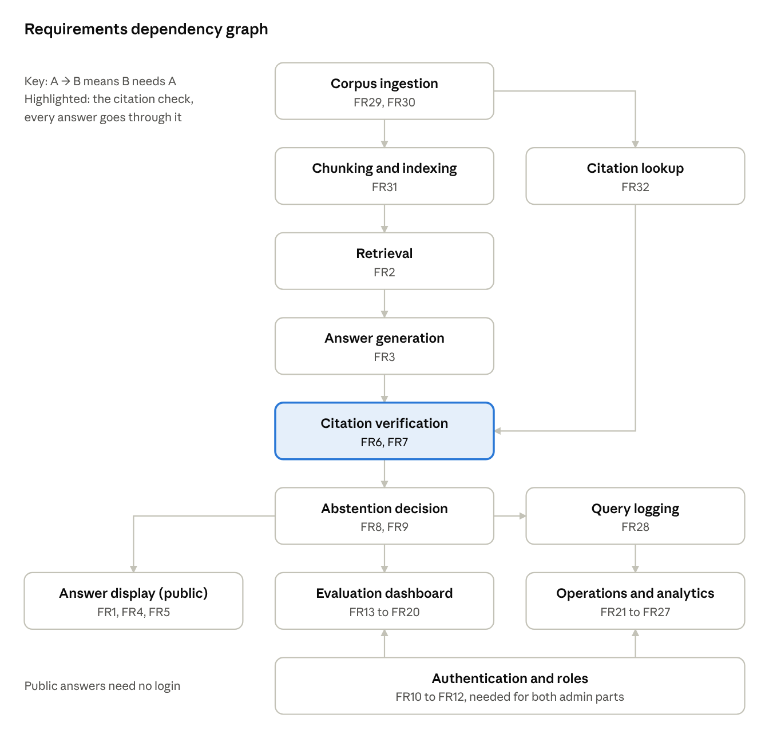
Figure 1: Requirements dependency graph
Data ingestion (FR29, FR30) is at the top because everything else depends on it. This is why the brief makes it the week 1 gate: if we cannot load our court's opinions and the citation data, we cannot build or test anything else.
From there, two separate paths meet at citation verification. The first is the text path: chunking, retrieval and answer generation. The second is the citation lookup, which is built from the CourtListener citation files. We can build and test the two paths separately, which helps us split the work between the three of us.
Abstention comes after verification, not just after retrieval, because the support score also depends on how much of the answer survived the citation check. So the abstention threshold can only be tuned once verification works, which matches weeks 7 and 8 of the plan. The evaluation dashboard and the operations pages need the whole pipeline and the query log before they show real numbers, so in week 5 they will only be skeletons. Login and roles are needed for both admin parts but not for the public page.
We expect some requirements to change during the semester:
- Corpus scope (FR29): the court or date range may change at the week 1 gate if the download or the number of opinions is not manageable. Since everything depends on it, a change here also means updating the test questions.
- Chunking (FR31): the chunk size will probably change after we measure the baseline in weeks 2 and 3.
- Retrieval (SR17, SR18): the reranker is our planned improvement for week 10. If it changes the scores, the abstention thresholds will have to be tuned again.
- Abstention thresholds (FR23, SR26 to SR29): these will change the most, first in weeks 7 and 8 and then based on what we see in the abstention list.
- LLM: we may change the model for cost or speed. Verification does not depend on the model, so this should not affect NFR1.
- New data releases (NFR13): CourtListener publishes new files every quarter. Loading a new release triggers a re-index and an automatic regression run (FR20).
The verification requirements (FR6, FR7, NFR1) should stay the same, since they are the main goal of the project.

7. Conclusion
In this document we defined the problem our system solves, the objectives and constraints of the project, 34 functional and 17 non-functional user requirements, and 43 system requirements, along with how they depend on each other and how we expect them to change. The most important requirement is that no unverified citation reaches the user, and that the system says "not supported" when the opinions do not answer the question. Since our final system will be assessed against our specification, we will use this document to write SPEC.md before we start coding, and we will come back to it whenever we make a design decision.

8. Appendix

A. Proposed data scope
We propose to use the opinions of the Supreme Court of the United States (CourtListener court ID "scotus") filed between 2000 and 2024, from the bulk release of 31/12/2024. The opinions file is 44,759,737,019 bytes according to the brief (checked on 21/09/2026), so we will only keep our court's rows. If the connection is not stable enough to stream it, we will download the full file first, filter it, and then delete it. The exact number of opinions will be counted at the week 1 gate and written in SPEC.md. We chose one well-known court because the download stays small, it is easier to write test questions with known answers, and it is clear which questions are outside our data.

B. Traceability (objectives and constraints to requirements)
Objective / constraint | Requirements
O1 | FR1, FR2, FR31, NFR4
O2 | FR3, FR4, FR5, NFR2
O3 | FR6, FR7, FR32, NFR1
O4 | FR8, FR9, NFR3, NFR10
O5 | FR13 to FR20
O6 | FR21 to FR28, NFR9
O7 | FR10, FR11, FR12, NFR7, NFR8
O8 | FR30
C1 | NFR5, NFR6
C2, C3, C4 | FR29, NFR11, NFR12, NFR13
C5, C7 | FR13a to FR13c, NFR16
C6 | NFR14, NFR15
C8 | NFR17

C. References
[1] Mata v. Avianca, Inc., 678 F. Supp. 3d 443 (S.D.N.Y. 2023). Summary: https://en.wikipedia.org/wiki/Mata_v._Avianca,_Inc.
[2] Stanford HAI, "AI on Trial: Legal Models Hallucinate in 1 out of 6 (or More) Benchmarking Queries", 2024. https://hai.stanford.edu/news/ai-trial-legal-models-hallucinate-1-out-6-queries
[3] LegalTech Monitor, "In redo of its study, Stanford finds Westlaw's AI hallucinates at double the rate of LexisNexis", June 2024. https://www.legaltechmonitor.com/2024/06/in-redo-of-its-study-stanford-finds-westlaws-ai-hallucinates-at-double-the-rate-of-lexisnexis/
[4] Business Law Today, "December in Brief: Legal Opinions and Ethics 2024". https://businesslawtoday.org/month-in-brief/december-in-brief-legal-opinions-and-ethics-2024/
[5] CourtListener bulk data, Free Law Project. https://storage.courtlistener.com/bulk-data/
[6] P4 project brief and Delivery No. 1 instructions, SE course, ESIB, Fall 2026-2027.

