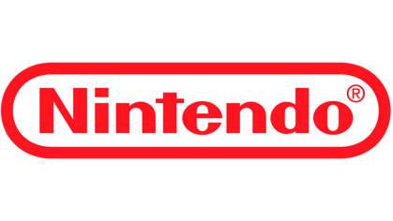
Cover Letter
Dear Hiring Team at Nintendo Technology Development,
I am writing to express my excitement to apply for the Associate Software Engineer (Audio) position at Nintendo Technology Development. My decision to pursue computer science was deeply influenced by Nintendo and the impact its technology has had on my life. I was heavily inspired by Satoru Iwata in his undeniable passion for video games and software development. His ability to problem-solve while putting people first in everything he did continues to inspire me every day I come to work and acts as a reminder to develop with user experience in mind.
I graduated as a Computer Science student from the University of Central Florida with my bachelor’s degree. I am a full stack developer, where I have been building real-world systems while developing a strong foundation in software engineering fundamentals, debugging, and system design. In my role at Entertainment Technology Partners, I work on a production analytics platform where I regularly modify existing code, implement new features, and debug issues across both frontend and backend systems. This experience has taught me how to work within established codebases, understand system behavior, and deliver reliable solutions under evolving requirements.
Additionally, through my work with Command Post Technologies, I have contributed to backend systems and tools that support simulated environments. This has strengthened my ability to test, debug, and collaborate effectively while improving system behavior in complex applications.
What draws me most to Nintendo is the opportunity to grow as an engineer in an environment that values fun, curiosity, collaboration, and creative solutions. I am especially inspired by Nintendo’s philosophy of creating experiences that are both technically sound and meaningful to the people who interact with them. That balance between engineering and creativity is the reason I chose this path, and it continues to guide the way I approach my work.
I am eager to continue learning, contribute to your team, and develop as an engineer in a way that reflects those values. I believe my technical foundation, adaptability, and genuine passion for this field would allow me to make a positive impact at Nintendo Technology Development.
Thank you for your time and consideration.
Sincerely,
Edwin Gabriel Villanueva

